**INTRODUCTION**

1. **RATIONALE**

On-the-Job Training or practicum training is a training method that helps the students to develop their skills and productivity while in the actual workplace. Students do actual work in the industries they are interested in, under a supervisor or manager. By training students this way, students learn and experience how a workplace functions, preparing for the real world.

Additionally, OJT provides students with the chance to practice what they have learned in school while developing new, relevant competencies. OJT also introduces them to the culture of their future profession or industry, teaching them how to adjust to the expectations of the workplace and gain valuable life skills for future success.

1. **COMPANY PROFILE**

Bizmatech Business Machine Technologies is a supplier of a wide range of business tools and equipment, including IT products, office equipment, security systems, communication systems, electricals, Pisonet gaming and vendo machines, and POS hardware/software. Established on March 8, 2016, its mission is to provide cost-effective technology solutions to help businesses grow and contribute to the economy through sales, services, innovation, and support.

As part of its expansion, Bizmatech Business Machine Technologies leveraged its proven expertise to offer a range of IT solutions and services, including hardware/software installation, printer repair, CCTV installation, networking, upgrades, and preventive maintenance. With a strong leadership team, Bizmatech delivers both on-site and off-site support, providing a comprehensive package of sales, services, and solutions aimed at driving innovation and ensuring customer satisfaction in the digital age.

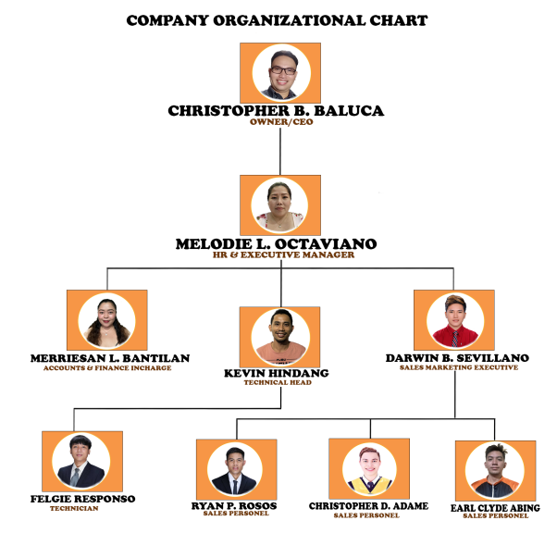**ORGANIZATIONAL STRUCTURE**

**DUTIES/ FUNCTIONS OF ON-THE-JOB TRAINEE**

During my on-the-job training at Bizmatech Business Machine Technologies in Mandaue City, Cebu, I was assigned to the digital marketing department. Along with my fellow trainees, I learned and enhanced my editing skills through the use of tools like Photoshop and Canva. We worked on creating brochures and editing materials for the company’s products, particularly computers, which we then promoted to the online market.

Later, I was assigned to the sales and marketing team, where our focus shifted to online marketing. My tasks included posting the company’s products on social media platforms, managing the company’s pages, and responding to customer inquiries.

In addition to these responsibilities, I also assisted with tasks like attending to walk-in customers, booking deliveries, handling phone inquiries, contacting suppliers, and assembling computer sets and hardware.