Alphabet Soup Charity Optimization

**Purpose**

The purpose of this report is to find the best optimization of Alphabet’s Soup Charity’s resources. We have created several models and used multiple sets of features to ascertain the best results.

**Results**

**Data Preprocessing**

**Target Variables**

For our target variable we used the data from the ‘IS_SUCCESSFUL’ column.

**Features**

We utilized two sets of features. The first set included the following data:

Application Type

Affiliation

Classification

Use Case

Organization

Income Amount

Special Consideration

Ask Amount

The second set of features included:

Application Type

Income Amount

Classification

Status

Only EIN and Name have been eliminated from the list due to being identifiers and therefore having no use in our neural network.

**The nn7 Model**

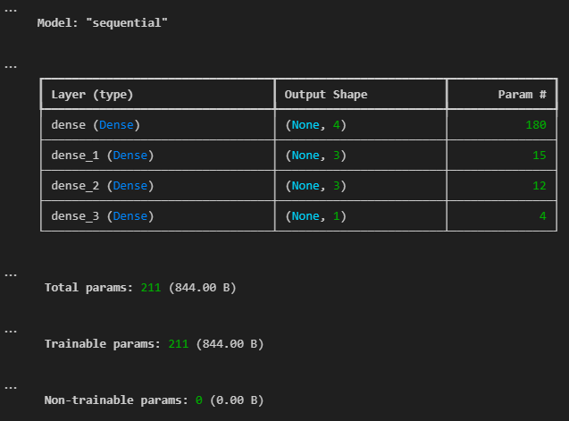

Layer 1: 4 nodes, Activation= relu

Layer 2: 3 nodes, Activation= tanh

Layer 3: 3 nodes, Activation= relu

This model was chosen after several attempts and ended up with the best results which ultimately did not meet our goal of 75% accuracy. The feature change we employed produced worse results so the original feature set was used. Any further details on previous models can be found in the code.