Weihao Huang March 24, 2022

Mingyan Zhou ESE516

**Assignment 7**

1.) What does “InitializeSerialConsole()” do? In said function, what is “cbufRx” and “cbufTx”? What type of data structure is it?

InitializeSerialConsole() starts the USART console for serial communication of the device by initializing cbufRx and cbufTx, configuring usart and its callback, and start constant reading. cbufRx and cbufTx are the circular ring buffers that holds char bytes in its data structure.

2.) How are “cbufRx” and “cbufTx” initialized? Where is the library that defines them (please tell the *C file they come from).

cbufRx and cbufTx are initialized by calling function circular_buffer_init() in the circular_buffer.c file that initializes specific a memory allocation data structure, assigning buffer and size value and resetting the new circular buffer.

3.) Where are the character arrays where the RX and TX characters are being stored on at the end? Please mention their name and size. Tip: Please note cBufRx and cBufTx are structures.

The characters arrays are being stored in char variables called:

rxCharacterBuffer[RX_BUFFER_SIZE]

txCharacterBuffer[TX_BUFFER_SIZE]

with size of 512 bytes each.

4.) Where are the interrupts for UART character received and UART character sent defined?

The interrupts are defined usart_interrupt.c file.

5.) What are the callback functions that are called when:

• A character is received? (RX)

usart_read_callback

• A character has been sent? (TX)

usart_write_callback

6.) Explain what is being done on each of these two callbacks and how do they relate to the cbufRx and cbufTx buffers.

In the read_callback, it takes the current character from the RX string, puts it into the cbufRx buffer, and then continues the reading of the RX string.

In the write_callback, it checks if there are any characters left to be sent (if the current character is not the last index of the cbufTx buffer). If there is, we call usart_write_buffer_job to send the character.

7.) Draw a diagram that explain the program flow for UART reception – starting at the user typing a character and ending on how that characters ends up in the circular buffer “cbufRx”. Please make reference to specific functions in the starter code.

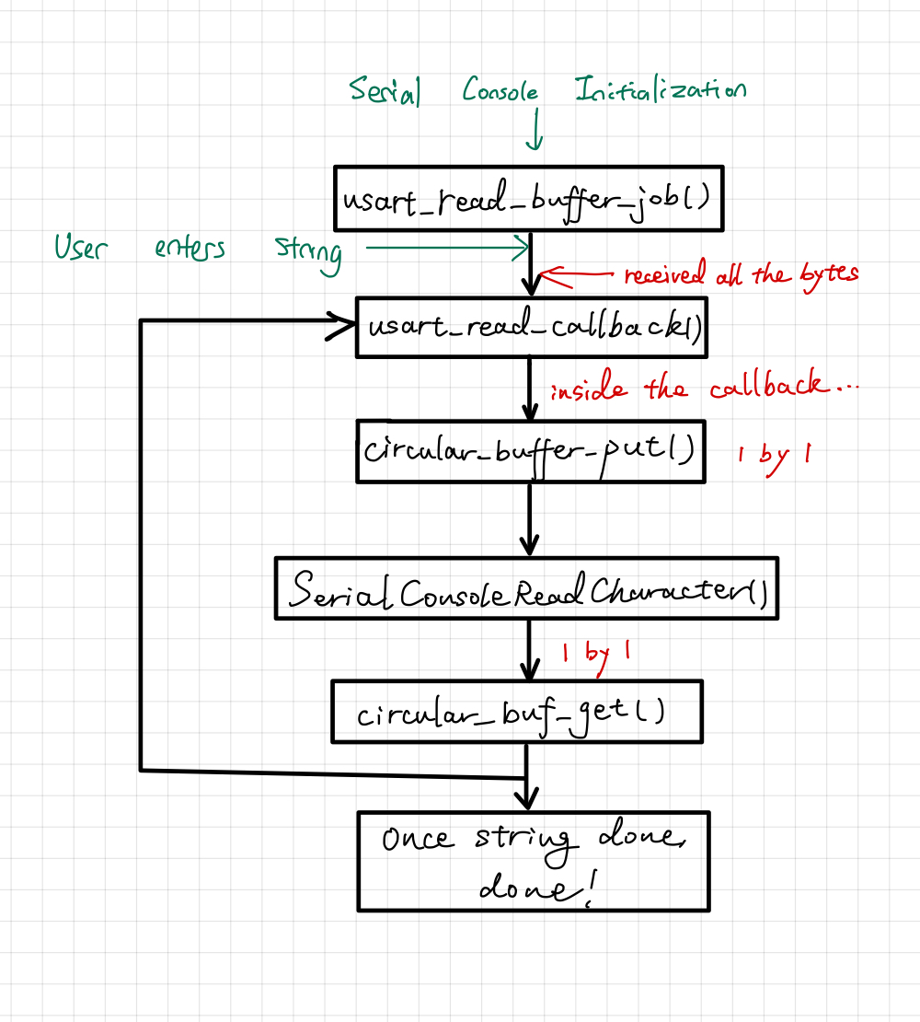

8.) Draw a diagram that explain the program flow for the UART transmission – Starting from a string added by the program to the circular buffer “cbufTx” and ending on characters being shown on the screen of a PC (On Teraterm, for example). Please make reference to specific functions in the starter code.

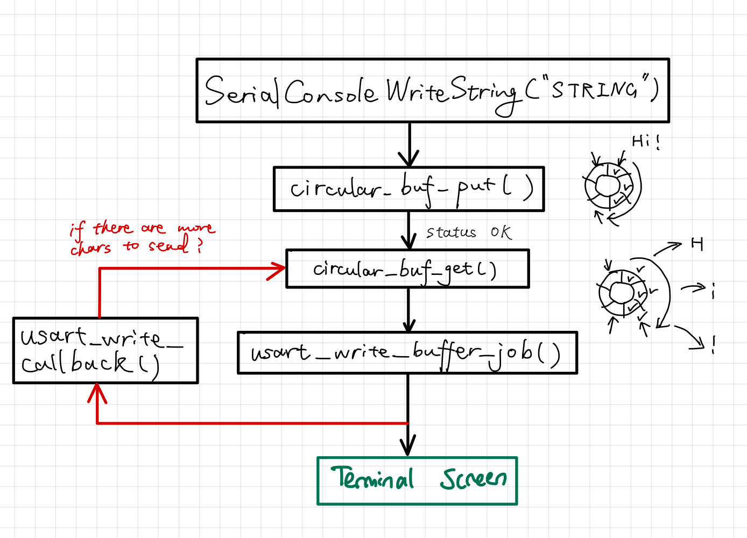

9.) What is done on the function “StartTasks()” in main.c? How many threads are started?

StartTasks() prints out the heap size before we start task. Then after tasks are initialized, it checks whether there is enough heap size to do so. Finally, it prints out the remaining heap size available. The starter code seems to have made 1 thread.