Simulation of Plain-Film X-Ray Imaging Using 2D and 3D Phantoms
Amber Kaul & Derek Herrera - COSC 4372

1. Introduction
This project involved developing a complete software system that simulates the acquisition of conventional film x-ray images. The simulator models Beer-Lambert attenuation, geometric imaging effects, and noise characteristics, and it provides both a 2D validation phantom and a 3D anatomical leg phantom with optional fracture modeling. Adjustable parameters include x-ray energy, source-object-film distances, beam angle, noise level, and fracture geometry. A graphical user interface (GUI) allows interactive experimentation.

The objectives of the project were:
- Determine how altering the distances between the x-ray source, object (phantom), and film influences magnification and sharpness
- Examine how varying x-ray energy affects contrast through changes in attenuation coefficients
- Evaluate how beam angle affects the projection of anatomical structures
- For the 3D leg phantom, assess how fracture visibility changes with fracture width and angle
2. Methods
The simulation system consists of several integrated components, each responsible for a key part of the imaging pipeline

2.1 Software Architecture
The environment is built from the following modules:
xray_simulator.py
- Generates 2D and 3D phantoms
- Applies Beer-Lambert attenuation
- Simulates geometric magnification, cropping, and penumbra blur
- Applies beam-angle rotation
- Adds Poisson and Gaussian noise
- Produces the final x-ray image
image_metrics.py
Computes image-quality metrics including:
- Contrast (RMS contrast for entire image)
- Variance of Laplacian (sharpness)
- Edge strength via Sobel operator
- Gradient entropy
- Mean and standard deviation
- Special fracture-region metrics for the 3D phantom
batch_analysis.py
Automates parameter sweeps for:
- Distance
- Energy
- Beam angle
- Fracture width and fracture angle
Streamlit GUI
Provides interactive control of:
- Energy
- Distances
- Beam angle
- Noise level
- Fracture width and angle
- Phantom selection (2D or 3D)
Displays the phantom, simulated x-ray, intensity profiles, and metrics

2.2 Material Attenuation Coefficients
Material properties are defined as lookup tables for attenuation coefficient mu(E). Example values:
- 'air': {20: 0.0001, 40: 0.00005, 60: 0.00003, 80: 0.00002, 100: 0.00002, 150: 0.00001}
- 'soft_tissue': {20: 0.75, 40: 0.23, 60: 0.19, 80: 0.18, 100: 0.17, 150: 0.15}
- 'bone': {20: 2.5, 40: 0.65, 60: 0.40, 80: 0.32, 100: 0.28, 150: 0.22}

Linear interpolation is used when the system receives an intermediate energy:
- mu = mu1 + (mu2 - mu1) * (energy - e1) / (e2 - e1)

This supports realistic energy-dependent contrast behavior.

2.3 Phantom Generation

2.3.1 2D Test Phantom
A labeled 512x512 image composed of:
- Air (0)
- Soft tissue (1)
- Bone (2)
The phantom contains:
- A large circular bone region
- A rectangular soft-tissue region
- A triangular bone region
- A smaller circular high-density inclusion
This phantom supports controlled evaluation of geometry and beam-angle effects
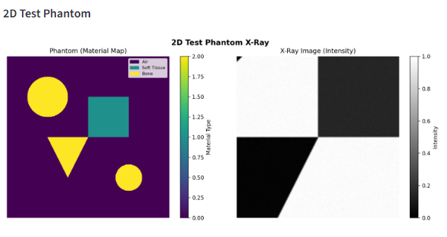

2.3.2 3D Leg Phantom
A cylindrical soft-tissue outer region with a concentric cylindrical bone interior.

Fracture modeling is applied by:
- Selecting the central portion of slices
- Rotating coordinates by the user-specified fracture angle
- Creating a linear gap by replacing bone voxels with soft tissue when:
  - |xr| < fracture_width / 2

This enables comparison between orthogonal, oblique, narrow, and widened fracture patterns
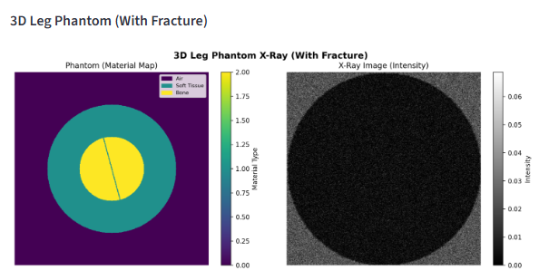
2.4 Beer-Lambert Projection
The attenuation model follows:
- I(x,y) = I0 * exp( - sum_over_materials( mu(material, energy) * thickness(material) ) )

2D Phantom
- Uses a constant 10 cm assumed thickness

3D Phantom
- Thickness is computed by summing voxels along the projection axis:
  - thickness = number_of_voxels * 0.1 cm

2.5 Geometry Model
Magnification:
- M = film_distance / object_distance
- Implemented via interpolation-based image scaling
- After magnification, images are cropped or padded to return to 512x512 pixels

Penumbra blur is applied with:
- blur_sigma = max(0.1, (film_distance - object_distance) / source_distance)
- This simulates focal spot blur and geometry-dependent sharpness changes.

2.6 Beam Angle Simulation
The beam angle rotates the phantom before projection:
- rotated = rotate(phantom, angle, reshape=False)
- For 3D phantoms, each slice is rotated

2.7 Noise Model
Poisson (quantum) noise:
- scaled = image * 1000
- noisy = poisson(scaled) / 1000

Gaussian (detector) noise:
- noisy = noisy + Normal(0, noise_level)

Image intensities are then clipped between 0 and 1

2.8 Full Simulation Pipeline
For each image the system performs:
- Phantom generation
- Beam angle rotation
- Beer-Lambert attenuation
- Magnification and cropping
- Geometric blur
- Addition of Poisson and Gaussian noise
- Display of phantom slice (for 3D) and x-ray image

2.9 Image Quality Metrics
Contrast (RMS)
- contrast = sqrt( mean( (I - mean(I))^2 ) )

Variance of Laplacian (Sharpness)
- sharpness = variance( laplace(I) )

Edge Strength
- edge_strength = mean( sqrt( sobel_x^2 + sobel_y^2 ) )

Gradient Entropy
- Computed from a normalized histogram of gradient magnitudes

Fracture Metrics
In a predefined ROI:
- Fracture contrast
- Local sharpness
- Local edge strength
- Mean intensity inside vs. outside the fracture region
2.10 Batch Parameter Sweeps
Sweeps produce:
- Images for each parameter setting
- Metrics tables (CSV)
- Multi-image comparison figures
This supports systematic evaluation of distance effects, energy effects, beam-angle behavior, and fracture visibility

2.11 Graphical User Interface
The GUI includes:
- Interactive controls for energy, distances, beam angle, noise, and fracture settings
- Phantom display
- Simulated x-ray display
- Horizontal and vertical intensity profiles
- Real-time metrics
- Phantom selection (2D or 3D)
- Buttons for generating batch analysis results
3. Results and Discussion

3.1 Distance Effects
Source Distance
- Increasing source distance reduces magnification and produces slightly sharper edges due to reduced penumbra
- Decreasing the distance increases magnification and softens edges

Object Distance
- Closer to the source results in stronger magnification and reduced sharpness. Closer to the film results in more compact and sharper structures

Film Distance
- Film distance modifies magnification through the geometric ratio and slightly influences sharpness

3.2 X-Ray Energy Effects
Energy was swept from 20 to 150 keV. As energy increases:
- Attenuation differences between materials narrow
- Contrast decreases
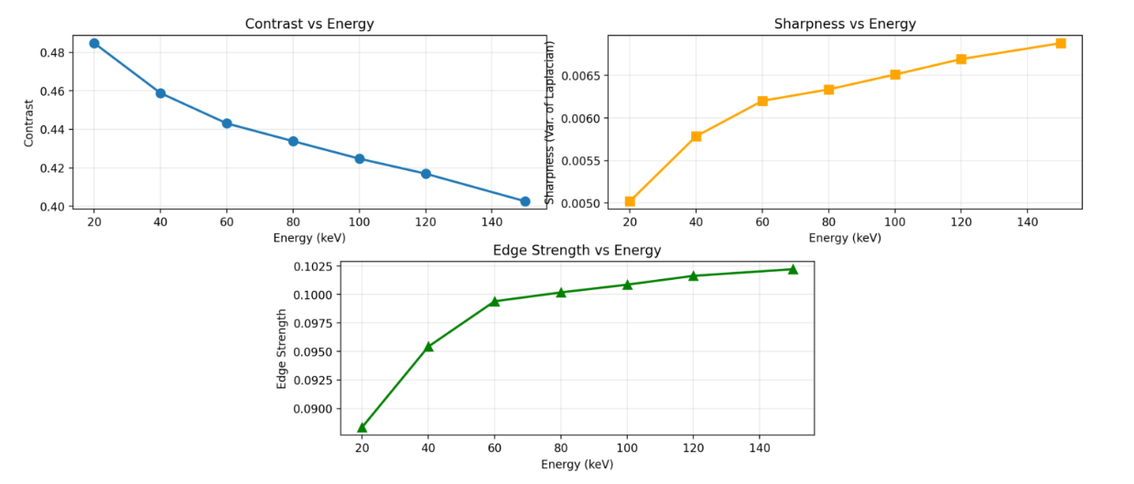
- Mean intensity increases

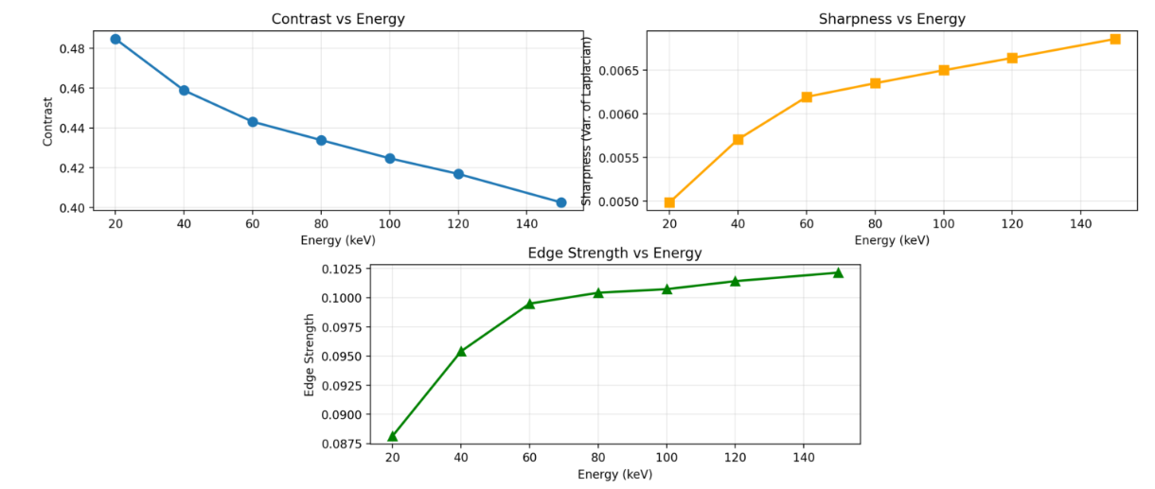

3.3 Beam Angle Effects
Beam angles from 0 to 45 degrees rotate and distort the projected anatomy. Structures shift and stretch depending on angle, changing the visual appearance of edges and profiles.
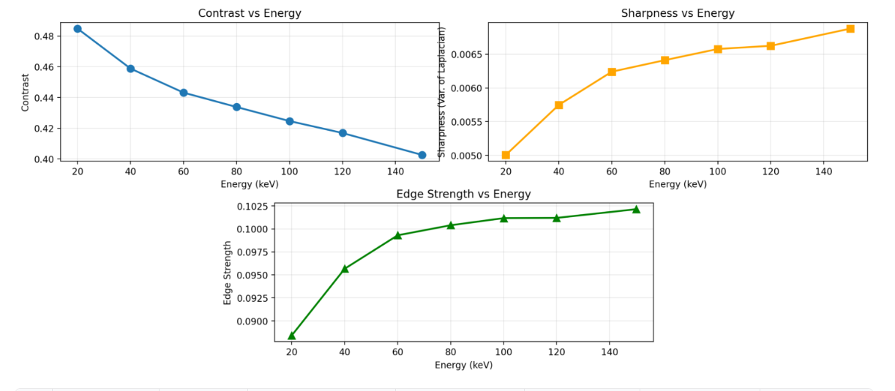

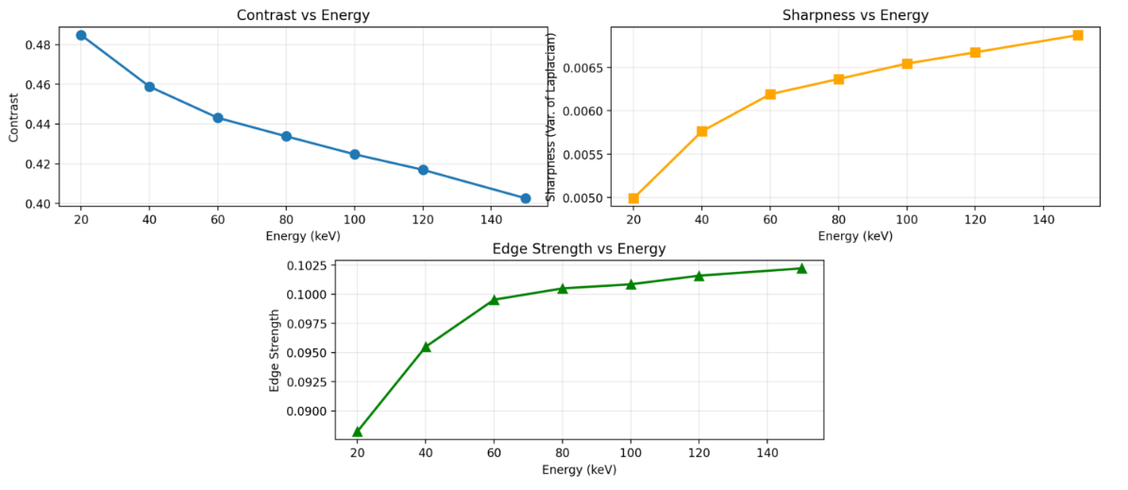

3.4 Fracture Visibility in the 3D Leg Phantom
Fracture Width
- Wider fractures produce more prominent low-intensity gaps, improving visual detectability

Fracture Angle
- A perpendicular fracture is sharp and localized
- Oblique fractures appear more diffuse as they extend across multiple slices
4. Limitations
- The attenuation model assumes monochromatic energy rather than full x-ray spectra
- Penumbra modeling is simplified relative to real focal spot geometry
- Global metrics average over the full image and may overlook local anatomical differences
- Phantoms are anatomically simple compared to detailed human structures
- The beam-angle simulation rotates the phantom rather than ray-tracing oblique paths
5. Conclusions
A complete x-ray simulation system was developed, including image physics, geometry, noise modeling, phantoms, a GUI, and batch analysis tools. The simulator demonstrates expected radiographic behavior, including distance-dependent magnification, energy-dependent contrast changes, beam-angle effects, and fracture visibility differences in the 3D leg phantom. The system provides a functional platform for exploring imaging physics and diagnostic visibility in radiography.

