- Which of the following is the valid override of equals method in java.lang.Object
  - public boolean equals(Employee eobj) {}
  - Private Boolean equals(Employee eobj) {}
  - public boolean equals(Object eobj) {}
  - All of the above
- Which of the following statements are true
  - catch(X x) can catch subclasses of X.
  - The Error class is a RuntimeException.
  - Any statement that can throw an Error must be enclosed in a try block.
  - Any statement that can throw an Checked Exception MUST be enclosed in a try block.
  - Any statement that can throw a RuntimeException MUST be enclosed in a try block.
- Identify the type to which “ArrayIndexOutOfBoundsException” fall?
  - Checked Exception
  - Unchecked Exception
  - Runtime Exception
  - Both (B) and (C)
- Which of the following Statement about finally Block is valid
  - Try-catch MUST have finally Block
  - Finally Block Gets always executed
  - Finally Block will get executed if System.exit() is in a catch block
  - Finally Block gets executed event if there is a forced exit in try-catch block
- If the block of a Method method1() throws an IOException what the Method could do
  - Can have throws Clause with public void method1() throws IOException{}
  - Can handle the IOException with try-catch Block
  - Can have Both throws Clause and handle the exception
  - Can have throws Clause with public void method1() throw IOException{}
- Which of the following method is implicitly called when an object is garbage collected
  - finally ()
  - final()
  - hashCode()
  - finalize()

- Which is valid about java.lang.Exceptions
  - The Class Exception and all its sublcasses that are not subclasses of Runtime Exceptions are checked exceptions
  - The class Error and all its subclasses are unchecked Exceptions
  - The Class Runtime Exception and all its subclasses are unchecked exception
  - None of the Above
- What is true of try-with –resources
  - Introduced in java 7
  - We need not write explicit code for closing files
  - Using multiple resources inside try with resources are also allowed
  - None of the above
- Resources that are closed by Java implements which interface
  - Java.lang.Autoclose
  - Java.lang.closeAutomatically
  - Java.lang.Autocloseable
  - Java.lang.closeable
- What will be output of following program -

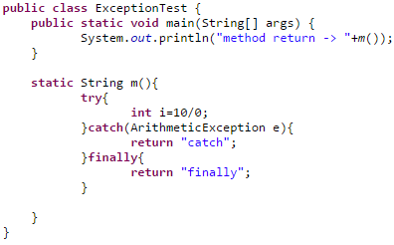

- Runtime exception
- Method return ->finally
- Method return -> catch
- Compile time error
- What will happen when catch and finally block both return value?
  - Method will return value returned by finally block
  - Method will return value returned by catch block
  - Finally Block won’t execute
  - None of the Above

- Which of these points will be valid If superclass method does not throw any exception
  - Overridden method of subclass can throw any RuntimeException
  - Overridden method of subclass cannot throw any checked exception
  - Overridden method of subclass may not throw any exception
  - All of the Above

- What will be output of following program -
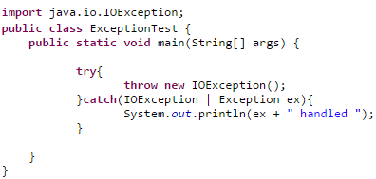

  - Runtime exception
  - Program will compile
  - Program won’t compile
  - None of the above

- In which condition will the finally block will not be executed?
  - When some error occurs
  - When Exception is raised
  - Whey System.exit() is called
  - In all the Cases
- Exception and Error are direct subclasses of
  - BaseException
  - Throwable
  - Object
  - Runtime Exception
- Which keyword is used to explicitly raise a exception
  - Catch
  - Throw
  - Throws
  - Raise

- Which of the following List the exception types from Most Specific and to Least Specific
  - Throwable,Exception,RunTimeException
  - RunTimeException,Throwable,ArrayIndexOutOfBoundsExeception
  - Error,Exception,Throwable
  - Object,IOException,FileNotFoundException

- How many finally blocks can be there in a try/catch structure

- Which of the following Class Best Suits for User Defined Exception

  - RunTimeException
  - Object
  - NullPointerException
  - Exeception

- Equals Method in Java can Throw which of the following Exception
  - ArithmeticExcpetion
  - NumberFormatException
  - CheckExcpetion
  - None of the Above

