SENG 466 Mechanotronics
Project 1

Team members
Jackson Hong
Derek Jacoby
Riley Nold

Introduction and problem statement

The goal of the first project is to demonstrate mastery over the individual component parts of the final hovercraft solution. These parts include the following:

Seeduino microcontrollers
Motor and servo motor outputs via the L298 motor controller
joystick and button inputs
I2C LED
Sonar input sensor for distance measurement
Radio connection for a control station and a remote station

In this first demonstration of functionality, the parts will be assembled on a non-moving platform so some of the sensors and motor outputs will be put to somewhat different uses than will be expected in the final hovercraft.

In addition, this first project is where we put together the support tools to allow us to develop as a team. In our case, we have decided upon the following:

Google calendar to coordinate availability
Google code as a source code repository to allow backup and change tracking
Eclipse as a development environment
Serial.print as the primary debugging mechanism, with the output viewable in Eclipse

This report will detail the steps we have taken in each of these areas to create a test platform for the technologies and teamwork that we will require to execute on the final project.

The component parts were each worked on individually, and then the final phase was to integrate them into a test scenario. Subsequent sections will detail the initial implementations of each section and then the integration work.

Test Scenario

In order to show that we can use each component in an integrated scenario, we need to define some actions. First, the components will be broken into a base unit and a remote unit. The sonar will be placed with the remote unit for greatest realism with respect to our final project hovercraft scenario. The two units will speak to each other over the radio.

The base unit consists of a Seeduino microcontroller that accepts the joystick input, including button presses. On the output side, the I2C LED will be placed on the base unit.

The remote unit consists of the second Seeduino, a motor output via the L298, a servo motor output through the L298, and the sonar input.

When the joystick (actually a flight controller) is turned to the right or left, the base unit seeduino will relay those commands to the remote unit seeduino and the servo motor will move to the right or left. A small flag will be placed on the servo motor arm so that it's position is readily visible. When the lever on the flight controller is moved up the motor attached to the remote seeduino will move from stopped up through full speed. The motor will have a fan blade attached so that this motion is apparent. When a button on the flight controller is pressed, the LED onboard the remote seeduino will be lit and it will go out when the button is released.

Normally, the I2C LED on the control unit is green. When an object (a hand, for instance) comes close to the sonar sensor the LED will reduce the intensity of green and add red until the hand is almost touching the sensor at which point the LED will be entirely red.

Here are some pictures of our setup.

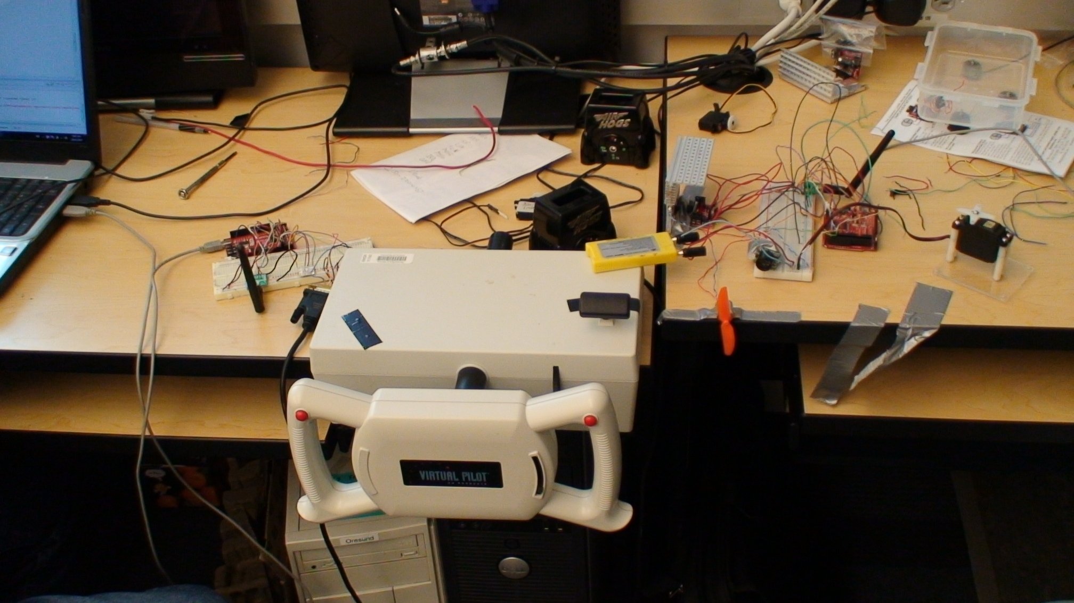Illustration 1: Overall setup
On the left hand side is the base unit, on the right is the remote unit. The yellow battery on top of the flight controller is driving the motors. The seeduinos at this point are driven from the USB port of the attached laptops.

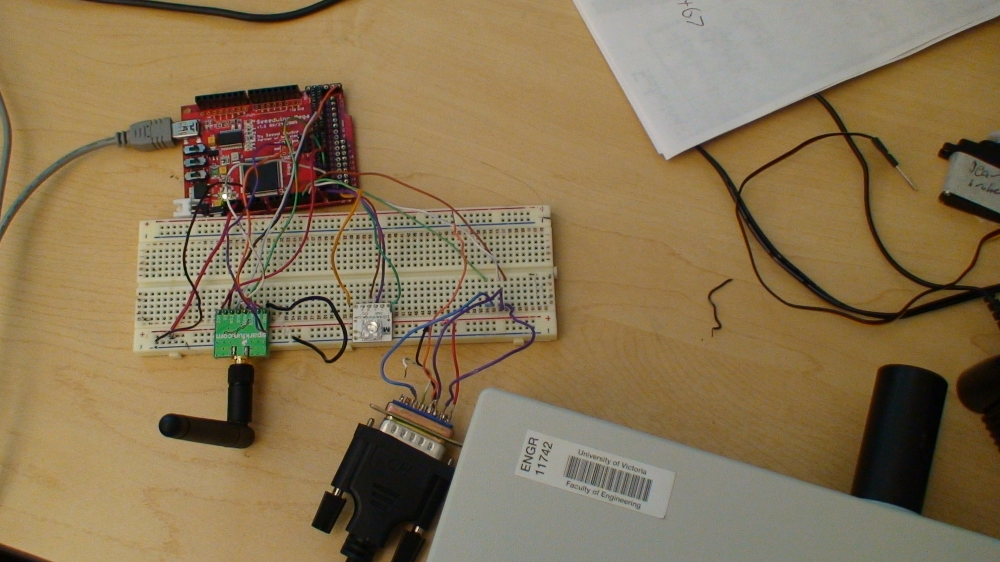Illustration 2: Base station
The base station setup is fairly simple. The red board is the seeduino. On the white breadboard is an I2C LED and a radio which are wired to the seeduino. Also wired through the breadboard is the flight controller (the black connector at the bottom of the image is the cable from the flight controller.)

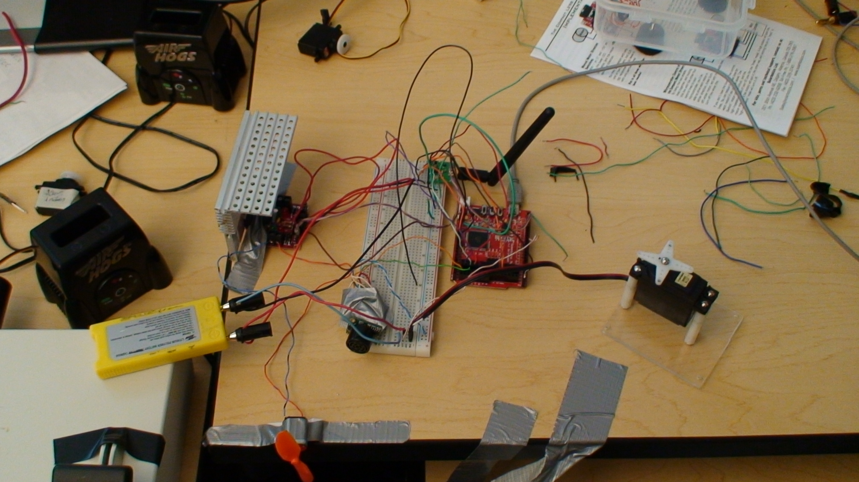Illustration 3: Remote station
The remote station setup is slightly more complicated. The yellow battery on top of the flight controller powers the L298 motor controller and the servo motor. The aluminium heat sink next to the yellow battery is attached to the L298 to prevent overheating. On the corner of the desk on the other side of the battery you can see the fan attached to our motor. The white breadboard contains the sonar and the radio. Attached to the bottom right of the breadboard are the connections between the seeduino, the power supply, and the servo motor.

