1. A ladybug with a velocity of 10.0 mm/s [W] crawls on a chair that is being pulled [W 50◦ N] at 40.0 mm/s. What is the velocity of the ladybug relative to the ground?

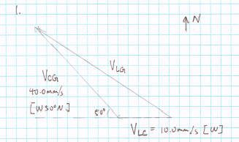

1. An airplane is flying to a city due west from its current location. If there is a slight wind blowing to the southwest, in what direction must the plane head(that is, in what direction must it point)? Explain you answer using a diagram.

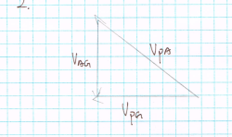

1. Do research to find out how relative velocity is related to the direction in which rockets are launched to send them into space. Explain the benefits (to society and/or the environment) of using a specific direction for launching rockets.

Rockets are launched with the same direction as the earth’s rotation. The earth’s surface rotates at approximately 1675km/h. By launching in the same direction as the earth’s rotation, rockets can use earth’s relative velocity and gain an considerable amount of boost in speed. This maneuver can reduce the flight time for the rocket to escape earth’s gravitational pull, and therefore save substantial amount of fuel required to launch. Economically, costs of rocket launches are reduced. Environmentally, less natural resources are used for fuel.

Kinetics:

1. Using the data that you have just collected, complete the Analysis questions and Conclusion statement for the projectile motion investigation.

Analysis:

* 1. Construct a labelled drawing of your investigation, indicating the object projected, the height from which it was projected, and its horizontal range.

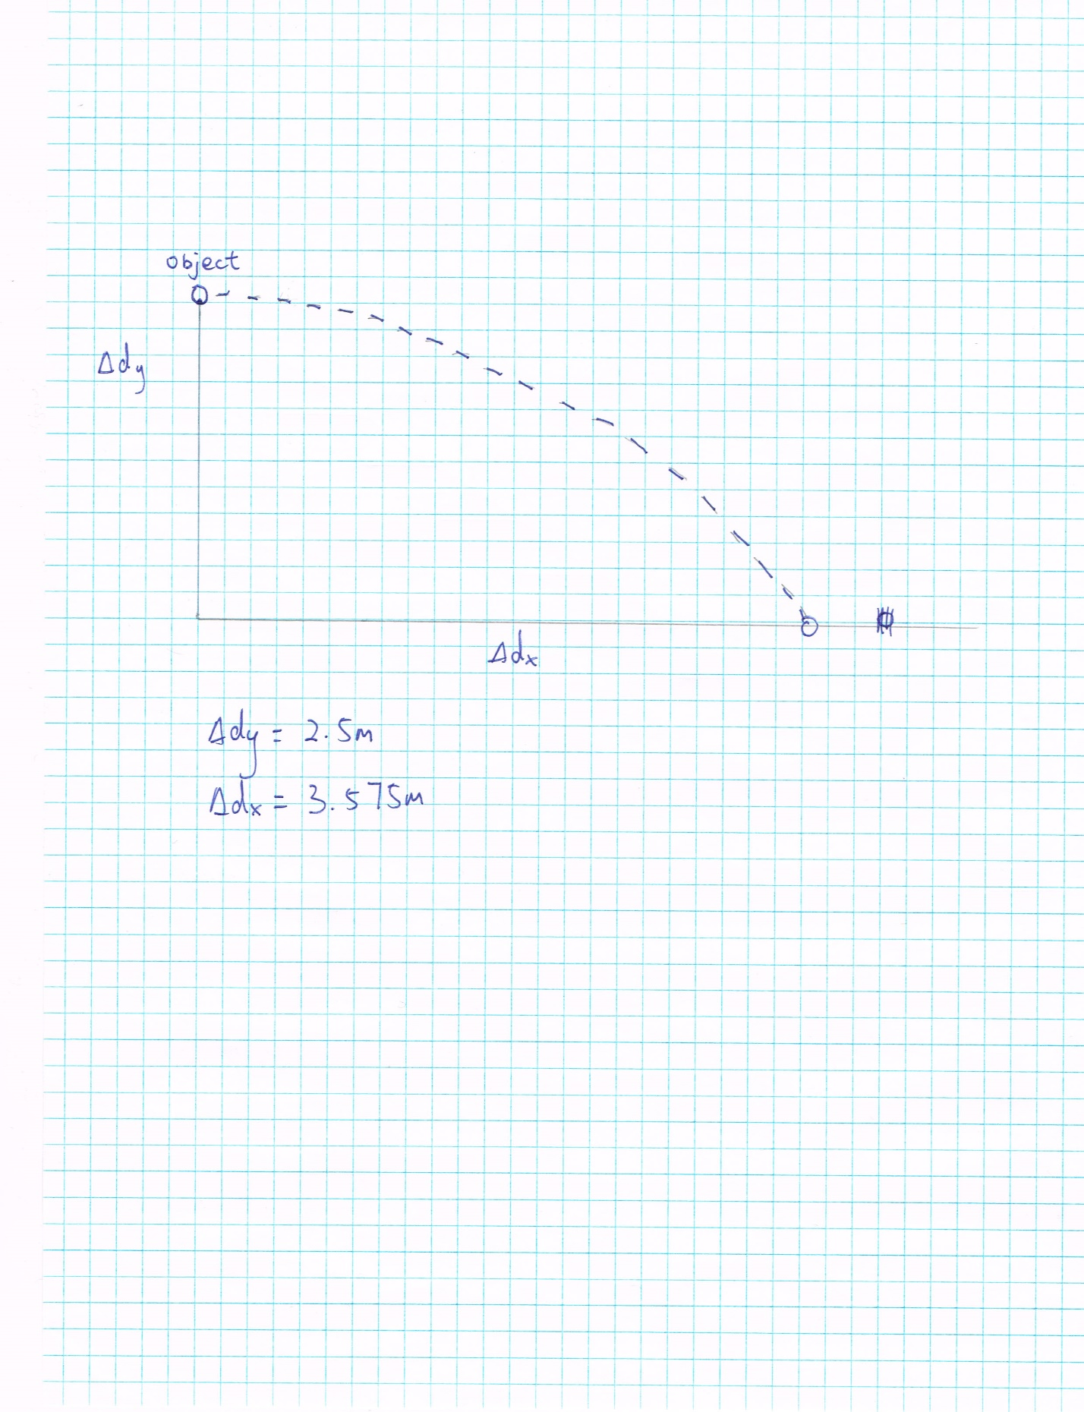

* 1. Using the known vertical height(∆), and the average horizontal range (), perform the necessary calculations to determine the initial velocity of your object.
  2. State two possible sources of error (reviewed here, or others that you can think of) and how you worked to reduce the possibility or effects of these errors.
     + 1. Using human force to push the object is not reliable because it is difficult to maintain the same amount of force for each push. To address this issue, I used a robot vacuum to push the object at constant speed, thus ensuring the precision of the object’s initial velocity
       2. Air friction can be a varying factor. Depending on the weather, fluctuating wind speed can affect the velocity of the object. To prevent this, I performed the experimented on a sunny day with minimal wind speed, to ensure the precision of the objects velocity.
  3. Describe any safety precautions taken when carrying out this investigation.

The space was clear of people to prevent injury.

Extra caution was exercised to prevent the damaged of electronic device

Rubber gloves were worn to prevent electric shock

Conclusion:

Write a conclusion by filling in the blanks in the following statement. Note that the statement is concise and is directly related to the objective of the investigation.

When projecting a tennis ball from a height of 2.5m, the average horizontal range was measured to be 3.573m and the magnitude of the initial velocity was calculate to be 5.0m/s

1. A projectile is launched so that its point of launch is lower than its landing point.
   1. When is the vertical velocity at a maximum?

Assuming upwards is positive, the maximum vertical velocity is at the moment the ball is thrown

* 1. When is the horizontal velocity at a maximum?

The horizontal velocity stays constant throughout the flight

* 1. When is the vertical velocity at a minimum?

As a scalar magnitude, the vertical velocity is at minimum when the projectile is at the top of its path when it is momentarily 0m/s. As a vector, assuming upwards is positive, the vertical velocity is at minimum just before it touches the ground

* 1. What is the acceleration of the object at the very top of its path? Explain

Disregarding air friction, the only source of acceleration is gravity, which stays constant at 9.8m/ throughout the trajectory

* 1. Which will take longer: the upward motion or the downward motion?

The upward motion will take longer

1. A child sitting in a tree throws his apple core from where he is perched(4.0m high) with a velocity of 5.0m/s [35° above the horizontal], and it hits the ground right next to his friend.
   1. How long does it take for the apple core to hit the ground?
   2. How far from the base of the tree will the apple core land?
   3. What is the velocity of the apple core on impact?
2. Describe three ways that understanding projectile motion and relative velocity could help you improve your success in a basketball game
   1. I would be able shoot more accurately, since I have a better understanding of the trajectory of the ball, including its angle and velocity of flight.
   2. Having understood velocity, I know that when I am moving, the ball is moving with me and has the same velocity as I do. So I will not require as much force to shoot the ball as I am while stationary
   3. I would understand the flight path of the ball better, and can anticipate the route of the ball more accurately.
3. If an object is in motion, does that mean that the object has a net force in the direction of that motion? Explain

If the motion of the object is constant, then there the acceleration on that object is 0m/, since

There is no net force on the object. Otherwise, if the motion is not constant, The direction of the net force is dependant on the direction of the acceleration.

1. At a construction site, a small crane is raising two boxes of nails on a plank to the roof. One box has already been opened and is half full, while the other box is new. The boxes, including the nails, weigh 10kg and 20kg, respectively, and are the same size.
   1. As the plank tilts towards the heavier box, predict which box of nails will start to slide first. Explain your prediction

It is evident from the equation that the mass of the objects has no effect on the falling of the boxes. Instead, it is dependant on the angle of incline. Therefore, both boxes will slide simultaneously

* 1. If the coefficient of static friction is 0.4, draw and FBD for each box of nails and use it to calculate the angle at which each box begins to slide

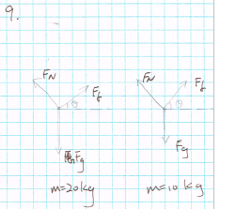

Both boxes begin to slide at 22 degrees

* 1. If the coefficient of kinetic friction is 0.3, how fast will the boxes accelerate along the plank, once they start to slide?

The accelerate of both boxes is 7.3m/

1. Design a simple experiment that you could carry out in your home to
   * 1. Determine the coefficient of static friction between an object and a surface
     2. Prove that the coefficient of static friction is dependent only on the surfaces in contact, and is not affected by any change in the mass of your object.
2. Describe your plan. It must include a list of materials, a diagram of the set-up, and an explanation of the steps you would take and the data you would collect.

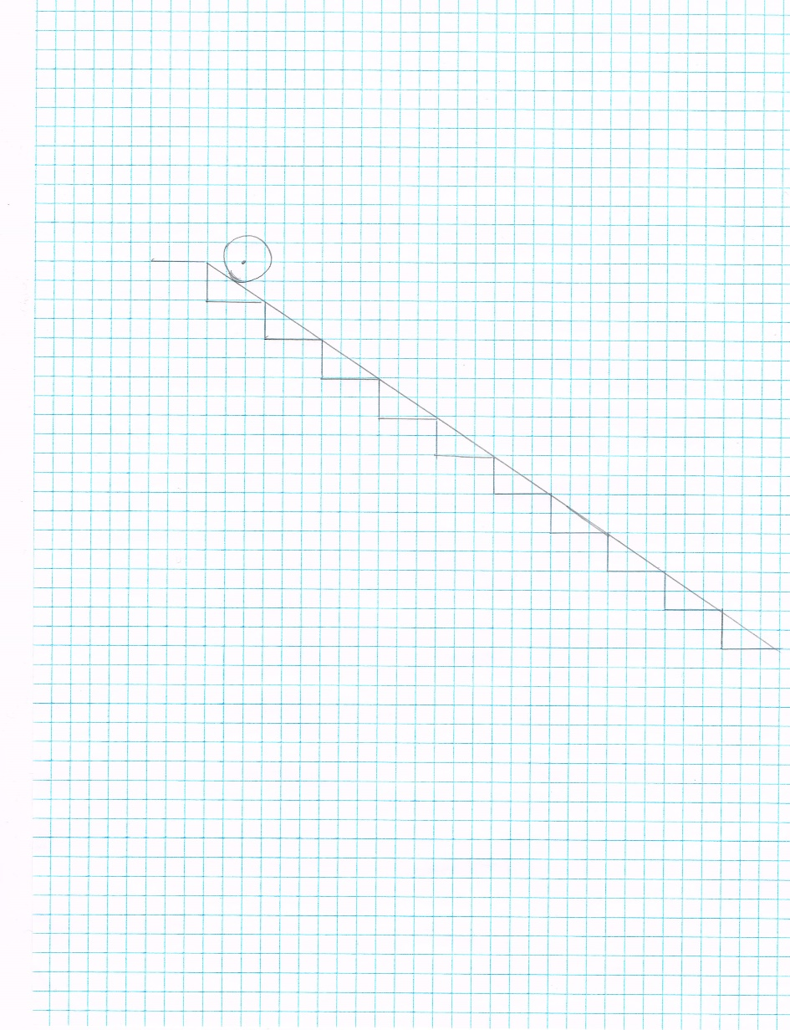

|  |  |
| --- | --- |
| Materials | 1 15kg dumbbell |
| 1 25kg dumbbell |
| 1 yoga mat |
| 1 large piece of sandpaper |
| timer |
| Staircase |
| Duct tape |
|  |

|  |  |
| --- | --- |
| Steps | 1. Lay the yoga mat on top of the stairs, using duct tape at the ends to reinforce the stability of the ramp. Record the length of ramp, as well as the angle it forms with the floor |
| 1. Place the 15kg dumbbell on top of the ramp and allow it to roll to the bottom; repeat the process 2 times, and record the average travel time |
| 1. Place the 25kg dumbbell on top of the ramp and allow it to roll to the bottom; repeat the process 2 times, and record the travel time |
| 1. Calculate the coefficient of static friction by using , and the data collected from rolling two sets of dumbbells on the yoga mat |
| 1. Swap the yoga mat with sandpaper, and tape the ends with duct tape. |
| 1. Repeat step 2~4 |
| 1. Compare the results obtained from step 4. |
|  |

1. Explain how you would analyze the collected data to determine the coefficient of static friction and prove that it is unaffected by any change in the mass of your object.

By changing the mass the of the object, I can collect data to calculate the gravitational and friction force of the object and the surface, and thus calculate the coefficient. If done correctly, the coefficient of static friction will remain constant, regardless of change in object mass. Additionally, to prove that the coefficient is dependant only on the surface, I can calculate the coefficient of two different surfaces(yoga mat and sandpaper), using the same object. The results will be different, and prove that the coefficient of static friction is not dependant on the

mass of the object, but on the surface of contact.

1. State one possible source of error that you might encounter in this experiment and state the steps you took to minimize or eliminate this source of error.

Simply attaching the ends of the surface to the stairs with duct tape may not be sufficient reinforcement in the surfaces’ stability. Since there is space between individual steps under the flexible surface, the force of gravity may be greater than the normal force, and cause the object to sink while rolling. Since the degree of sinking may be dependant on the mass of the object, it is possible that the object may experience different intervals of acceleration, due to the degree of sinking of the surface, and produce inaccurate data. This potential error can be addressed by attaching additional duct tape along the sides of the surfaces. By doing so, I can minimize the sinking and receive more reliable results.

1. Efficient and safe transportation depends on friction being either minimized or maximized, as necessary.

Using research, find

* 1. One example in which friction is maximized to aid in transportation.

Brakes in automotive uses friction material to convert the kinetic energy of the vehicle to thermal energy through friction. The lower kinetic energy an object have, the slower it will move. Using friction, cars can slow down in a very short period of time.

* 1. One example in which friction is minimized to aid in transportation.

For each situation, explain how the friction is maximized/minimized and why this is necessary or beneficial

The design of modern aircrafts aim to reduces the force or air friction to the minimum by adopting shapes and structures that are aerodynamically efficient, thus minimizing the loss of speed caused by air friction.

* 1. Give at least one source that you used for your research.

<https://en.wikipedia.org/wiki/Aircraft>

<https://en.wikipedia.org/wiki/Brake_pad>

1. Does the label “centripetal force” ever appear in an FBD? Explain

No it does not. Centripetal force is not a new type of force; it is simply the sum of combination of forces that contribute to the circular motion.

1. Sometimes, road surfaces have banked curves. Use an FBD to explain how this helps cars to make turns more safely.

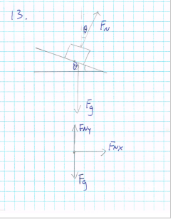

When the surfaces banks. The normal force vector becomes banked as well, and the x-component becomes the forces keeps the car in its track, preventing it from sliding out of the curve.

1. A bus passenger has her laptop sitting on the flat seat beside her as the bus, travelling at 10.0m/s, goes around a turn with a radius of 25.0m. What minimum coefficient of static friction is necessary to keep the laptop from sliding?

Minimum coefficient needed is 0.41

1. Keys with a combines mass of 0.100kg are attached to a 0.25m long string and swung in a circle in the vertical plane.
   1. What is the slowest speed that the keys can swing and still maintain a circular path?
   2. What is the tension in the string at the bottom of the circle?

The tension at the bottom of the circle is 2.0N

1. Do research to find out what artificial gravity is and how it is related to centripetal motion. Explain how artificial gravity could be created in a weightless environment and give a reason why we would want to do this. Give at least one source that you used for your research.

Artificial gravity is an inertial force that simulates the force of gravity. It can be generated by using centripetal force, which is essentially a sustained normal force generated by circular motion. In a weightless environment such as space, artificial gravity is generated by the rotation of spacecrafts. From its constant rotation, the spacecraft produces a constant normal force between touching surfaces inside the craft. Artificial gravity can be beneficial for astronauts’ health while in space. Various health problems can by caused by lack of gravity, including loss of white blood cells and muscle mass. Thanks to artificial gravity’s ability to mimic gravity, it can help alleviate such health risks that are involved with space flight.

Source: https://en.wikipedia.org/wiki/Artificial_gravity