1. The earth has a mass of 5.98 × 1024 kg and the moon has a mass of 7.35 × 1022 kg. The distance from the centre of the moon to the centre of the earth is 3.84 × 108 m. A rocket with a total mass of 1200 kg is 3.0 × 108 m from the centre of the earth and directly in between the earth and the moon. Find the net gravitational force on the rocket from the earth and moon. (4 marks)
2. A 12 kg meteor experiences an acceleration of 7.2 m/s2, when falling towards the earth.
   1. a)  How high above the earth’s surface is the meteor? (3 marks)
   2. b)  What force will a 30 kg meteor experience at the same altitude? (2 marks)
3. A 500 kg satellite experiences a gravitational force of 3000 N, while moving in a circular orbit around the earth.
   1. a)  Find the radius of the circular orbit. (2 marks)
   2. b)  Find the speed of the satellite. (2 marks)
   3. c)  Find the period of the orbit. (2 marks)
4. To simulate gravity, a circular space station with a radius of 150 m is rotated so that astronauts standing on the inner surface move at 30 m/s. If the 75 kg astronaut stands on a bathroom scale, what reading will it give? (Assume that the scale is calibrated in newtons.) (3 marks)

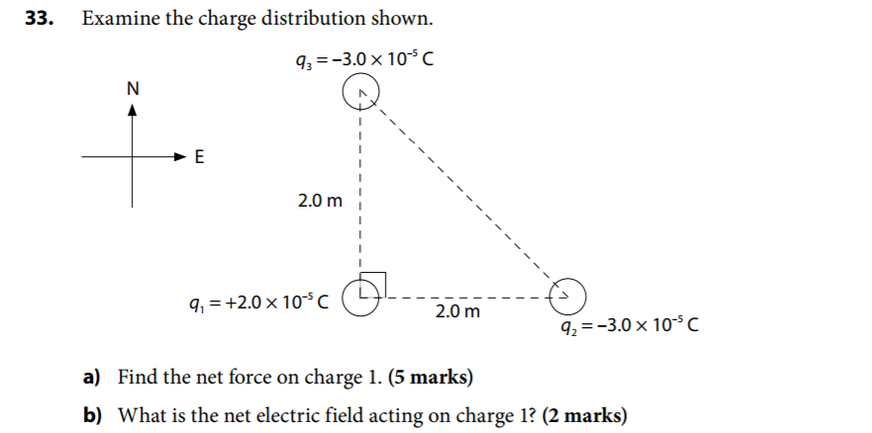



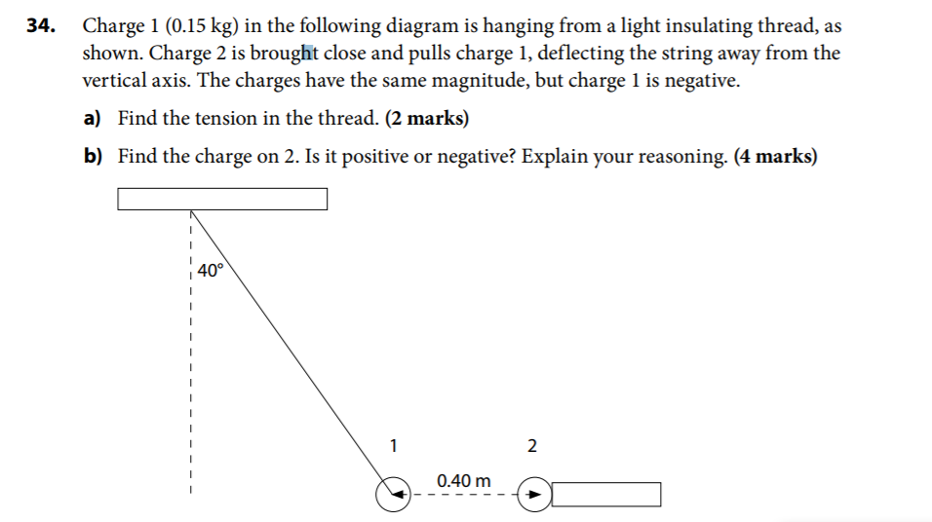

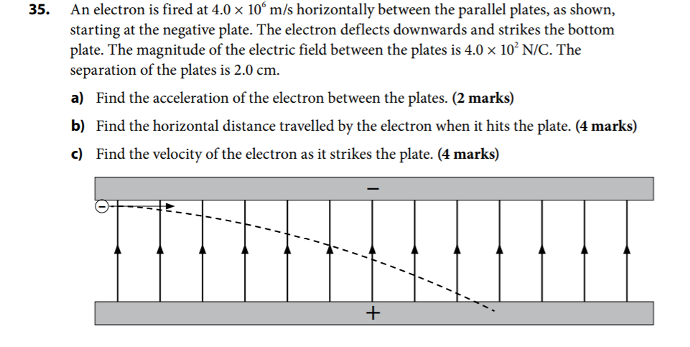



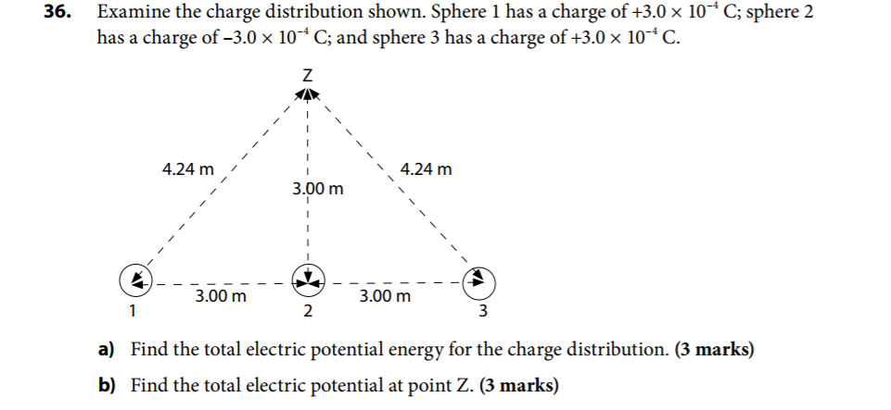



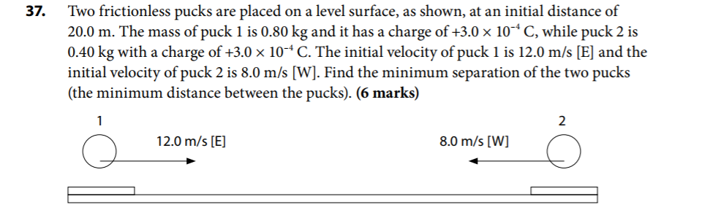

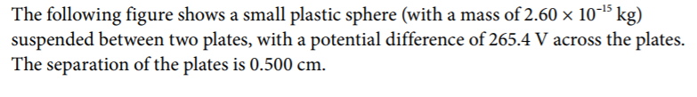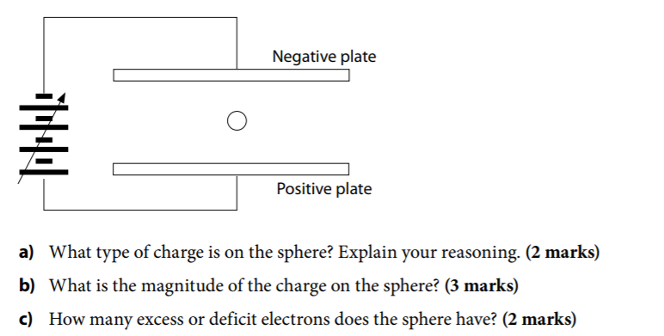

1. In order for the sphere to stay afloat, the vertical net force acting on it must be zero. Therefore, the electric force must has an upwards direction. This is only possible if the charge on the sphere is positive, in which case it is attracted to the negative plate and repelled by the positive plate.

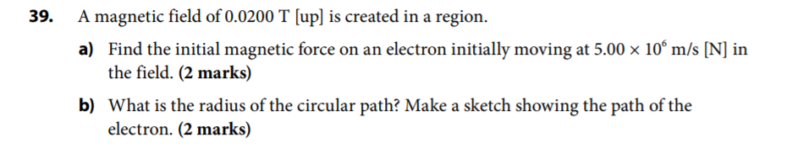



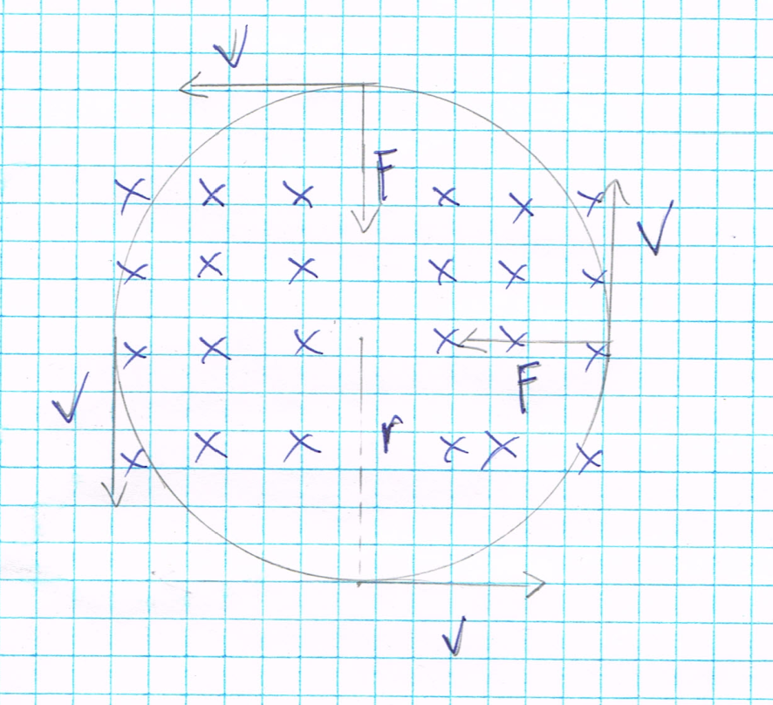

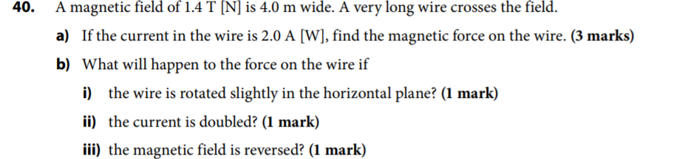

2. i. if the wire rotated horizontally, the angle between the current and the magnetic field will change, and the magnetic force will decrease

ii. Since the magnetic force is directly proportional to the current, if the current doubles, the resulting magnetic force will also double

iii. The magnitude of the force will not change. But the direction of the magnetic force will be reversed, since the directions of the magnetic force must be perpendicular to the direction of the magnetic field.

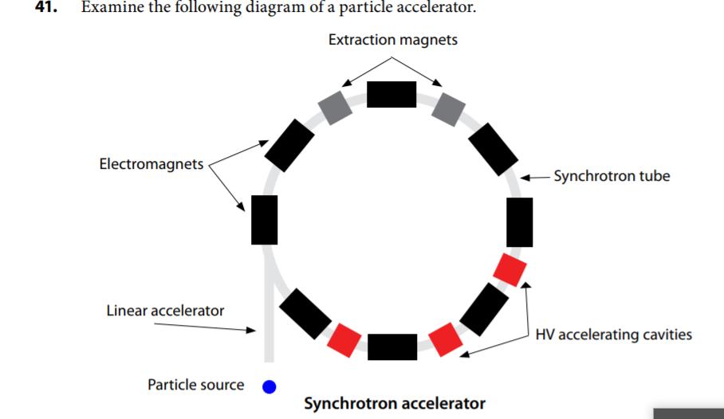

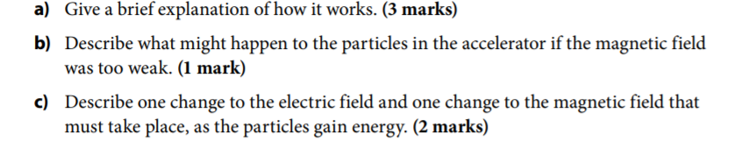

1. Linear accelerators fire charge particles into the synchrotron. While moving, electromagnets are used the path of the particles into a circle. As the particle moves in the circular path, accelerating cavities are used to speed up the particles. After the past one cavity, the charge must be switch to opposite to push the particle forward. Likewise, the cavity in front of the particle must be oppositely charged to pull the particle forward
2. As the speed of the particle increases, so does its radius of curvature. To keep the curvature within the path of the accelerating, stronger magnetic force must be present. If the magnetic field is too weak, the magnetic force will not be strong enough to keep the particles in the desired travel path.
3. The electric field surrounding the particle must change in direction according to the direction of the particle. As the speed of the particle increases, the magnitude of the electric field and magnetic field must increase to compensate.