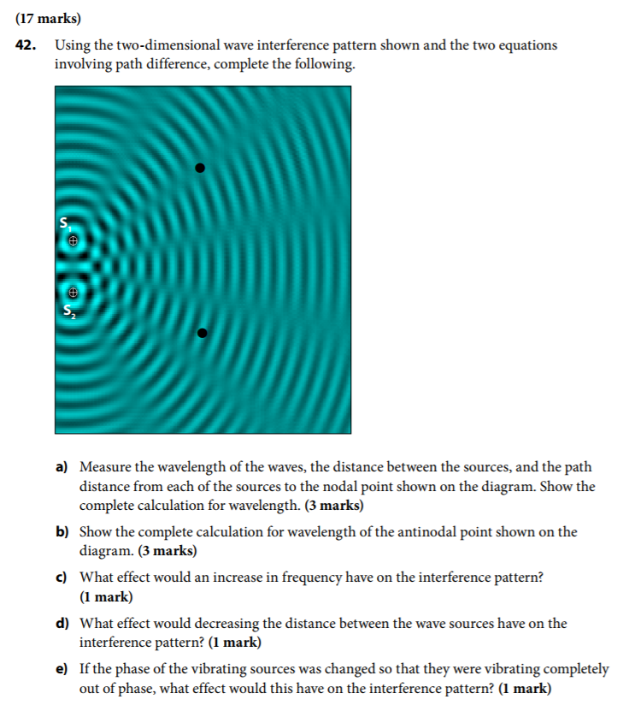

C:\Users\Kai\AppData\Local\Microsoft\Windows\INetCache\Content.Word\chrome_2017-10-18_15-24-06.png

From the investigation conducted earlier in this lesson, I understood that when wave length is constant, frequency and diffraction are inversely proportional of each other. Higher frequency has lower diffraction, while lower frequency has higher. Therefore, if I hear music in the distance, I would be more likely to hear the bass notes of the music due to lower notes having lower frequency and higher diffraction.

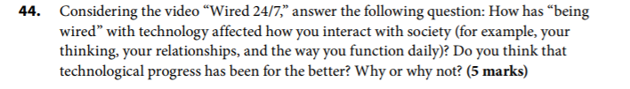

For me, being constantly in contact with technology and information has been mostly beneficial for my life. As a full time student, my studying efforts have been greatly aided by technology. Being constantly in touch with my classmates and professors enables me to learn more efficiently and solve problems faster than before. Technology has been crucial in helping me maintain and develop my romantic relationship as well. With the help of Instant Messengers and webcams, I can speak face-to-face with my girlfriend who lives 500km away in Montreal. Of course, the advancement of information technology has it problems, such as increased stress and over-dependence on technology, but overall I believe the pros outweigh the cons

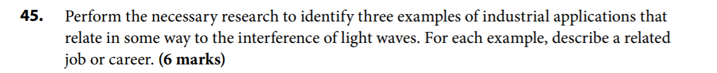interferometer- investigative tools used in science and engineering fields to make minute measurements that are impossible to do in any other ways, using interference of light. By studying the variations in pattern projected through interferometer, scientists and engineers can determine very small changes in the surface of the object being measured.

Astronomical Interferometer – high resolution measurements using combinations of multiple telescopes instead of one. Used to make measurements of very small astronomical objects.

Optical coherence tomography—medical imaging technique used to visualize internal tissue microstructures, using interferometry.

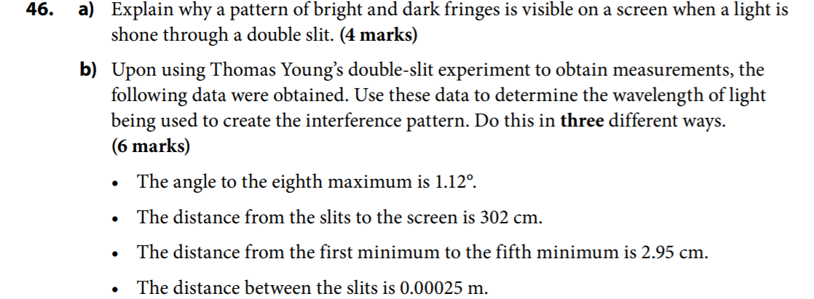

1. When light waves travels through a double slit, they are diffracted and their angles are changed. As a result, interference occurs. During interference , the waves that are in-phase will interefere constructively, creating bright fringes, while the out-of-phase waves will interfere destructively, creating dark fringes.

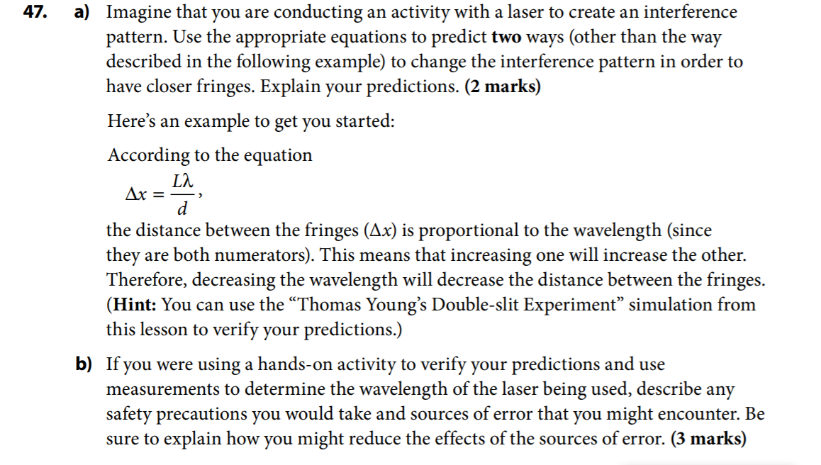

1. According to the equation , is proportional to the distance between the slits and the fringes. Therefore, decreasing will also cause to decrease.

From the same equation, is inversely proportional to the distance between the slits . Therefore, increasing will cause to decrease

1. Precautions: wear goggles to protect my eyes from laser.

Reduce the effect of the sources of error: perform the experiment multiple times and obtain their results. Calculate the outcome using at least 3 different methods I have learned in this lesson, then take the average.

48. Choose a technology such as MP3 players, lasers, medical imaging, or another that interests you (other than the cell phone). Research the Internet and find out how it is related to the physics of light and waves. In approximately 100 to 150 words, write a paragraph explaining the link between our understanding of the laws of physics and your chosen technology. Evaluate how this technology has affected our daily lives. Be sure to briefly describe the technology, its use, and its link to science.

Lasers are devices that emit narrow beams of intense electromagnetic radiation. The term is an acronym for “light amplification by stimulated emission of radiation”. Compared to conventional light sources, lasers emit light coherently, allowing radiation to be focused to a tight spot over great distances, and emit a single color of light. Although it did not see much application when first discovered, lasers are used in many fields of science and engineering nowadays. It is a versatile tool that can be tuned to suit the needs of many different fields based on intensity(power). High power lasers are used as a cutting technique in industrial production, while lower power lasers are used to record information on discs(DVDs and CDs). More common examples of laser include barcode scanners, laser printers, etcs.

49. A laser emitting light with a wavelength of 560 nm is directed at a single slit, producing an interference pattern on a screen that is 3.0m away. The central maximum is 5.0cm wide.

a. Determine the width of the slit and the distance between adjacent maxima.

b. What would the effect on this pattern be, if

i. the width of the slit was smaller?

Since the width is inversely proportional to the width of the fringes. If the width of the slit was smaller, the width of the fringes would increase, resulting in larger diffraction and a larger , less focused pattern.

ii. the screen was moved further away?

Since the distance from the slit to the screen is proportional to the width of the fringes, if the screen was moved further away, the length would be increased, and the width of the fringes would also increase. The result is larger diffraction and a larger, less focused pattern.

iii. a larger wavelength of light was used?

Since the wavelength of light is proportional to the width of the fringes. If no other factors are changed, a larger wavelength of light would result in wider fringes. The result is larger diffraction and a larger, less focused pattern

1. How would this interference pattern differ if the light was shone through a
   * 1. Double slit?

The fringes would be more evenly distributed, and the pattern would be clearer.

* + 1. Diffraction grating?

The interference pattern would be clearer and more defined

50. Light from a laser with a wavelength of 760nm is directed at a diffraction grating of 1500 lines/cm. If the diffraction grating is located 1.5m from the screen, calculate the distance between adjacent bright fringes.

51. Lenses often contain thin coatings to reduce reflections and UV radiation. Explain how this works.

The coatings (called AR) equalizes the intensity of the lights reflected from the inner and out surfaces. The coating works by shifting the light waves out of phasing and resulting in destructive interference. Since the two reflections from each surface interfere destructives, they will cancel each other out.

As the reflection is cancelled, they emitted energy that is absorbed by the lenses. Therefore, lenses are made of UV radiation absorbing materials that can absorbed the UV emitted onto the lenses

52. Imagine that you had two polarizing films and were holding them one on top of the other. What would the effect of rotating the two polarizing films, with respect to one another, be? Explain what would be seen, and why.

Assuming the polarizing films are identical and in the same alignment. When rotating one film by 90 degrees. No light can pass through the films. That is because the at 90 degrees, the already polarized light encounters a second polarized film, whose polarizers are perpendicular to the polarized waves. When rotating at 180 degrees, the polarizers become aligned again, allowing the polarized light to pass through. When rotating at 270 degrees, the same conditions occurs as 90 degrees, and no light can pass through. Finally, at 360 degrees, Lights pass through the two polarizing films as if they were one.

53. A cell phone sends and receives electromagnetic waves in the microwave frequency range.

a. explain the physics of how an oscillator creates these waves.

Most modern cellphones create waves with different frequencies using crystal oscillators. Crystal oscillators use crystals that are made of piezoelectric material, which vibrates mechanically when applied with voltages of appropriate amount. The crystal is made in to shapes that will physically resonate at the desired frequency. The resonation can be tuned with specific frequencies to create specific electromagnetics waves. For wave in the microwave frequency range, Surface Acoustic Wave filters are used to ensure the frequency is within the appropriate range.

* 1. Research the possible side effects of using cell phones. Citing at least three websites that you consider reliable, write a short 100- to 150-word paragraph summarizing three main conclusions based on your research and your opinions; in other words, will your cell phone usage change, based on what you have learn

Although never scientifically proven, there are many health risks associated with mobile phone uses, as proclaimed by various authorities such as the WHO, the National Cancer Institute, and so on. Out of the many risks that has been investigated, the most dangerous is cancer. RF fields(radio frequency fields, a.k.a. radio waves) that are commonly used in cellphones have been classifies by authorities as possibly carcinogenic to humans([www.who.int](http://www.who.int)). When used, cellphones emitted radio waves from the antennas, which can be absorbed by nearby tissues. The absorption of such waves and the energy they carry can cause the tissues and cells to mutate, possibly forming tumors. However, such a correlation between cellphone use and possibility of cancer development has never been scientifically proven. As such, the topic of health risk associated with mobile phone use stays controversial. Regardless, in concern with my health, I have been reducing my mobile phone usage, especially while driving and studying. I have also changed my sleeping habits by place my mobile phone further away from my bed while sleeping.

Citations:

[www.who.int/features/qa/30/en](http://www.who.int/features/qa/30/en)

[www.cancer.gov/about-cancer/cuses-prevention/risk/](http://www.cancer.gov/about-cancer/cuses-prevention/risk/)

en.wikipedia.org/wiki/Mobile\_phone\_radiation\_and\_health

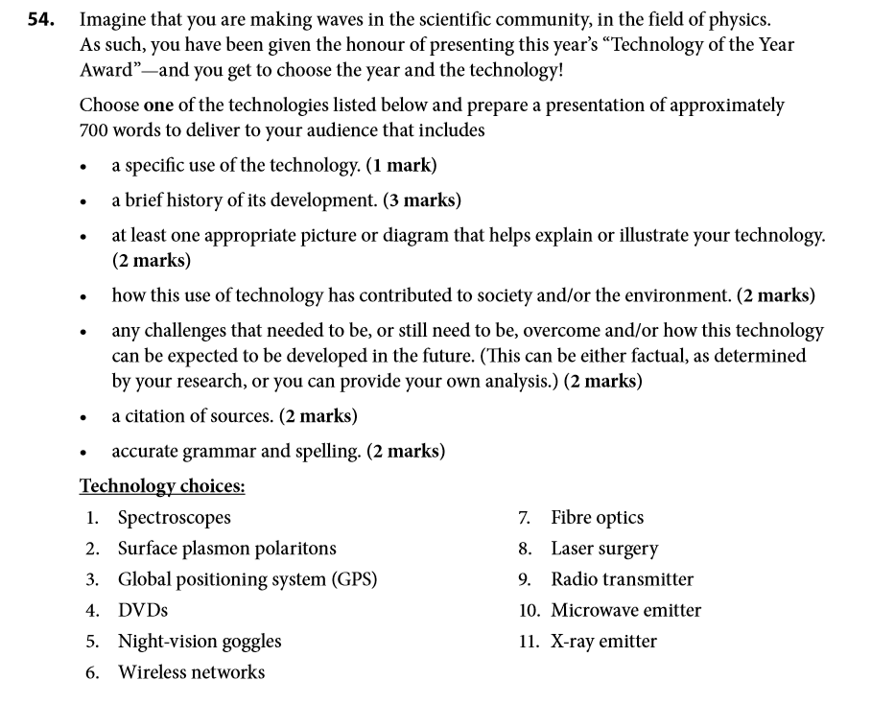

Topic of choice: Wireless networks

Have you wondered how you are able to access the Internet almost anywhere, and stay connected almost all the time? Have you thought about the technologies behind smartphones, smartwatches, or GPSs? None of these devices would have existed without the invention of wireless networks. In fact, you are probably reading this essay from a computer connected to a wireless network. Wireless network gave us the freedom of moving freely in our houses, while still being connected to the Internet. This essay will discuss the history and wireless network, the technologies and operations, as well as its application and future developments.

Although The technology existed as early as 1969, when the first professional wireless network was developed at the university of Hawaii, it was not until late 1980s did wireless network become commercialized. This is largely because when wireless network was first developed, it was restricted to military use, and no frequencies were release to commercial developers. In fact, due to lack of standardization, wireless network did not become popular until the standardization initiated by the IEEE in 1997. Even by then, the idea of wireless network was introduced as a “nice to have” addition to the existing wired network, not an replacement. There were no handheld mobile phones that utilized wireless network, and very few laptops that did. It was not until the beginning of the twenty-first century did wireless network become more popular and eventually standard in homes and business. The growing demand gave wireless network at new name too: “Wi-Fi”. Wi-Fi was boosted by the growing popularity of high-speed broadband internet connections in the home; it is the easiest way to enable several devices to share a broadband link. To this day, Wi-Fi’s remains the more popular method of connecting to the internet for home users.

For the sake of convenience, Wi-Fi uses the same five-layer data structure previously established for wired networking: the TCP/IP model. TCP/IP uses five layers to encode computer message to physical data and transmits it to the destination. The application layer creates the message, defines the protocol, and converts message to digital format. The Transport layer adds headers and footers to specify the source and destination of the code, and is also responsible for controlling the flow of data. The Internet Layers adds IP addresses and prepares the data to be sent to routers. The Data Link Layer adds MAC addresses, and check for possible errors in the code. If there is error, the code will be resent. The Physical Layer provides encoding and decoding of data and transmits the bits across physical medium such as copper cable and optical fiber.

Wireless network has liberated us from the cumbersome cables, and made access to Internet more convenient than ever before. While wired connection is still prevalent in business sectors due to its higher speed and security, Wi-Fi has dominated homes and public spaces. The biggest attraction wireless network holds is the increased mobility. Being able to access the server at anywhere within the vicinity is a great advantage. Increased mobility results in increased productivity. Employees and employers can perform their tasks anywhere and anytime, without having the restriction of a cable wire. Wi-Fi is more cost effective as well. While marginally more expensive than wired network at installation, the cost of operating wireless network becomes exponentially less expensive when more users are added.

That is not to say wireless network is the perfect solution. As convenient as it may be, wireless network is by no means perfect. One of the most critical weakness is its lack of security. With wired network, it is virtually impossible for hacker to steal information from networks, because the information travels in physical wires that cannot be eavesdropped. This is not the case with wireless network. Since the information travels in air as waves, it is very susceptible to eavesdropping. It takes no more than a little computer skill and the right training for a person to access a wireless network and obtain information. Therefore, large businesses prefer wires over routers. Wireless network is also much slower than wired network, and more vulnerable to interference, due to the way information travels.

Despite all the disadvantages mentioned previously, wireless network remains the most common choice of connection for home users. With wireless capable devices becoming more and more popular and wireless technology getting cheaper, the hassle of running wires starts to become a huge minus. It is no surprise wireless network has become a technology that changed the way people live in the twenty-first century.

Citation sources:

Wikipedia.org/Wireless\_network

Economist.com/node/2724397

Techwalla.com/articles/disadvantages-of-wireless-networks