409410090 資工三 李明翰

Note: The C subset defined in this doc is based on C99 standard

1. Keywords

Note: The keywords with postfix (C23) or (C11) are excluded from our C subset.

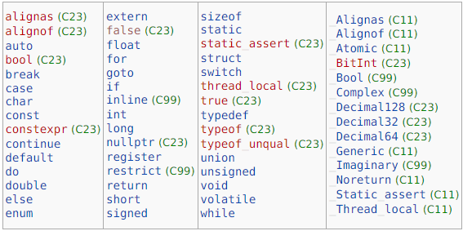

Reference: <https://en.cppreference.com/w/c/keyword>

1. Data Types

Void Types: void

Basic Types: int, char, void, float, double, bool, complex, imaginary

(some prefix can be added, e.g., short, long, signed, unsigned…, etc.)

(the type modifiers and specifiers can be founded in mylexer.g)

Enumerated Types: enum

Derived Types: array, structure, union, function, pointer

Reference: <https://en.cppreference.com/w/c/language/type>

1. How to Comment

Single line: //

Multiple line: start with /\* and end with \*/

1. Operators

Note: Alignof is not included.

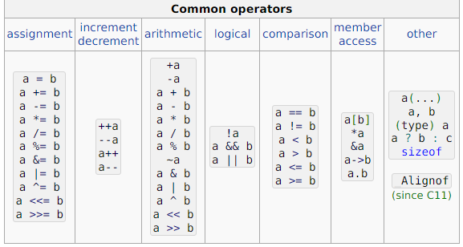

Reference: <https://en.cppreference.com/w/c/language/operator_precedence>

1. Punctuations

…

,

:

;

#

(

)

[

]

{

}

?

‘ and “ are considered to be a part of a string literal or a character literal

Reference: <https://en.cppreference.com/w/c/language/punctuators>

1. Control Flows

switch

case

default

do

while

break

continue

for

if

else

goto

return

1. Program Execution

The program should consists of only one main function, with zero or more library functions or user-defined functions

1. Functions

Note: We are not going to list those user-defined functions here.

main()

printf(), puts(), scanf() for basic I/O functionality

1. Literals

The string literal defined in this C subset is a sequence of characters in a single line.

For character literals, We assume there is at most one character in it.

Note: the escape sequences are not implemented.

1. Others

Some specifier for variables and functions:

const

restrict

inline

short

long

signed

unsigned

auto

register

static

extern

typedef

special operator: sizeof