409410090 資工三 李明翰

The C subset defined in this doc is based on ANSI C, But I removed user-defined data types and function declarations to make it more concise. (https://github.com/antlr/examples-v3/blob/master/java/C/C.g)

1. Keywords

The keywords with suffixes are excluded.

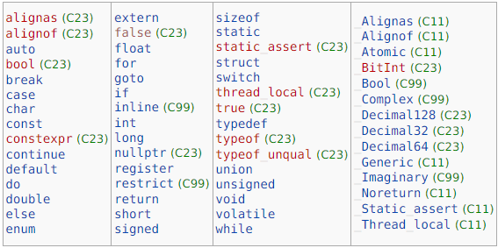

Reference: <https://en.cppreference.com/w/c/keyword>

1. Data Types

Void Types: void

Basic Types: int, char, void, float, double

(some prefixes can be added, e.g., short, long, signed, unsigned…, etc.)

(the type modifiers and specifiers can be founded in mylexer.g)

Derived Data Types: array, structure, union, function, pointer

(User-defined data types are not implemented)

Reference: <https://en.cppreference.com/w/c/language/type>

1. How to Comment

Single line: start with //

Multiple line: start with /\* and end with \*/

1. Operators

Member access for structrues are not implemented.

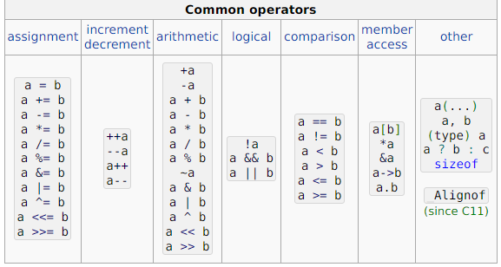

Reference: <https://en.cppreference.com/w/c/language/operator_precedence>

1. Punctuations

…

,

:

;

#

(

)

[

]

{

}

?

‘ and “ are considered to be a part of a string literal or a character literal

Reference: <https://en.cppreference.com/w/c/language/punctuators>

1. Control Flows

switch

case

default

do

while

break

continue

for

if

else

goto

return

…

1. Program Execution

The program should consists of only one main function, with zero or more library functions or user-defined functions

1. Functions

User-defined functions are not implemented to make the validation easier

Support single main function and built-in functions like printf.

1. Literals

Support both character and string literal with some simple escape sequences.

Decimal and floating numbers are also valid, but a suffix is not allowed to exist.

1. Others

Some specifier for variables and functions:

const

short

long

signed

unsigned

auto

register

static

extern

…