409410090 資工三 李明翰

The C subset defined in this doc is based on ANSI C, But I removed user-defined data types and function declarations to make it more concise. (https://github.com/antlr/examples-v3/blob/master/java/C/C.g)

1. Keywords

The keywords with suffixes are excluded.

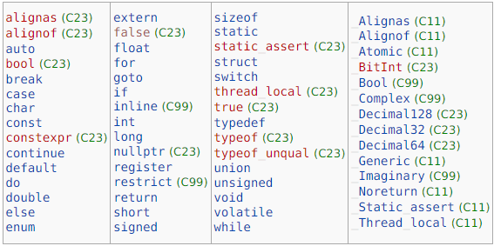

Reference: <https://en.cppreference.com/w/c/keyword>

1. Data Types

Void Types: void

Basic Types: int, char, void, float, double

(some prefixes can be added, e.g., short, long, signed, unsigned…, etc.)

(the type modifiers and specifiers can be founded in mylexer.g)

Derived Data Types: array, structure, union, function, pointer

(User-defined data types are not implemented)

Reference: <https://en.cppreference.com/w/c/language/type>

1. How to Comment

Single line: start with //

Multiple line: start with /\* and end with \*/

1. Operators

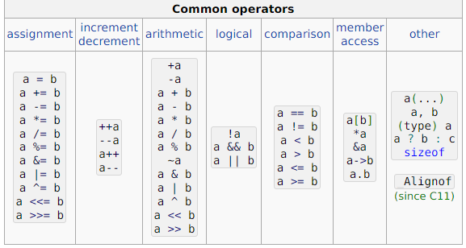

Reference: <https://en.cppreference.com/w/c/language/operator_precedence>

1. Punctuations

…

,

:

;

#

(

)

[

]

{

}

?

‘ and “ are considered to be a part of a string literal or a character literal

Reference: <https://en.cppreference.com/w/c/language/punctuators>

1. Control Flows

switch

case

default

do

while

break

continue

for

if

else

goto

return

…

1. Program Execution

The program should consists of one main function, with zero or more library functions.

1. Functions

User-defined functions are not implemented to make the validation easier

Support single main function and built-in functions like printf.

1. Literals

Support both character and string literal with some simple escape sequences.

Decimal and floating numbers are also valid, but scientific notation is not supported

10.Others

Some specifier for variables and functions:

const

short

long

signed

unsigned

auto

register

static

extern

…

1. Type Checking Rules (project 3)

Each variable must be declared before it is used.

Each identifier can be only declared once.

The types of the operands of an operator must be the same.

The types of the two sides of an assignment must be the same.

Type of the result of comparison expression is Boolean.

The types of condition in control-flow statement are Boolean.

When Initializing a variable, the value of a number can be implicitly casted to correct type. E.g., int a = 8;, while the type of 8 is “char”.

However, due to the code complexity, other expressions and statements only support same type of operands of an operator. The programmer should use minimal data type to prevent type mismatch error.