

Implementation Manager Dashboard - Executive Summary

Project Overview
Project Title: Implementation Manager (IM) Dashboard
Brief Description: A centralized internal application serving as the “Implementation Command Console” for ParentSquare. Establishes a single source of truth for implementation project status, health monitoring, and workflows, integrating with HubSpot, Jira, Zendesk, and ParentSquare usage systems. Reduces manual work by 75% while improving data quality and visibility across the organization.
Project Lead Name: Derek McBride
Project Member Names: - Aimee Lem - Cody Dacus - Robert Smith
XFN Teams: - Implementation Manager Team (Primary Users) - RevOps/Sales Operations (HubSpot Integration) - Customer Success (Secondary Users) - Engineering (Development & Maintenance) - Leadership (Strategic Oversight)

The Problem
Implementation Managers currently face critical productivity and data quality challenges:
- Fragmented data sources requiring manual aggregation from HubSpot, Jira, Zendesk, and product usage systems
- Inconsistent HubSpot data where deal stages and fields don’t reflect actual implementation reality
- Manual synchronization burden consuming 30-45 minutes per day per IM, leading to reporting delays and data drift
- Limited visibility into contact coverage gaps and implementation health signals
- No unified workflow forcing IMs to context-switch between multiple systems daily

The Solution
The IM Dashboard is a centralized, net-new internal application that serves as the “Implementation Command Console” for ParentSquare. It establishes a single source of truth for implementation project status, health, and workflows.

Core Capabilities
For Implementation Managers: - Manage complete portfolio of implementation projects in one interface - Track milestone completion with automated HubSpot synchronization - Monitor customer health through aggregated signals from multiple systems - Ensure contact coverage by validating key stakeholder roles - Reduce manual work by 75% through automated status updates and intelligent workflows
For CS/Sales Teams: - Access real-time, reliable implementation data in HubSpot - View health status, phase progression, and contact coverage without interrupting IMs - Enable better forecasting and resource planning
For Leadership: - Portfolio-level visibility across all implementations - Accurate risk identification and trend analysis - Data-driven insights for team capacity planning

Architecture Overview
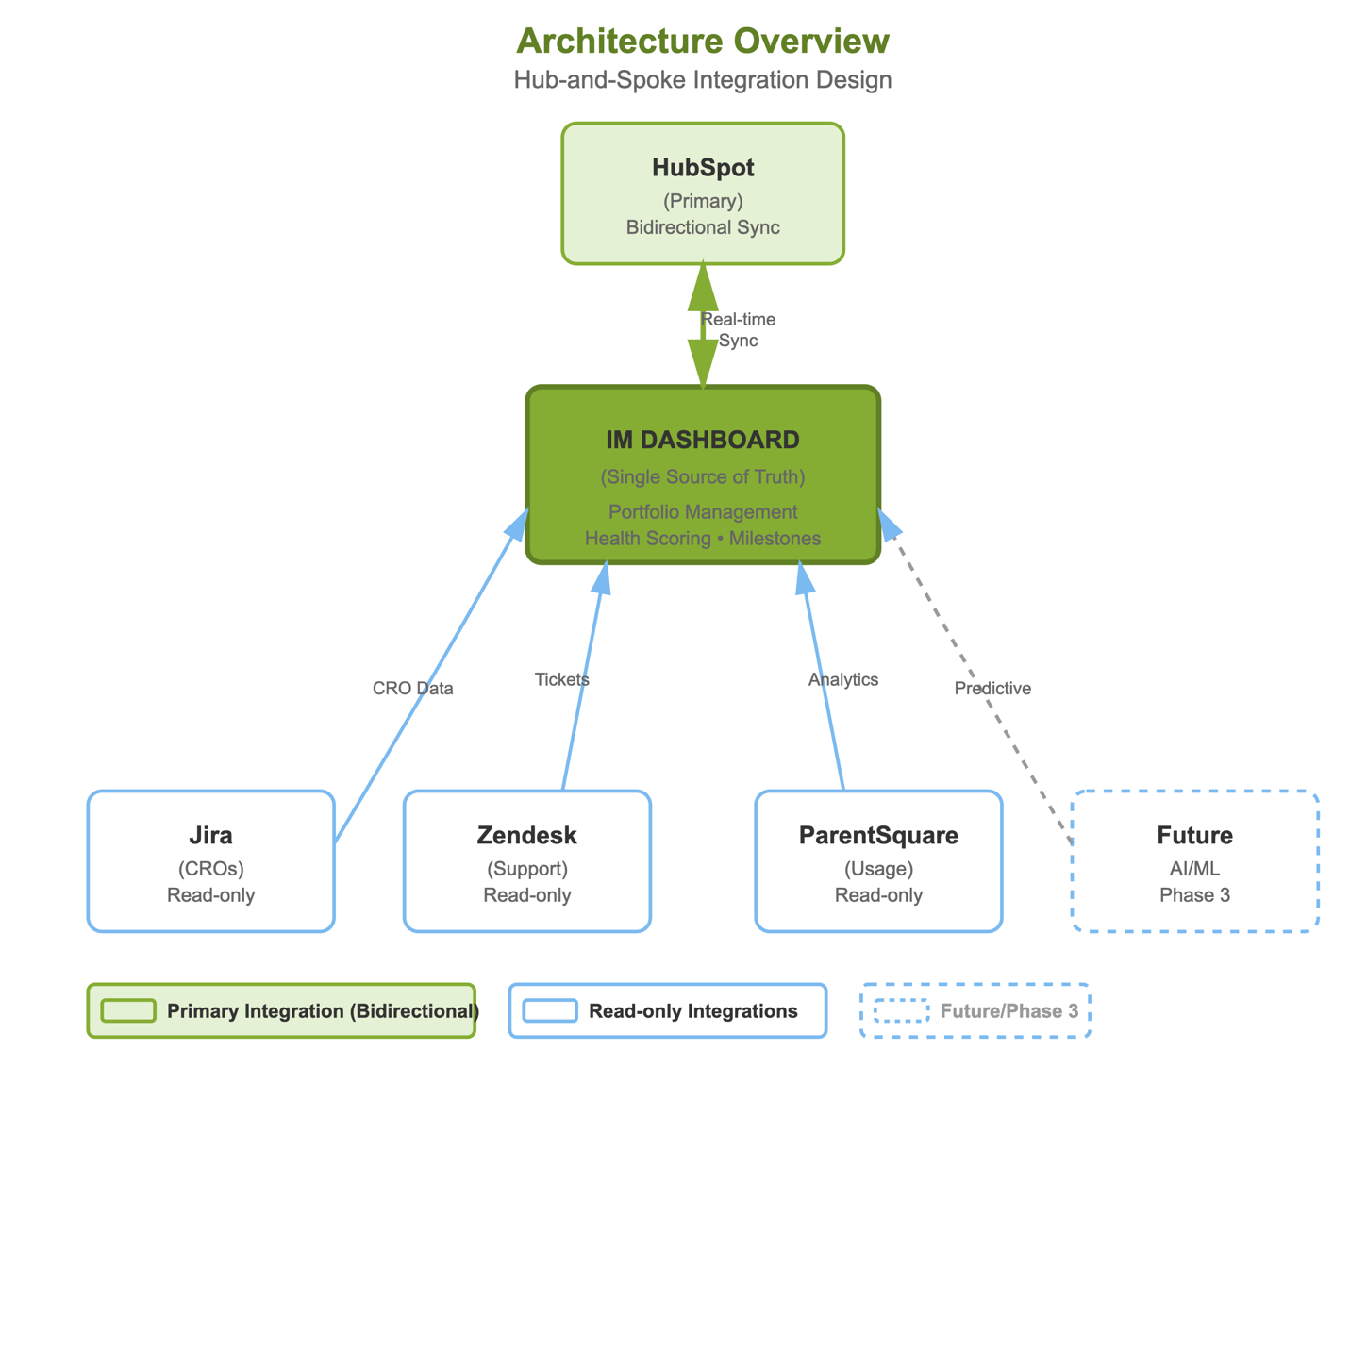
Key Design Decisions: - Dashboard owns implementation phase and health data; HubSpot mirrors it - Bidirectional HubSpot sync with conservative stage automation (only 1-2 critical transitions in v1) - Multi-system health scoring (Jira tickets, Zendesk support, product usage, manual IM input) - Contact coverage validation flags gaps without creating records - Extensible architecture ready for future AI/ML enhancements

Business Impact

Time Savings
- Before: 30-45 min/day updating HubSpot manually per IM
- After: 5-10 min/day managing projects in dashboard
- Result: 75% reduction in administrative tasks

Implementation Roadmap

Phase 1 (8-12 weeks) - MVP
- Core portfolio management and project tracking
- Basic HubSpot bidirectional sync
- Health monitoring with manual override
- Contact coverage validation

Phase 2 (Months 4-6)
- Jira CRO integration (read-only)
- Zendesk support ticket integration
- ParentSquare usage analytics integration
- Advanced health scoring algorithm
- Automated alerting and notifications

Phase 3 (Months 7-9)
- Predictive health modeling (AI/ML)
- Advanced analytics and reporting
- Mobile-responsive interface
- Enhanced workflow automation

Success Metrics
Operational Efficiency: - 75% reduction in manual HubSpot update time - 90% on-time milestone tracking - <5% data sync errors
Data Quality: - 95% HubSpot data accuracy - 100% implementation phase visibility - Real-time health status reporting
Business Outcomes: - 10% improvement in implementation on-time completion (Year 1) - 5% improvement in customer retention during implementation - 15% increase in IM capacity (same headcount, more implementations)

Next Steps
- Stakeholder Alignment - Validate with IM team, RevOps/Sales, Engineering, and Leadership
- Technical Validation - Confirm HubSpot API capabilities and integration approach
- Resource Allocation - Secure engineers for 8-12 week sprint
- Requirements Finalization - Address open questions and finalize v1 scope
- Sprint 0 - Infrastructure setup, HubSpot sandbox, and technical design

Recommendation
This dashboard is not just a productivity tool—it’s a transformation of how ParentSquare manages implementation success. With a 467% ROI and 2-3 month payback period, this represents a high-value investment that will scale with the business and provide compounding benefits over time.
Approval requested to proceed with Phase 1 development.

