-----Petronela Ezaru & Oana Botez-----

Generated tests scripts

In order to test the csl language and the csl compiler, small tests that are generated by Perl scripts are used. There are almost 250 scripts written by the test team, which can generate valid or invalid tests, and the scripts are created accordingly. One test generator can only have valid or invalid tests. The name of the script suggests what command(s)/object(s) are being tested in the current script. Each script creates a directory which will contain all the generated tests. This folder and the tests in it have a suggestive name also.

There are two ways to generate all the tests and then run them:

- This is the classic method were you have to do it all manually. The first step is to delete everything you have in the directory test/csl_test_gen/ (because this is where the generated tests will stored). Then you have to run all the scripts in test/scripts/ (this is the location were all the scripts that generate tests are), one script at a time. The path with the generated tests is shown when the script is ran. Last step is to run the regression script run_regress.pl for the csl_test_gen directory:
run_regress.pl -hdl csl_test_gen

- The second method is to go in misc/scripts/ and run the script: run_all_gen_tests.pl . That's it! Simple, no? The script will do everything that is in the first method, which includes : delete the old generated tests from test/csl_test_gen/, run all the scripts in test/scripts/, compile the generated csl tests using the regression script and publish the results in test/report/.

The test matrices contain all the different cases that can be used as tests, and each cell in the matrix represents one of these cases. For every cell there is a test generated using the scripts. For example, in the connect_by_name matrix, a connection between a signal part select (rows) and an input port part select (columns) represents a legal test case that has a corresponding test which will be generated by a Perl script.
The test generators (Perl scripts) create csl code with all the cases in the test matrices.

If we want to generate the tests just for one script and compile them, we can consider the example above; in order to run the script that generates the test and then compile the generated csl code, the following must be done:
- in test/scripts/ :
./ar_conn_name_port_valid.pl
- in test/csl_test_gen/ :
./run_regress.pl -hdl csl_test_gen -dir_filter ar_conn_name_port_valid
- the results are stored as HTML pages in : test/report/results_2008.09.20_13_41_55/

The script will only generate valid csl tests, which is suggested by the name of it. The created directory with the tests has the same name as the script and is used with the -dir_filter option in order to compile just the tests from it. The number of generated tests depends on how many cases are included in the script and each test has a unique but suggestive name (e.g. ar_conn_name_port93_legal.csl).
One of the generated tests for verifying the connection between signal part select with port part select, and port part select with port is :

//Generated by oanab

csl_bitrange br1(17);
csl_bitrange br2(15);
csl_bitrange br3(83);
csl_unit a13 {
csl_port p_x388(input,32);
a13 () { }
};

csl_unit b13 {
a13 a13_0;
b13 () {}
};

csl_unit c13 {
b13 b13_0;
csl_port p_c388(input,32);
csl_port p_b388(input,br2);
c13 () {
b13_0.a13_0.p_x388[31:17].connect_by_name(p_b388); // p.ps---port (CP)
}
};

csl_unit d13 {
c13 c13_0(.p_b388(s_d388[97-:15]));
csl_signal s_d388(98);
a13 a13_1;
d13 () {
s_d388[97:83].connect_by_name(c13_0.p_c388[31-:15]); // sig.ps---p.ps (PC)
}
};

Note that a script contains more than one test case, otherwise there would have been way too many scripts and running such a large number of test generators is not justified.

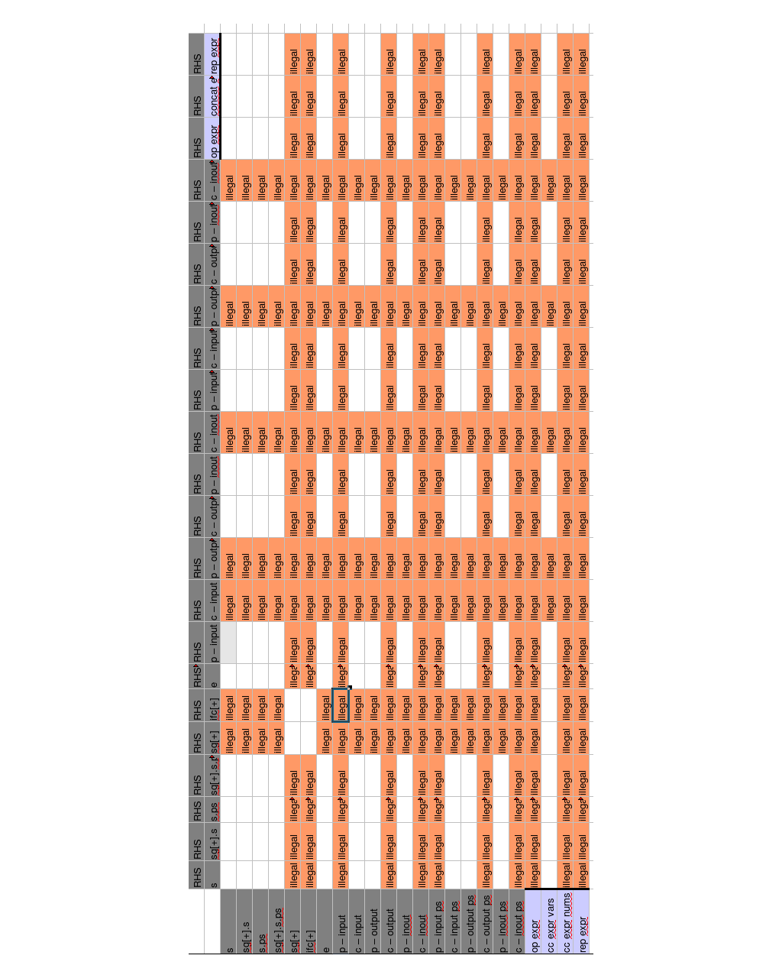
Assign matrix

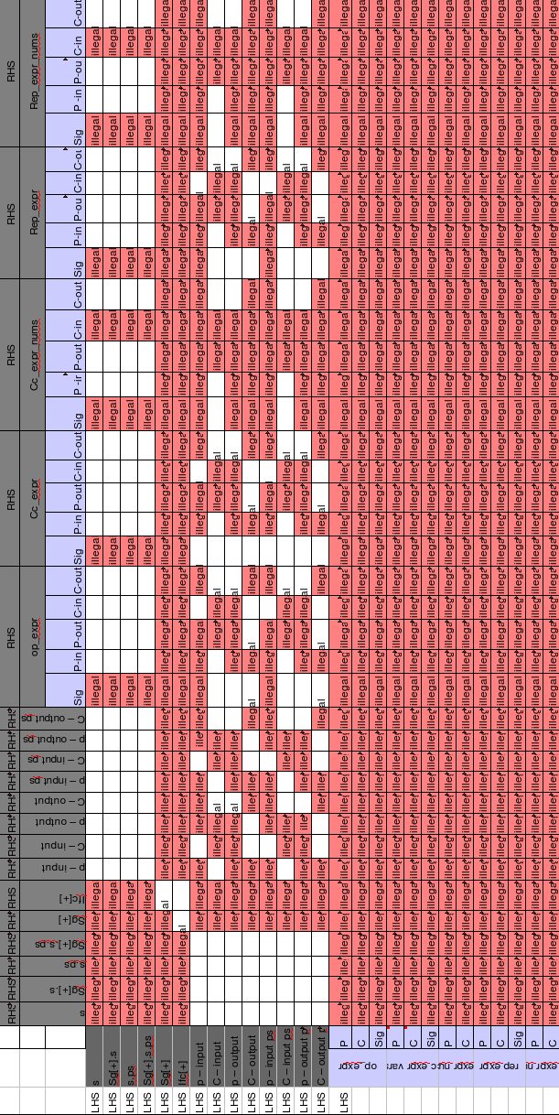
Connect
by
name
matrix

Connect_by_pattern matrix

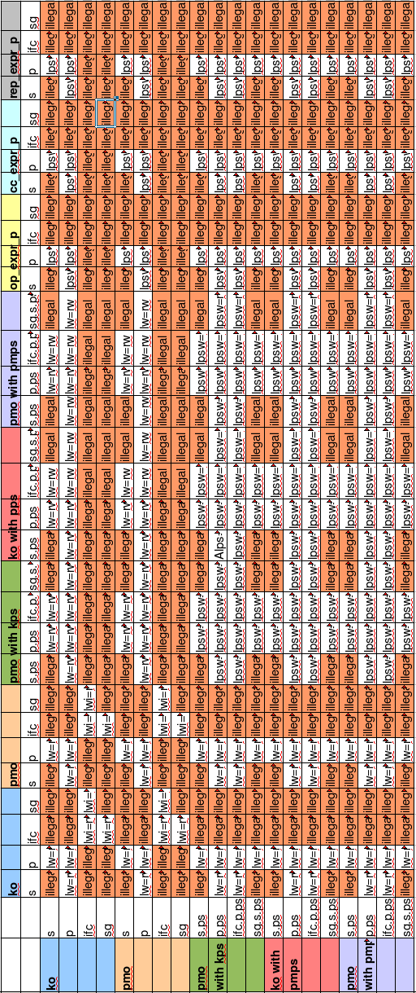

Connect_by_
name with
parameter
and part select

Formal to actual matrix
