Fastpath Logic, Inc. Whitepaper
Why build when you can buy?
Abstract:
Fastpath Logic has built a new type of tool (CSLc) that generates chip infrastructure and verification support C++ code and RTL code, and documentation from a single input. A single language is used to describe chip infrastructure and verification support structures. Relationships between these structures results in a synergy that cannot be achieved using multiple point-tools. A single language compiler can check the relationships between the parts of the chip infrastructure and verification support description. Multiple point tools cannot check the relationships between multiple chip infrastructure and verification support descriptions. In addition CSLc can check the connections between Verilog RTL and the chip and verification intrastructure. CSLc is a single point tool which results in a more efficient design process. It is currently estimated that design teams spend 50% of their time verifying chips. Many of the bugs that need to be fixed are consistency bugs between design elements and between the design, the simulator and or verification environment. CSLc prevents these types of bugs by using a single input to specify the and the chip and verification infrastructure components and the connections between these components.

RTL coding tasks falls into two categories:
- Algorithmic: the core data-paths and control logic that differentiates your implementation from the competition: For example: your MPEG implementation, your traffic manager, your cache.
- Chip infrastructure and verification support: all the additional code and connectivity required to turn your algorithm implementation into a functional chip. For example: block inter-connect, programmable register access, instruction set mapping, block test-benches.

The algorithm is what you architect, design, and implement; the chip and verification infrastructure is what you have to develop to build and test your design. The algorithm implementations change dramatically from project to project. Chip and verification infrastructure creation is repetitive by nature and does not change much from project to project. CSL and CSLc automates the chip design and verification infrastructure generation tasks.

Maintenance is also a big issue, particularly for chip and verification infrastructure. Design changes must be reflected in C++ models, verification suites, software memory maps, and chip documentation etc. Changing the same information in multiple places is tedious and error-prone. Changing the information in one place saves time in many ways.

Designers need a tool that reduces the time spent coding and maintaining chip and verification infrastructure so they can concentrate on algorithm design and implementation. FPL provides a single tool which check the relationships between the different parts of the chip and verification infrastructure . CSLc generattes code for most major chip infrastructure tasks:
- interconnect/design hierarchy, hierarchical interfaces, signal groups, ports, signals, and automatic connections between end points using an auto router. The auto router takes the list of end points and connects them using a routing algorithm. Ports are added to the intermediate nodes and top level signals are also added.
- memory map and auto mapper-The memory map is generated from memory elements which are included in the memory map.
- test benches and vector/state data generators fortransaction level modeling and verification
- behavioral register files, fifos, memories
- C++ simulator code for the design hierarchy, interconnect, vector and satte data writers connected to the interconnect and cycle based simulation support library
- instruction set architecture definition constants, simple decoders, and select lines
- decoders from instruction sets, bit ranges, enumerated types,
- registers which are added to the memory map
From a single input, CSLc generates outputs in C++ and Verilog (and others in the pipeline…), so you make a change in one file and all outputs are updated. For example, from a single input file (.csl in the above figure), CSL can generate: RTL for programmable registers, C++ header files for software and verification suites, and pdf register documentation. Parameterizable IP can be described in library files which can be reused on differen projects.
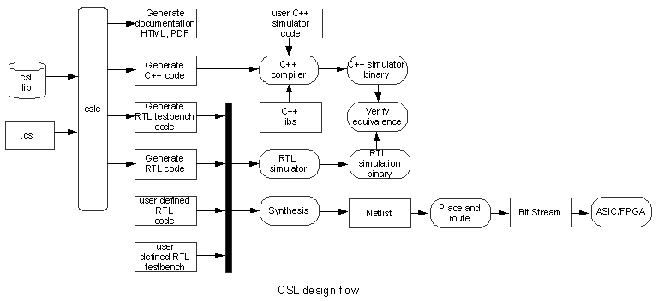

CSLc provides a consistent input language for multiple chip infrastructure tasks that reduces the learning curve compared to buying or developing a set of point tools and eliminates parallel “book keeping” by the different teams which results in a more efficient design and verification process.

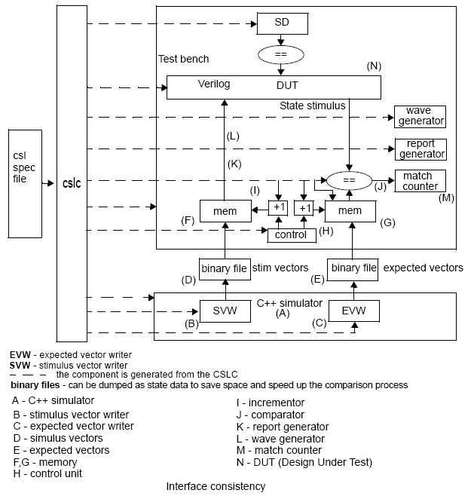
The input to CSLc can specify the interdependencies between different chip and verification infrastructure components. Examples of interdependencies that can be specified are as follows: C++ simulator interfaces, simulation vectors, test bench memories, test bench signals, DUT interfaces, and comparators.

1. A new figure which shows the relationship between the input specification file, the CSLc, and the C++ generated and RTL units. I will supply the drawing.
2. A new figure which shows the relationship between the input specification file, the CSLc, and between the different RTL units.

An example of an industry point tool is Denali's RDL/Blueprint solution. RDL is a high level specification language is effectively used to define memory maps. CSLc includes memory map generation and much more. Using a single consistent tool is much easier than maintaining the code created by the current in-house or purchased set of point-tools. A single tool is better than multiple tools. The counter argument is that picking the best point-tool for each task is better than picking a single tool that may be poor in some areas. This is true if the tool consumes a particular type of input such as a sythesis tool which consumes RTL and generates netlists and timing reports. This is not true if the tool has to understand and check the relationships between different chip and infrastructure components.
The C++ simulator team and the RTL design team each implement their own algorithm(s). The algorithms are “plugged” into the chip and verification infrastruture generated by the CSLc tool. Having two models can introduce consistency bugs in the algorithm implementations. There should not be verification failures due to chip and verification infrastructure inconsistencies. Some people argue that a C-model can be generated from the RTL or visa versa. Then the RTL can be verified using this C-model. This process does not verify the RTL. In fact it verified the C-model generation program.

the users current testbench -Cadence e, Vera, System-C - and how CSLc compliments their existing or prefered solution.
SystemC event driven simulation is slower than cycle based simulation.
Maintaining a consistent design/model/software is difficult. Why spend resources developing and maintaining an in-house tool suite when FPL has a professionally maintained and documented tool that solves all your chip-infrastructure needs. Why use point tools from a variety of vendors when FPL has all you’ll need and more. Why build when you can buy.?

