Patent #2 Overview patent
Once the design hierarchy and interconnect is captured into a specification language it is converted into an object model by a software program. The object model may then be converted into different types of object such as C++ simulation code, test benches, and RTL implementation code in may different languages such as C++, SystemC, VHDL, System Verilog, and Verilog. The interfaces between objects in each of the domains (C++ reference model, test benches, and hardware implementation) are guaranteed to be correctly connected. Any errors in the specification are reported by the software tool. The connections between different domains (C++ reference model to testbench, testbench to hardware design under test) are guaranteed to be correctly connected and any errors are reported. The main point is that is a single description of the design can be converted into different domains (reference models, testbenches, and hardware implementations) in many different languages and the connections/interfaces between the objects within a domain and between domains are guaranteed to be correctly generated by the software tool as long as the specification is correct. Incorrect specifications are flagged and reported as warnings or errors.

The specification can be described in a higher level language or GUI which is processed by a software program and converted into an object model which is transformed into objects in different domains represented in different or the same languages.

The simulation team then must refer to the generated RTL interconnect which effectively becomes the specification for the project. The functional simulation and testbench teams must refer to this information to manually create and maintain the design hierarchy, interconnect, and vector and state data writers for the reference model. This is effectively parallel bookkeeping an duplication of effort which results in transposition errors and productivity loss.

Verification team
Then capture the design under test interfaces in the testbenches.

The interfaces for each of the instances in the design are effectively the same in each of the different domains (i.e. reference model, testbench, and RTL interconnect/design hierarchy). In fact within each domain the interfaces are replicated (e.g. testbenches must interface stimulus and checkers to the inputs and outputs respectively to the design under test).

The above tools do not check their specification against other parts of the chip specification.
the tools have limited checking built into them. The generated code is checked with an RTL compiler.

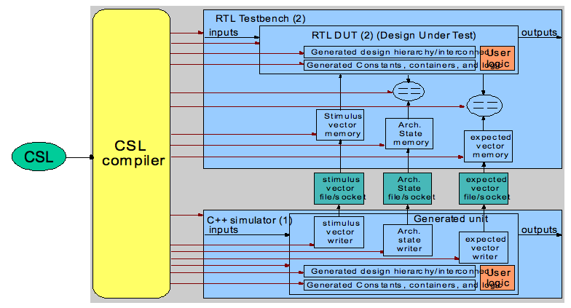

Patent #3 Instruction set architecture (ISA) provisional patent

Architect writes ISA using spreadsheet
C++ reference model writer implements ISA based on ISA spreadsheet
Verilog designer implements ISA based on ISA spreadsheet
Assembler/C compiler writer implements the software tools using spreadsheet

Old way to describe ISA (spread sheet)
Old way of building a processor
Old way of extending a processor pipeline (Altera, Xilinx, Tensilica)
Old way of building application specific processors

ISA fields
ISA enumerated types
ISA formats
ISA format tree

ISA GUI
ISA HW synthesis
ISA code generation in different langugages
ISA documentation generation
ISA overall flow (includes all ISA steps)
INPUTS
A processor description file is modified/extended by the user through a GUI or text editor. The processor description file
contains the description of the processor pipeline and ISA. The user can add instructions to or delete instructions
from the processor description.

A language description file or a GUi entry which contains the following elements:
ISA name
ISA enumerated types
ISA enumerated items
ISA fields
ISA formats
Tree of instruction formats
Design hierarchy and interconnect description
Logic which implements the instructions

State of the art
Soft IP processors (Tensilica, MIPS,ARM, NIOS,...) can be extended by adding additional instructions. However, the type of
instructions and in some cases the performance of those instructions is limited because the basic processor pipeline cannot be
extended or modified by the end user. Instructions can only be added external to the processor pipeline and communicate with
the processor pipeline via inputs to and outputs from the processor pipeline.

Basic processor pipeline
instruction fetch
instruction decode
execute
write back

Examples
Adding a multi way branch involves modifying the processor instruction fetch logic and the input to the program counter in particular. Adding new instructions which require a register file external to the basic processor pipeline requires putting the register file in the same pipeline as the processors existing register file. For performance reasons the external.
USING THE GENERATED SIGNALS OUTPUT FROM THE DECODER
The problem with using generated code in user written code is that the generated code signal names can change. Therefor a method to access the generated signals must be used that guarantees that the correct signal names are used.

GENERATING THE CONNECTIONS BETWEEN BLOCKS
The connections between the blocks are made by an auto router which populates the object model design hierarchy by adding the ports in each unit and the connections between the units. Note that the connections between the units can be formal to actual mappings or the connections between the units can be assign statements with expressions (e.g. concatenations) or identifiers on the left hand and right hand sides.

OUTPUT CODE:
generation of RTL including Verilog, VHDL, SystemC, C++ reference model code
generation of software tools such as assemblers and compilers.
generation of the instruction decoder
generation of the processor pipeline

REPORTS
Reports are created in different document formats listing the connections between intermediate points end points in the design hierarchy at the signal (vector) and bit level).

DESIGN DATABASE (C++ Object Model):
The design hierarchy and interconnect specification is then converted to a object model which forms the basis foradditional specifications. The object model is constructed hierarchically based on the tree of units and unit instances. Connections are made between the unit's and their instances using formal to actual mappings.

ADVANTAGES
Configurable and extendable ISA
User may modify the processor pipeline. Not done in other processors.
Automatically generated instruction decoder.
Automatically generated assembler and compiler
Instructions included in the design can be selected by the user
Outputs of the instruction decoder can be selected using a hierarchical identifier which eliminates
Concise representation
ISA changes are propagated to all output formats therefor synchronizing changes.

Examples/usage model
Application specific processors
Multi core ASP's

Architect writes ISA using CSL
- C++ reference model writer implements ISA based on automatically generated C++ reference model infrastructure code plus user algorithmic code.
- Verilog designer implements ISA based on on automatically generated based on automatically generated C++ reference model infrastructure code plus user algorithmic code
- Assembler/C compiler writer implements the software tools based on automatically generated C++ infrastructure code plus user algorithmic code

Custom processor
- new way of building a processor
- new way of extending a processor pipeline (Altera, Xilinx, Tensilica)
- new way of building application specific processors

Trees describe hardware ISA's and ISA formats, fields in registers,
signals, ports, aggregate objects

3. Networks connect objects
Higher level abstractions of the model may or may not contain the same granularity of interface details.

GUI
interface library file
design hierarchy file
connections table

Patent #4 Automatic generation of Producer/consumer address pattern generators

Patent #5 memory map

2. Memory map provisional patent
BACKGROUND
A state element holds values which only change after a clock changes and optionally a control signal is asserted. Examples of state elements include registers, FIFO's, register files, and memories. The state element can be written or read or optionally can be read only (contain constant values). Different groups in a project can have different permission level to read and write the state elements.

Permissions refer to read and write permission.
Access rights are granted to different groups on the project such as hardware, a set of hardware elements, software driver, and software applications. A design has an associated address range. Parts of the address range may be reserved for future use. Parts of the address range may be labeled as illegal (no addressable objects may be assigned to this range). Designs contain state elements which have addresses. We will call these elements addressable objects. Addressable objects can be read or written depending on the accessor permissions and access rights.
An addressable object can have a single address associated with it or an address range associated with it. Addressable objects may not be allocated in illegal or reserved address ranges. Endianess.
Actions can be associated with addresses. Examples of actions include causing a counter to increment or generating an input to a state machine. Addresses can be associated with entire words or partial words (i.e. fields or bits).
The transactions contain an address, a command to execute, and optional data.
Examples of commands include read, write, DMA read, DMA write, ping, run, enable, poll, interrupt, read reply.
Transactions are sent to units. Units listen for transactions addressed to them. When a transaction addressed to them is received
The unit receives the transaction and executes the command.
Address maps can be flat or hierarchical.
In either case addresses are associated with addressable objects in units.
Hierarchical address maps contain a set of local addresses for each addressable object. This is the local address map.
Unit instances are accessed with a unit address/identifier.
Addresses can be explicitly associated with addressable objects. Example the status register is located at address 15 in unit x.
Or the addressed can be assigned based on their relative position in a list that the user creates by specifying the relationship between
the addressable objects in the unit.

