SystemRDL License Agreement

SystemRDL (System Register Description Language) is an open language, available under the terms of the SystemRDL License Agreement below. Please complete the following form to access the language specification and other SystemRDL development resources.
Top of Form
SystemRDL Specification Rev 2.0 License Agreement
1. Subject to the provisions of Clauses 2 and 3, Denali hereby grants to Licensee a perpetual, non-exclusive, nontransferable, royalty free, worldwide license to use and copy the SystemRDL Register Description Language for the purpose of developing, having developed, manufacturing, having manufactured, offering to sell, selling, supplying or otherwise distributing products which comply with the SystemRDL Register Description Language.
2. THE SYSTEMRDL REGISTER DESCRIPTION LANGUAGE IS PROVIDED "AS IS" WITH NO WARRANTIES EXPRESS, IMPLIED OR STATUTORY, INCLUDING BUT NOT LIMITED TO ANY WARRANTY OF SATISFACTORY QUALITY, MERCHANTABILITY, NONINFRINGEMENT OR FITNESS FOR A PARTICULAR PURPOSE.
3. No license, express, implied or otherwise, is granted to Licensee, under the provisions of Clause 1, to use Denali's trade name, or trademarks in connection with the SystemRDL Register Description Language or any products based thereon. Nothing in Clause 1 shall be construed as authority for Licensee to make any representations on behalf of Denali in respect of the SystemRDL Register Description Language.
4. NOTWITHSTANDING ANYTHING ELSE WILL DENALI'S TOTAL AGGREGATE LIABILITY FOR ANY CLAIM, SUIT, PROCEEDING OR OTHERWISE, RELATING IN ANYWAY TO THE SYSTEMRDL REGISTER DESCRIPTION LANGUAGE EXCEED $1.00USD
I accept the above terms and conditions by clicking the "I Accept" button below.

SystemRDL & Blueprint™

Using SystemRDL with Blueprint™ enables a correct-by-construction methodology, and provides dramatic increase in both engineering productivity, and quality of the resulting designs.
A key value of using SystemRDL with Blueprint™ is synchronization of the hardware design with its accompanying documentation, verification source code, driver development code, and software models. This automated approach streamlines much of the documentation effort and greatly improves communication of register modifications and fixes throughout the design cycle.

SystemRDL Resources: SystemRDL Compiler | SystemRDL Language | SystemRDL Alliance
Using SystemRDL with Blueprint - a simple example
As an introduction to using Blueprint with SystemRDL, the following procedure demonstrates how to generate three different types of output from a single SystemRDL specification. For this example we will generate HTML, Verilog, and C++.
Step 1. Define a specification in a text file on your server.
The following code shows a very basic SystemRDL specification. SystemRDL keywords are shown in bold font.
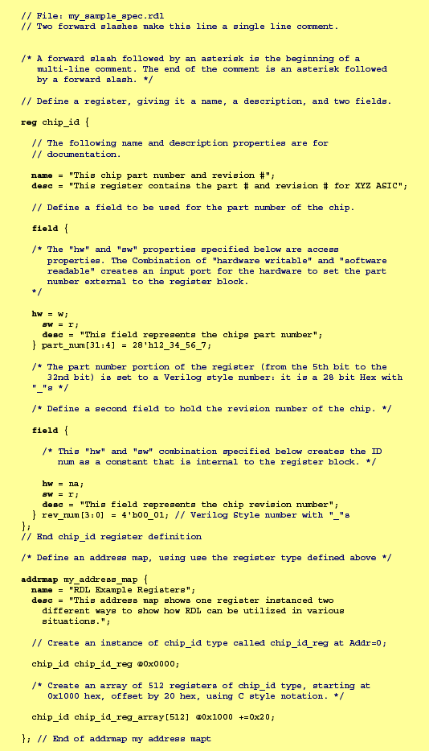
Step 2. Compile your design in Blueprint, and specify the outputs
You can generate multiple output types as well as specify other options when you invoke Blueprint. For example, the following Blueprint command reads the specification from the file shown in Step 1, generates HTML, Verilog, and C++, and places the output into a directory named "output":
As Blueprint is generating output it will display messages similar to the following:
