Chip Specification Language (CSL) and the CSL compiler (CSLC): How to save time designing and verifying chip designs.
Abstract
Fastpath Logic, Inc. has designed a higher level specification language for computer chip architecture, design, and verification components specification, and a corresponding compiler which compiles the specification files into RTL, C++, and documentation.
The generated code files are “skeletons” to which designers, the verification team and C++ programmers add their detailed logic. The detailed logic is the designer's value added contribution. Consistency between the different generated language files is guaranteed eliminating mismatches between reference and implementation models during verification.
The specification may be changed quickly and consequently all hardware and software teams will see all changes reflected in the languages that they use to implement and test the chip design and in application code which communicates with the chip design.
The chip design community is reaching a another inflection point in the design process. The change to CAD schematics in the late '70's and early '80's, and the change from CAD schematics to RTL in the late '80's and early '90's resulted in productivity gains. However, the increasing complexity (SOC's, networks of multiprocessors, pipelines with hundreds of pipe stages, ...) and the sheer increase in the number of transistors in designs is outstripping the ability of the hardware design teams to keep up in terms of schedule.
The interdependencies between different cross functional areas in the architecture, design, and verification components has not been addressed by current tools.
Fastpath Logic has a new solution for solving the interdependency problem: the Chip Specification Language (CSL) and compiler (CSLC). CSL and the CSL compiler solve the current problems that design teams face. Modifications should be made to one set of specification files which a compiler checks for correctness and then generates a set of output files with consistent representations in different languages.
Abstract:
- We have this language; it generates code; it’s easy to maintain. Not sure what it does, but “architectural specification” seems scary – EDA companies think this phrase is cool, but designers think this is marketing crap.
- Chip design is getting more complicated; “interdependencies between cross functional areas in the architecture, design, and verification components has not been addressed by current tools” (whatever that means!); we have this tool that generates code.
What is the current problem with chip design schedules?
What is the current problem with chip design schedules?
- Designers have lots of things to think about, so scheduling is hard and teams burn out. Most designers will tell you that last minute marketing changes are the biggest schedule problem. Most design manager will tell you that most designer don’t know how to come up with a schedule.

http://www.cadence.com/company/newsroom/press_releases/pr.aspx?xml=102306_logic_design_team_solution
Logic design teams are asked to create increasingly sophisticated products in shrinking geometries while meeting a growing range of design objectives, such as correct reusable functionality, power efficiency, functional quality, adequate testability, and physical feasibility among others. As design complexity has increased, the interdependency of these objectives has grown as well, limiting the scalability of today's manual, sequential and highly iterative approaches. The result is a growing scheduling 'predictability crisis', in which changes made to improve one goal degrade the others, increasing project risks and schedule convergence challenges.
Cadence recognizes the problem meeting current schedules. "The schedule predictability crisis is real," said Ted Vucurevich, senior vice president and chief technology officer at Cadence.
There is a cost to stretching a design team to meet a goal. The design team burns out after a few projects where the goals push the designers to work long hours to meet the project deadline.

How can equivalence between two models be checked: C++ simulator and RTL model.

Questions. I don’t understand what you’re getting at here? It’s a long build-up.
know that the C++ simulator and the RTL design/test bench are communicating
correctly?
The only way to know is to use equivalent code in each model. The only way to guarantee equivalent code is to use a single specification language which is what we are doing.
guarantee that the software and hardware teams are using equivalent code?
guarantee that the compiler can talk to the processor?
guarantee that software driver can talk to the graphics hardware?
minimize the amount of time spent developing and debugging the SW/HW interface?
minimize the amount of time spent developing and debugging the Rtl modules design hierarchy and interfaces?
minimize the amount of time spent developing and debugging the C++ simulator/test bench/design interfaces?
minimize the amount of time developing and debugging the interfaces between
designers?
generate hardware circuits from a specification that are tied into the rest of the design?
The above list of questions are just a few of the areas that design teams spend (waste) time
writing parallel code streams in C++ and RTL and verification languages.
Point tools

- Writing your own point-tools, or even buying them, is a bad idea. Here you accuse your customers of writing poor, inconsistent, point-tools that only solve part of the problem. Don’t accuse your customers of being dumb – they won’t appreciate it. Instead say that using a single consistent tool is much easier than maintaining the current in-house or purchased set of point-tools. “… problems in the other dimensions of the architecture, … spaces” – what does this even mean?
Many large companies have teams dedicated to writing point tools to automate many of these functions to automate the code generation process and to eliminate some of the consistency problems between the architecture, design, verification, and C++ simulation spaces. The problem with that solution is that the point tools do not check the relationships between the different input specification languages. Therefore the point tools solve some of the consistency problems in design but not the problems in the other dimensions of the architecture, design, verification, and C++ simulator spaces. The point tools are limited in scope. Individual companies typically have a subset of the point tools written in different languages by different developers and teams. Some times companies have multiple point tool solutions which results in many tools with limited features rather than one robust tool. There is usually limited back annotation functionality in these tools. For example, which point tool input file and line number generated the RTL or C++ code that has the bug.
There are a lot of point tools out there that people are using at different companies to
try and solve the design complexity problems that they are encountering and the engineers
are not as productive as they can be if they had a single tool.
There are too many point tools that are required in the chip design flow to build these tools in house. Moreover, poorly designed point tool languages become excess baggage in the legacy code
bases inside of companies that have proliferation projects. It takes time for new engineers
to learn the new, often poorly designed, languages with arcane syntaxes. Using a well known
language such as C++ with additional syntactic sugar to provide hardware, verification,
and C++ simulator language support results in an easy to learn solution with a shallow learning
curve. Startups have different problem than large companies with respect to point tools. Startups
must build their products and get to market as fast as possible. They do not have time to engage
in non-value added activities such as building point tools. They build C++ simulators but some
times abandon them late in the project because the simulator team (often one person) can't
keep up with the changes in the RTL design interfaces and logic. Too may consistency problems
creep into the simulator. This problem also occurs in large companies. However the simulator
team must "run" to keep up with the changes in the RTL design.
Timing analysis, synthesis and formal equivalense tools which were once developed in house at semiconductor companies are now “owned” by dedicated companies. Similarly point tools will be consolidated into single languages and compilers which are developed and maintained by dedicated companies.

Other peoples’ languages suck. Some very poorly chosen examples here as none attempt solve the problem your trying to solve. Don’t compare yourself to Verilog, System C, Vera, e, or even TIE – why would you, they aren’t your competition. RDL is competition so say how your solution is better – RDL lacks scope is very feeble, be more specific.
None of the current RTL design languages such as System Verilog, SystemC, Verilog, VHDL, solve
all of the consistency problems that the new language that we have desinged solves. Denali's RDL (which came out of Cisco) is a high level specification language but it is very limited in scope. Vera and e are verification languages and do not know about the architecture and design. Tensilica's
high level specification language TIE is limited to adding new instructions to the base processor.
Other tools address very specific issues in chip design. What is required is a high level specification language that can tie the functions of the various point tools together.
High level specification language

Multiple tools are bad. Something about C++ simulators. Not sure what “interfaces between the tools” means exactly. An example would help. I have no idea what you’re trying to say about C++ simulators.
Single tool better than multiple tool. I didn’t think design complexity was what was being solved here – perhaps design size. The counter argument is that picking the best point-tool for each task is better than picking a single tool that may be poor in some areas – you need to address this concern.
Using these tools independently of one another requires that the interfaces between the tools be verified down stream using Verilog compilers and simulation cycles. Many of these problems can be "caught" earlier if a high level specification language is used by the high level specification language much like formal verification can eliminate some simulation cycles. A high level specification language facilitates the rapid changes in the specification that is required in todays projects and moreover the generation of equivalent code in C++ and RTL. The verification of chip designs using C++ simulators is an accepted industry practice on processor and multimedia chip projects. In addition there are no commercial tools available that have a cycle based C++ simulator solution which is tied to the test bench and design under test.
Formal equivalence tools have two models which they compare: the specification (RTL) and implementation (gate level) models. Verification also has two different models. The C++ simulator and the RTL design under test. The two models are connected via a test bench. There are many points in the connections between the two models where bugs can be introduced which are not related to bugs in the design. The bugs in the simulator and verification components such as the vector generators and the test benches can be eliminated with a high level specification language. There are bugs due to inconstitencies in C++ driver code, software tools (compilers), C++ simulators, RTL designs, and test benches. These consistency bugs also can be eliminatted with a high level specification language that specifies the interconnections/design hierarchy, the verifcation components (vectors and state data), memory map, memories, registers, register files, FIFO's, pipelines, ISA's, buses, bus interfaces, and many other cross functional areas that cause consistency bugs between RTL design modules and between C++ and RTL.
In order to reduce the amount of time spent on debugging interfaces, memory maps, ISA's, vector signal ordering, ... one must use a higher level specification language that will generate the C++ and RTL code and the corresponding documentation so that the software and hardware teams are using equivalent sets of code.
CSL is a new high level specification language for specifying the architecture and generating the design, verification, and cycle based C++ simulator frameworks. We convert the language into C++, RTL (Verilog, working on SystemC, and can easily do any other RTL language using visitor
functions). The language can be extended easily by adding new keywords and could
be used to generate assertions and other verification code. The compiler also generates
documentation. The high level specification language is C++ compatible with some
additional syntactic sugar with HDL compatible functionality. It will not compile with a
C++ compiler. It requires our compiler with built in elaboration for vectors, test benches,
memory maps and interconnect to mention a few components. The high level specification
language is the HDL analog to object oriented design patterns. We have a language with
over 300 keywords (classes and methods) that covers most of the major cross functional
areas in chip design. The language supports keywords with hierarchical and linked list
structures which are used to represent the common HDL hardware design patterns.
CSL is used in conjunction with Verilog and C++ to build chips faster with less bugs.

What is the relationship between schedule slips and the current tools?

Time is spent on projects manually creating or using point tools to create the RTL design, C++ simulator, and test bench components and intra and inter connections between these components. The time spent creating the skeletons (the hierarchies and the connections between the hierarchies) in the RTL and C++ simulator can be automated. The memory map for the design can be specified and used to generate the RTL and C++ code representing te memory map. Instruction set architectures can be specified instead of created using spreadsheets and then manually transferring the spreadsheet information to a set of manually created defines.
Much of the additional time spent on new projects is spent manually debugging intra design consistency problems and design/simulation/verification infrastructure problems. It is currently estimated that design teams spend 50% of their time verifying chips. Many of the bugs that need to be fixed are consistency bugs between design elements and between the design, the simulator and or verification environment.
How can the design process be improved and schedules returned to a predictable time period?
These types of bugs can be prevented if a high level specification language to specify the architecture, design, simulation, and verification components and the connections between these components and the specification is compiled by a high level language compiler. The output of the compiler is code and documentation for the architecture, design, simulation, and verification teams. The Fastpath Logic high level specification language (Chip Specification Language-CSL) and compiler simplifies the process of architecting and writing the design, simulator, and documentation files for the chip which directly reduces the amount of work required to complete the project and hence shortens the project schedule.

What is the customer business opportunity based on the limitations and problems with current design tools?
Current design specification tools only provide a limited set of functionality with respect to the different aspects of chip architecture, design, and verification. Currently design teams automate the generation of RTL, C++ and documentation to a limited extent. Several different RTL code generation tools may be used on a single project. This leads to problems since the different tools (e.g.. interconnect, vector, and test bench specifications depend on each other. The different tools have different input files. The code in the different input files depend on one another.
Design teams usually use many different tools to convert their written specifications into a high level specification language which is then compiled into RTL, C++, and documentation. The combined set of generated RTL files is then compiled with the user written RTL file and simulation executable is then created and simulated. Specification bugs are found in one of the above three steps. Clearly it is more efficient to find specification problems in one static compilation step as opposed to two compilation steps and one simulation step. Since the current design methodology in many companies uses many different specification tools it is not possible to check the many different specifications with respect to one another at specification compile time.
Fastpath Logic has designed a specification language that can be used to specify the chip designs architecture, “skeleton” design implementation, and the verification framework and methodology and flow. The hardware and software engineers add the low level logic using the interfaces, signals, design hierarchy, constants.
General purpose design languages (e.g. Verilog, VHDL,...) cannot be used to specify cross functional relationships between different units on a chip. Specialized vertical design tools (e.g. Denali RDL, Coware, Arteris) are limited in scope. As a result users waste time merging the debugging the output of the various tools. Clearly there is room for improvement in high level languages and tools for chips architecture, design, and verification.

What is the Fastpath Logic high level language specification solution and what value will it add?
A single high level specification language compiler is used to check the specification input files for correctness with respect to syntax, semantics, cross functional relationships, architectural and
design correctness. The compiler then generates a consistent set of RTL, C++ and documentation files which are used by the software, hardware and verification teams. The result is the elimination of parallel “book keeping” by the different teams which results in a more efficient design process. Moreover, architects and designers have the advantage that can visualize the design at a higher level while still maintaining control over the implementation details. In addition the specification can be modified and all changes propagate to the different teams at the same time preventing inconsistency bugs between teams. Companies need to add value not reinvent the wheel. Building the design skeleton, the verification environment, the C++ simulator skeleton, and the documentation on a project do not add value. The value added proposition of the high level specification language and compiler is simplification of and the automation of the mundane processes of building the design skeleton (e.g. interconnect/hierarchy, test benches, memory map/register relationships, ISA/pipeline relationship, signal/field/enum relationship, and many more), the verification environment, and the automatic generation of the documentation. The value added proposition of a design team are the algorithms and data paths which implement the low level details which make the chip do something which has been done before or make the chip faster.

What is the unique niche of the company’s product in the ESL world?
Providing a single computer chip architecture, design, and specification language which results in a more efficient design process.

Who is the technology important to?

- Your in-house tools suck. C++ plus syntactic sugar (never use this horrible phrase again – “additional syntax” is fine) is better as it has a small learning curve (it doesn’t unless you already use C++ or System-C already). Startups don’t build their own tools (yes they do – but won’t if they don’t have to). Maintaining a consistent design/model/software is hard (agreed).
- Why build when you can buy. Just because it happened historically! There are good business reasons why it’s better to buy.
ASIC, FPGA, and custom VLSI architecture, design, and verification teams. Most large companies do not want to pay for large design automation teams to build and maintain in house tools for several reasons. The large companies realized long ago that a dedicated tool supplier can do a better job at building tools at a lower price (higher price performance ratio) than an in house team can build the same tool. The dedicated tool supplier interfaces with a large number of customers and gets feedback from many different companies and hence is able to incorporate the customer's feedback into future versions of the tool.
Chip design startups share several fundamental concerns: preserve cash and “tape out” as soon as possible with correct functionality and with no bugs. Startups do not have the time or luxury of building complex design and verification tools. However, most chip design startups by definition employ experienced engineers from large companies. The large companies have automated their design environments. The experienced engineers are used to working in an automated environment. They appreciate automation because they know it reduces the amount of manual labor. However, they know it takes time and money to automate processes. Startups do not have time and money. They need solutions.

Why is the Fastpath Logic solution better than the competition's?
The Fastpath Logic solution uses one high level specification language and compiler as opposed to competing solutions which use many different tools to accomplish the same goals. Since there is one tool problems are found during the specification compilation step which reduces the amount of time spent debugging errors. In addition people are involved in finding the bugs since the source of the bugs are found in only one language file. Currently design, simulation, and verification teams may share common specification files which generate code for their respective teams. However, the tools used to compile the specification files are limited with respect to the amount of checking done and/or are not able to check their input specification files with respect to other point tool input specification files. Because the input specification files for different point tools can not be checked with respect to one another at the specification step, bugs in the specification files are found at later stages during compilation and simulation steps.

How does the Fastpath Logic tool help the customer?
- CSL is easy to learn since it is compatible with C++ and includes syntactic sugar borrowed from HDL type languages.
- CSL specifications are concise
- CSL reduces the amount of work required to build a chip.
- CSL reduces the risk of making changes in the specification which need to propagate to all parts of the design team: RTL, simulation, verification, and application software.
- CSL automates the code generation process.
- CSL checks the connections between the simulation, design and verification components reducing the amount of time spent on no-value added activities.
- CSL focuses the team on the value added activities and allows the team to make changes quickly with little or no schedule risk.

What is the Fastpath Logic advantage and why will companies sign up to use the CSL language and the CSL compiler?
Fastpath logic's CSL language and compiler and compiler is the most comprehensive high level specification language and compiler available on the market (see the attached competitive analysis matrix). Therefore we will attract chip design firms which recognize that their current design processes can be improved by incorporating a high level specification language and compiler into their design and verification flows. This will in turn result in reduced work loads for engineering teams, higher quality products, and faster time to market.

Why is it worth learning CSL which is not very different from Verilog and C++?
Hardware designers are reluctant to learn new languages. New languages are adopted by hardware design and verification teams when the level of complexity in and the sheer size of design projects cannot be managed with existing solutions and there are schedule slips. After the design team struggles with complexity/size problems on one or more projects the design team will look around for additional and/or different tools to solve design problems. Complexity and size problems can be solved with new tools which automate and simplify the design process. Designers only have so much time during the day. It is important to reduce the amount of manual labor (e.g. reptitive tasks, “book keeping”-maintaining parallel files, changes made for the same reason in many places...). These types of tasks can and should be automated. Design teams recognize this and have developed in house solutions or have purchased outside solutions. However, the in house and outside solutions are limited in scope. In order to solve current design problems languages and tools which can capture the design complexity and eliminate the parallel book keeping are required. At the same time the tools must check the relationships between the different cross functional areas listed above otherwise the design and verification team will have to do it. CSL is used to specify most of the functional areas in a chip design. The CSL compiler checks the relationships between the cross functional areas which the design and verification team would other wise do during RTL compilation and simulation. Therefor there is a savings in terms of the number of steps required to discover problems and there is a reduction in the number of people involved in finding problems. Specification problems which are not found early fan out to affect large parts of the design and a large percentage of the team and of the team's time. Elimination of specification errors early in the design process reduces the development time and time to market, saving both time and money.

Why Fastpath Logic is better/different compared to other design tools?
Fastpath Logic focuses on the front end architecture, design, C++ simulator, and verification component specification and code generation. Fastpath Logic is different from other companies because the Chip Specification Language (CSL) is a much more complete high level specification language. Other companies offer high level specification languages which effectively are the same as the semiconductor in house point tools and only offer limited specification functionality. CSL is the most complete high level specification language solution for the front end architecture, design specification, and verification component areas of chip design on the market today.

Why is using a high level specification language important?
Current design methods have reached an inflection point. Design teams are struggling to meet their schedules because of ever increasing work loads due to increasingly complex designs and shorter times to market. What can be done to reduce the hardware design teams work load?
- eliminate consistency errors in different language files which contain the same information by using a high level language specification and compiler to generate the different language files automatically from a single specification file(s).
- make changes quickly in the specification file(s) which are then compiled and propagated to all consumers of the generated file(s)
- specify and generate the code to connect the design components and test benches
- specify and create instruction set architectures automatically

Conclusion
Fastpath Logic has designed a new high level specfication lanaguage and compiler for architecture, design, verification, C++ simulator code generation. The CSL language captures the relationships between the different functional and cross functional areas in the architecture, design, verification, C++ simulator, and floor planner. The CSL compiler (cslc) compiles the input specification languages, analyzes the input specification for correctness. generates consistent code in RTL and C++ and generates documentation. The CSL language and the cslc tool are the only solution on the market today that faciltates the specfication of the individual components of each of each these areas and the relationships between each of the areas which results in the reduction of bugs and faster time to market.
CSL reduces bugs in chip designs in two fundamental ways:
1. A high level specification is compiled and generates consistent RTL module to module code
which eliminates errors due to consistency problems between RTL modules.
2. A high level specification is compiled and generates consistent C++ simulator connections to
test bench RTL code and generates consistent test bench to RTL module code (DUT), which eliminates errors due to consistency problems between RTL modules.

CSL Whitepaper Feedback

RTL coding tasks falls into two categories:

- Algorithm implementation: the core data-paths and control logic that differentiates your implementation from the competition: For example: your MPEG implementation, your traffic manager, your cache.
- Chip infrastructure and verification support: all the additional code and connectivity required to turn your algorithm implementation into a functional chip. For example: block inter-connect, programmable register access, instruction set mapping, block test-benches.

The algorithm implementation is what you want to design; the chip and verification infrastructure is what you have to design.

Maintenance is also a big issue, particularly for chip and verification infrastructure. Design changes must be reflected in C models, verification suites, software memory maps, and chip documentation etc. Changing the same information in multiple places is tedious and error-prone.

Designers need a tool that reduces the time spent coding and maintaining chip infrastructure so they can concentrate on algorithm implementation.

FPL provides this tool. It automates code generation for most major chip infrastructure tasks -
<list them here>.

From a single input, cslc generates outputs in C++ and Verilog (and others in the pipeline…), so you make a change in one file and all outputs are updated. For example, from a single input file, CSL can generate: RTL for programmable registers, C++ header files for software and verification suites, and pdf register documentation.

UPDATE THE FIGURE AFTER IT IS FIXED
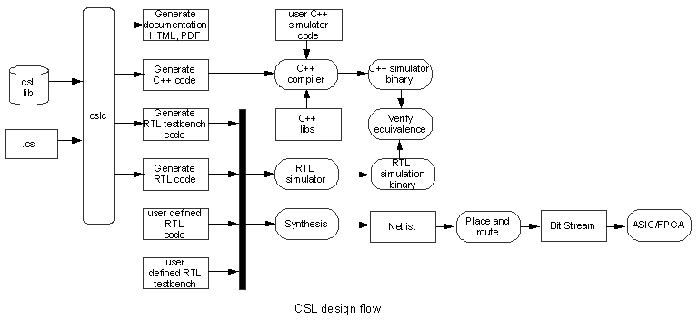
It provides a consistent input language for multiple chip infrastructure tasks that reduces the learning curve compared to buying or developing a set of point tools.

Explain the synergy of using a single language and how it’s better then having multiple point-tools. Use real-world examples. If you can’t then you have a point-tool suite with a common input format.

UPDATE THE FIGURE AFTER IT IS FIXED
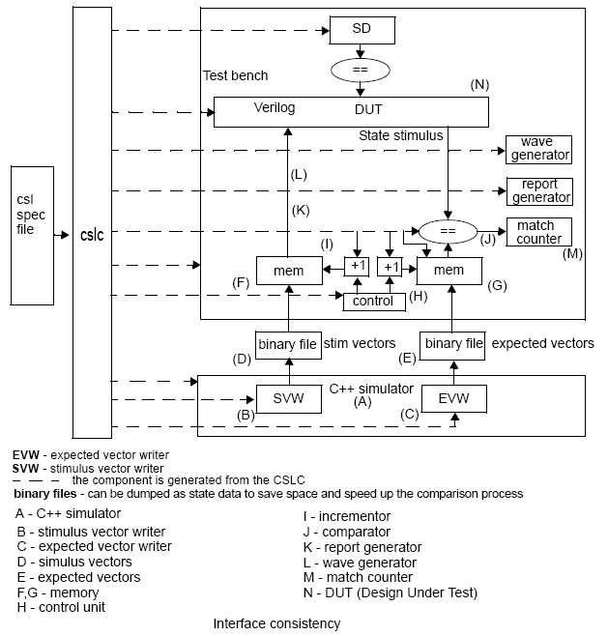

UPDATE THE FIGURE AFTER IT IS FIXED

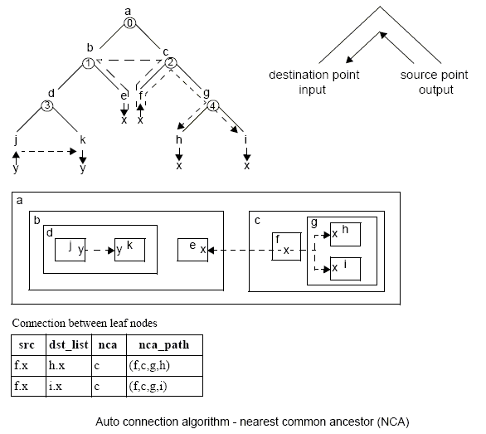
UPDATE THE FIGURE AFTER IT IS FIXED

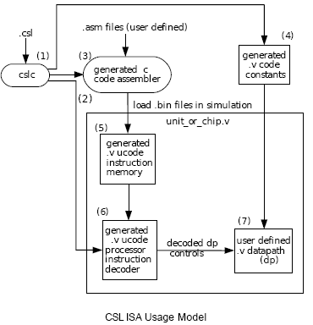
Why spend resources developing and maintaining an in-house tool suite when FPL has a professionally maintained and documented tool that solves all your chip-infrastructure needs.

Why use point tools from a variety of vendors when FPL has all you’ll need and more.
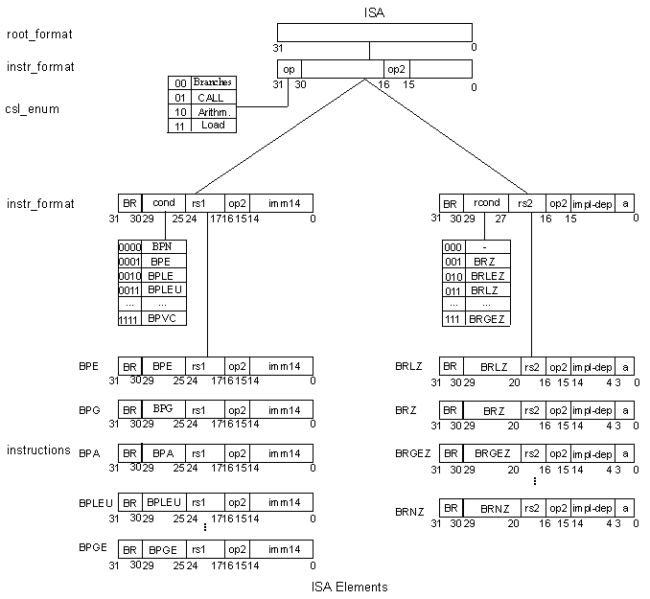
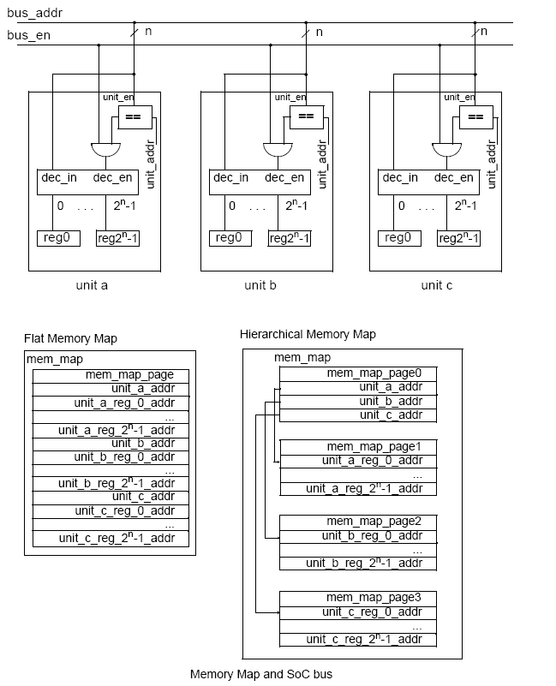
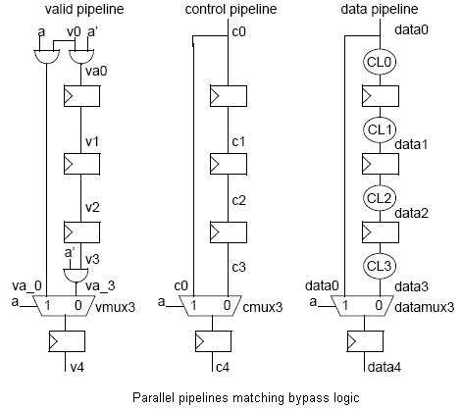

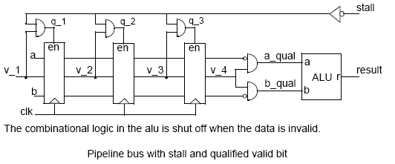

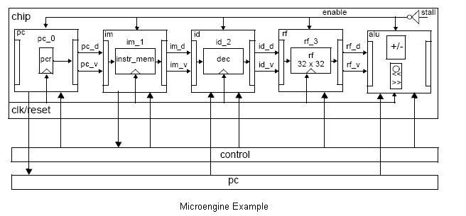

Notice that I did not stress: we have this new language …; that’s an instant turnoff. I said: this is what you do; this is something that we can improve; this is how we can help you. I did it in a page, but to do it properly would take 3 including diagrams – not 9.

How you said it

I’ll describe each section paragraph by paragraph. You should see that the structure is confusing, you drift off-topic – sometimes quite a way, and that you use needless and annoying jargon.

- Single source file generates RTL, C, and documentation…

At this point I’m getting bored and so are your potential readers. There’s too many words – 9 pages, lots of jargon - “cross functional areas”, and the structure is confused - What is the current problem with chip design schedules? It took time for designers to accept formal tools.

If you don’t like how I’ve described your product, come up with your own document structure – the current one isn’t working. Be as clear and concise as possible. Don’t tell designers why their job is hard – they know this. Don’t discuss the history of EDA – we know this. Don’t use jargon or phrases like “syntactic sugar” – in a 9-page document it’s like kicking someone when they’re down. Don’t be vague: “has problems”, “lacks scope”, be specific or give examples. Actually mention what type of code you generate –instruction sets, memories, block interconnects, test-benches… the full list with a description.

I’ve invented a language: exciting for you, off-putting for your customers.
I can generate interconnect, FIFOs, memory decodes, test-benches: boring for you, really useful for your customers.

