Instruction set architecture (ISA) provisional patent
I. Definitions
Basic processor pipeline
Processors are built using pipelines to increase the operational speed of the processor. Below we list the typical stages in processor pipeline.
- Instruction fetch
Process the program counter and fetch the next instruction.
- Instruction decode
Decode the instruction in the instruction register and read the register file.
- Execute
Execute the instruction in the execute pipe stage.
- Write back
Write back the results to the register file.

Bit-range
Bit-ranges have an upper and lower index and a width.

Fields
Fields have a bit range. Fields have an associated name. Fields can have an associated enumerated type or enumerated item. Fields can be non-hierarchical or hierarchical.

Enumerated types
Enumerated types are used in ISA's to define opcode sets and sub opcodes which are associated with fields. An enumerated type is a collection of named integer constants, called enumerated items. Enumerated items can have a value assigned. An enumerated type or enumerated item can be associated with a field.

Opcodes
Opcodes are the symbolic types that are used to identify the instruction formats. The major opcode is typically located in the left most field of the instruction format. Opcodes are used to distinguish between different types of operations that the CPU can execute. Some opcodes have associated sub opcodes which tell specific functional units within the processor which operation to perform. An opcode in a sense is an enumerated type and is associated with a specific field in the instruction format.
Field Types
Field are assigned a type from table 1. The types indicate the operations controlled by or the values held by the field.

Field name | Description
opcode | opcode associated with the left hand field in an instruction format
sub opcode | sub opcode associated with a sub field in an instruction format which is specified by an opcode
rf_address | register file address - used to hold a register file read or write address
mem_address | memory address - used to hold a memory read or write address
im | immediate constant -holds a constant value that is loaded into the data path and used in an operation or loaded into a register, register file, or memory location
mux_selector | mux selector - a mux selector that selects a mux input
op_selector | selects an option in a unit such as an ALU which supports multiple operations
reserved | reserved bits

Table 1. Example field types

Instruction Formats
An instruction format has a width. The instruction format width is measured in bits. Fields are associated with specific bit positions in an instruction format. Fields in an instruction format can have an associated enumerated type.

Example Instruction Format
An example instruction format is shown in figure 1. Two enumerated types are created: e_op and e_alu, The enumerated types are associated with fields. The enumerated type e_op is associated with the field OP and the enumerated type e_ ALU is associated with the field ALU. The field ALU is considered to be associated with the field OP when it has the enumerated item value e_op::ALU.

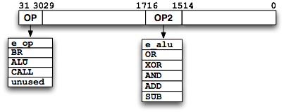
Figure 1. Example instruction format with associated enumerated types and enumerated items

ISA tree of instruction formats
ISA's are described using a hierarchy of instruction formats. The hierarchy is effectively a tree of instruction formats-see figure 2. Parent instruction formats are inherited by the off spring instruction formats. Off Spring instruction formats add information to the parent instruction formats.

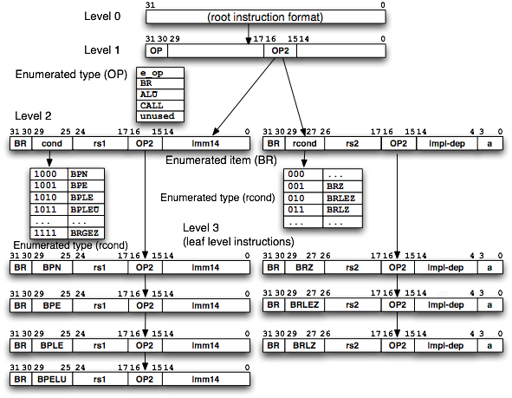
Figure 2 Instruction format tree

Each node in the tree is an instruction format which contains fields and optionally associated enumerated types. The leaf level nodes in the tree have a single major opcode (left hand) associated with the instruction format. The tree may have intermediate levels which add fields and associate enumerated items with fields.

Therefore there are three types of nodes in the tree. The root which sets the width of the instruction format and the left most opcode enumerated type, the intermediate level instruction formats, and the leaf level instruction formats.

Root Instruction Format
The root instruction format specifies the width of all instruction formats in the ISA (level 0 in figure 2). All instruction formats in the ISA are a direct or indirect descendent of the root instruction format. If the ancestor (parent or above) of the current instruction format contains an enumerated type associated with a specific field then the current instruction format may associate an enumerated item from the ancestor's field with the current field. For example, in figure 2 the instruction format in level 1 has a field named op which has an associated enumerated type with the members {BR, ALU, LOAD}. The fourth enumerated item is not specified and can be used to define a new opcode to extend the existing instruction set. The instruction format in level 3 with the cond field which contains BPE has selected the enumerated item BPE from the cond field in the level 2 instruction format .

New Instruction Formats
New instruction formats are derived from a more general instruction format. A new instruction format inherits the instruction format of the parent instruction format. If the parent instruction format has free bits then additional fields can be added to the free bits in the off spring instruction format.

Instructions
Instructions are created by assigning an opcode and/or sub opcode from an instruction format at a higher level to the opcode or sub opcode field of the current instruction format. Instructions appear at the leaf level of the ISA tree. Instructions have associated Mnemonics.

Mnemonic
Assembler mnemonics are associated with the instruction formats (e.g. opcodes and fields) in the ISA. A generated assembler is built by generating a “lexer” which recognizes the mnemonics associated with each of the instruction formats and the rest of the assembler software pipeline. The generated assembler then assembles the instructions and generates a binary file with the fields in the binary instructions set to the values of the associated mnemonics, as well, as passing through the constants in the input file.

Instruction Set Architecture (ISA)
ISA's contain a set of instructions that are executed by a CPU and cause operations to be performed in a certain order. A typical ISA contains instructions which are grouped by functionality. Examples of functional instruction groups include ALU, branch, and memory instructions. Each functional instruction group uses one or more instruction formats. There may be one opcode and optionally a sub opcode used to define each instruction.

An ISA for a single instruction in a single instruction word is created with the following steps (Note: other types of instruction sets can be described with the ISA such as VLIW, SIMD, MIMD [Jim Wen make sure that this covers the different types of instruction sets that exist]:

- Define a root instruction format with one or more fields (not necessarily the entire set of bits in the instruction format). One of the fields is the left most field in the instruction format and will be used as the opcode field in the off spring instruction formats.
- Create a off spring format.
- Create an enumerated type with the ISA root opcodes.
- Create an instruction format and associate the left most field with the opcode enumerated type.
- Create an instruction derived from the instruction format. Select one of the opcodes in the root instruction format opcode enumerated type to associate with the opcode field in the off spring instruction format.
- Define additional fields in the unused portion of the parent's format in the off spring instruction formats . which control some aspect of the processor pipeline.
- Associate types (e.g. opcode, branch_address, selector) with the fields. The following is a list of some of the typical types of fields found in typical instructions: register file selects, operand selects, write enables, operations (e.g. alu, branch), memory read/write, constant, and program control (branch, trap).

Special data paths
Architects/designers accelerate the performance of specific applications by developing custom data paths which execute in a single instruction what would take many instructions in a conventional processor. Building programmable hardware with specialized data paths combines fast execution time with programmability resulting in flexible solutions for end users. Custom instruction sets contain single instructions with the equivalent functionality of sequences of instructions that take many cycles to execute on conventional processors or which are executed with state machines and data paths that are not programmable. ISA's can be extended or created with application specific instructions that utilize the custom data paths. The fields in the application specific instructions are used to control the custom data path.

II. Existing Methods
Existing method for Describing and Developing an ISA
- An architect creates an ISA using a spreadsheet to specify the instruction field positions and widths or the instructions can be drawn in figures. Opcodes are added as separate tables to either the spreadsheet or figures..
- C++ reference model writer implements ISA based on ISA spreadsheet
- Verilog designer implements ISA based on ISA spreadsheet
- Assembler/C compiler writer implements the software tools using spreadsheet

Issues with Existing Methods for Describing and Developing an ISA Manually
The instruction format tree is copied from the ISA spreadsheet and/or document and converted into code by the software and hardware teams. This manual conversion process results in consistency and maintenance problems. The creation of the ISA involves creating and changing the widths of the fields. The fields are then aligned with respect to other fields. After the fields are aligned in an instruction format, off spring instruction formats are derived from the current instruction format and additional fields and enumerated types are added to the off spring instruction format. . Any change to an ancestor instruction format must be manually made in all off spring instruction formats. This manual process results in mismatches between off spring and ancestor instruction formats.

Examples of typical ISA manual construction errors include the following: mismatches between the width of a field and the enumerated type associated with the field, incorrect combinations of opcodes and sub opcodes in instruction formats, incorrect usage of enumerated items. With out an ISA compiler these checks must be done manually and are subject to error.

New programmatic method for describing an ISA
In contrast a programmatic description of an ISA can be created which is then compiled and automatically generates the documentation, software tools, reference model simulator, and the synthesizable RTL code. Automated checking tools are used to check and validate the ISA specification for correctness and completeness.

Creating the Processor Description File
A processor description file is modified/extended by the user through a GUI or text editor. The processor description file contains the description of the processor pipeline and ISA. The processor description consists of the following elements.
- ISA tree of instruction formats
- ISA instruction fields
- ISA enumerated types
- Pipe line description-lists the processor pipe stages register file(s) in the pipeline

Associating ISA tree of instruction formats with assembly language instructions
Each ISA tree leaf level instruction format is associated with an assembly language instruction. This makes the translation from the assembly code to the binary instruction format a one to one translation using lookup tables and pass through values for variables.

Once the instruction format tree is defined, the tree can be checked for correctness with a set of rules using an automated tool. The correctness check replaces the hand check that architects make with their spreadsheets and the programmatic checks that the implementors make. The checker finds conflicts between root, intermediate, and leaf level instruction formats that can occur in the following ways:
- The instruction formats contain overlapping fields
- The instruction formats have more than one enumerated type associated with the same field in different instruction formats
- Two or more intermediate level or leaf level fields in different branches have selected the same opcode for the same field (the opcodes are mutually exclusive)
- A field in a lower level is assigned to part or all of an upper level field that is reserved or illegal.

Once the instruction format tree is conflict free, the compiler generates RTL and C++ code that implements the processor ISA instruction decoder, a simple assembler to assemble programs using the assembler instructions associated with the leaf level instruction formats.

ISA Generation Flow
Figure 3 shows the ISA generation flow. The ISA description is entered into the GUI or hand coded and compiled. If there are any errors the user corrects them and then recompiles the updated input(s). The CSL compiler generates the C++ constants and functions which are used in the C++ reference model and also any related software tools written in C++. RTL code is also generated with an instruction decoder and other processor data path elements. The user adds additional logic to the processor data path to implement the functionality associated with custom instructions.

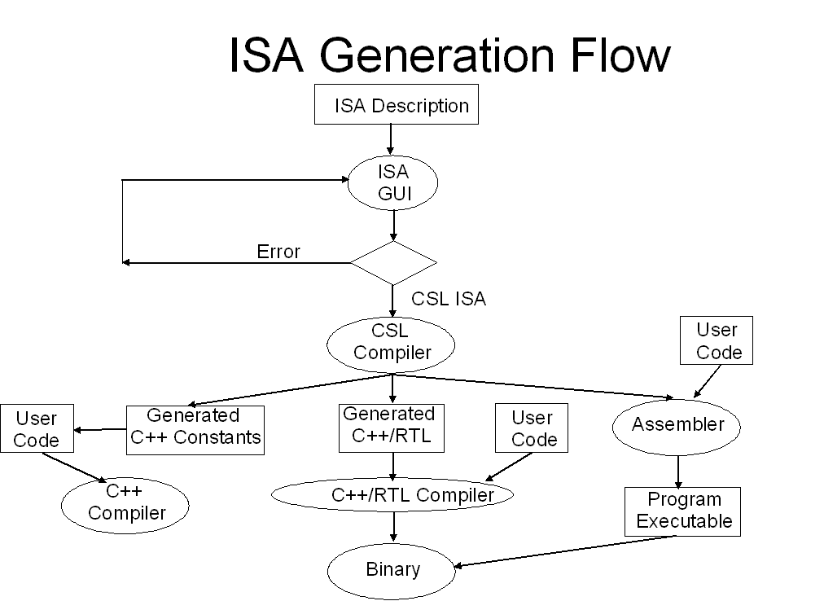
Figure 3. ISA Generation Flow

An assembler is generated which will compile the assembler programs written in the assembly language which represents the ISA. The user then writes an assembly program and assembles the program using the generated assembler into a binary executable. The binary executable is then executed on the simulation binary or the RTL simulator. The custom processor and software tools flow has the advantage that the software tools (e.g. assembler), the C++ reference model, and the RTL all use the same set of constants which describe the opcodes and field positions. In addition if the user has added field type information to the ISA specification the compiler can check for correct connections between instruction register fields which drive the processor data path and the data path elements. This requires that a type be added to the inputs of the data path elements that corresponds to the driver field type else there is an error when they are connected.

Describing and Compiling an ISA
The ISA specification can either be created with a GUI or an editor. The new method for describing and compiling an ISA is described in the following section.
- A user creates a new ISA by defining the width of the root instruction format. Then the user describes the field(s) in the root instruction format.
- Then the user associates an enumerated type with opcodes with the opcode field. Then the user adds off spring instruction formats with additional fields and optionally associated enumerated types or items.
- The user adds the ISA instruction formats to the ISA tree starting with the root instruction format.
- Fields are added to the instruction format and enumerated types and items are associated with fields.
- Off spring instruction formats are linked to parent instruction formats and a tree is constructed. The tree is built from instruction formats.
- The instruction formats are built from fields.

ISA GUI
A GUI can be built that the users enters the ISA instruction format tree. The GUI has an entry mode which facilitates building the tree by placing instruction formats and fields within those instruction formats and associating enumerated types with the instruction fields much like the tree shown in figure 2. In addition the GUI checks that the user only selects opcodes from fields that have a parent set of opcodes. The GUI tracks the opcodes that are selected in the descendants of the instruction format that contains the opcode set. Only one opcode may be selected by one instruction format in the set of off spring. In other words the selection of the individual opcodes and association of the individual opcodes with a specific off spring instruction format is mutually exclusive.

These objects can be drawn in the GUI.
  - Lines linking instruction formats are used to construct the instruction format tree.
  - Fields can have their position in the instruction format set either using absolute positions (i.e. the upper and lower index bit positions) or the relative relationships between the fields can be set using links to left or right fields in the instruction format.
  - The User names each of the fields in the instruction format.
  - When a field is created in a parent instruction the field will appear in all of the of spring of the parent instruction format.
  - Any conflicts (e.g. overlapping fields) between fields in the same instruction format or parent off spring instruction formats is shown by highlighting the overlapping fields.
  - The overlapping fields are then corrected by the user by moving the offending fields to the left or right. This mechanism provides instant feedback to the user when there are problems in the inheritance of fields or overlapping fields in the same instruction. The user is able to immediately correct the problems in the GUI.
  - The enumerated types and enumerated item values are shown ether in or next tothe associated field.
  - The upper and lower indices of the fields are shown .
  - The unused and unused bits of the instruction format are shown.
  - Conflicting fields in the instruction format are shown.
  - The GUI may contain a pipeline drawing which allows the user to specify which signals are used in specific pipes.

In addition as the ISA is constructed the user or an automatic mechanism can compile the ISA format into various formats. The compilation will check the ISA for correctness and report any errors to the user.

GUI Advantages
The advantage of describing an ISA via a GUI or context sensitive editor is as follows:
- The input to each instruction format can be checked for correctness with respect to the other instruction formats in the tree using a list of rules and errors can be flagged visually.
- The ISA designer can see the relationships between the different parts of the tree.
- The ISA designer can drag and drop various parts of the ISA instruction format tree.
- The GUI will force the ISA designer to select valid values at the lower levels of the tree (e.g. a field with an enumerated type is inherited by lower level instruction formats which can only use the value in the upper level enumerated type once).
- The GUI representation is more compact than the code representation.
- Information only needs to be entered once using the GUI as opposed to a hand written specification which requires that information be entered in parallel in different classes and the data is not checked.
- Ease of use.

The compiler will produce the following outputs:
- ISA documentation showing the name of each instruction in a list
- A description of each instruction including a pictorial representation of the bit wise format of the instruction and its fields and associated enumerated type(s) and items and its mnemonic representation,
- A generated assembler,
- Software components for a compiler to use to generate the assembly code, RTL/C++ code implementing the instruction decoder for the ISA, RTL/C++ code implementing the signal fan out of the instruction register. The fan out includes all possible instruction formats fields of the instruction represented in individual signals which can then be pipelined.

Checks performed by compiler
The user can optionally add type information to the instruction format fields describing the data path operation associated with the field. Types include opcode, select, register file address, memory address, and alu operation. The type information associated with the field can be used to check the connections of the instruction register fan out against a high level description of the hardware elements. The individual signals are driven by fields in the instruction register which are connected to pins on on hardware elements in the processor data path. If the pins on the hardware elements also contain type information then a software tool can check compatibility of the type of the signal against the type of the pin .

ISA Example
Part of the instruction tree in figure 2 is described programmatically.

Each component of the ISA description is described using an instantiation of a class. There is one object for each unique instance in the ISA description. In the following code there are enumerated types, fields, enumerated items, and ISA elements.

Fields have associated types such as the f_opcode field which has a type of opcode. Instruction formats have associated formats. Fields also have associated enumerated types such as the field f_opcode which has the associated enumerated type f_opcodes. The field is then instantiated in an instruction element such as f_opcode being instantiated in base_format.

In addition an enumerated item can be associated with a field.

The top most format has a root format type and inherited instruction formats have an instruction format type. If an instruction element has an ancestor that contains a field with an associated enumerated type the associated field in the current element can be set to an enumerated type item from the ancestor's field. For example in figure 2, bpe_instr is derived from base_format and the two fields in bpe_instr are set to enumerated items with the following code: f_opcode.set_enum_item(br)
f_conds.set_enum_item(bpe)

In figure 2 the instruction format bpe_instr is equivalent to the following code:

// bpe instruction

csl_isa_element bpe_instr: f1_format {
bpe_instr () {
set_type(instr);
f_opcode.set_enum_item(br);
f_conds.set_enum_item(bpe);
}
};

Compiler Outputs
The compiler generates the following components:
- RTL including Verilog, VHDL, SystemC, C++ reference model code
- software tools such as assemblers and compilers.
- the instruction decoder
- the processor pipeline
- Documentation

Generated ISA component consumers
Who are the generated ISA component users on a chip design project?
- Software tools team
- Simulation team
- RTL design team
- Software driver team
- Software applications team

CSL ISA Usage Model:
- The architect enters the ISA specification by either writing CSL code or using the CSL ISA GUI to enter the specification.
- The architect verifies that the CSL ISA specification is correct using the CSL ISA checker
- The C++ reference model writer implements the ISA by adding logic to the automatically generated C++ reference model infrastructure code.
- Verilog designer implements ISA by adding logic to the automatically generated RTL infrastructure code
- Assembler/C compiler writer implements the software tools based on automatically generated C++ infrastructure code plus user algorithmic code. The assembler uses the mnemonics which are associated with the opcodes, other enumerated types, and fields in the ISA. The software tools team uses instruction opcode constants and instruction field offsets to build assemblers and compilers.

Generating assemblers automatically
Micro engines and small processors with custom instruction sets need software tools. Assemblers can be generated for CSL ISA specifications. A compiler reads the ISA specification. The instruction in the ISA specification each have associated opcodes and instruction formats. The Instruction formats also have associated mnemonics. An assembler is generated which reads each line of the assembly code, parses it, finds the opcode(s) in the instruction, reads the values in the fields in the instruction and converts it into the binary equivalent representation.

Existing methods for building new application specific processors with custom instruction sets.
Standard soft IP processors (Tensilica, MIPS,ARM, NIOS,...) are available on the market today. The soft processors can be extended by adding additional instructions. However, the type of instructions and in some cases the performance of those instructions is limited because the basic processor pipeline cannot be extended or modified by the end user. Instructions can only be added externally to the processor pipeline and communicate with the processor pipeline via inputs to and outputs from the processor pipeline.
Therefor it is difficult to pipeline extended instructions and not possible for extended instructions to modify the behavior of the existing processor pipeline.

Existing method for extending a commercial processor pipeline (e.g. Altera, Xilinx, Tensilica).
Additional logic is added to the arithmetic logic unit (ALU) stage. See figure 4. The extended instructions are decoded in the instruction decode stage and the signals are passed on. It is not possible to pipeline the operations for the extended instruction in the program counter and register file pipeline stages which lowers the performance. Extended instructions must perform all extended operations in one pipe stage (e.g. alu pipe stage) as opposed to existing instructions which use the entire processor pipeline. If the extended instruction operation takes more than one clock cycle then multiple cycles will be used and the previous pipe stages will be stalled. Alternatively extended instructions with operations that exceed the maximum pipe stage time period will stall the previous pipe stages. 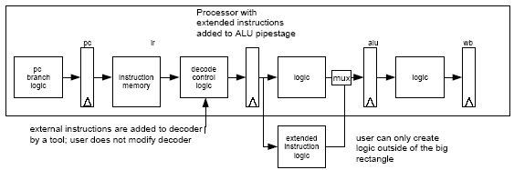This is unlike existing instructions that are part of the processor instruction set which are pipelined which will have a higher operating frequency than the current methods of slowing down the processor or stalling the previous processor pipe stages. Examples of multi-cycle instructions include instructions which have additional register files and data path logic which require more than one cycle to execute. It is difficult to add multi way branch instructions without access to the PC logic.

Figure 4: Existing method for extending a processor pipeline
The vendor’s main processor pipeline stages are shown in figure 4 in the large rectangle. Logic for extended instructions are added outside of the vendor’s main processor pipeline stages with the instruction decoder logic and any associated control signals which are generated by the addition of the instruction. Additional control signals are pipelined through the vendor’s main processor pipeline stages, The control signals are routed to the extended instruction logic outside of the vendor’s main processor pipeline stages.

The logic in the vendor’s main processor pipeline stages typically cannot be modified. Figure 4 shows how existing soft processors extend ISA’s by adding logic to the instruction decoder and all datapath elements outside of the main processor pipeline. The benefits of contraining ISA extensions to these points is that the main pipeline’s timing is preserved. Also the soft cores IP is not exposed to the customer. Encrypted processor models can be supplied to the user.

The existing processor code is not available to the customer because the code is generated from Perl scripts or hardwired Verilog. Adding instructions/operations to the main pipeline requires the modification of the source code. Currently available processors have “hooks” are available to add instructions/operations to the pipeline. The tools from the vendors that allow users to add instructions to existing processor add inputs and outputs to the alu pipe stage. The user then adds data path logic to implement the instruction operations in the alu pipe stage. The logic may include a register file, alu operations, and pc branch operations. The register file belongs in the register file pipe stage. The pc logic belongs in the pc pipe stage.

The operation may takes more than one cycle to complete in the extended instruction logic because logic which would otherwise be located in another pipestage (e.g. additional register file) is included in the single extended logic pipe stage.

New method for extending a processor pipeline
A processor is described with an ISA specification and logic written in C++ and/or RTL. This is called an ISA processor template.The infrastructure components are described using the ISA specfication. The logic is described using C++ and or RTL. The logic plugs into the infrastructure. The ISA specification is compiled. The compiler generates constants and structures. The infrastructure components and the logic are tied together using the generated constants and structures. The use of generated constants and structures in the logic has the advantage of tying the infrastructure and logic together using programmatically generated structures as opposed to having a designer make changes in the logic or infrastructure manually. Manual changes are subject to error. If a user wants to make a change to an instruction typically changes to the processor pipeline will have to be made to the control signals which propagate from the instruction decoder. In addition data path changes may also have to be made.

The ISA processor template is modified by the user. The user adds instructions to the ISA specification and then compiles the ISA template. The user then takes the generated code and adds the user data path logic to implement the datapath logic for the new instructions. The compiler generates the control and datapath signals whch are pipe lined through the processor. The control and datapath signals are connected to the units in the processor (e.g. the program counter logic, the instruction decoder logic, the register file stage, the alu stage, and write back stage). The user then connects the control and datapath inputs and outputs to the pipe stage logic and uses the generated constants and constructs in the pipe stage logic. Any changes to the ISA specification automatically change the pipelined control and datapath signals. The control and datapath signal changes must then be reconciled in the user generated logic. The updated generated logic and the user logic is then recompiled. Errors during compilation are fixed by the designer and the code is recompiled. Generation of control and datapath signals from a single source with associated constants and structures results rapid processor development, ability to make rapid profliferation project changes, and the ability to simulate in both C++ and RTL.

A processor is coded using a specification language which describes the ISA. The ISA code can be extended by adding additional instructions and instruction formats. The ISA is compiled and the ISA infrastructure is generated. The processor data path elements are coded using the generated code. At this point the processor is treated as a template which can be extended. A user can directly add additional instructions to the native ISA code, thus offering significantly greater control and flexibility. Typical problems with adding instructions to an ISA and modifying the processor data path include the following:
- It is difficult to modify the program counter logic
- It is difficult to modify the instruction decoder logic
- It is difficult to add/delete/change the instruction decoder pipelined control signals
- It is difficult to add/delete/change the register file data pipelined signals

An ISA is captured in code which can be modified and compiled. The compiler generates infrastructure code which is equivalent in both the reference model language (e.g. C++ or SystemC) and the implementation language (e.g. Verilog). The user then can focus on making modifications to the processor data path.
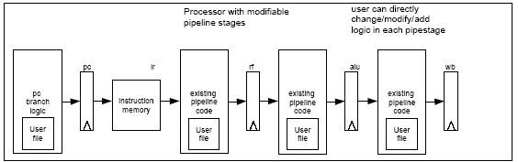

Figure 5: New method for extending a processor

Additional logic is added to any pipe stage. See figure 5. The extended instructions are decoded in the instruction decode stage and the signals are passed on. The extended instructions are pipelined in the program counter,, instruction memory, register file, and execute pipeline stages. Extended instructions perform extended operations using the entire pipeline resulting in higher performance than the conventional method described above.

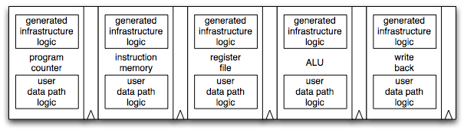Figure 6: New method for extending a processor showing generated and user logic.

Figure 6 shows both the automatically and user generated logic in each block.

Automatic Processor Verification Process
Both the reference model and the implementation model are generated from the same source. The compiler also generates the verification infrastructure to compare the state in the reference and RTL models. The state is compared on an event in the pipeline. The event is specified and is either cycle accurate (i.e. the pipeline clock triggers a state capture and comparison) or is driven by a boolean event (e.g. a valid bit or a register write). The user specifies the pipeline state which should be compared and the comparison event. Generating the reference model and RTL model infrastructure from the same code prevents consistency bugs between the two designs. Moreover, this work is automated thus increasing productivity.

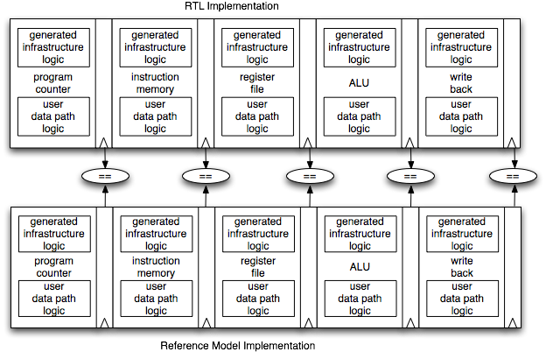
Figure 6: New method for verifying a processor

The generation of the C++/SystemC reference model and the RTL model infrastrucrture components is augmented with the automatic geneneration of the verification transport mechanism. The verification transport mechanism facilitates the comparison of the state in the reference and RTL models. The verification transport mechanism includes the vector and state data capture components in the reference model, the mechanism for communication between the reference model and a testbench or the RTL code, and a mechanism to applay or compare the vectors/state data to the RTL design under test. The vectors and state in the reference model are used to verify the RTL model. The automatic generation of the transport and comparison mechanisms eliminates any mismatches between the two models due to bugs in the verification transport and communication mechanism. (See FPL003 provisional patent application for a detailed description of the ).

- Key Inventions
The over view of the invention is shown in figure 7. The user ISA code is compiled and generates the ISA documents, the assembler, the reference model processor infrastructure, the RTL design processor infrastructure, and the verification infrastructure. 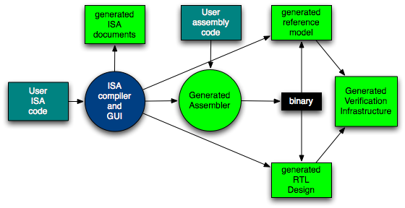
Figure 7. Overall flow

The key inventions are:
- ISA specification language - powerful language for describing a complete ISA.
- ISA GUI - Enables a user to easily describe an ISA using a specialized GUI from which the ISA specification is automatically generated.
- ISA compiler that checks the ISA specification for syntactic and semantic correctness.
- ISA compiler automatically generates ISA infrastructure components for the following design and verification components:
  - C++ or SystemC Reference model
  - RTL infrastructure (Verilog, System Verilog, SystemC, VHDL)
    - Instruction decoders
      - Pipelined control and data signals
      - Verification infrastructure for the RTL and C++ reference models
  - Automatically generated components used for comparison of the reference and RTL models
  - Documentation for the ISA and assembler
  - Processor templates
  - Assembler generation that enables a processor executable to be built.
  - Verification code used to automatically load the binary executable programs into the processor
  - Self consistent reference model, RTL model, and assembler
  - Reference model stimulus and expected vector capture mechanisms.
  - Reference model expected state data capture mechanisms.
  - Reference model to test bench and/or RTL communication mechanism.
  - Program load mechanism for both the reference model and RTL models.
  - Comparison mechanisms for the processor state data in the RTL test bench.
- Key Advantages
Unlike manually created ISA's where the relationships between instruction formats are not necessarily clear and must be derived by the reader, a formal description of an ISA can create relationships between instruction formats.

- The ISA can be extended
  - New instructions can be added to the ISA easily
  - Instructions can easily be removed from the ISA
  - User may modify the processor pipeline. Not done in other processors.
- Automatically generated processor and corresponding verification infrastructure
  - Instruction decoder.
  - Assembler and compiler
  - Documentation

- Powerful and highly concise representation compared to existing design languages such as Verilog and VHDL
- ISA changes are automatically propagated to all output instruction formats therefore synchronizing changes.
- The ISA specification can be checked automatically by the compiler.

Wide applicability to different types of designs that would otherwise need custom hardware and custom state machines.

- Implementation of embedded solutions using industry standard RISC processors and hardware extensions can be replaced with software tools and custom processors generated from the ISA specification. This results in a solution that has higher performance and a smaller form factor than standard RISC processors.

- Typical digital designs use state machines for control logic. The control logic can also be implemented using micro engines with custom ISA's. The advantage is that the traditional design flow consisting of RTL coding, synthesis, timing analysis, place and route, and bit file generation flow is replaced by a much faster flow which involves assembler (re)coding, assembly, and downloading the resulting binary to the FPGA . The cycle time difference between the two flows is on the order of minutes for recoding the assembly code vs. up to a day for the traditional design flow.

