Generated test scrips

In order to test the csl language and the csl compiler, small tests that are generated by perl scripts are used. These tests can be valid or invalid, so the scripts are created accordingly. One test generator can only have valid or invalid tests. The name of the script suggests what command(s)/object(s) are being tested in the current script. Each script creates a directory which will contain all the generated tests. This folder and the tests in it have a suggestive name also.
There are two ways to generate all the tests and then run them:

- This is the classic method were you have to do it all manually. The first step is to delete everything you have in the directory csl_test_gen (because this is were the generated tests will be). Then you have to run all the scripts in test/scripts/ (this is the location were all the scripts that generates tests are), one scripts at the time. Last step is to run the regression script run_regress.pl for the csl_test_gen directory:
run_regress.pl -hdl csl_test_gen

- The second method is to go in misc/scripts/ and run two scripts: run_all_gen_tests.pl . That's it! Simple ,no? The script will do everything that is on the first method.

The test cases in the matrices below are included in the Perl scripts that generate tests.

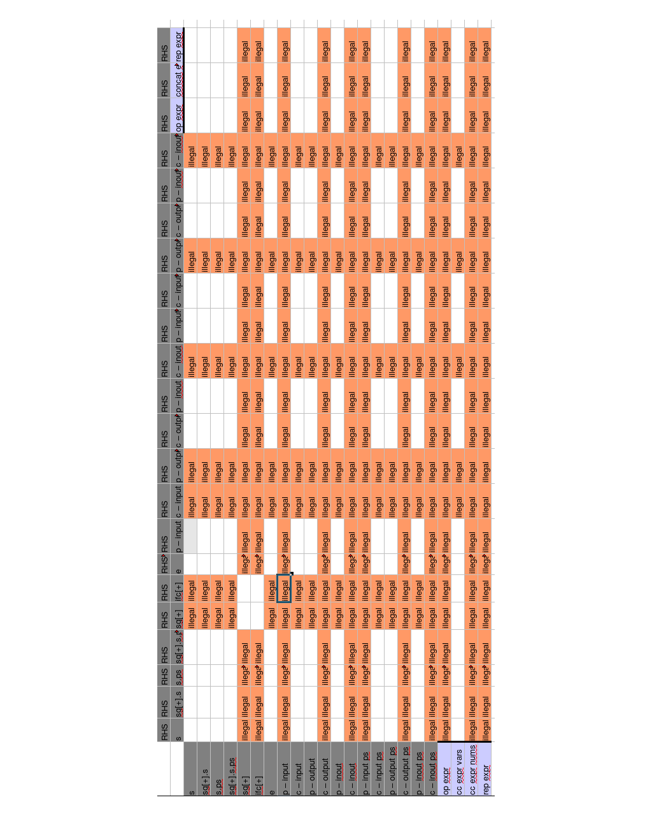
Assign matrix

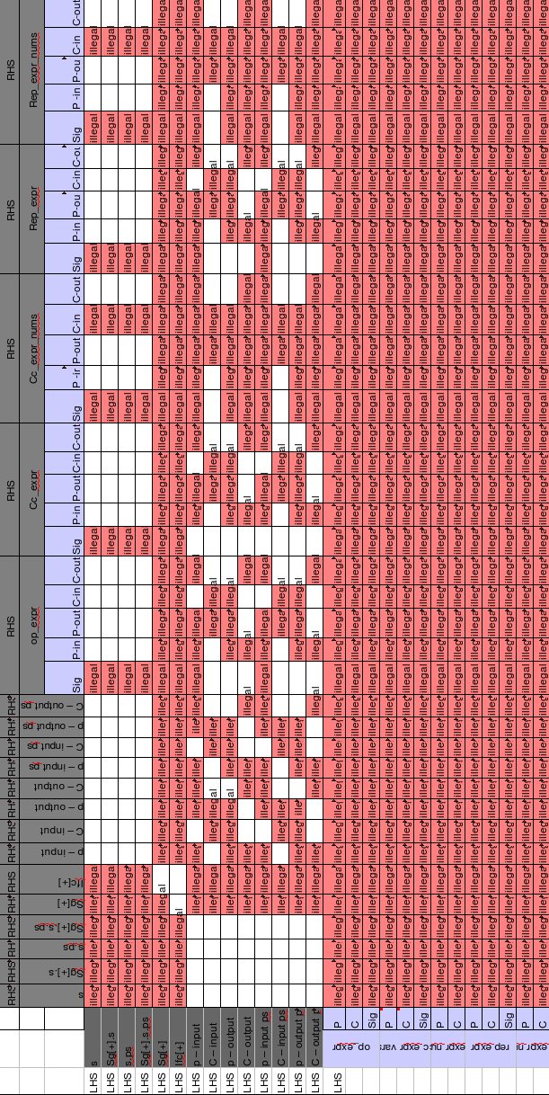
Connect
by
name
matrix

Connect_by_pattern matrix

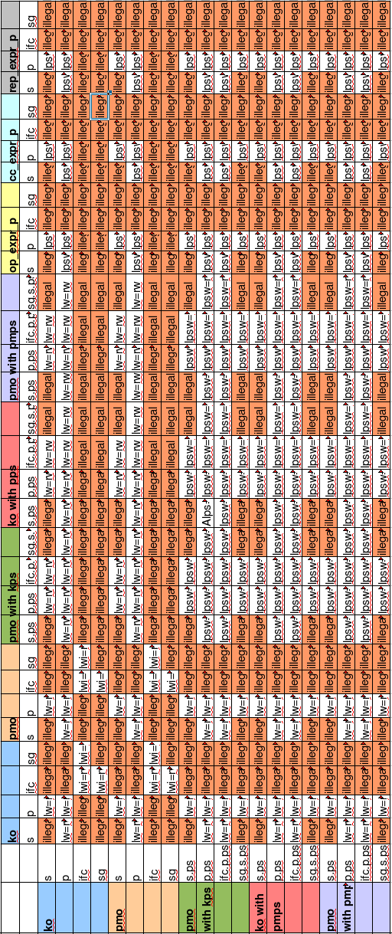

Connect_by_
name with
parameter
and part select

Formal to actual matrix
