Venturr — Brand & Design System
Version 1.0
Status: Locked foundation
Audience: Product, design, engineering, agencies, Replit collaborators

1. Brand Essence
What Venturr is
Venturr turns social inspiration into real travel plans. It collects scattered ideas (posts, screenshots, links) and quietly organizes them into something useful, trustworthy, and actionable.

What Venturr is not
• Not a booking engine
• Not a navigation app
• Not influencer-first
• Not loud, playful, or gimmicky

Brand personality
• Quietly smart
• Calm
• Modern
• Intentional
• Trustworthy

Think: Pinterest + Notion + maps, not Expedia or TikTok.

2. Logo & App Icon System
Primary App Icon (Locked)
Symbol: Abstract V-mark forming a subtle travel pin silhouette.
Meaning:
• V → Venturr, intent, direction
• Tapered point → place / destination
• Abstraction → planning over navigation
Style: Flat, minimal, architectural.

Usage rules
• Never add text to the icon
• Never add gradients, gloss, or highlights
• Never redraw the mark
• Never place on busy backgrounds
• Apple applies rounding automatically — do not round manually

Approved colors
• Background: Coral
• Mark: White
• Edge/shadow: Gunmetal (very subtle only)

3. Color System (Core)
Primary Palette
• Coral 500 — #F25F5C (Primary brand / CTAs)
• Gunmetal 900 — #1F2933 (Primary text)
• Gunmetal 700 — #3A4753 (Secondary text)
• Gunmetal 500 — #6B7280 (Metadata / icons)
• Neutral 50 — #F8FAFC (App background)
• Neutral 0 — #FFFFFF (Cards)
• Neutral 200 — #E2E8F0 (Borders)

Supporting Accents (use sparingly)
• Success — #4CAF93
• Warning — #F4B740
• Info — #4C82F7

4. Color Usage Rules
Coral
• Primary CTAs
• Active states
• Selected navigation
• Key highlights
• Brand moments

Gunmetal
• Headlines
• Place names
• Long-form reading
• Structural emphasis

Neutrals
• Layout
• Cards
• Lists
• Maps
• Backgrounds

Never use coral for body text.
Never use gunmetal as a background fill.

5. Typography
Primary Typeface
Inter (recommended)
Fallback: -apple-system, SF Pro, system-ui

Type scale & weight
• H1 / Section titles: 600
• Card titles / Place names: 600
• Body: 400
• Meta / Counts / Dates: 400 (smaller, lighter)

Tone rules
• Clear
• Confident
• No hype language
• No emojis in core UI
• AI copy should sound helpful, not clever

6. Iconography
Style
• Outline or filled-outline (consistent)
• Rounded corners
• Single stroke weight
• No decorative detail

Color rules
• Default: Gunmetal 500
• Active / Primary: Coral 500
• Destructive: Neutral + label (avoid red overload)

7. Layout & Components
Cards
• Radius: 12–16px
• Soft shadow only
• No heavy borders
• White on neutral background

Buttons
• Primary: Coral fill, white text
• Secondary: White fill, gunmetal text, neutral border
• Destructive: Neutral + icon (no red buttons unless critical)

Spacing
• Generous vertical rhythm
• Avoid dense UI
• Let content breathe

8. Motion & Interaction
Motion principles
• Slow
• Purposeful
• Never playful
• Never jittery

Timing
• ease-in-out
• 200–300ms for UI transitions

Brand motion idea (future)
• Subtle rotation or pulse of the V-mark during AI processing, loading, onboarding

9. AI Experience Guidelines
Venturr must earn trust.

Visual states
• Suggested by AI: neutral styling + small label
• Confirmed by user: subtle coral accent
• Uncertain: warning accent + clear copy

Copy rules
• Say “We think this might be…”
• Ask for confirmation when unsure
• Never over-promise accuracy

10. Replit / Engineering Tokens
:root {
--coral-500: #F25F5C;
--gunmetal-900: #1F2933;
--gunmetal-700: #3A4753;
--gunmetal-500: #6B7280;
--neutral-50: #F8FAFC;
--neutral-0: #FFFFFF;
--neutral-200: #E2E8F0;
--success: #4CAF93;
--warning: #F4B740;
--info: #4C82F7;
--radius-md: 14px;
--radius-lg: 18px;
--shadow-sm: 0 4px 14px rgba(31,41,51,0.08);
}

11. Do / Don’t Summary
Do
• Keep things calm and structured
• Let coral guide attention
• Use cards as the core metaphor
• Be transparent about AI

Don’t
• Add visual noise
• Overuse color
• Add mascots or characters
• Make the app feel “social media loud”

12. Brand North Star
Venturr helps people turn inspiration into intention.

Every design decision should reinforce clarity over chaos, planning over scrolling, and trust over novelty.

Visual References
Primary App Icon (Locked)
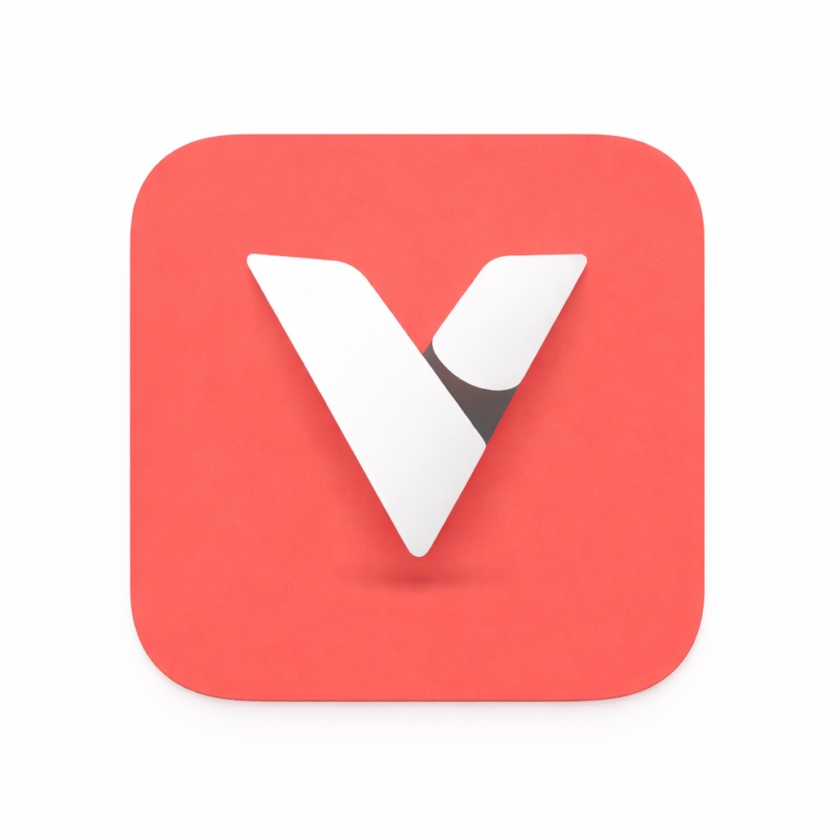
Color Palette
