Microprocessors

Table of Contents

Microprocessors 1
Table of Contents 1
Table of Figures 2
Brief 3
History of the Microprocessor 4
Designing for Mobility 6
Manufacturing Process 7
Current market manufacturers and their chips 8
AMD: Advanced Micro Devices 8
Centaur Technology 8
Elbrus International 8
SIS Silicon Integrated Systems 8
ST Microelectronics 9
Texas Instruments 9
Transmeta 9
Processor Types 10
Reduced Instruction Set Computer: 10
Complex Instruction Set Computer: 10
Very Long Instruction Word: 10
Super-scaler Processors: 10
Others: 11
Architecture 12
Setting Flags 13
The Registers 13
The General-Purpose Registers 13
The Address Registers 14
Program Counter (PC) 14
Stack Pointer (SP) 15
Bus system, instruction set and fetch/execute cycle 16
The Instruction Execution Cycle 16
Fetch 16
Decoding and Execution 17
References 18

Table of Figures

Figure 1 The etching process ………………………………………………………7
Figure 2 "Standard" Microprocessor Architecturre………………………………..11
Figure 3 Shift and Rotate … ………………………………………………………13
Figure 4 The 16-bit Address Registers Create the Address BusFigure ……………14
Figure 5 Fetching an Instruction ………………………………………………… 16
Figure 6 Automatic Sequencing ………………………………………………… 17

Brief

Write a research paper describing the various microprocessors employed in Desktops, Tablets, PDAs and Smartphones, past and present. Use the following areas in your report, or any other you feel relevant to strengthen your submission:

• development history
• manufacturing process
• current market manufacturers and their chips
• types of processor and likely trends.
• processor specification (computing power etc.)
• architecture
• the bus system, the instruction set, the fetch/execute cycle
• chip applications and why a particular processor is used

The report length should be 3000 words, approx 10 pages, TNR 12, 1.5 spacing using DIT Guidelines. All references should be included at the end of the report document with appropriate annotation throughout the document. The Harvard Referencing system should be used. The report should contain a Table of Contents, Table of Figures, Table of Tables, Abstract, Introduction, various subsections and References.

History of the Microprocessor
Just over forty years ago Intel placed an advert in a magazine declaring that they had an integrated circuit that contained enough components on a self contained processor on a single chip for the first time, They said that they had just invented the first microprocessor, the Intel 4004 was born.

Controversey still surrounds the actual inventer but Intel’s 4004 became the first chip commercially available to whom ever wanted to build something that needed microchips.

It was Intel’s knowledge of the silicon manufacturing process that allowed them to succeed were others had failed.

A Japanese company, Busicom were in the process of developing a calculator, in 1971 they approached Intel, asked them to produce a chip that would suit their needs, Intel had other ideas and developed a chip for general purpose use that be used for other tasks.

The 4004 had just 2,300 transistors that might seem like a remarkably low number when you compare it to today’s mircoprocessors that harness the power of almost a billion transistors.

The ROM, RAM and IO components used a 4bit bus to communicate which meant that the 4004 chip could not address any more than 4KB of program memory (ROM) and a maximum of 1280 words of 4bit data memory (RAM).

The 4004 chip was viewed as a solution to handle process control for devices such as calculator’s and printer’s.

Intel then created the next version of its processor in 1972, the 8008, the first 8bit microprocessor, this addressed up to 16kb of memory, it went on to be the power behind some very early micro-computers.

It wasn’t until 1974 did micro-computers start to take off, the 8080 chip had 64kb of memory space, it had an 8bit processor with a speed of up to 2MHz.

This was the spark that the industry needed to ignite it, Zilog’s Z80 and Altair’s 8800, the Altair’s processor was sold as part of a kit for hobbyists to build their own computers.

Digital Research’s Gary Kildall created an the CP/M operating system based around Intel’s 8080, this was to become the driving factor for the development of the personal computer.

The first portable computer named the “Osbourne 1” was developed to use the CP/M operating system, some of the earliest software packages to be created to run on this computer included “WordStar word processor” and “dBase database” .
Some other manufacturers had started to develop their own microprocessors, Motorola had their 6800 while MOS Technology produced the 6502.

MOS Technology’s processor proved to be very popular due to it’s relatively low cost. It was to be the processor of choice for the Apple II, the Commodore Pet and the BBC Micro.

Intel continued to work developing new processors, there main aim was a 32bit processor, but while this was being developed they had come up with a 16bit version in 1978, it was named he 8086. The 8086 was the first of many Intel processors that would eventually lead them to there current multi-gigahertz multi-core chips.Intel’s success very largely based on IBM’s decision to use their chip in their 1981 design for a new standard computer which is still the basic standard used today. The success of this new computer was in a way responsible for holding back improvements in chip advancements as the system board of the IBM computer had limitations.

Around the same time Motorola introduced the 68000 processor, Apple used this chip in the Macintosh computer while Sun used it in their Unix workstation.

The hunt was still on to find faster and better chip designs that only relied on bumping up the clock speed. Thanks of Moore’s law (Wiki, 2012) engineers were able to alter the circuitry by adding memory caches that was able to address the issues between processor clock speeds and the rate that memory chips could operate. Intel passed he 1 million transistor mark 1989 with the introduction of their 486 chip, this chip included a floating point unit for the first time.

A massive shift in the architecture of the x86 came with the introduction of the Pentium Pro in 1995. The line between complex instruction set (CISC) processors and reduced instruction set (RISC) processors was becoming blurred. RISC (RISC, 2012) was designed in the 1970’s to make instruction execution as simple as possible.

It was the ARM architecture (ARM architecture, 2012) used in the 1980’s in desktop PC’s, its relative simplicity made it a good candidate to be used in the production of modern day appliances such as smart-phones and battery powered mobile devices.

The need for speed in recent times meant that processors were being packed with more and more transistors, in 1999 speeds of 1GHz was passed. This meant that in the early 2000’s there was so much heat generated that Intel’s Pentium 4 was maxed out at a speed of 3.8GHz, there was a chance that the processor could melt if it was pushed any harder.

The next stage of development saw chip manufacturers switch to a multi core design. The idea was to fit two of more processors onto one piece of silicon.

Processors today can be made up of billions of transistors, this makes them more than a million times more complex than the original Intel 4004 chip. No matter how complex the latest microprocessors become they still have a lot in common with Intel’s original single chip design. (Forty years of the microprocessor, 2012)

Designing for Mobility

To keep up with the ever changing and increasing demands of mobile devices, microchip manufacturers are designing more compact models that will need less power and give more performance. (more for less)

Taking desktop computer architecture in putting it in a smaller device is not the answer, the smaller the transistor the more problems with electricity leakage which is a complete no-no for mobile devices.

Intel and IBM are radically changing their designs, Intel are using better insulaters while IBM are designing a honey comb structure with empty spaces as a vacuum is the best insulator of them all.

Another design is to use multi-core, this is a way of layering or stacking chips, this is a better way but can be harder to program.

Qualcomm, Intel, and IBM are taking this idea a step further by developing designs for three-dimensional chips with multiple layers of circuitry. These designs save energy by shortening the distance bits must travel between, for example, the processor and a memory chip

(Qualcomm expects to have such chips in products next year.)

Intel will release their next generation of its mobile Atom processor this summer, it will use a between 33% and 50% less power than a conventional chip when it's active and just a 50th as much power as when the device is idle.

|The net result in the short term is the drive to boost microprocessor performance while saving energy will mean smart phones, netbooks, and tablets that work better and run longer on a single battery charge. High-performance processors that require less energy may also change the way mobile devices are powered. The trickle of energy produced by a solar cell, or a piezoelectric device that converts the biomechanical energy of walking into electrical current, can't do too much for today's gadgets. But future mobile processors might get a significant boost from such energy sources. (Designing for mobility, 2012)

Manufacturing Process

Chip making is all about applying thin layers with specific patterns onto silicon wafers. It starts with the creation of an insulating layer. A photo-resist is applied, and unwanted sections are removed with high-intensity light through masks, the exposed areas are removed, some of the silicon is revealed, which is the removed by a process called etching.

The photo-resist is then removed, that leaves a silicon pattern. More steps apply layers until the desired 3D structure is completed. Every layer is doped with ions that change the electrical properties. Windows to each layer are created in each step to create interconnects by applying metal.When the wafer process is complete, the wafers need to be thinned, so they can be cut into single processor dies. Electrical probes energize and test each die on the wafer. Finally, the wafer is cut into individual dies and non-functional ones are disposed of. The microprocessor chip is now ready for use. (How chips are manufactured, 2012)

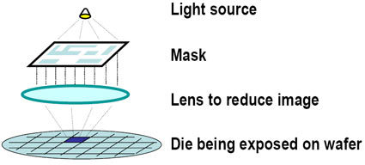
Figure 7 The etching process

Current market manufacturers and their chips

AMD: Advanced Micro Devices

AMD is a global supplier of integrated circuits for the personal and networked computer and communications markets. AMD produces microprocessors, Flash memory devices, and support circuitry for communications and networking applications.

Centaur Technology

Centaur Technology was founded in 1995 with the then-revolutionary idea that a small team of microprocessor engineers could design an affordable x86 processor for the neglected sub-$1000 PC market. In six years, Centaur has succeeded by designing the world's smallest x86 processors, shipping six different parts, and consistently having the fastest design cycle in the industry.

Elbrus International

Russian microprocessor manufacturer - An advanced level of our projects was confirmed by USA patents and industrial production implemented: a general-purpose multi-processor computer based on a SPARC-compatible work station and a SPARC-compatible microprocessor.

IDT- Integrated Device Technology, Inc.

IDT offers a range of standalone and integrated communications processors and development tools. IDT targets the highest-growth communications market segments such as DSLAMs, residential gateways, SOHO routers and Ethernet switches.

Intel Corp.

Intel Corporation is the world's largest chip maker and leading manufacturer of personal computer, networking, and communications products.

National Semiconductor Corp - National Semiconductor's Geode family offers a wide range of silicon and system solutions for information appliances. The Geode GX1 processor, together with the Geode CS5530A I/O Companion provides a scalable, flexible, system solution for information appliances ranging from set-top boxes to hand-held personal

SIS Silicon Integrated Systems

Silicon Integrated Systems Corp. (SiS), founded in 1987, is located in the Hsinchu Science-based Industrial Park in northern Taiwan.SiS offers full range of 3C products including CPU, core logic 3D graphics, and connectivity for mainstream PC and networking applications.

ST Microelectronics

STMicroelectronics is a global independent semiconductor company that designs, develops, manufactures and markets a broad range of semiconductor integrated circuits (ICs) and discrete devices used in a wide variety of microelectronic applications, including telecommunications systems, computer systems, consumer products, automotive products and industrial automation and control systems.

Texas Instruments

Texas Instruments Incorporated is the world leader in digital signal processing and analog technologies, the semiconductor engines of the Internet age. TI is a leader in the real-time technologies that help people communicate. We are moving fast to drive the Internet age forward with semiconductor solutions for large markets such as wireless and broadband access and for new emerging markets such as digital cameras and digital audio

Transmeta

Transmeta develops, in concert with OEM customers, platform solutions for the Mobile Internet Computing market. Transmeta's premier product line is the Crusoe smart processor for a new class of ultra-light mobile computers, and ultra-dense, low power servers.

ZF Micro Devices

ZF Micro Solutions - manufacturer of the ZFx86 System-on-a-Chip.

Processor Types

Reduced Instruction Set Computer:

John Cooke, a researcher with IBM found that a computer only uses 20 percent of the total available instructions. In 1974 he developed the Reduced Instruction Set Computer (RISC), this processor need fewer transistors, was cheaper to produce and user fewer instructions. Although RISC chips use fewer instruction they need more lines of code to perform the same tasks. Software is the important factor in order for them to perform well. The software will be more complex. RISC chips are most commonly used in devices such as oven, air conditioners and other kitchen type appliances.

Complex Instruction Set Computer:

The Complex Instruction Set Computer (CISC) is a term that was introduced to separate this type of processor from RISC chips, CISC chips are more complex , they use more instructions in comparison to RISC chips. In short the basic principle of CISC chips is that the hardware is always faster then the software making the CISC chip the chip of choice for laptops, servers and desktop computers.

Very Long Instruction Word:

Very Long Instruction Word (VLIW) showed a totally new concept of parallel instructions. The design was to pack multiple independent instructions into one very long instruction. In order to do this the software had to be able to distinguish individual instructions. VLIW works on the basis that the larger number of clock cycles per second, the faster the microprocessor is. The VLIW chip uses a computer compiler to compress a sequence of code into a very long instruction word.

Super-scaler Processors:

Super-scaler processors operate by allowing the computer to run multiple instructions simultaneously and independently. The Super-scaler microprocessor uses pipe lining to allow multiple processing instructions, each instruction in a Super-scaler processor needs to be in a different pipeline stage at a given moment. However, there are some limitations with Super-scaler microprocessors and they include: resource conflicts, when two or more instructions compete for the same resource; control dependencies, which occurs because the branches create problems in maintaining an optimum parallelism; and data conflicts, which are produced by data dependencies between instructions in the program.

Others:

General Purpose Processor (GPP) was designed to process a variety of operations, not just for one specific application or software.

Special Purpose Processor (SPP) has similar functions to the microcomputer peripheral chip, the difference being that a SPP is designed to control specialized instructions independently, while the microcomputer peripheral chip is controlled by the central processing unit.

Application-Specific Integrated Circuit (ASIC) is a specially designed integrated circuit for specific applications. An example of this is an Application Specific Integrated Circuit created for a line of mobile phones will only work for that specific phone design.

Digital Signal Processor (DSP) is used in math intensive because of its extremely fast microprocessor.

Architecture
Most of the microprocessor chips in the current market implement the same architecture. We will refer to it as the "standard" architecture for the purpose of this assignment. The modules of this standard microprocessor and there functions will be described from right to left as you view the image in Figure 2.

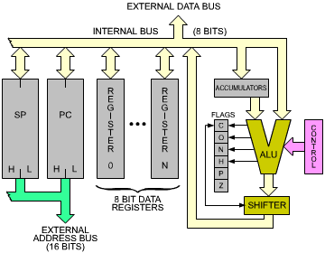
Figure 8 "Standard" Microprocessor Architecture

On the right hand side of Figure 2 is the control box, it represents the control unit, which synchronizes the entire system. Its role will be described as you read the remainder of this section.

The ALU (arithmetic logic unit) performs arithmetic and logic operations. A register equips one of the inputs of the ALU, the left input here. It is called the accumulator. (Several accumulators may be provided.) The accumulator may be referenced as input and output (source and destination) within the same instruction.

Shift and rotate facilities must be handled by the ALU. A shift operation can be described as moving the contents of a byte by one or more positions to the left or to the right. This process can be seen in Figure 3, a bit has been shifted to the left by one position. (Inside a microprocessor, 2012)

Figure 9 Shift and Rotate
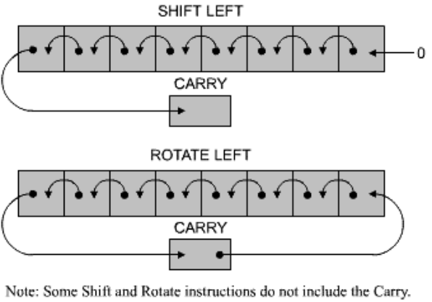

The shifter might be situated on the ALU output, as illustrated in Figure 3, or may be situated on the accumulator input. To the left of the ALU, the flags or status register appear. Exceptional conditions are stored within the microprocessor and the specialized instructions are used to test the contents of the flags registers or they may be read on the internal data bus. Depending on the value of one of these bits the execution of a new program may be caused by a conditional instruction. (Inside a microprocessor, 2012)

Setting Flags

The flags will be changed depending on the instructions performed by the processor. The manufacturers chart should be consulted to determine which bits that will be modified by the instructions that are executed. It is essential if you are to fully understand how the program is executed. (Inside a microprocessor, 2012)

The Registers

Look again at Figure 2. The left of the illustration shows how the registers of the microprocessor appear. Conceptually, you can tell the difference between the general-purpose registers and the address registers. (Inside a microprocessor, 2012)

The General-Purpose Registers

To perform data manipulations at high speed within the ALU (arithmetic logic unit) general-purpose registers must be provided.
The number of bits is governed by certain restrictions, because of this the number of registers is limited to less than eight. (Inside a microprocessor, 2012)

Each registers is a set of eight flip-flops, attached to the bi-directional internal data bus. The eight bits may be moved concurrently to or from the data bus. The implementation of the flip-flops provide the quickest level of memory available, and the contents of the registers can be accessed in less than tens of nanoseconds.
Internal registers are marked from 0 to n. The registers job is not predefined: they are known as "general-purpose" Registers. The data they store can be used by the program. Registers of the “general-purpose” type are normally used to store eight-bit data. Certain microprocessors exist to manipulate two of these registers at a time. They are known as "register pairs." This register type enables the storage of 16-bit quantities, whether data or addresses. (Inside a microprocessor, 2012)

The Address Registers

The storage of addresses is handled by 16-bit registers known as “Address registers.” They can also be referred to as data counters or pointers. They are double registers, i.e., two eight-bit registers connected to the address bus. The address registers create the address bus. The address bus can be viewed on the left and the bottom part of the image in Figure 4 (Inside a microprocessor, 2012)

The data bus must be used to load the data in these 16-bit registers. To move the 16-bits, two transfers are required using the data bus. The lower half of the transfer is labelled L denoting bits 0 to 7 and the label H denotes the bits 8 to 15. These labels are used if it is necessary to distinguish between both sides of the registers. Most microprocessors have at least two registers. At least two address registers are present within most microprocessors. (Inside a microprocessor, 2012)

"MUX" in Figure 4 stands for multiplexer.

Figure 10 The 16-bit Address Registers Create the Address BusFigure =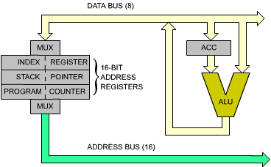

Program Counter (PC)

Every processor must have a program counter. The address of the next set of instructions to be executed is stored here. No programs can be executed without the program counter. The execution order of every program is normally sequential, in order to access to the next set of instructions they must be brought in from memory and into the processor. The program counters contents are loaded into the address bus a sent towards the memory, the word value is returned from the MPU. (Inside a microprocessor, 2012)

Stack Pointer (SP)

Software is used in general-purpose microprocessors to implement the stack i.e., within the memory. To track the top of this stack within the memory, a 16-bit register is assigned to the stack pointer or SP. The SP stores the address of the top of the stack in the memory. (Inside a microprocessor, 2012)

Bus system, instruction set and fetch/execute cycle

The Instruction Execution Cycle

The image in Figure 5 shows a visual interpretation of the “Instruction Fetch cycle”, Memory is depicted on the right side with the microprocessor on the left, the memory stores the data along with instructions. For this description we will deal with any memory object that contains instructions, one instruction will be fetched to show the role of the program controller, we assume that the program controller contains valid instructions. A 16-bit address which points to the next instruction to be fetched from memory, the processor will now perform three cycles: (Inside a microprocessor, 2012)

Figure 11 Fetching an Instruction 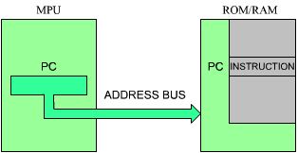

Fetch

The first cycle, the program counter contents are deposited on the address bus and gated to the memory (on the address bus). At the same time a read signal may be issued on the control bus of the system, if needed. This address points to one location within the memory. Once the read instruction is received, the memory will interpret address it has received, through internal decoders. The eight-bit word is the instruction that we want to fetch. In our illustration, this instruction will be deposited on the data bus on top of the MPU box. (Inside a microprocessor, 2012)

We will now summarize the sequencing: the program counter contents are output on the address bus. A read signal is generated. The memory cycles, and perhaps 300 nanoseconds later, the instruction found at the specified address is placed on the data bus. The data bus is then read by the microprocessor and places its contents into a dedicated internal register known as the IR (instruction register). It contains the instruction that was just fetched from memory. The fetch cycle is now completed. The instruction is now physically present in the special internal register of the MPU. The IR appears on the left of Figure 6. It is not accessible to the programmer. (Inside a microprocessor, 2012)

Figure 12 Automatic Sequencing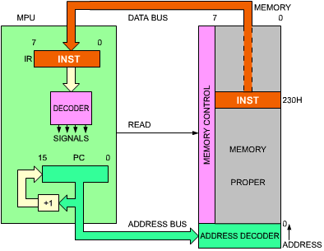

Decoding and Execution

Now that the instruction is loaded into the IR, the instruction will be decoded by the microprocessor and then create the correct order of internal and external signals so that the instruction can be executed.

The MPU will execute some of the instructions entirely while other instructions will deposit or fetch data into or from memory.

The length of time taken to process the instructions is measured in units known as clock cycles. (Inside a microprocessor, 2012)

References

Moore’s Law. [online].
Available from: http://en.wikipedia.org/wiki/Moore's_law
[Accessed March 2012]

RISC Architecture. [online].
Available from: http://en.wikipedia.org/wiki/Reduced_instruction_set_computing
[Accessed March 2012]

CISC Architecture. [online].
Available from: http://en.wikipedia.org/wiki/Complex_instruction_set_computing
[Accessed March 2012]

ARM Architecture. [online].
Available from: http://en.wikipedia.org/wiki/ARM_architecture
[Accessed March 2012]

Forty years of the microprocessor. [online].
Available from: http://www.v3.co.uk/v3-uk/analysis/2124832/microprocessor
[Accessed March 2012]

Designing for Mobility. [online].
Available from: http://www.technologyreview.com/computing/25149/?a=f
[Accessed March 2012]

How chips are manufactured. [online].
Available from: http://www.hardwaresecrets.com/article/How-Chips-are-Manufactured/252/1
[Accessed March 2012]

Inside a microprocessor. [online]. Available from: http://www.msxarchive.nl/pub/msx/mirrors/msx2.com/zaks/z80prg02.htm
[Accessed March 2012]

