# SDC HW3

# EKF Fusion

**RED** arrows are ground truth odometry

**GREEN** arrows are EKF result

**BLUE** arrows are radar odometry

* 1. 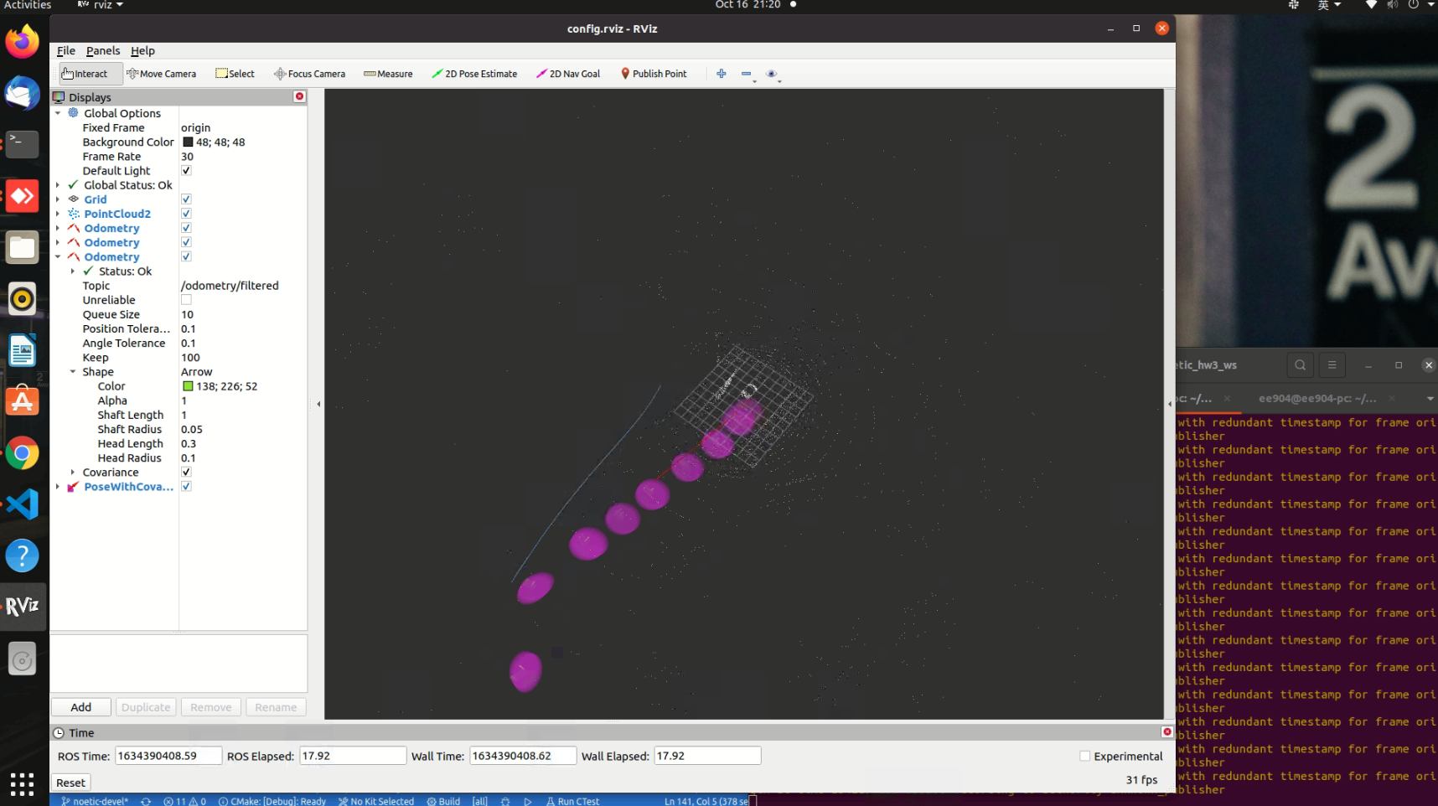**EKF with GPS**
  2. 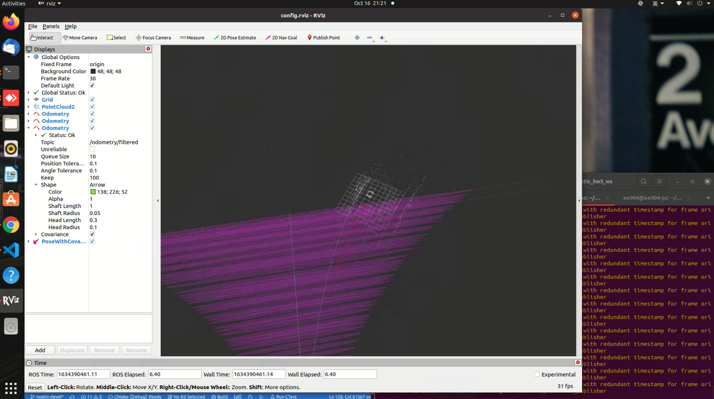**EKF with radar odometry**
  3. 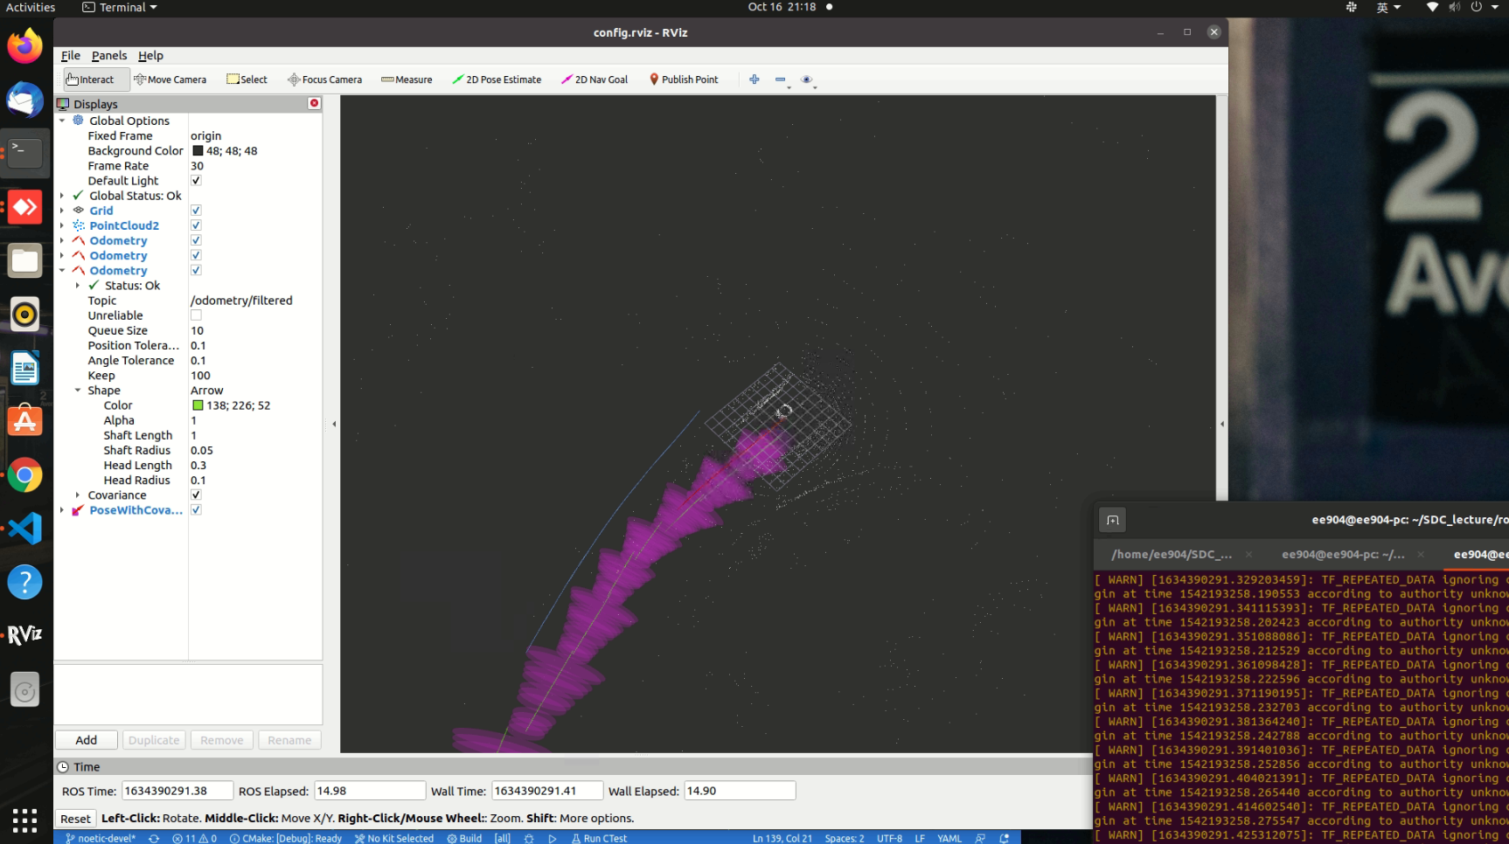**EKF with radar odometry and GPS fusion**

# Discussion

1. How do robot_localization package know the covariance matrix of GPS and radar odometry?  
   Robot localization package’s launch file read the parameters from params/*.yaml files, where you can tell the launch file which topic you want to subscribe and fuse. The topics include information of covariance matrix.
2. What is the covariance matrix of GPS and what does it mean?

This means that the correlations between x and x, y and y, is 3. And these arguments will not change in GPS data. 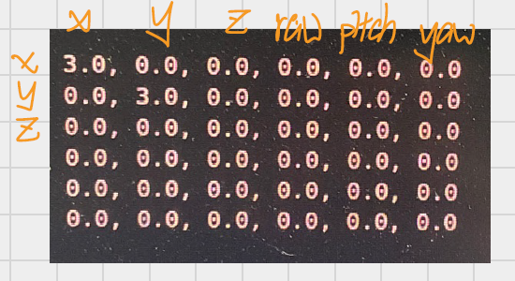

1. In the yaml file, do you set differential parameter of odometry and GPS to true? or false? Why?  
   I set differential param of GPS to false because GPS get the car’s position (x, y) absolutely with error.

I set differential param of radar odometry to true because radar get the car’s position by calculating the difference between position at time t and (t+N), relative to a specific starting position.

# Bonus

1. 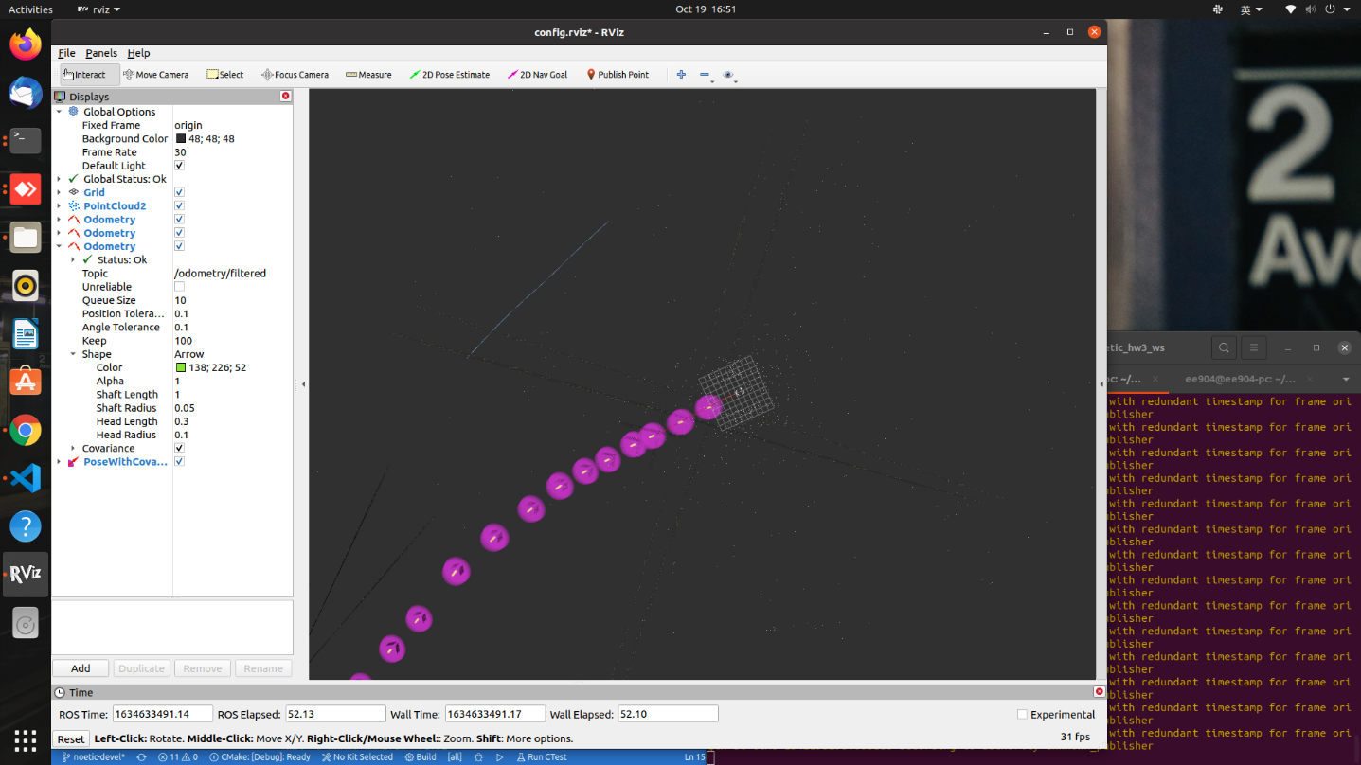**UKF with GPS**
2. 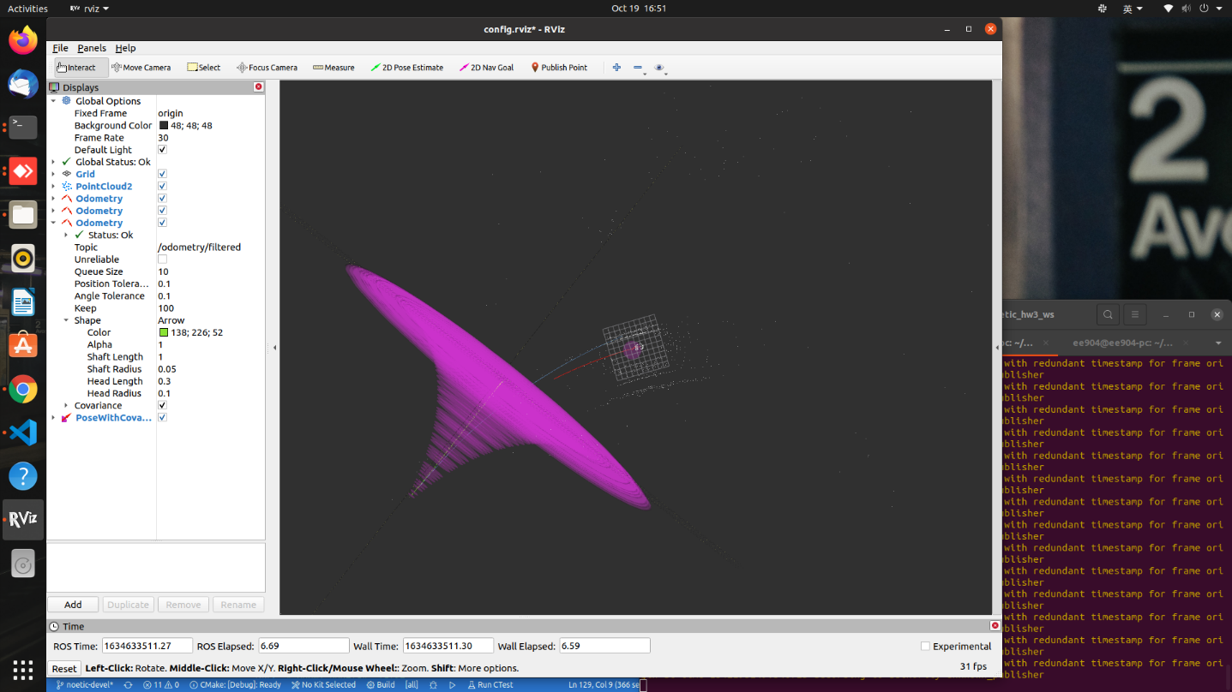**UKF with radar odometry**
3. 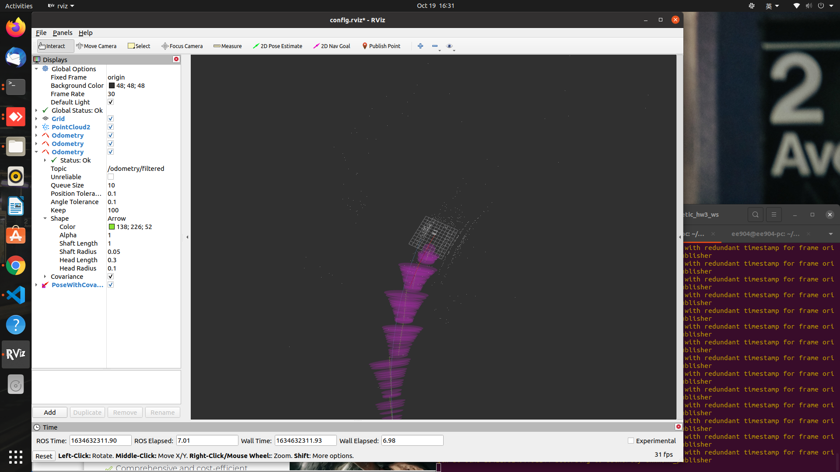**UKF with radar odometry and GPS fusion**