ICP Localization

* 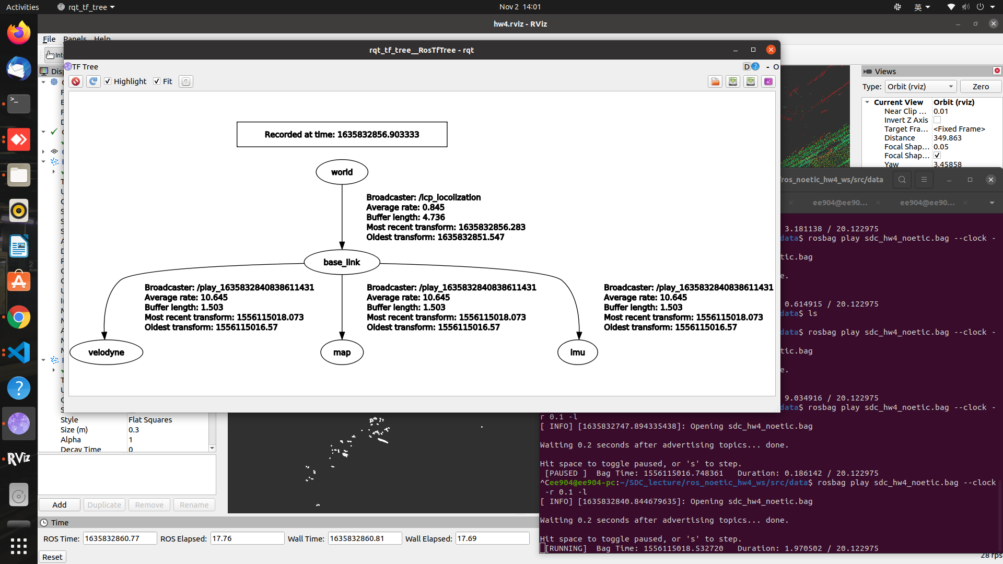**Rqt_tf_tree**
* 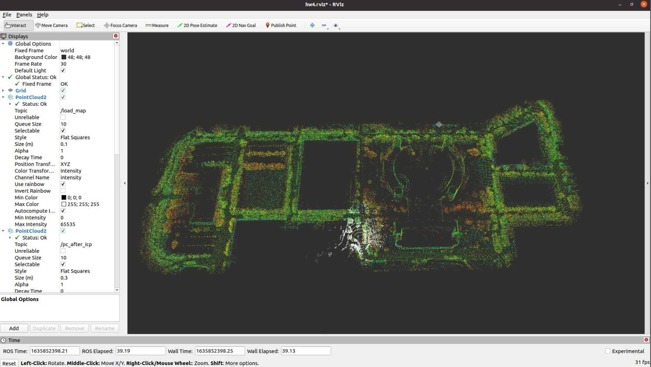**Map point cloud**
* 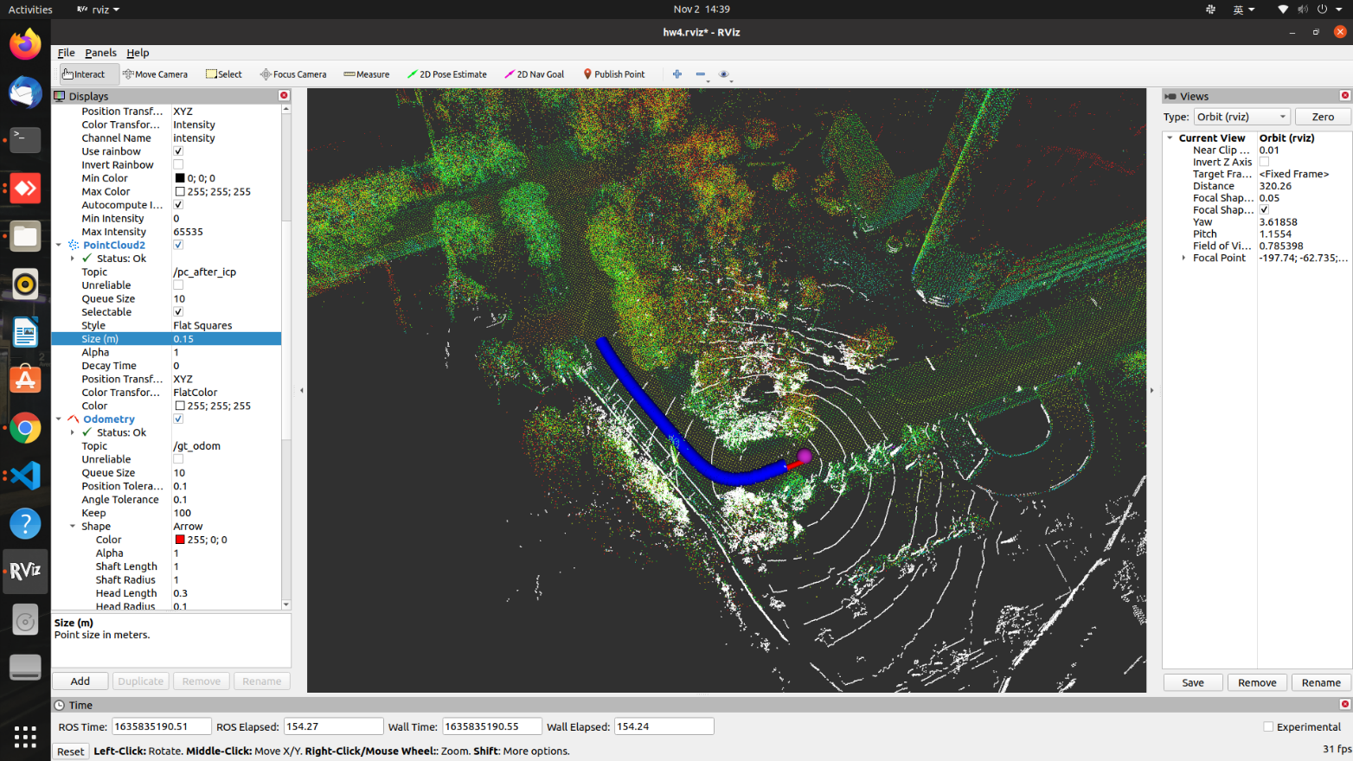**Result of ICP Localization  
    
  Red Arrows**: ground truth odometry  
  **Blue Arrows**: your result  
  **Cyan Dots**: GPS measurements  
  **White Points**: point cloud from LiDAR  
  **Colorful Points**: point cloud map