Student Planner – Functional Specification

Overview

Student Planner is the most robust and comprehensive way for students to organize their university academics.

New

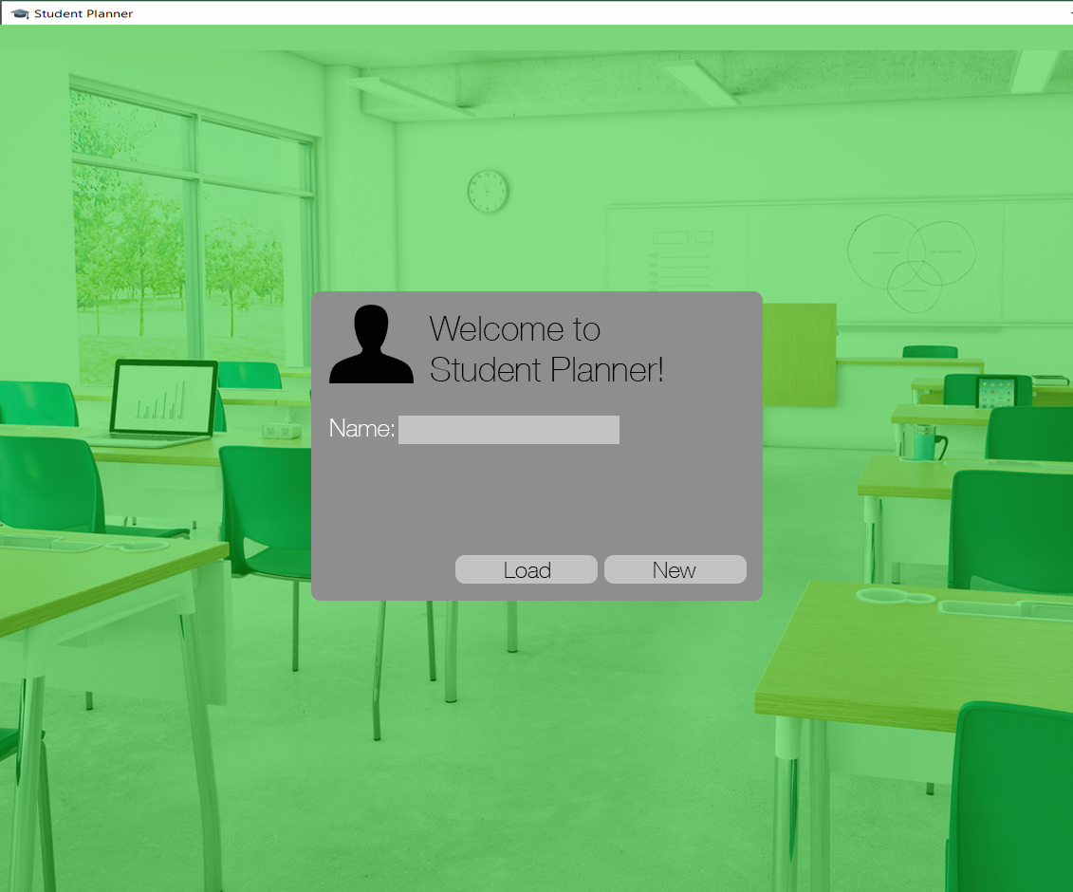

Here the user can enter a name that will be used to identify their profile and create a new profile by pressing “New,” which will take you to Add Terms. “Load” will open a file explorer where an existing profile can be selected and loaded, which will take you to Main – Course Schedule.

Add Terms

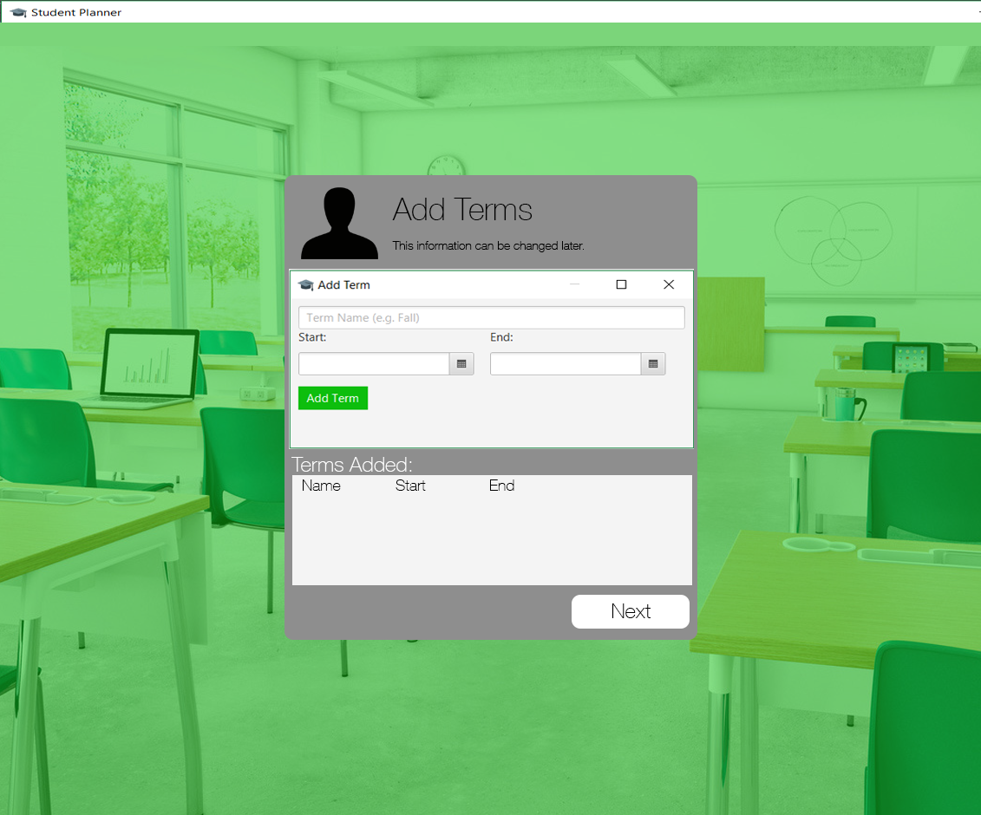

Here the user must enter at least one Term. Clicking “Next” will take you to Add Courses.

Error Conditions:

- Term Name is empty

- Start is after End

I don’t believe a minimum length for a term is required.

These are checked upon the “Add Term” button being clicked. If one or more is violated, an Alert will display all of the conditions violated by the fields provided.

Otherwise, it will be added to the ‘spreadsheet view’ of Terms at the bottom that the profile will initially have.

The user must also specify a colour for the term, which does not need to be unique among the other terms in the Profile.

Add Courses

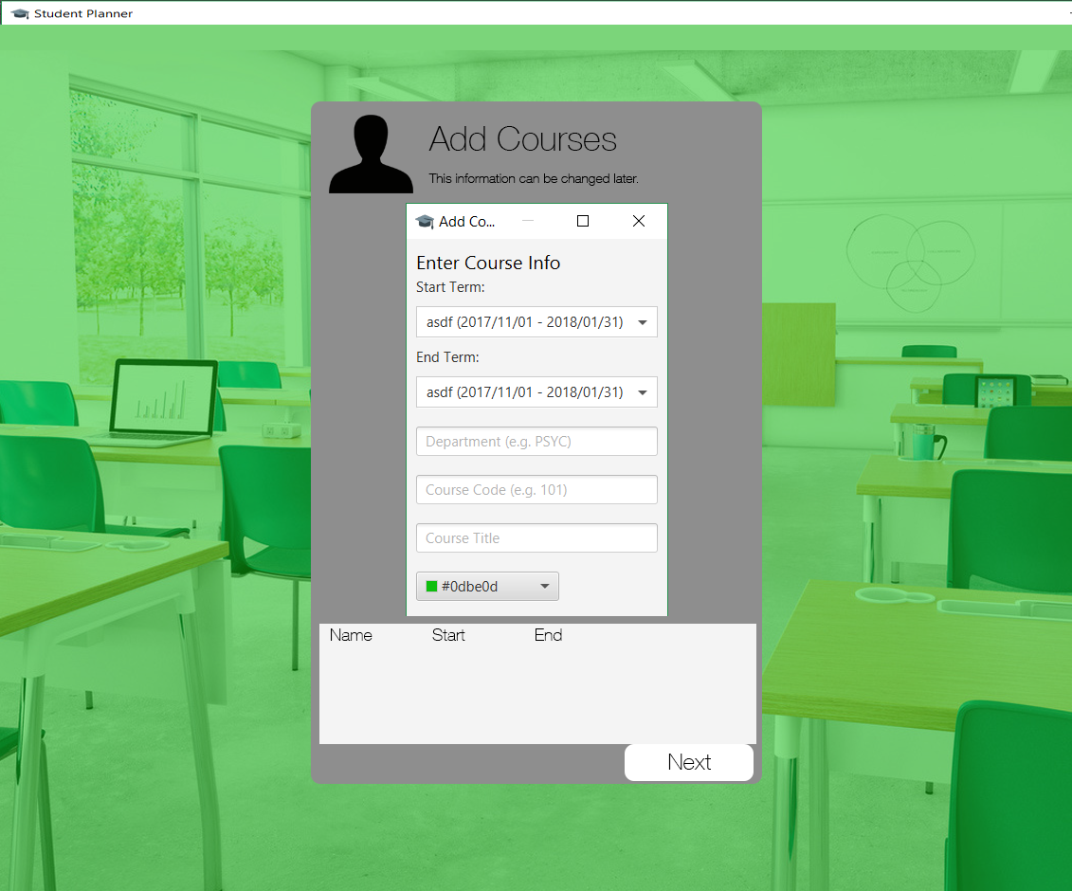
Here the user can any enter number of courses (including zero) before clicking “Next” which will take you to Main – Course Schedule.

Error Conditions:

- Start Term is after End Term

These are checked upon the “Add Course” button being clicked. If one or more is violated, an Alert will display all of the conditions violated by the fields provided.

None of the fields need to be unique among the other courses in the Start or End Term.

Main

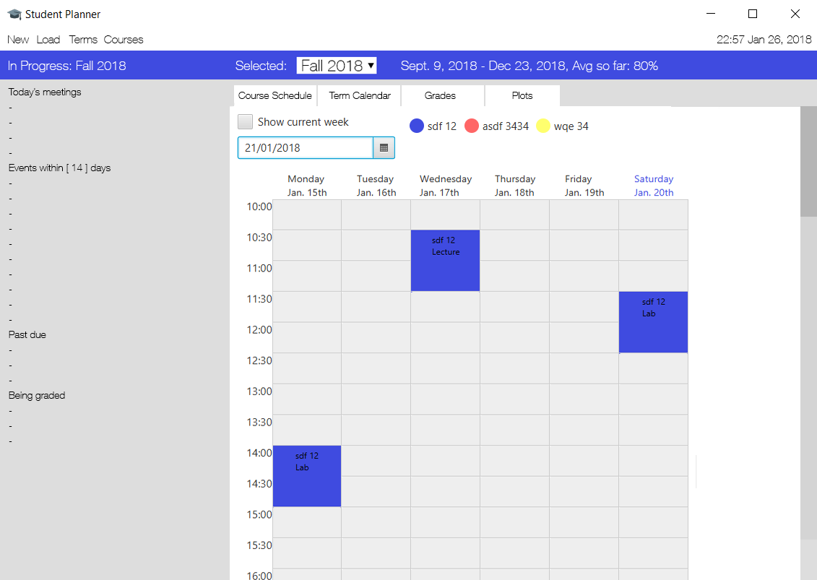
The menu bar contains four options: “New”, “Load”, “Terms”, “Courses”.

“New” takes you to New Profile while “Load” will open a file explorer where an existing profile can be selected and loaded. “Terms” takes you to Terms; “Courses” takes you to Courses.

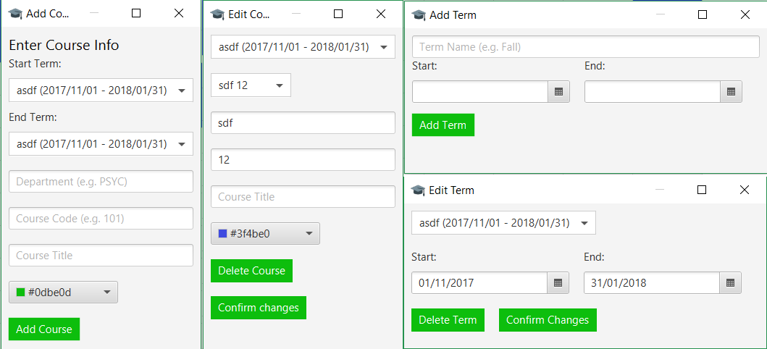
On the left the name of the term that is chronologically in progress will be displayed. Underneath, the following information will be listed:

- “Today’s meetings” lists all of the meetings that are taking place that day.

- “Events within x days” lists all of the events occurring within x days including those in future terms.

- “Past due” shows all of the course-related events with a non-zero weight that have not been marked as Submitted from any term past or present that were due in the past.

- “Being graded” shows all of the course-related events with a non-zero weight that have been marked Submitted but do not have a grade entered for them from any term past or present.

The following views can be selected in the tabbed viewpane on the right: Course Schedule, Term Calendar, Grades, Plots.

By default, alert windows will open when:

- A meeting is 30 minutes away

- An event is 30 minutes away

Course Schedule

The Course Schedule shows the user’s weekly schedule. Any week of the selected term can be shown by selecting a date near the top. There is also a checkbox used to instantly show the current week.

The schedule’s start and end point will adjust based on the meetings entered by the user – the first timeslot will be 30 minutes prior to the user’s first meeting on any day of the week and the last timeslot shown will be 30 minutes after the user’s last meeting on any day of the week.

The user will be able to bring up the Add Meeting window by clicking anywhere on the schedule. The day, start time, and end time of the new meeting will be initially filled out with the timeslot that the user clicked on to add the meeting (rounded to the nearest half hour increment, with a default length of one hour). However, the user will be able to have start and end times for meetings that are any time of day for any length of time (so long as start time < end time). Meetings cannot take place over multiple days.

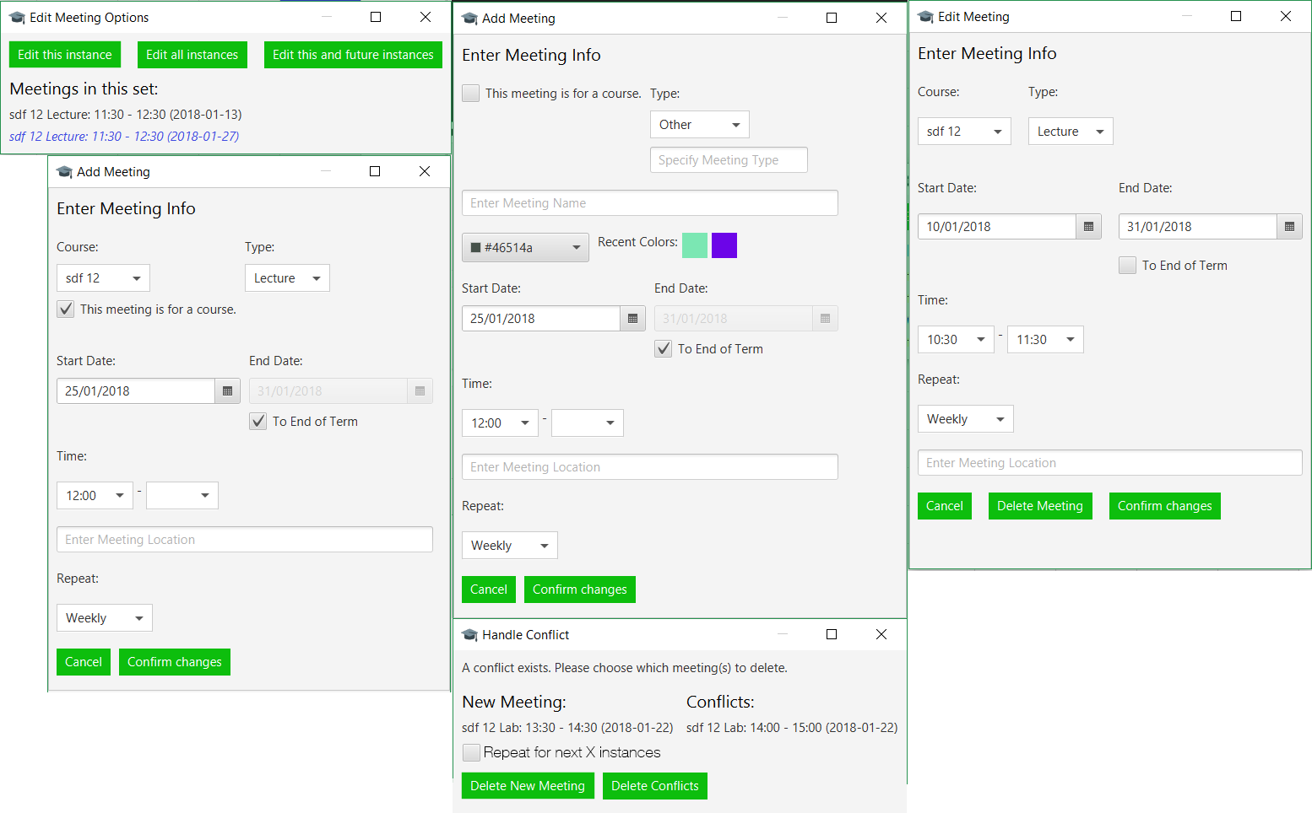
Term Calendar

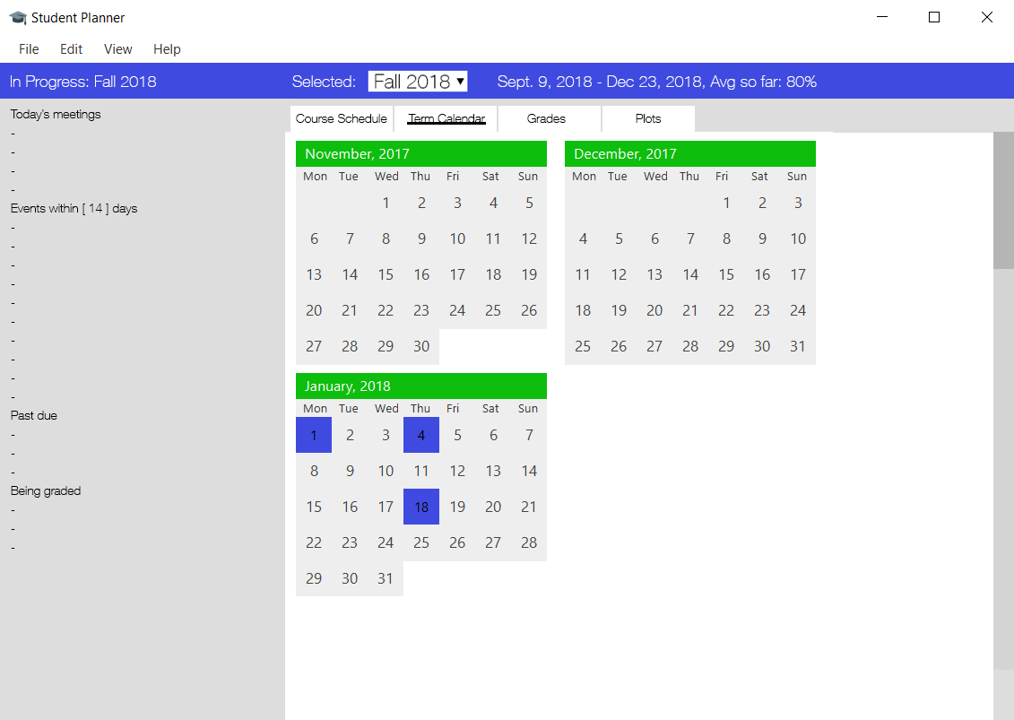
The Term Calendar shows a small calendar of each month in the selected term. Clicking on a date will allow the user to either add an event or edit an existing one on that date.

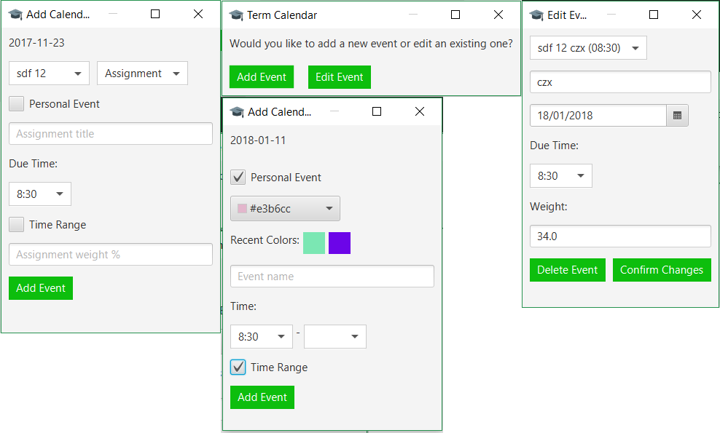
If multiple events take place on a single date, then the colour of the date on the calendar will be that of the event with the greatest weight. There will be a graphical indication that more than one event is present.

Grades

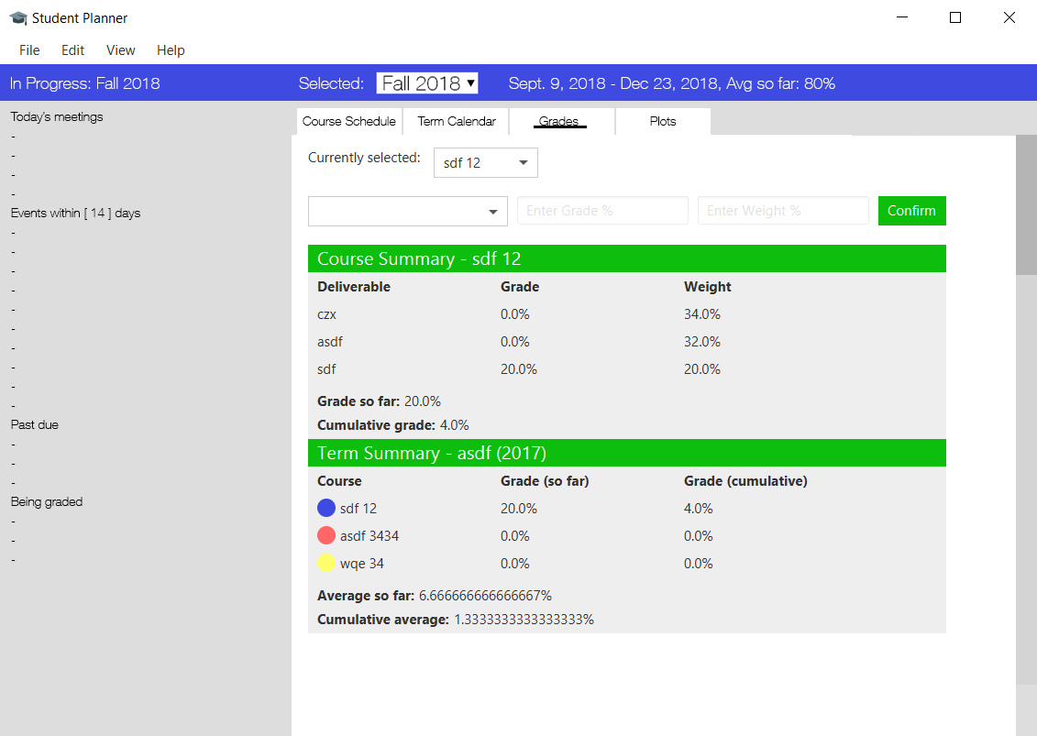
A course that takes place over multiple terms will only count towards its final term’s grade.

Plots

