Student Planner – Functional Specification

Overview

Student Planner is the most robust and comprehensive way for students to organize their university academics.

New Profile

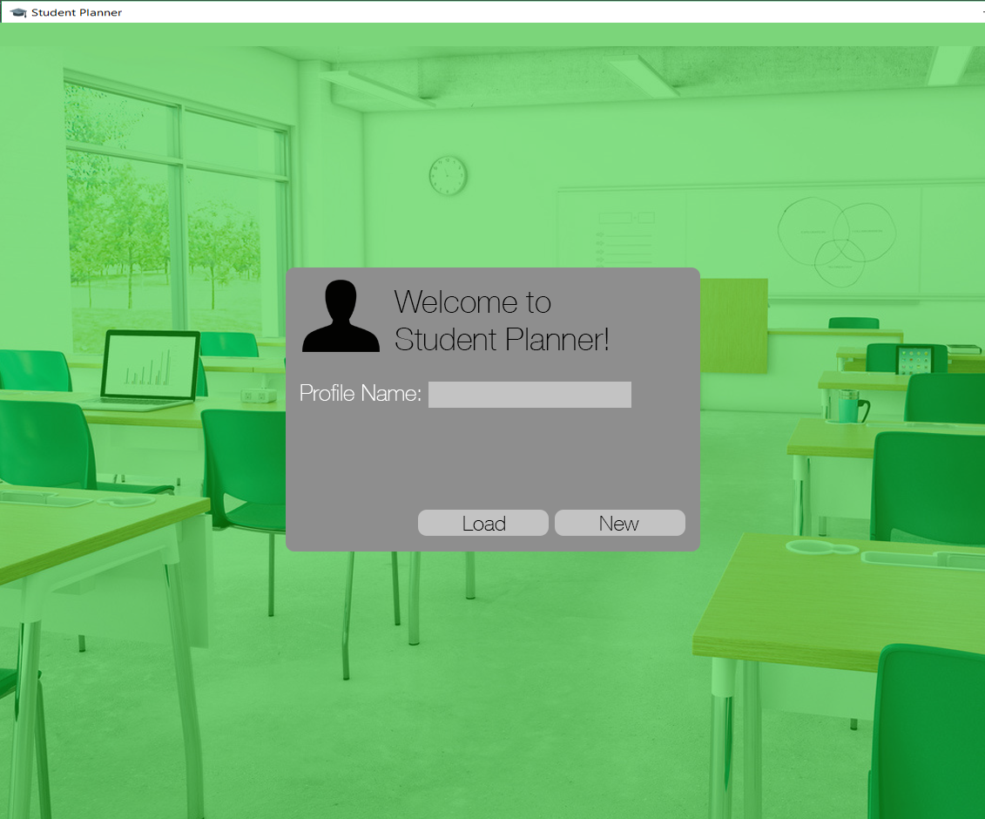

Here the user can enter a name that will be used to identify their profile and create a new profile by pressing “New,” which will take you to Add Terms. “Load” will open a file explorer where an existing profile can be selected and loaded, which will take you to Main – Course Schedule.

Add Terms

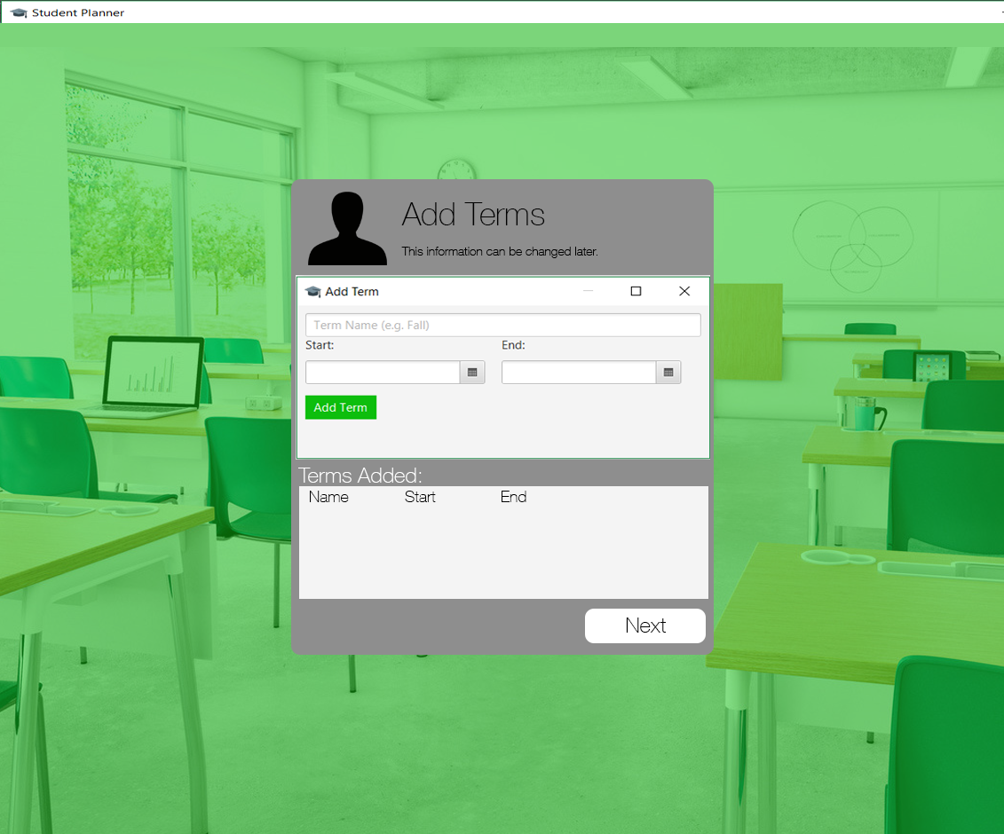

Here the user must enter at least one Term. Clicking “Next” will take you to Add Courses.

Add Courses

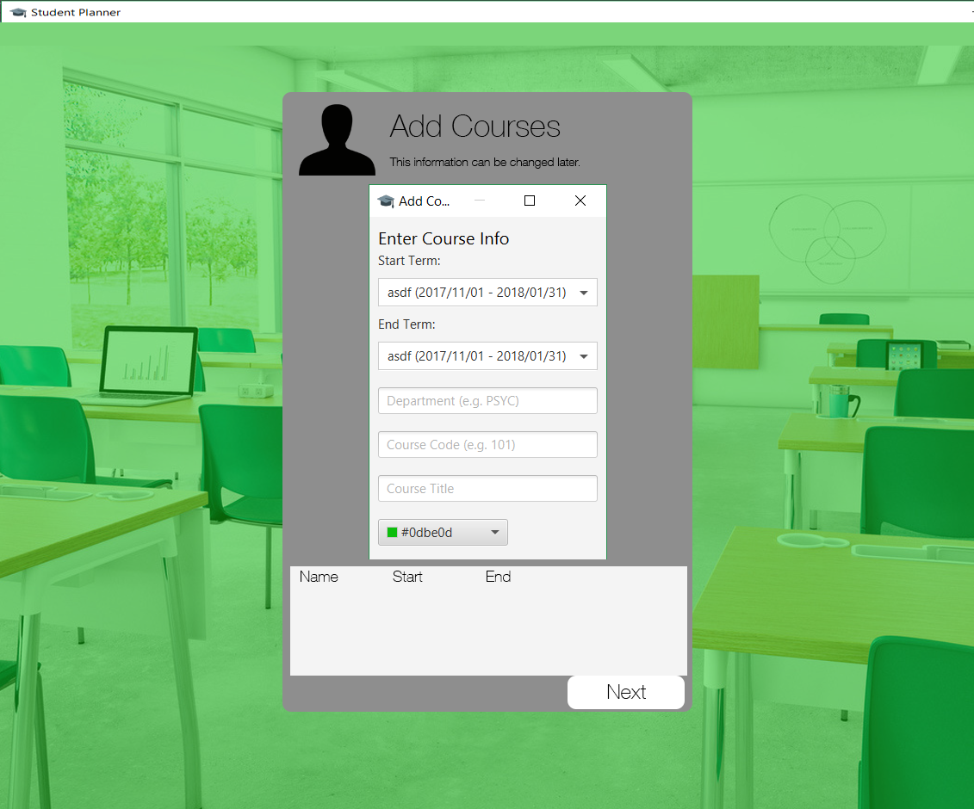

Here the user can any enter number of courses before clicking “Next” which will take you to Main – Course Schedule.

Main

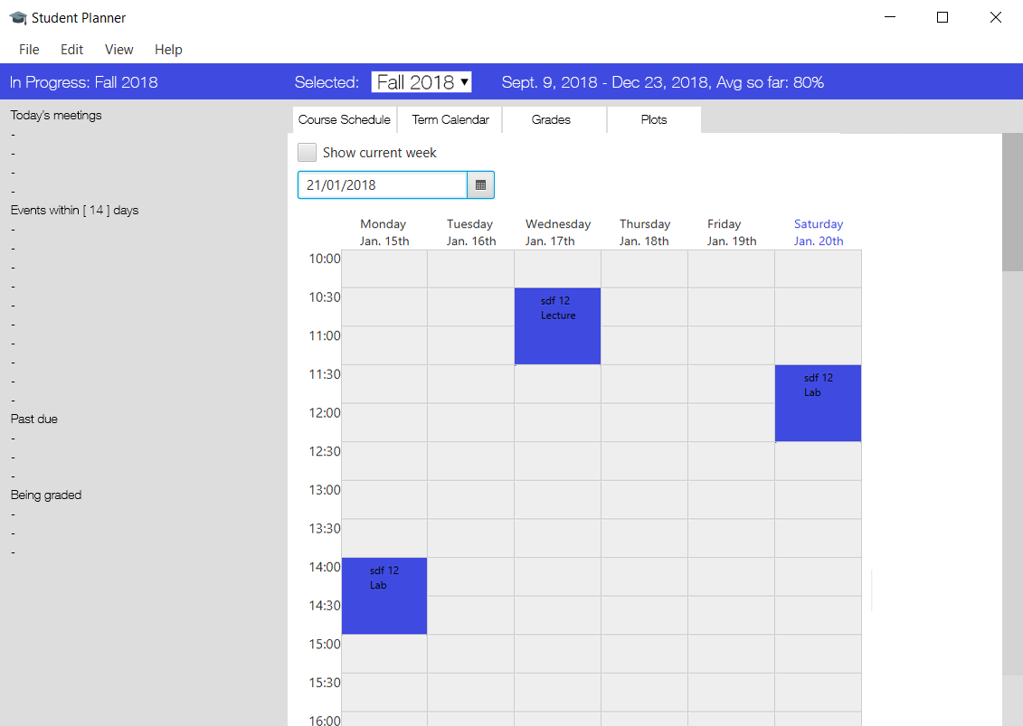
The menu bar contains four dropdown options: File, Edit, View, and Help.

On the left the name of the term that is chronologically in progress will be displayed. Underneath, the following information will be listed:

- “Today’s meetings” lists all of the meetings that are taking place that day.

- “Events within x days” lists all of the events occurring within x days including those in future terms.

- “Past due” shows all of the course-related events with a non-zero weight that have not been marked as Submitted from any term past or present that were due in the past.

- “Being graded” shows all of the course-related events with a non-zero weight that have been marked Submitted but do not have a grade entered for them from any term past or present.

File leads to New Profile, and Load Profile. New Profile takes you to New Profile while “Load Profile” will open a file explorer where an existing profile can be selected and loaded.

Edit leads to Profile, Terms, and Courses. Profile takes you to Edit Profile; Terms takes you to Edit Terms; Courses takes you to Edit Courses.

View leads to Customize. Customize takes you to Customize.

Help leads to Manual. Manual takes you to Manual.

The following views can be selected in the tabbed viewpane on the right: Course Schedule, Term Calendar, Grades, Plots.

By default, alert windows will open when:

- A meeting is 30 minutes away

- An event is 30 minutes away

Course Schedule

The Course Schedule shows the user’s weekly schedule. Any week of the selected term can be shown by selecting a date near the top. There is also a checkbox used to instantly show the current week.

The schedule’s start and end point will adjust based on the meetings entered by the user – the first timeslot will be 30 minutes prior to the user’s first meeting on any day of the week and the last timeslot shown will be 30 minutes after the user’s last meeting on any day of the week.

The user will be able to bring up the Add Meeting window by clicking anywhere on the schedule. The day, start time, and end time of the new meeting will be initially filled out with the timeslot that the user clicked on to add the meeting (rounded to the nearest half hour increment, with a default length of one hour). However, the user will be able to have start and end times for meetings that are any time of day for any length of time (so long as start time < end time). Meetings cannot take place over multiple days.

Term Calendar

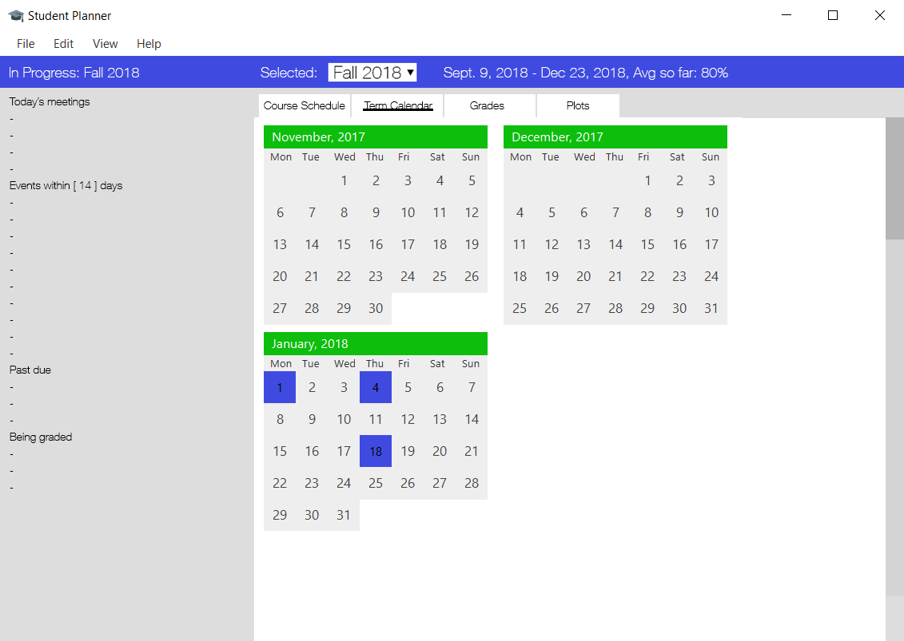
The Term Calendar shows a small calendar of each month in the selected term. Clicking on a date will allow the user to either add an event or edit an existing one on that date.

Grades

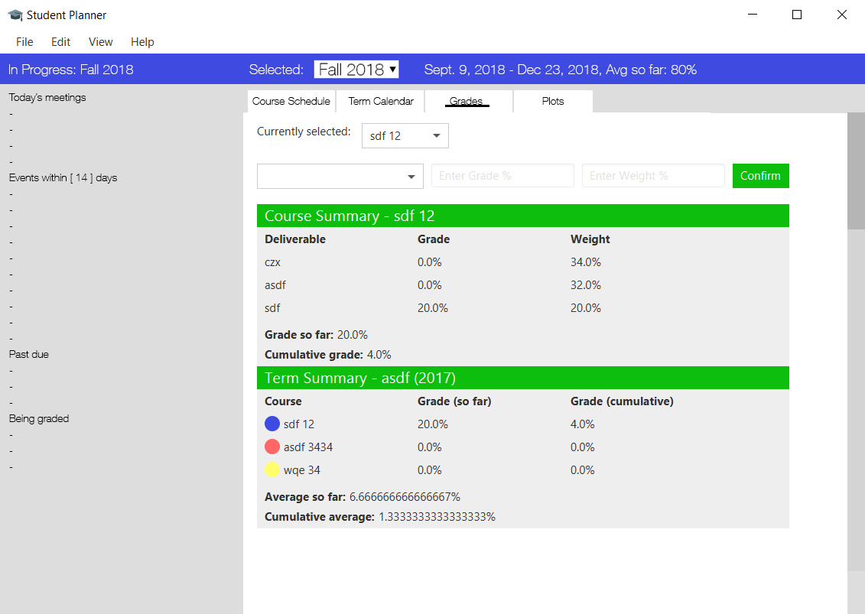

Plots

