Student Planner Functional Specification

Overview

Student Planner is the most robust and comprehensive way for students to organize their university academics.

New

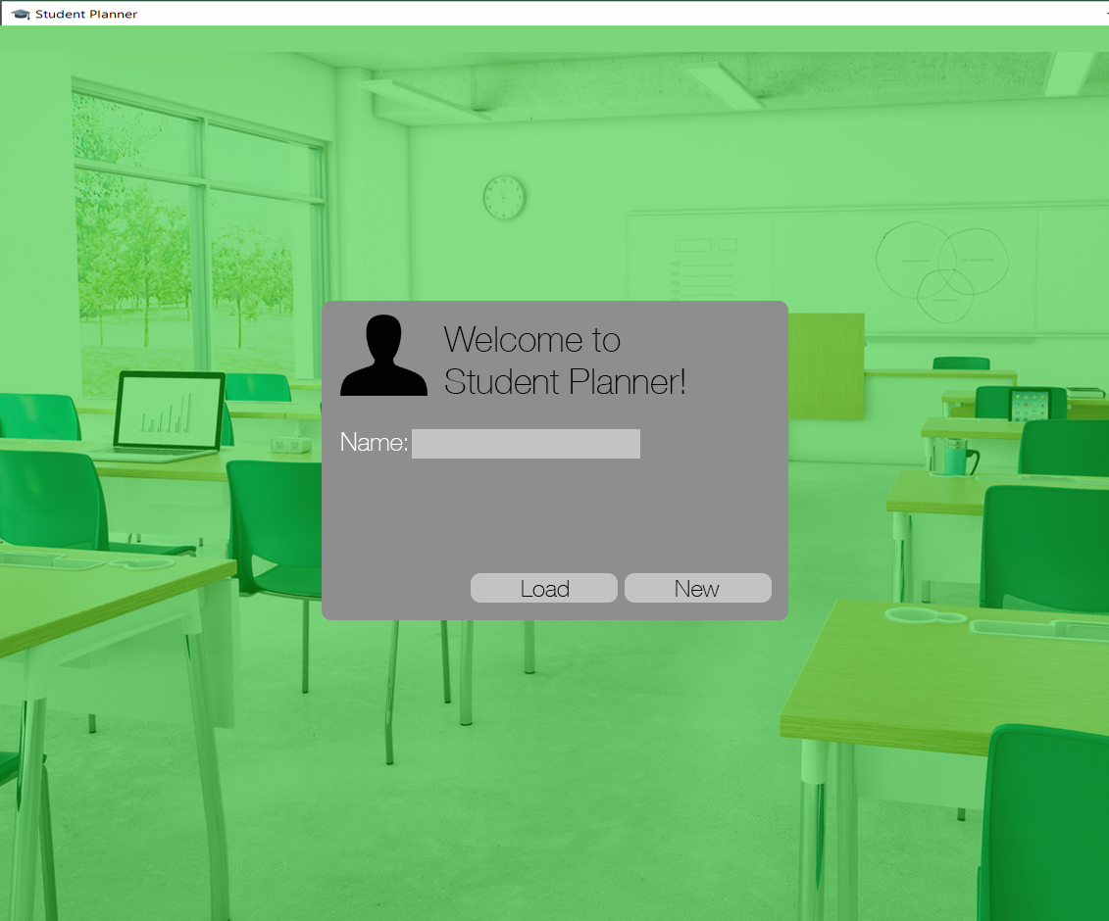

Here the user can enter a name that will be used to identify their profile and create a new profile by pressing “New,” which will take you to Add Terms. “Load” will open a file explorer where an existing profile can be selected and loaded, which will take you to Main – Course Schedule.

If the user came here from clicking on “New” in the Main view, then there will be a “Cancel” button which will take them back to Main with the previously loaded profile.

Add Terms

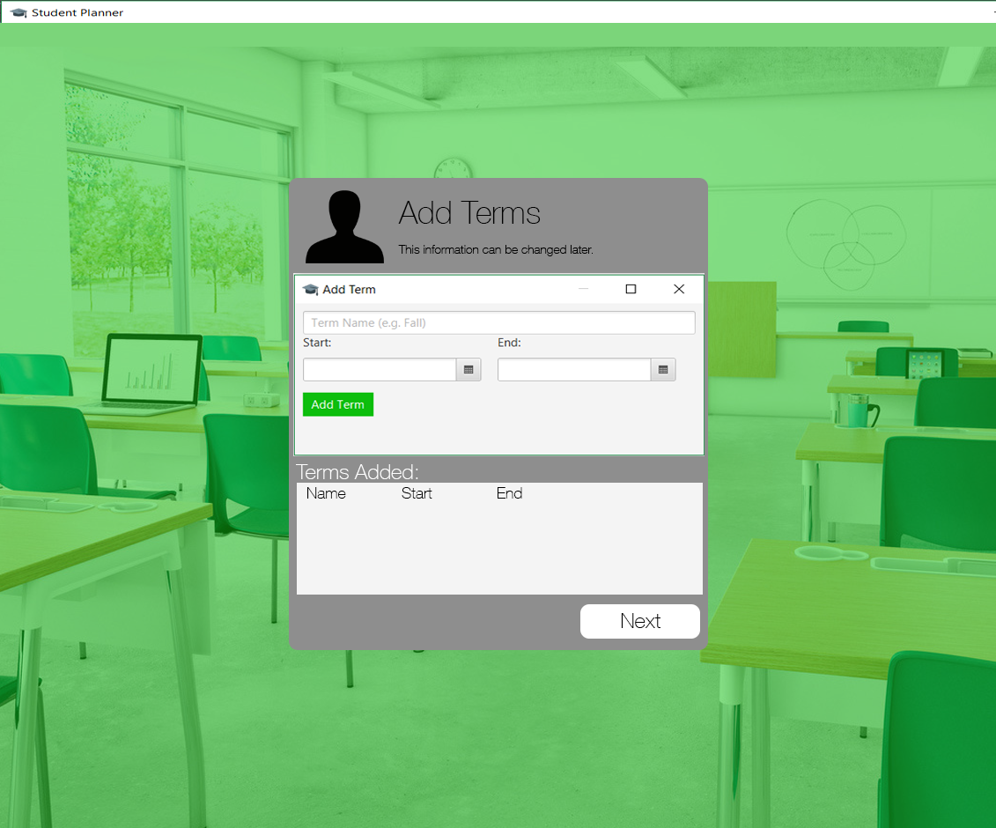

Here the user must enter at least one Term. Clicking “Next” will take you to Add Courses.

Error Conditions:

- Term Name is empty

- Start > End

One-day-long term (i.e. start == end) is accepted input.

These are checked upon the “Add Term” button being clicked. If one or more is violated, an Alert will display all of the conditions violated by the fields provided.

Otherwise, it will be added to the ‘spreadsheet view’ of Terms at the bottom that the profile will initially have.

The user must also specify a colour for the term, which does not need to be unique among the other terms in the Profile.

Add Courses

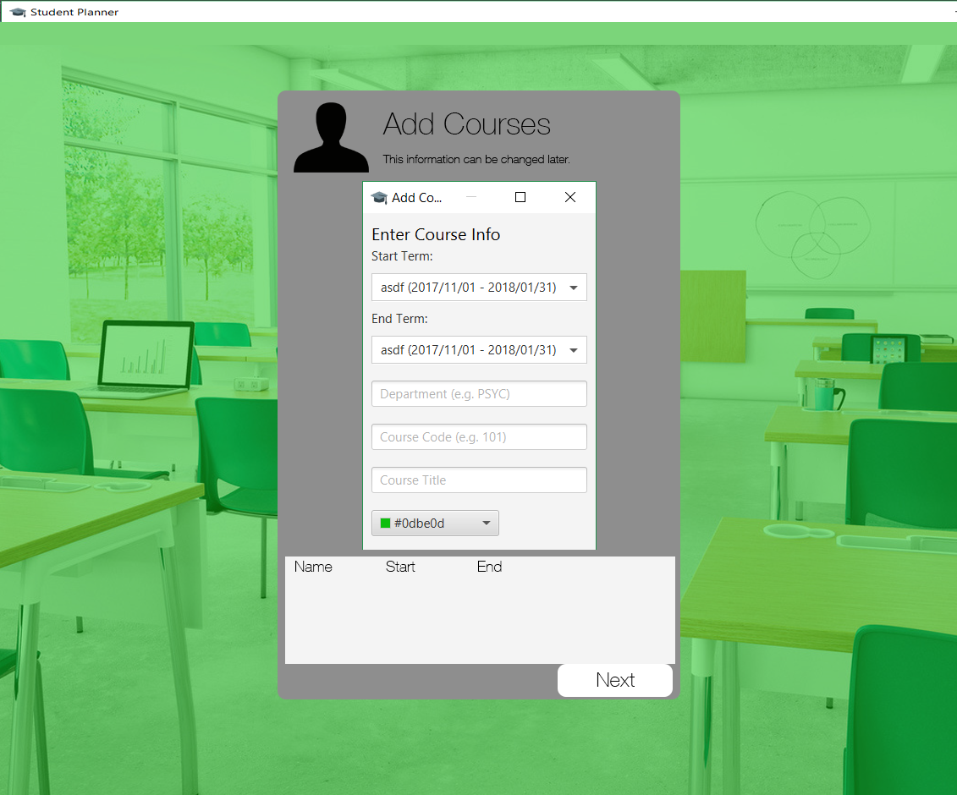
Here the user can any enter number of courses (including zero) before clicking “Next” which will take you to Main – Course Schedule.

Error Conditions:

- Start Term is after End Term
- Another course with same Dept ID + Code already exists between Start & End Terms.

These are checked upon the “Add Course” button being clicked. If one or more is violated, an Alert will display all of the conditions violated by the fields provided.

A course cannot share Dept ID + Code with any other course in the start or end terms, or any term in-between.

Main

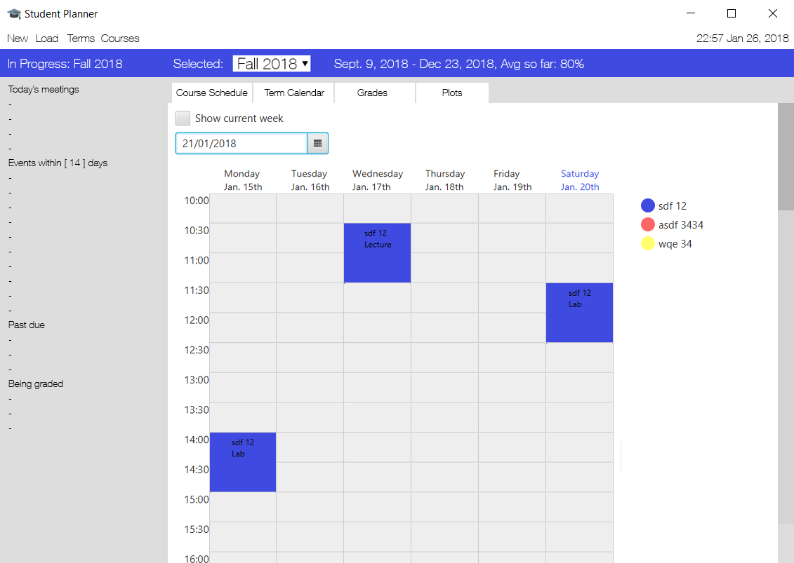
The menu bar contains four options: “New”, “Load”, “Terms”, “Courses”.

“New” takes you to New Profile while “Load” will open a file explorer where an existing profile can be selected and loaded. “Terms” takes you to Terms; “Courses” takes you to Courses.

In Terms and Courses you will be able to override the automatically calculated grade assigned to them. Otherwise, the grades of terms are calculated as the average grade of all of the courses ending in that term, and the grades of courses are calculated from the grades of their course events.

In Terms, you will also be able to create GPA scales and associate them to terms individually (or automatically associate them to all present terms when creating them). When adding a term through this view, you will be able to select a GPA scale in addition to the options seen when starting a new profile. A Term’s length cannot be reduced if any Meetings or CalendarEvents exist in the days that would be removed from the Term.

In Courses, you will be able to create letter grade scales and associate them to courses individually (or automatically associate them to all present courses when creating them). When adding a course through this view, you will be able to select a letter grade scale in addition to the options seen when starting a new profile.

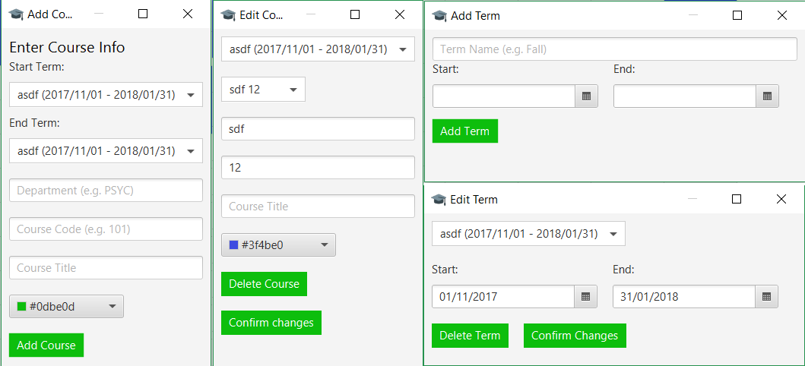
On the left the name of the term that is chronologically in progress will be displayed. Underneath, the following information will be listed:

- “Today’s meetings” lists all of the meetings that are taking place that day.

- “Events within x days” lists all of the events occurring within x days including those in future terms.

- “Past due” shows all of the course-related events with a non-zero weight that have not been marked as Submitted from any term past or present that were due in the past.

- “Being graded” shows all of the course-related events with a non-zero weight that have been marked Submitted but do not have a grade entered for them from any term past or present.

The following views can be selected in the tabbed viewpane on the right: Course Schedule, Term Calendar, Grades, Plots.

By default, alert windows will open when:

- A meeting is 30 minutes away

- An event is 30 minutes away

Course Schedule

The Course Schedule shows the user’s weekly schedule. Any week of the selected term can be shown by selecting a date near the top. There is also a checkbox used to instantly show the current week; this checkbox will only appear if there is a Term that contains the current date (i.e. a Term in progress).

If the user chooses a date that is outside of the currently selected Term’s timeframe:

1. If there is no Term containing that date, an error will be displayed.
2. If a Term does contain that date, then that Term & new date will be selected.

The schedule’s start and end point will adjust based on the meetings entered by the user – the first timeslot will be 30 minutes prior to the user’s first meeting on any day of the week and the last timeslot shown will be 30 minutes after the user’s last meeting on any day of the week.

The user will be able to bring up the Add Meeting window by clicking anywhere on the schedule. The day, start time, and end time of the new meeting will be initially filled out with the timeslot that the user clicked on to add the meeting (rounded to the nearest half hour increment, with a default length of one hour). However, the user will be able to have start and end times for meetings that are any time of day (e.g. a Meeting could start at 3:09pm) for any length of time (so long as start time < end time). Meetings cannot take place over multiple days.

Meetings cannot overlap. If a conflict with a Meeting being added exists, the user will have to delete the new or old Meeting to continue. The user will be asked to decide what to do for each conflict individually, but at each time, will have an option to apply the same decision for all conflicts that have yet to be decided upon (see Handle Conflict window below).

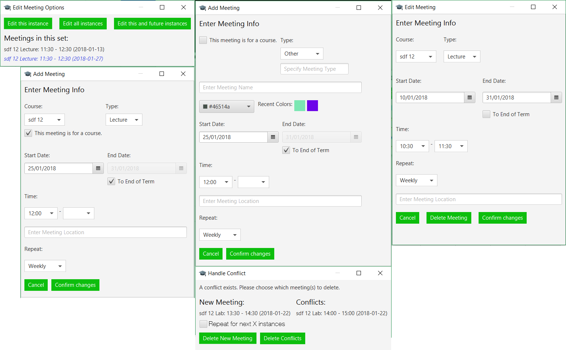
Term Calendar

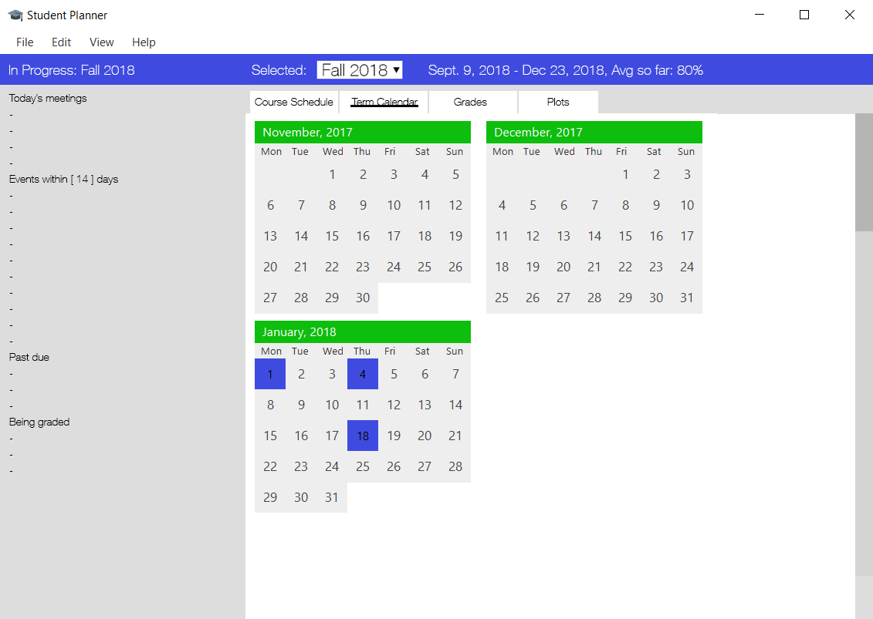
The Term Calendar shows a small calendar of each month in the selected term. Clicking on a date will allow the user to either add an event or edit an existing one on that date.

CalendarEvents can overlap and take place during each other. If multiple events take place on a single date, then the colour of the date on the calendar will be that of the event with the greatest weight. There will be a graphical indication that more than one event is present on that day in the calendar.

Non-CourseEvent CalendarEvents can take place over multiple days, and can be considered “All-Day Events” or have a specific time or time range attached to them. Any CalendarEvent taking place over multiple days will be considered All-Day Events for each of those days.

When adding a CourseEvent, the user can select the Type of CourseEvent they wish to add: “Assignment,” “Test,” or “Other.” Assignments will have a specific “due time” attached to them while Tests will have a time range. If Other is selected, the user can define the name of the type of CourseEvent and whether or not it has a specific due time or time range attached to it. CourseEvents cannot take place over multiple days or be All-Day Events.

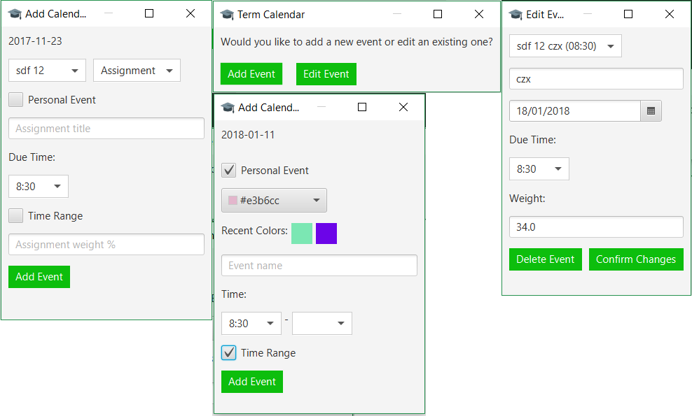
Grades

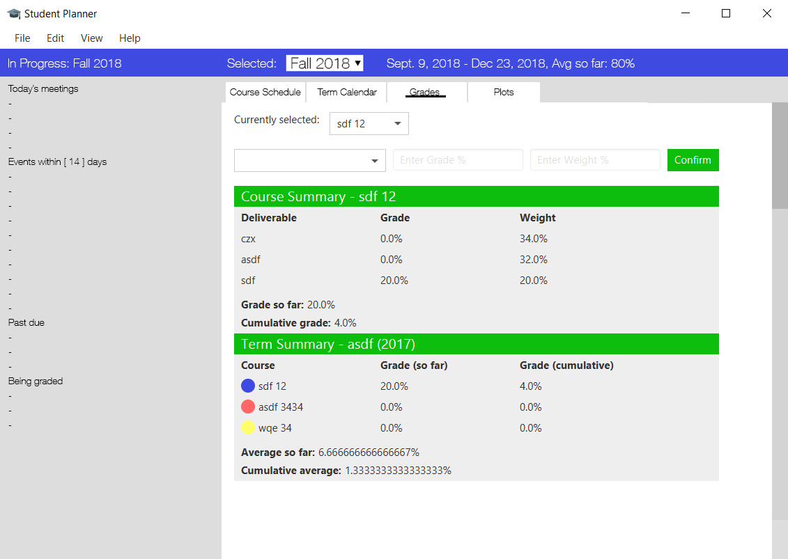
A course that takes place over multiple terms will only count towards its final term’s grade.

Plots

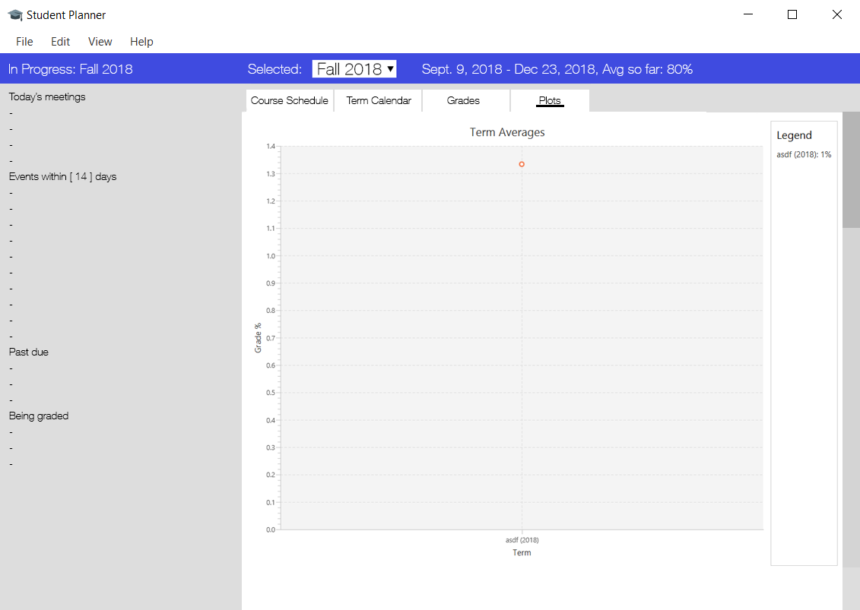
Misc

The planner will launch as 1024 x 768 but can be resized to any size; when the program is restarted, it will start up as the size last set by the user.

When views are changed, they should appear as the current size of the window.

