Exploring Estimators

Derek Sonderegger

11/19/2018

## ── Attaching packages ───────────────────────────────────────── tidyverse 1.2.1 ──

## ✔ ggplot2 3.1.0 ✔ purrr 0.2.5  
## ✔ tibble 1.4.2 ✔ dplyr 0.7.8  
## ✔ tidyr 0.8.2 ✔ stringr 1.3.1  
## ✔ readr 1.1.1 ✔ forcats 0.3.0

## ── Conflicts ──────────────────────────────────────────── tidyverse_conflicts() ──  
## ✖ dplyr::filter() masks stats::filter()  
## ✖ dplyr::lag() masks stats::lag()

We have observed clusters of *C. diff.* patients. For each cluster, we let $c_{i}$ represent the number of patients in the cluster that have HAI. For this simulation, we assume that this number is the number of patients in the cluster $n_{i}$ minus 1. So we assume $c_{i}=n_{i}−1$. Notice that $c_{i}$ can take on values of $0,1,2,…$.

To create a population to sample from, we will model $c_{i}$ being random variables from a Poisson($λ$) distribution, and thus $n_{i}$ are random variables from a shifted Poisson distribution with a shift of $+1$.

Full.Data <- generate_population(n=1000, lambda=2) #   
Full.Data %>%  
 count(Aquired) %>%  
 mutate(proportion = n/sum(n))

## # A tibble: 2 x 3  
## Aquired n proportion  
## <chr> <int> <dbl>  
## 1 Community 416 0.416  
## 2 Hospital 584 0.584

Full.Data %>%  
 count(clusterID) %>% rename(clusterSize = n) %>% # How many patients in each cluster  
 count(clusterSize) %>% rename(numClusters = n) %>% # How many clusters in each cluster size  
 mutate(numCommunity = numClusters ,  
 numHAI = numClusters * (clusterSize-1),  
 numPatients = numCommunity + numHAI )

## # A tibble: 8 x 5  
## clusterSize numClusters numCommunity numHAI numPatients  
## <int> <int> <int> <dbl> <dbl>  
## 1 1 121 121 0 121  
## 2 2 124 124 124 248  
## 3 3 91 91 182 273  
## 4 4 52 52 156 208  
## 5 5 22 22 88 110  
## 6 6 3 3 15 18  
## 7 7 2 2 12 14  
## 8 8 1 1 7 8

# Create the Sampled Data sets  
frac_sampled <- 1.0  
Sample.Data <- Full.Data %>%  
 sample_frac(frac_sampled, replace = FALSE)

# If the population acutally is actually Poisson distributed  
# then we really need 30% sampling or more to actually get any accuracy  
n <- 1000  
N <- 50  
sample_frac = .4  
lambda_range=seq(.5,8, by=.1)  
  
out <- NULL  
for( sample_frac in c(.1, .2, .3, .4, .6, .8, 1) ){  
 for( lambda in lambda_range ){  
 for( i in 1:N ){  
 Full.Data <- generate_population(n, lambda)  
 Sample.Data <- Full.Data %>% sample_frac(sample_frac, replace = FALSE)   
 True.HAI <- Full.Data %>% filter(Aquired == 'Hospital') %>% nrow(.)/nrow(Full.Data)  
 Obs.HAI <-   
 Sample.Data %>%   
 group_by(clusterID) %>% count() %>%   
 mutate(n = n-1) %>% ungroup() %>%   
 summarise(HAI = sum(n)) %>% pull(HAI)  
 proportion <- Obs.HAI / nrow(Full.Data)  
 out <- rbind(out, data.frame(lambda=lambda, n=n, sample_frac=sample_frac, Obs.HAI.rate=proportion, True.HAI.rate = True.HAI))  
 }   
 }  
}  
Poisson <- out  
usethis::use_data(Poisson)

ggplot(Poisson, aes(x=Obs.HAI.rate, y=True.HAI.rate)) +   
 geom_point(alpha=.5) +  
 facet_grid(. ~ sample_frac, scales='free' ) +  
 labs(x='Observed HAI rate', y='True HAI rate') +   
 ggtitle('Poisson: Observed HAI rate vs Truth, by sampling fraction')

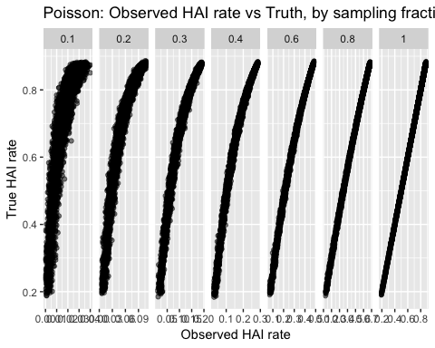

# If the population acutally is Poisson distributed mixed with logNormal  
n <- 1000  
N <- 50  
sample_frac = .4  
lambda <- 2  
lambda_range=seq(.5,8, by=.1)  
  
out <- NULL  
for( sample_frac in c(.1, .2, .3, .4, .6, .8, 1) ){  
 for( lambda in lambda_range ){  
 for( i in 1:N ){  
 Full.Data <- generate_population(n, lambda, mixed=TRUE, mix.proportion = .01)  
 Sample.Data <- Full.Data %>% sample_frac(sample_frac, replace = FALSE)   
 True.HAI <- Full.Data %>% filter(Aquired == 'Hospital') %>% nrow(.)/nrow(Full.Data)  
 Obs.HAI <-   
 Sample.Data %>%   
 group_by(clusterID) %>% count() %>%   
 mutate(n = n-1) %>% ungroup() %>%   
 summarise(HAI = sum(n)) %>% pull(HAI)  
 proportion <- Obs.HAI / nrow(Full.Data)  
 out <- rbind(out, data.frame(lambda=lambda, n=n, sample_frac=sample_frac, Obs.HAI.rate=proportion, True.HAI.rate = True.HAI))  
 }   
 }  
}  
Mixed <- out  
usethis::use_data(Mixed)

ggplot(Mixed, aes(x=Obs.HAI.rate, y=True.HAI.rate)) +   
 geom_point(alpha=.5) +  
 facet_grid(. ~ sample_frac, scales='free' ) +  
 labs(x='Observed HAI rate', y='True HAI rate') +   
 ggtitle('Mixed: Observed HAI rate vs Truth, by sampling fraction')

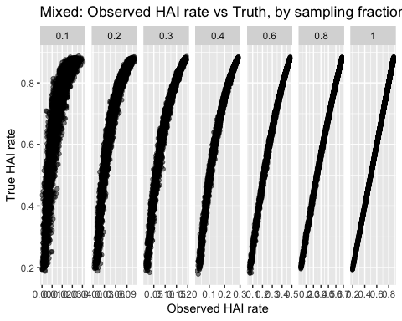

# # Can we use the Conway-Maxwell Poisson distribution?  
# df <- Sample.Data %>%  
# group_by(clusterID) %>% count() %>% rename(clusterSize = n)   
# library(glmmTMB)  
# model <- glmmTMB(clusterSize ~ 1, data=df, family=truncated_compois)  
# confint(model)[1,] %>% exp()  
# # This fails as the sampling fraction gets small < 0.4. So unless I  
# # can figure out how to specify the weighting fraction. Basically  
# # we must use that we know the sampling fraction.

# Full.Data <- generate_population(n=1000, lambda=2) #   
# Full.Data %>%  
# count(Aquired) %>%  
# mutate(proportion = n/sum(n))  
#   
# Full.Data %>%  
# count(clusterID) %>% rename(clusterSize = n) %>% # How many patients in each cluster  
# count(clusterSize) %>% rename(numClusters = n) %>% # How many clusters in each cluster size  
# mutate(numCommunity = numClusters ,  
# numHAI = numClusters * (clusterSize-1),  
# numPatients = numCommunity + numHAI )

# I created a Poisson distribution that truncates and, via weighting,  
# we also account for the sampling schemes.  
  
# Create the Sampled Data sets  
# Full.Data <- generate_population(n=2000, lambda=2) #   
# frac_sampled <- .2  
# Sample.Data <- Full.Data %>%  
# sample_frac(frac_sampled, replace = FALSE) %>%  
# arrange(clusterID)  
# df <- Sample.Data %>%  
# group_by(clusterID) %>% count() %>% rename(clusterSize = n) %>%  
# mutate(HAI = clusterSize - 1)  
#   
# temp <- Vectorize(function(lambda){  
# out <- dtruncated_weighted_poisson(  
# x=df$clusterSize, lambda=lambda,  
# N = nrow(Full.Data), n=nrow(Sample.Data), log=TRUE )  
# # out <- dweighted_poisson(  
# # x=df$HAI, lambda=lambda,  
# # N = nrow(Full.Data), n=nrow(Sample.Data), log=TRUE )  
#   
# out <- sum(out)   
# return(out)  
# })  
#   
# data.frame( lambda = seq(0.1, 4, by=.1) ) %>%  
# mutate( loglikelihood = temp(lambda) ) %>%  
# ggplot( aes(x=lambda, y=loglikelihood) ) +  
# geom_line() + geom_point()  
#   
# optimize(temp, c(0,4), maximum = TRUE )