Measuring Hospital Acquired Infection Rates under Incomplete Sampling

Derek Sonderegger, Jason Sahl, and Paul Keim

2019-05-20

## Abstract

*Clostridioides difficile* is a diarrheagenic pathogen often associated with healthcare-acquired infections and is a common secondary infection in patients on strong antibiotic therapy. Identifying if the pathogen was already present in/on the patient versus first encountered at the healthcare facility and due to a transmission between patients has monetary implications in regard to U.S. Medicare reimbursements as well as informing clinical sanitation procedures. By genotyping *C. diff* disease strains among all patients with the disease, we could detect transmission events between patients therefore calculate the HAI rate. Because genotyping strains from every *C. diff* positive patient would be prohibitively expensive, we consider various levels of sampling effort and demonstrate that the sample HAI rate is an underestimate of the population HAI rate and propose a bias-correction procedure. We apply the the bias-corrected estimator to two clinical populations where nearly the full population was genotyped as well as to simulated population. The bias-corrected estimator appears to work well but performance degrades as sampling and transmission percentages decrease.

## Introduction

*Clostridioides difficile* is a ubiquitous, diarrheagenic, bacterial pathogen often associated with healthcare-acquired infections (HAIs) that can cause a range of symptoms from mild, self-limiting disease to toxic megacolon and death. Treatment for symptomatic *C. diff* infections is an antibiotic course of metronidazole, vancomycin, or fidaxomicin. Individuals carrying *C. diff* in their dermis or gastro-intestinal tract can remain asymptomatic due to competitive pressures in the microbiome. Because *C. diff* displays a wide range of antibiotic resistance, when patients are treated with antibiotics to address another infection, the competitive suppression of *C. diff* is removed and the patient endures a secondary infection. Alternatively, the patient undergoing an antibiotic course at a healthcare facility might first be exposed to *C. diff* at the facility.

The different sources of *C. diff* has substantial implications to the healthcare facility. In the United States, Medicare reimbursement rates are informed by the facilities overall rate of HAIs with incentives and penalties up to $±1\%$ which could be millions dollars (???) for a mid-sized regional hospital. If patients are primarily encountering *C. diff* within the facility, then sanitation procedures within the hospital could affect the HAI rate providers should be concerned about strains endemic to the healthcare facility developing resistance to the treatment course. If patients are bringing the pathogen, then options for reducing HAI rates are substantially reduced.

Phylogenetic studies utilizing whole genome sequencing have investigated the spread of fluoroquinolone-resistant strains of *C. diff* (CITATION). These same techniques can identify clustering of strains within a healthcare facility versus those present in the environment outside the facility. The methods in this paper require an initial clustering step that classifies patients into clusters, where a cluster contains at least one patient. If all $N$ patients bring their own strain into the facility, then we should observe $N$ different clusters, each with a cluster size of one. Conversely, if all the infections are a result of a single *C. diff* source, we would observe a single cluster with a cluster size of $N$.

Medicare defines a *C. diff* case as being a HAI if the diagnosis occurs more than three days after admittance. In this paper, we will instead define case as healthcare-acquired if there is evidence that it occurred via a patient-to-patient transmission. We define a healthcare facility’s *C. diff* HAI rate as the ratio of patient-to-patient transmissions to the total number of $C.diff$ cases.

The problem of detecting patient-to-patient transmission could be considered as a network graph problem with each patient denoted by a vertex and a transmission as an edge. However, most network graph analysis methods assume that the graph is fully known and informally most network analysis experts recommend needing at least $80\%$ of the nodes/edges being observed. In our context, there are $N$ nodes and $N×N$ possible edges, but most of those edges are unobserved.

## Materials and Methods

#### Data Sources: Clinical

Eyre *et al* (2013) [1] describes a study in Oxfordshire, United Kingdom where they genotyped nearly all cases of *Clostridium difficile* infections in Oxfordshire. Using single-nucleotide polymorphisms (SNPs), they created clusters of infection lineages by grouping cases that differed by two or fewer SNPs using complete linkage clustering. Most (536 / 811 = 66%), of the patients where in a cluster by themselves, i.e. their *C.difficile* case was more than two SNPs different than all other cases. Another 28% of the patients were in cluster groups between 2-13 and 50 patients (6%) were in one large cluster.

Eyre *et al* [1] justified their choice of $≤2$ SNPs differences by looking at within patient differences, but the cluster size distributions were not sensitive to small changes in this threshold, but the extreme choice of a threshold of 10 SNPs differences results in an additional large cluster of 29 patients.

Flagstaff Medical Center, a regional hospital in Northern Arizona, attempted to collect samples from every *C. diff* case that was diagnosed from **20XX-20XX**. The samples were genotyped at PMI and we again used the two SNP differences to define clusters.

#### Data Sources: Simulated Populations

Both the Oxfordshire and Flagstaff data could be reasonably modeled using a mixture of two distributions to separate the small clusters sizes from the large. We chose to model the small clusters sizes using a truncated Poisson distribution with the zero truncated out. The large cluster sizes were modeled from a discretized logNormal distribution.

$$n_{i}|λ∼TPoisson(λ) with probability ρ$$

$$n_{i}|λ∼logNormal(μ,σ) with probability 1−ρ$$

for $i$ in $I$.

#### Estimators

First we denote $N$ as the total number of patients, and $α$ as the proportion of patients that are sampled (therefore $αN$ patients are randomly sampled). We define $n_{i}$ be the true size of the $i$ th cluster, and $m_{i}$ as the observed size of the $i$ th cluster. We denote the total number of clusters in the population as $||I||$ where $I$ is the set of cluster indices. Because $||I||$ can be thought of as the number of non-HAI cases, defining the true HAI rate as $γ$ we have

$$γ=\frac{N−||I||}{N}=1−\frac{||I||}{N}$$

We first consider the simplest data generating model of latent cluster sizes

$$n_{i}\overset{iid}{∼}TPoisson(λ) for i∈I$$

Regardless of how the cluster sizes $n_{i}$ are generated, the simple random sampling results

$$m_{i}|n_{i}∼ZTHyperGeometric(n_{i}, N−n_{i}, αN) for i∈I$$

where $I$ is a subset of $I$ and the ZT represents the zero truncated out. This distribution is subject to the requirement that $∑m_{i}=αN$, but because in the clinical examples, the number of clusters is quite high, the correlation between any two clusters is small and we chose to ignore this and assume independence among the $m_{i}|n_{i}$ observations.

Results for the zero truncated hypergeometric distribution rely of knowing, or approximating, the hypergeometric distribution probability of observing a zero

$$f(0|n_{i})=\frac{\left({n_{i} \atop 0}\right)\left({N−n_{i} \atop αN}\right)}{\left({N \atop αN}\right)}$$

Notice that $α$ and $f(0|n_{i})$ are inversely related and we could crudely approximate

$$f(0|n_{i})≈1−α$$

Furthermore

$$E[m_{i}]=E[E(m_{i}|n_{i})]=E[(1−f(0|n_{i}))^{−1} α n_{i}]$$

Utilizing this information, can derive two different estimators for $n_{i}$.

1. The plug-in estimator that ignores the RHS expectation, and approximates ${\left[1−f(0)\right]}^{−1}≈α^{−1}$. This results in ${\overset{̂}{n}}_{i}=m_{i}$.
2. Ignoring the expectations, we could utilize the actual hypergeometric function for $f(0|n_{i})$ and solve the following equation for ${\overset{̂}{n}}_{i}$. This solution needs to be solved via numerical methods because the “chooses” in $f(0|{\overset{̂}{n}}_{i})$.

$$m_{i}=(1−f(0|{\overset{̂}{n}}_{i}))^{−1} α {\overset{̂}{n}}_{i}$$

Regardless of which method is used to estimate ${\overset{̂}{n}}_{i}$, then denoting $\overset{̂}{n}=∑{\overset{̂}{n}}_{i}$, a reasonable estimate for the HAI rate is



Initial testing of this estimator demonstrated a significant bias and we use a bias correction scheme to correct it. First, we repeatedly sub-sample at $α$ rate $J$ times and calculating ${\overset{̂}{γ}}_{j}^{*}$ for the $j$ th sub-sample. For notational convenience, define $ξ$ as the logit transformed $γ$ value, with similar transformation for all index variations, for example ${\overset{̂}{ξ}}_{j}^{*}=logit({\overset{̂}{γ}}_{j}^{*})$. Finally we do the bias correction

$$\overset{̂}{ξ}={\overset{̂}{ξ}}^{*}+\frac{1}{J}∑\left({\overset{̂}{ξ}}^{*}−{\overset{̂}{ξ}}_{j}^{*}\right)$$

We performed the bias correction step on the logit scale to ensure the resulting estimator is in $[0,1]$.

The bias correction step also provides an estimate of the standard error of $\overset{̂}{ξ}$ as the standard deviation of the ${\overset{̂}{ξ}}_{j}^{*}$ values. An approximate $95\%$ confidence interval for $ξ$ we use

$$\overset{̂}{ξ}±Z_{0.975} StdDev({\overset{̂}{ξ}}_{j}^{*})$$

If the subsample has no clusters with more than one patient, then ${\overset{̂}{γ}}_{i}^{*}=0$. If all of the subsamples have this problem, we don’t do any bias correction.

Notice that the calculations that resulted in this estimator do not depend on the distribution of $n_{i}$ and therefore should be applicable across a wide variety of data generating scenarios.

#### Methods

For clinical data, we repeatedly sample at five different sampling intensities (20, 40, 60, 80 and 100%) and the apply both the plug-in and hypergeometric estimators to the sampled data. We repeated this process 1000 times for each dataset and sampling intensity and then compare the estimated HAI rates to the true HAI rate calculated from the complete data. We calculated the observed coverage rate of the 95% confidence coverage.

For the simulated populations (Figure 2), we considered four values of $λ∈(0.5,2)$, five values of $ρ∈(0,0.01)$. For the lognormal distribution we used a mean $μ=\log_{10}35$ and log standard deviation of $σ=0.25$.

For each combination of parameters considered, we created 100 replicate populations, each comprised of approximately 1000 patients. For each replicate population, we calculated the true HAI rate and then sampled at the five different sampling intensities and and the apply both the plug-in and hypergeometric estimators to the sampled data.

## Results

For the clinical data (Figure 3), both estimators work well for the large sample fractions $α≥0.6$. Both the bias and confidence interval length decreases as the sampling intensity increases. For the Oxfordshire data, the confidence interval lengths for $α≥0.6$ are quite small and the coverage rate is quite good. and the 95% confidence interval length is greatest for the $α=0.4$ simulations and is very small for the $α=0.2$ simulation. Similarly, the Flagstaff clinical data displays a peak confidence interval width at $α=0.6$. The plug-in estimator underestimates in the $α=0.2$ cases for both the Oxfordshire and Flagstaff data. The hypergeometric estimator displays high sampling variability in both the Oxfordshire and Flagstaff data at the $α=0.2$ sampling intensity. Both estimators’ confidences intervals fail to cover the true HAI rate for at low sampling. In terms of bias and coverage rate, the hypergeometric estimator outperform the plug-in across the full range of sampling effort and across both clinical data sets (Figure 4).

As in the clinical data, the both estimators work well for the large sample fractions $α≥0.6$, but at lower sampling rates or with fewer large clusters, the plug-in estimator is still biased towards underestimating and the hypergeometric estimator displays high variance that is not utilized in wider confidence intervals (Figures 5 and 6).

## Discussion

These simulations demonstrate that even without complete sampling of all patients, our estimators can produce approximately unbiased estimators if the sampling effort is $50\%$ or greater. Unfortunately, the estimators don’t work well for sampling efforts $≤30\%$ with the plug-in estimator underestimating the true HAI rate and the hypergeometric estimator demonstrating unacceptable sampling variability that is not accounted for in the confidence intervals. This result shows that bias correction procedures can be implemented in network analysis problems where the sampling proportions are less than the conventional rule of thumb of having $≥80\%$ of nodes.

In building these estimators, we have investigated alternative methods to improve the estimator performance. The most obvious was instead of subsampling, we could build a estimated population by bootstrapping the cluster sizes. This did not result in an improvement because the estimated population structure has the same under count bias as the sample.

We see two possibilities to improve the estimator performance that don’t require additional assumptions. First, we could modify the confidence intervals formula to include a multiplicative term that is inversely proportional to $α$ so as to widen the confidence interval for small $α$ values. Because we have not yet worked out a mathematical justification for such an addition, the form and magnitude of this modification is still in a speculative form. Second, instead of using independent hypergeometrics, we could model the whole data set using a multinomial distribution. We don’t believe that this will help in the low HAI cases because the correlation between group sizes should be small.

We see three possible extensions to this work, but will require assumptions about either the distribution of the true cluster sizes. First, instead of ignoring the LHS expectation, we could simplify the $f(0)$ term and evaluate the expectation. This should result in a some function that depends on the variance of $n_{i}$. Estimating this term will require making some assumptions about the distribution of $n_{i}$. Second, assuming that the large clusters are all detected as large, we could pursue the mixture model approach and estimate a Poisson rate parameter from the observed small clusters and estimate the true cluster size for the large. Then assuming that all the unobserved clusters are from the Poisson process, we could produce an overall estimate. Third, we’ve considered hybrid estimators that utilizes both the plug-in and hypergeometric estimators and behaves differently for low/high HAI values. These three extensions all require validation of some critical assumption and will require more real clinical examples. We are hopeful that with a richer set of datasets, the cluster size distributions can be modeled and accurate confidence intervals for HAI rates, even at low sampling intensity, can be created.

The hypergeometric estimator has lower bias and better confidence interval coverage compared to the plug-in estimator in the clinical data sets across all the sample fractions. While the Oxfordshire data showed that the hypergeometric can display reasonable performance at $40\%$ sampling, the Flagstaff data shows that $60\%$ sampling is necessary in scenarios without one or more large clusters.

We have created an R package to give access to functions that calculate HAI rates (https://github.com/dereksonderegger/HAI). The package contains a vignette that walks users through how to use the calc_HAI() function as well as the Rmarkdown file that produced all the simulations and graphics used in this paper.

## Bibliography

## Figures

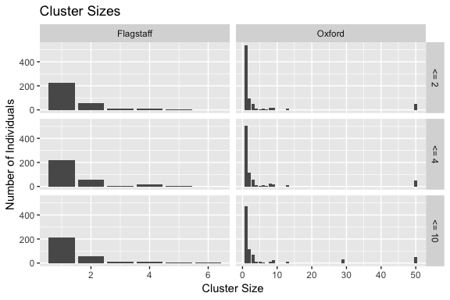

Figure 1: Distribution of Cluster Sizes of Oxfordshire and Flagstaff Data. The row labels denote the threshold number of SNPs would constitute a cluster.

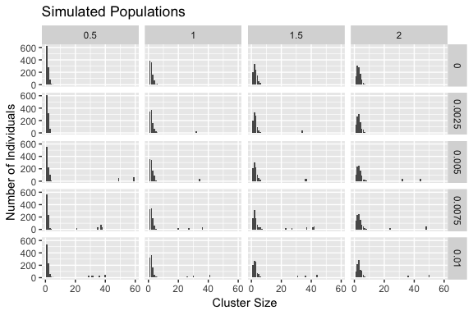

Figure 2: Distribution of Cluster Sizes of Simulated Data. Each column represents the $λ$ parameter of a Poisson distribution, with larger values representing average larger cluster sizes among the none extremely large clusters. The rows represent different levels of mixing in a lognormal distribution and therefore lower rows have more extremely large clusters.

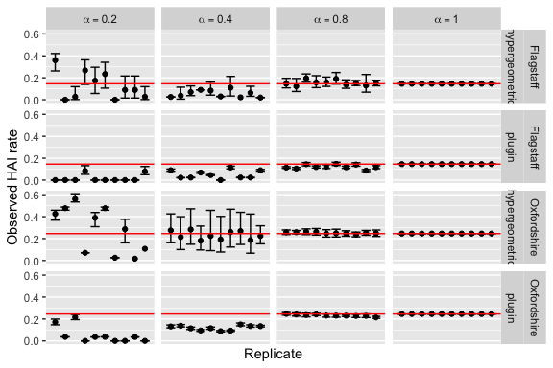

Figure 3: Estimators applied to clinical data sets at different sampling rates. Each graph shows ten replicates Monte Carlo simulations and associated 95% confidence interval. The red horizontal lines display the HAI rate in the full data set.

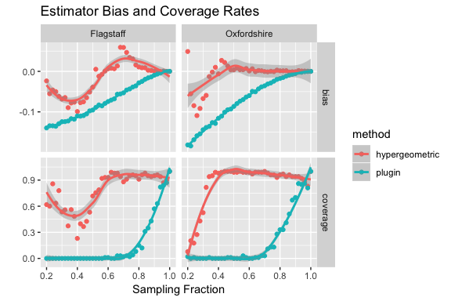

Figure 4: Bias and coverage rates at different sampling fractions for each clinical data set and estimator. The lines represent the loess smoothed function of the observed values across the sampling fraction.

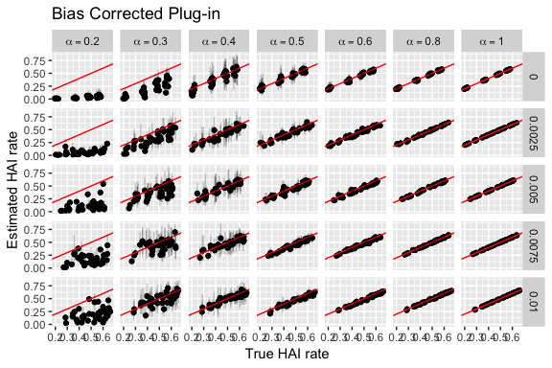

Figure 5: Plug-in estimator applied to simulated data. Columns denote the sampling fraction while rows denote the mixing fraction with lower rows having more large cluster sizes.

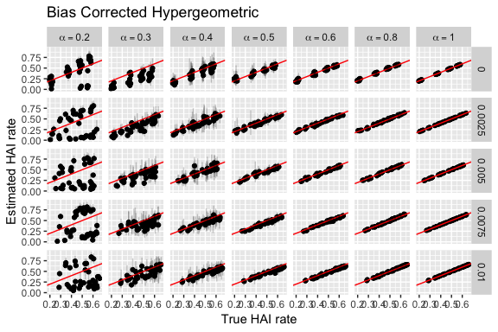

Figure 6: Hypergeometric estimator applied to simulated data. Columns denote the sampling fraction while rows denote the mixing fraction with lower rows having more large cluster sizes.

1. Eyre DW, Cule ML, Wilson DJ, et al (2013) Diverse Sources of <i>C. difficile</i> Infection Identified on Whole-Genome Sequencing. New England Journal of Medicine 369:1195–1205. <https://doi.org/10.1056/NEJMoa1216064>