1. **Introduction**

The purpose of this document is to develop a set of un-collocated FDTD equations for easy implementation in MATLAB or other high-level languages. The term *un-collocated* refers to a solution where the voltages and currents are staggered, as shown in Figure 1. The un-collocated configuration is convenient for centered difference approximations to the differential equations.

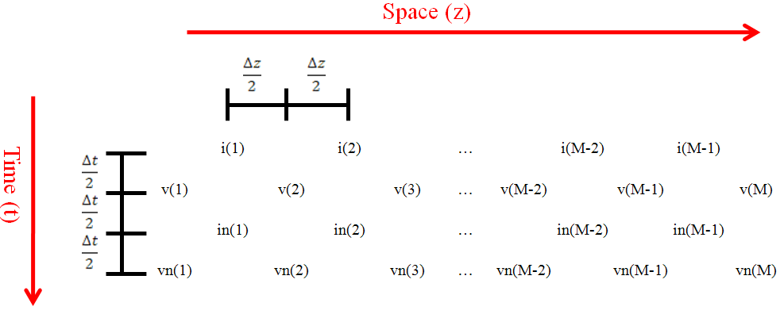

**Figure 1:** Representation of the un-collocated configuration. Notice that the currents (i) and voltages (v) are staggered at half-intervals. The terms “in” and “vn” simply refer to the *next voltage* and *next current*, as will be implemented in the computer algorithm.

1. **Developing Equations For The Central Nodes**

Recall the transmission line equations:

|  |  |  |
| --- | --- | --- |
|  |  |  |

|  |  |  |
| --- | --- | --- |
|  |  |  |

As we develop centered difference approximations for (1) and (2), notice how each of these equations corresponds to a “star” configuration as shown in Figure 2. This will help us visualize the updating procedure that will be implemented in computer code.

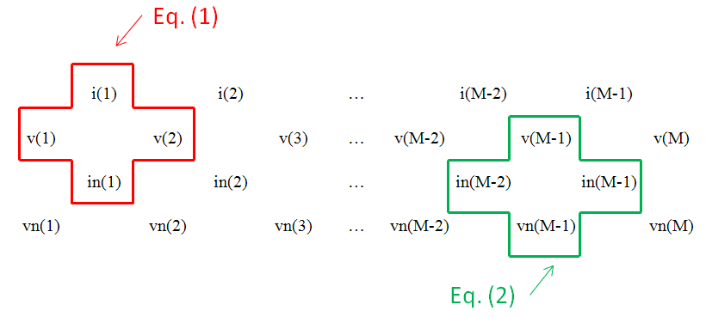

**Figure 2:** “Star” shapes representing the central difference approximations to Equations (1) and (2). In the computer algorithm, the Equation (1) star will first move from left to right and update the “in” row. Then the Equation (2) star will move from left to right and update the “vn” row. Notice that the stars cannot reach the end values, vn(1) and vn(M)—special boundary conditions will have to be developed for these.

Looking at Equation (1) and the corresponding star shape in Figure 2, we can write:

|  |  |  |
| --- | --- | --- |
|  | $$-\frac{v\left(m+1\right)-v(m)}{∆z}=R^{'}i+L'\frac{in\left(m\right)-i(m)}{∆t}$$ |  |

Now we must decide which current value to substitute into the ${(R}^{'}i$) term of equation (3). For stability, we will average the two currents:

|  |  |  |
| --- | --- | --- |
|  | $$-\frac{v\left(m+1\right)-v(m)}{∆z}=R^{'}\frac{in\left(m\right)+i(m)}{2}+L'\frac{in\left(m\right)-i(m)}{∆t}$$ |  |

Solving for …

|  |  |  |
| --- | --- | --- |
|  |  |  |

|  |  |  |
| --- | --- | --- |
|  |  |  |

Looking at Equation (2) and its corresponding star in Figure 2, we can write:

|  |  |  |
| --- | --- | --- |
|  | $$-\frac{in\left(m+1\right)-in(m)}{∆z}=G^{'}v+C'\frac{vn\left(m+1\right)-v(m+1)}{∆t}$$ |  |

1. **Boundary Condition At The Termination**
2. **Boundary Condition At The Source**