**CSci 384: Artificial Intelligence Spring, 2020**

**Derek Trom Date: March 12th, 2020**

**Due: by the end of day, March 22th, 2020 (Sun.)**

**Home Assignment 3: Propositional Logic (150 points)**

**Q1.** [10 pt] Consider a vocabulary with only five propositions, *A,B,C*, *D* and *E*. How many models are

there for the following sentences? Explain your answer.

1. [5] (A ∧ C) ∨ (¬C ∧ D) ∨ (B ∧ ¬E)
   1. This would be 3 * 23 - 4 = 20. Since there is an or between each clause the models would be (A = True, C = True), (C = False, D = True), (B = True, E = False). The 4 accounts for the overlapped models that would be double counted
2. [5] (A ↔ ¬C ↔ E)
   1. The models would be (B = True, C = False, D = True) and (B = False, C = True, D = False). This leaves A 2 choices and E 2 choices for model. Meaning 22 + 22 = 8 models.

NOTE: It’s **not** suggested to get the number of models by Truth Table Enumeration.

**Q2.** [25 pt] Decide whether each of the following sentences is valid, unsatisfiable, or neither.

Verify your decisions using the ***inference rules*** given in the handout and by ***the logical equivalences*** of Fig.7.11 of the textbook. **Justify each procedure** of inference.

Hint: To prove that a sentence is valid, the ‘True’ should be yielded by applying a sequence of

inference rules. On the other hand, the ‘False’ should be yielded as a result of inferences

for the proof of unsatisfiability.

NOTE: **Do NOT prove it by Truth Table Enumeration. – You will get NO point.**

1. [5] ((P ∧ ¬Q) ∨ ¬R) → (Q ∨ ¬R)
   1. |-- ¬((P ∧ ¬Q) ∨ ¬R) ∨ (Q ∨ ¬R) by implication elimination
   2. |--(¬ (P ∧ ¬Q) ∧ R) ∨ (Q ∨ ¬R) by De Morgan’s
   3. |--((¬ P ∨ Q) ∧ R) ∨ (Q ∨ ¬R) by De Morgan’s
   4. |--(R ∧ ¬ P) ∨ (R ∧ Q) ∨ (Q ∨ ¬R) distribution
   5. |--(R ∧ ¬ P) ∨ (Q ∨ ¬R) conjunctive argument
   6. |-- Satisfiable unless P = True, Q = False, R = True
2. [5] (( P → Q) ∧ (Q → ¬R) ∧ (¬P → ¬R)) → ¬R
   1. |--((P→ ¬R) ∧(¬P → ¬R)) → ¬R by syllogism
   2. |--((R→ ¬P) ∧(¬P → ¬R)) → ¬R by contraposition
   3. |--(R→ ¬R) → ¬R by syllogism
   4. |--¬ (¬R ∨ ¬R) ∨ ¬R by implication elimination
   5. |-- ¬(¬R) ∨ ¬R by simplification
   6. |-- R ∨ ¬R by double negation
   7. |--True Valid
3. [5] ((P ∨ R) ↔ ¬ Q) ∧ ¬ Q ) → (¬ P ∧ R)
   1. |-- (((P ∨ R) →¬ Q) ∧(¬ Q→( P ∨ R))) → (¬ P ∧ R) biconditional elimination
   2. |-- ((¬ (P ∨ R) ∨ ¬ Q) ∧( Q∨ ( P ∨ R))) → (¬ P ∧ R) by implication elimination
   3. |-- (((¬P ∧ ¬R) ∨ ¬ Q) ∧( Q∨ ( P ∨ R))) → (¬ P ∧ R) by De Morgan’s
   4. |--¬ (((¬P ∧ ¬R) ∨ ¬ Q) ∧( Q∨ ( P ∨ R))) ∨ (¬ P ∧ R) by implication elimination
   5. |-- ( ( ( P ∨ R ) ∧ Q) ∨ (¬ Q ∧ (¬P ∧ ¬R ) ) ) ∨ (¬ P ∧ R) by De Morgan’s
   6. |-- ( ( ( P ∨ R ) ∧ (Q ∨ ¬R)) ∨ (¬ Q ∧ (¬P ∧ ¬R ) ) ) ∨ (¬ P ∧ R) by disjunctive addition
   7. |-- ( ( P ∨ Q ) ∨ (¬ Q ∧ (¬P ∧ ¬R ) ) )∨ (¬ P ∧ R) by resolution
   8. |-- ( ( P ∨ Q ) ∨ (¬ Q ∧ ¬P ) )∨ (¬ P ∧ R) by simplification
   9. |--(( P ∨ Q) ∨ ¬ Q )∨ (R) by simplification
   10. |-- (Q ∨ ¬ Q) True
   11. |-- True valid
4. [5] (¬P → ¬ Q) → (P → Q)
   1. |-- (Q→P) → (P → Q) by contraposition
   2. |--¬(¬ Q ∨ P) ∨ (¬P ∨ Q) by implication elimination
   3. |-- (Q ∧ ¬P) ∨ (¬P ∨ Q) by De Morgan’s
   4. |-- (¬P ∨ Q)
   5. |-- Satisfiable if P is False or Q is true
5. [5] ¬ (¬ P → Q ) ∧ ¬ (P → Q)
   1. |-- ¬ (P ∨ Q) ∧ ¬ (¬P ∨ Q) by implication elimination
   2. |-- (¬P ∧ ¬Q) ∧ (P ∧ ¬Q) by De Morgan’s
   3. |-- ¬P ∧ P by simplification
   4. |-- False Unsatisfiable

***Example***: P → P

|-- ¬P ∨ P -- by implication elimination

|-- True -- tautology

So, the sentence is valid.

**Q3.** [30 pt]

1. [12] Convert the following set of sentences to clausal form.

S1. A ↔ (B ∨ E) = (¬A ∨ B ∨ E) ∧ (¬B ∨ A) ∧ (¬E ∨ A)

S2. E → D = ¬E ∨ D

S3. (C ∧ F) → ¬B = ¬C ∨ ¬F ∨ ¬B

S4. E → B = ¬E ∨ B

S5. B → F = ¬B ∨ F

S6. B → C = ¬B ∨ C

1. [8] By means of ***resolution***, prove ¬A ∧ ¬B from the above clauses.

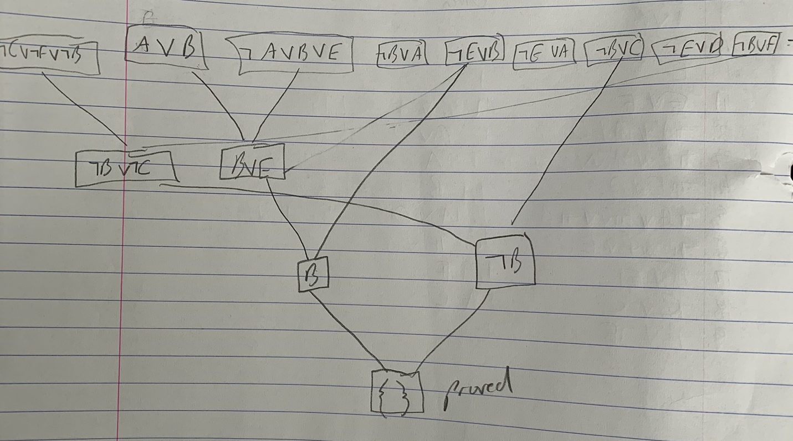

1. [10] Trace the execution of ***DPLL*** on the conjunction of the clauses in 1).
   1. D is pure model D = True
      1. Clauses: {(¬A ∨ B ∨ E), (¬B ∨ A), (¬E ∨ A), True, (¬C ∨ ¬F ∨ ¬B), (¬E ∨ B), (¬B ∨ F), (¬B ∨ C)}
      2. Symbols: {A, B, C, E, F}
      3. Model: {D = True}
   2. DPLL( clauses, rest, model U {A = True})
      1. Clauses: {(False ∨ B ∨ E),True, True, True, (¬C ∨ ¬F ∨ ¬B), (¬E ∨ B), (¬B ∨ F), (¬B ∨ C)}
      2. Symbols: {B, C, E, F}
      3. Model: {A = True, D = True}
   3. DPLL( clauses, rest, model U {B = True})
      1. Clauses: {True, True, True, True, (¬C ∨ ¬F ∨ False), True, (False ∨ F), (False ∨ C)}
      2. Symbols: {C, E, F}
      3. Model: {A = True, D = True, B = True}
      4. Unit clause found F = True
   4. DPLL(clauses, rest, model U {F = True})
      1. Clauses: {True, True, True, True, (¬C ∨ False ∨ False), True, True, (False ∨ C)}
      2. Symbols: {C, E }
      3. Model: {A = True, D = True, B = True, F = True}
      4. Unit clause found C = False
   5. DPLL(clauses, rest, model U {C = False})
      1. Clauses: {True, True, True, True, True, True, True, (False ∨ False)}
      2. Symbols: { E }
      3. Model: {A = True, C = False, D = True, B = True, F = True}
      4. False Clause found return to call c
   6. DPLL( clauses, rest, model U {B = False})
      1. Clauses: {(False ∨ False ∨ E),True, True, True, True, (¬E ∨ False), True, True}
      2. Symbols: {C, E, F}
      3. Model: {A = True, D = True, B = False}
      4. Unit clause found E = True
   7. DPLL( clauses, rest, model U {E = True})
      1. Clauses: {True, True, True, True, True, (False ∨ False), True, True}
      2. Symbols: {C, E, F}
      3. Model: {A = True, D = True, B = False, E = True}
      4. False clause in clauses return to Call B
   8. DPLL( clauses, rest, model U {A = False})
      1. Clauses: {True, (¬B ∨ False), (¬E ∨ False), True, (¬C ∨ ¬F ∨ ¬B), (¬E ∨ B), (¬B ∨ F), (¬B ∨ C)}
      2. Symbols: { B, C, E, F}
      3. Model: {D = True, A = False}
      4. Unit clause found B = False
   9. DPLL( clauses, rest, model U {B = False})
      1. Clauses: {True, True, (¬E ∨ False), True, True, (¬E ∨ False),True, True}
      2. Symbols: { C, E, F}
      3. Model: {D = True, A = False, B = False}
      4. Unit clause found E = False
   10. DPLL( clauses, rest, model U {E = False})
       1. Clauses: {True, True, Tre, True, True, True, True, True}
       2. Symbols: { C, F}
       3. Model: {D = True, A = False, B = False, E = False}
       4. All true clauses return True

**Q4.** [20 pt]According to some political pundits, a person who is radical (R) is electable (E) if (s)he is conservative (C), but otherwise is not electable.

1. [10] Write the above sentence in propositional logic using the given propositions R, E and C.
   1. R → (E ↔ C)
2. [10] Is your sentence in 1) in ***Horn form***? Justify your answer.
   1. Yes
   2. R → (E→C) ∧ (C →E)
   3. ¬R ∨ ((¬E ∨ C) ∧(¬C ∨ E)) implication elimination
   4. (¬R ∨ ¬E ∨ C) ∧ (¬R ∨ ¬C ∨ E) distributive
   5. There is only one positive literal in each clause

**Q5.** [30 pt] Consider the following sentences in the Knowledge_Based and a query.

**KB**: The price of oil will continue to rise.

If the price of oil continues to rise, then the value of the dollar will fall.

If the value of the dollar falls, then Americans will travel less.

If Americans travel less, then airlines will lose money.

**Query**: Will airlines lose money?

1. [10] By deciding the propositional symbols that represent the sentences, translate the sentences into the logical sentences in Propositional Logic. You can disregard the tense of verbs.
   1. R = Oil Rise
   2. D = Dollar Rise
   3. T = Travel More
   4. A = Airlines Gain Money
2. [10] Convert your sentences in 1) into Conjunctive Normal Form (CNF).
   1. R
   2. R → ¬D = ¬R ∨ ¬D
   3. ¬D→ ¬T = D ∨ ¬T
   4. ¬T→ ¬A = T ∨ ¬A
3. [10] Using ***resolution***, answer the query.
   1. R Premise
   2. ¬R ∨ ¬D Premise
   3. D ∨ ¬T Premise
   4. T ∨ ¬A Premise
   5. A query
   6. ¬D resolve a, b
   7. ¬T resolve f, c
   8. ¬A resolve d, g
   9. {} empty clause reached e, h
   10. Thus the airlines will lose money

**Q6.** [35 pt] (Adapted from Barwise and Etchemendy (1993).)

Given the following, can you prove that the unicorn is a) mythical?, b) magical?, or c) Horned?

If the unicorn is *mythical*, then it is *not mortal*,

but if it is *not mythical*, then it is a *mortal mammal*.

If the unicorn is either *immortal* or a *mammal*, then it is *horned*.

The unicorn is *magical* if it is horned.

1. [10] Convert the above statements in KB and a query to the sentences of propositional logic.
   1. Mythical → ¬Mortal
      1. S1 Y → ¬ R
   2. ¬Mythical → Mortal ∧ Mammal
      1. S2 ¬Y → R
      2. S3 ¬Y → M
   3. ¬Mortal ∨ Mammal → horned
      1. S4 ¬R → H
      2. S5 M → H
   4. Horned → Magical
      1. S6 H → G
2. [15] Answer each query (a – c) by applying either ***forward chaining*** or ***backward chaining*** *inference algorithm*. Show your steps of inference.
   1. Using forward chaining with the first 2 propositions make the unicorn either immortal or a mammal but not both.
   2. The third premise will always imply horned regardless of the mythical status of the unicorn.
   3. Since the third premise is always horned the unicorn is horned. Since horned always implies magical the Unicorn is magical. However it cannot be proven whether a unicorn is mythical or not from the premises.
3. [10] Justify why you have chosen forward chaining inference or backward chaining inference to answer each query in 2).
   1. I used forward chaining because I wanted to work from what was known and see what could be classified as true or not true towards the conclusion.