**CSci 384: Artificial Intelligence Spring, 2020**

**Instructor: Dr. M. E. Kim** **Date: April 10, 2020**

**Due: by the end of the day, April 19th (Sun.), 2019**

**Home Assignment 6: Probabilistic Reasoning (100 points)**

**Instruction:**

For each question, show the computational steps precisely.

For the submission, please follow the submission instruction on the blackboard: e.g.) HW6-KimM

**Q1.[10]** In the given Bayesian network where P(*a*) = .4, P(*b*|*a*) = .3, P(*b*|*¬a*) = .2, P(*c*|*a*) = .8, P(*c*|*¬a*) =.5, compute the ***distribution*** of P(B | *c* ).

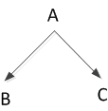

1. P(a) = .4
2. P(b|a) = .3
3. P(b|*¬*a) = .2
4. P(c|a) = .8
5. P(c|*¬*a) = .5
6. P(B|c) = P(b|*¬a*)P(c|*¬*a)P(*¬*a) + P(b|a) P(c|a) P(a)
7. P(B|c) = .2*.5*.6 + .3*.8*.4
8. P(B|c) = .06 + .096 = .156 when B = True
9. P(B|c) = 1-P(b|*¬a*)P(c|*¬*a)P(*¬*a) + 1-P(b|a) P(c|a) P(a)
10. P(B|c) = .8*.5*.6 + .7*.8*.4
11. P(B|c) = .24 + .224 = .464 when B = False
12. <.156/(.464 + .156) , .464/(.464 + .156)>
13. <P(b|c), P(*¬*b|c) > <0.2516, 0.7484>

**Q2. [35]** In the given Burglary Network, compute the followings.

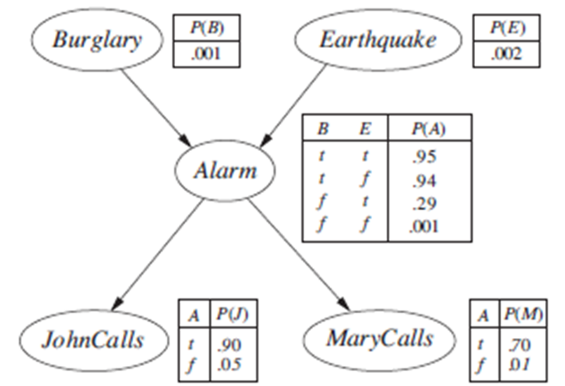

1. [10] the distribution of P(A), P(J), P(M), i.e. (P(*a*), P(*¬a*)),
   1. P(A) = P(a,b,e)+ P(a, *¬*b, e) + P(a,b,*¬* e)+ P(a, *¬*b,*¬* e)
      1. P(A) = P(a|b,e)P(b,e)+ P(a|*¬*b, e)P(*¬*b, e)+ P(a|b, *¬*e)P(b, *¬*e)+ P(a|*¬*b, *¬*e)P(*¬*b, *¬*e)
      2. P(A) = (0.95*0.001*0.29)+ (0.29*0.999*0.002)+(0.94*0.001*0.998)+(0.001*0.999*0.998)
      3. P(A) = 0.00252
   2. P(J) = P(j,a) + P(j, *¬a)*
      1. P(J) = P(j|a)P(a)+P(j|*¬a*)P(*¬*a)
      2. P(J) = 0.9 * 0.0025 + 0.05 * (1-0.0025) = 0.052
   3. P(M) = P(m,a) + P(m, *¬a)*
      1. P(M) = P(m|a)P(a)+P(m|*¬a*)P(*¬*a)
      2. P(M) = 0.7 * 0.0025 + 0.01 * (1-0.0025) = 0.0117
2. [5] P(*j* | *b*)
   1. P(j|b) = P(j,b)/P(b) = [P(j,a,b)+ P(j, *¬*a, b)]/P(b)
   2. =[P(j|a)P(a|b)P(b)+ P(j|*¬*a)P(*¬*a|b)P(b)]/P(b)
   3. =P(j|a)P(a|b) + P(j|*¬*a)P(*¬*a|b)
   4. = .9*0.94002 + .05* .05998 = 0.849017
3. [5] P(*a* | *b*)
   1. P(a|b) = P(a|b,e)P(e)+ P(a|b, *¬*e)P(*¬*e)
   2. = 0.95*0.002+0.94 * 0.998 = 0.94002
4. [5] P(*j* or *m* | b)
5. [5] P(*b* | *m*).
   1. P(b|m) = P(m|b)P(b) /P(m)
   2. = 0.659*0.001/0.0117 = 0.056
6. ~~P(~~*~~b~~* ~~|~~ *~~j~~* ~~or~~ *~~m~~*~~)~~
7. [5] P(e|¬*a*)
   1. P(e|*¬*a) = P(*¬*a|e)P(e) /P(*¬*a) =( .05*.002 + .06*0.998)*0.002/ .99748

**Q3. [10]** A diagnostic system is to be made for a dynamo-powered bicycle light using a Bayesian network. The variables are defined below:

|  |  |  |
| --- | --- | --- |
| **Variable** | **Value** | **Meaning** |
| L | true / false | Light is on |
| S | dry, wet, snow | Street condition |
| F | true / false | Dynamo flywheel worn out |
| R | true / false | Dynamo sliding |
| V | true / false | Dynamo shows voltage |
| B | true / false | Light bulb OK |
| K | true / false | Cable OK |

The following variables are independent: S, F, B, K.

Th following pairs of variables are independent: (R, B), (R, K), (V, B), (V, K)

and the following equation holds: P(L | V, R) = P(L|V), P(V |R, S) = P(V | R), P(V | R, F) = P(V | R).

Draw the Bayesian network with the given variables in the Causal model.

S F

R

V B K

L

**Q4. [30]** Consider the following belief network with Boolean variables and the following conditional probabilities:

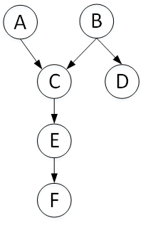

.

P(*a*) = 0.02 P(*d* | *b* ) = 0.9

P(*b*) = 0.01 P(*d* | *¬ b*) = 0.01

P(*c* | *a, b*) = 0.5 P(e | *c)* = 0.88

P(*c* | *a*, *¬ b*) = 0.99 P(*e* | *¬ c)* = 0.001

P(*c* | *¬ a, b*) = 0.85 P(*f* | *e*) = 0.75

P(*c* | *¬ a, ¬ b*) = 0.0001 P(*f* | *¬ e*) = 0.01

1. [15] a) Compute the conditional distribution P(A | *d*, *f* ) using Variable Elimination (VE).

b) Which variables are irrelevant to inference? First, prune irrelevant variables. Show the complete computation steps with the factors that are created for a given elimination ordering.

a. P(A|d,f) =

1. [15] c) Compute P( *e* | *b*) using VE. a) Which variables are irrelevant to inference? b) Which factors can be reused from (1)? d) Show the factors that are different from those in (1).

**Q5. [15]** In the given Bayesian network, compute the following probabilities.

1. [15] Compute the probability that an elderly female who is over 60 gets no cancer (i.e. benign).
   1. P(C = benign| Age>60, Gender = female) = ∑e ∑s P(C=benign, Age>60, Gender= female, e, s)
   2. P(>60) P(female) [ P(e | >60) P(benign | e, s) P( s | >60, female) + P(e| >60) P(benign | e, *¬* s) P(*¬*s | >60, female) + P(*¬*e | >60) P(benign | *¬*e, s) P( s | >60, female) + P(*¬*e | >60) P(benign | *¬*e, *¬*s) P(*¬*s | >60, female) ]
   3. P(>60) P(female) = (0.7*0.1*0.1)+(0.7*0.4*0.9)+(0.3*0.4*0.1)+(0.3*0.9+0.9)
   4. P(>60) P(female) = .007 + .252 + .012 + .243 = .514
   5. P(C=malignant|>60 , female) = P(>60) P(female) * P( C= malignant) = ↑ P(>60) P(female)= 0.486 = <(.514/(.514+.486), .486/(.514+.486)> = <.514, .486>
2. [15, optional] Compute the probability that an elderly female patient with low Serum Calcium to have no cancer (i.e. benign).
   1. This is assuming you meant med instead of low
   2. P(c=benign|SC=med, Age>60, Gender = female)
   3. P(SC=med|benign) = 0.4
   4. P(C = benign| Age>60, Gender = female)=0.514

P(SC = med | Age > 60, G = Female) = ∑benign P(SC=med | benign, Age > 60, G = female) * P(benign | Age > 60, G= female) = 0.4* 0.514 + 0.3 *(1 - 0.514) = .3514

* 1. P(benign | Serum Calcium = med, Age > 60, Gender = female) = (0.4* 0.514) / .3514= .585
  2. This is how I would add in low to the table
  3. P(c=benign|SC=low, Age>60, Gender = female)
  4. P(SC=low|benign) = 0.5
  5. P(C = benign| Age>60, Gender = female)=0.514

P(SC = low | Age > 60, G = Female) = ∑benign P(SC=low | benign, Age > 60, G = female) * P(benign | Age > 60, G= female) = 0.5* 0.514 + 0.1 *(1 - 0.514) = .3056

* 1. P(benign | Serum Calcium = low, Age > 60, Gender = female) = (0.5* 0.514) / .3056= .841

