CSci 435: Formal Languages and Automata

Instructor: Dr. M. E. Kim Name: ____Derek Trom______

**Home Assignment 1: 100 points + 10 points (optional)**

Q1. [25] For Σ = {a, b}, construct the minimal DFA that accept the language consisting of

1. [8] all strings with an even number of *a*’s and an odd number of *b*’s.
   1. 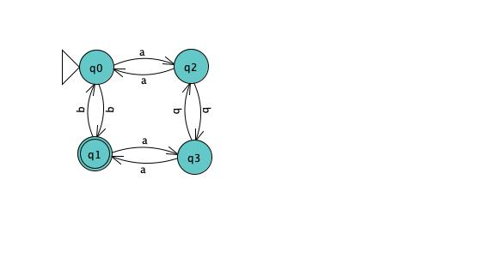
2. [8] every ‘*aa’* is followed immediately by a ‘*b’*. For example, the strings *aab*, *aaba*, *aabaabbaab* are in the language, but *aaab* and *aabaa* are not. Construct a DFA with 4 states.
   1. 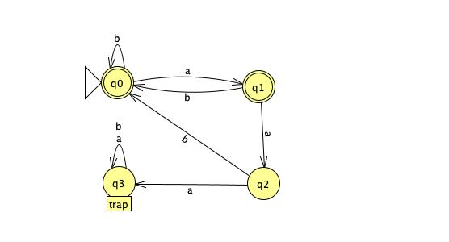
3. [9] L = {w | ( *na*(*w*) – *nb*(*w*) ) mod 3 = 0 }. Construct a DFA with 3 states.
   1. 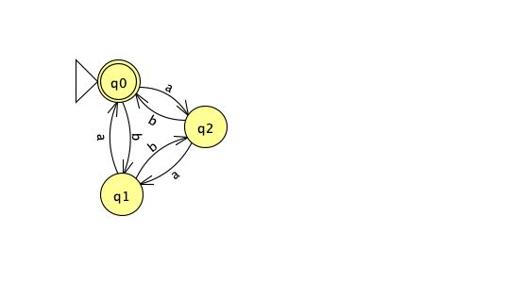

Q2. [10] Show that the language L = { *a****n***| *n* ≥ 0, *n* ≠ 3 } is regular.

To show that a language is regular, we must find a DFA that will accept it. L is regular if DFA M exists such that L=L(M)

1. 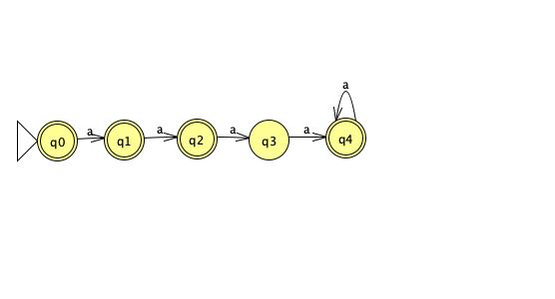

Q3. [15] For the language L = {*an* | *n* ≥ 1 } ∪ {*bmak* | *m* ≥ 0, *k* ≥ 0}

1. [8] Construct an NFA with three states that accepts L.
   1. 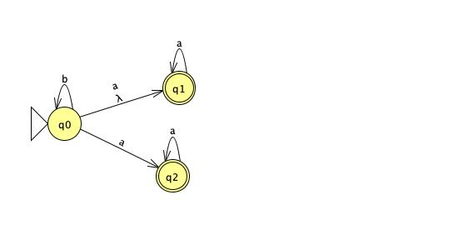
2. [7] Can you construct an NFA with the fewer states that accepts L? If so, construct it; otherwise, justify why your NFA in 1) is the minimal NFA.
   1. Yes it can be minimized by removing q2
   2. 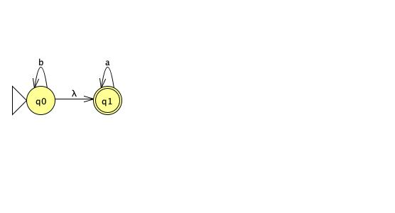

Q4. [20] For a given NFA in the figure,

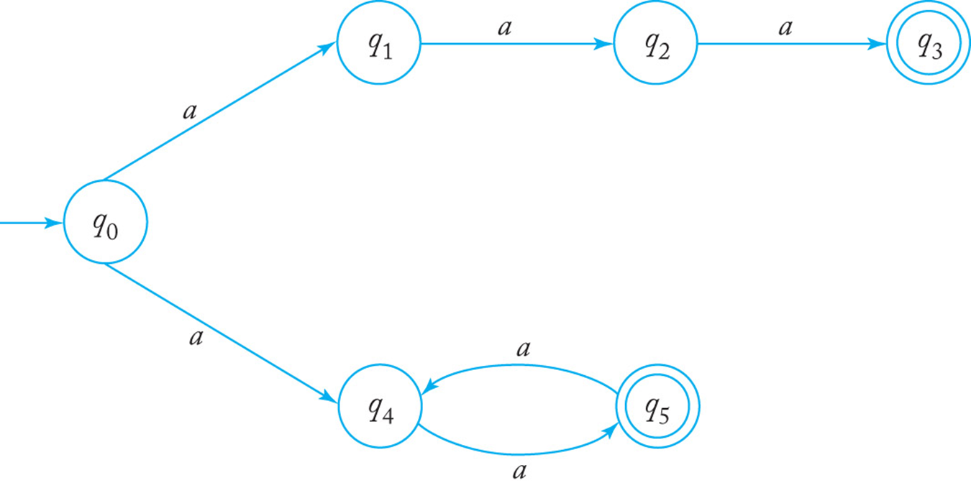

1. [10] Give a language *L* that is accepted by the NFA. Describe L in the proper mathematical format, not in the verbal English description. E.g.) L = { *a****n***| *n* ≥ 0, *n* ≠ 3 }
   1. L= {an | n%2 = 0, n=3 , n>1}
2. [10] Find a *DFA* that accepts the ***complement*** of the language defined by the NFA, i.e. $\overline{L}$.
   1. 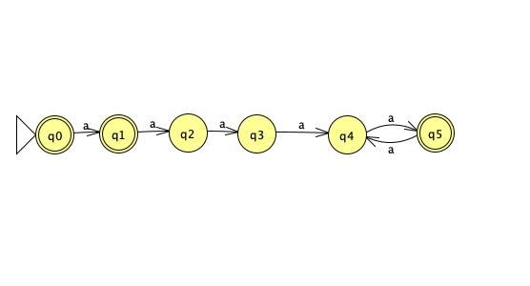

Q5. [10] Construct an NFA with the ***minimum*** number of states that accepts

*L* = { *an* | *n* ≥ 0 } ∪ { *bna* | *n* ≥ 1 }.

1. 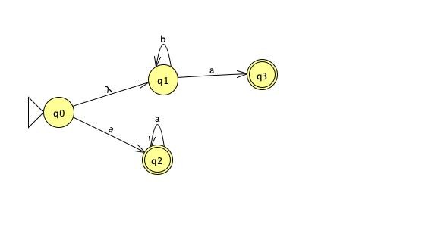

Q6. [10] Convert the NFA defined by the transitions below with the initial state *q0* and the final state *q2* into an *equivalent DFA*. Draw the transition graph of the DFA.

δ(*q0, a*) = { *q0, q1* }, δ(*q1, b*) = { *q1, q2* }, δ(*q2, a*) = { *q2* }, δ(*q1,* λ) = { *q1, q2* }.

1. 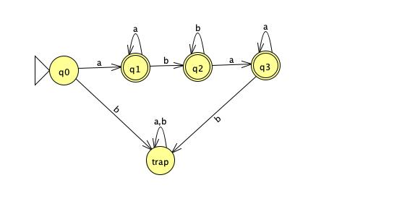

Q7. [20] For a given language, L = { *anb* | *n* ≥ 1 } ∪ { *bna* | *n* ≥ 1},

1. [10] Construct a *minimal DFA* with the minimum number of states that accepts L.
   1. 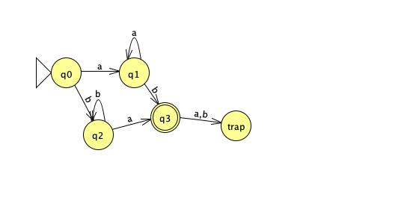
2. [10] Prove that your DFA in 1) is minimal. Hint: Check if any pair of the states are indistinguishable to be merged in the same class so that the number of states are minimized
   1. (q0,a) = q1 (q0,b) = q2
   2. (q1,a) = q1 (q1,b) = q3
   3. (q2,a) = q3 (q2,b) = q2
   4. Thus, there are no indistinguishable states to be merged and it is minimal.

Q8. [10, optional] Prove or disprove the following conjecture: If L is regular, so is LR.

If it is true, construct a NFA MR s.t. L(M’) = LR , from a NFA M that accepts L, i.e. L(M) = L. Then, show that L(M’ ) = LR .

Otherwise, give a counter example.

1. By using the nfa from question 3.2 we can show the NFA M accepts the language L = {*an* | *n* ≥ 1 } ∪ {*bmak* | *m* ≥ 0, *k* ≥ 0} below.
2. 
3. By reversing all the arcs, making the start state from M the final state, and creating the new start state for M we will achieve MR shown below. Which accepts the language of M, thus proving that is L is regular so is LR. ♣
4. 