CSci 435: Formal Languages and Automata

Instructor: Dr. M. E. Kim Name: ___**Derek Trom**________

**Home Assignment 2: 102/100 points + 10 points (optional)**

Q1. [10/10] Find all strings in L((*ab* + *b*)* b (*a* + *ab*)*) of length ***less than*** four.

1. b, ba, bb, abb, baa, bab, bba, bbb

Q2. [17/10] Give a ***regular expression*** for the language

1. [10/10] L = {*anbm* | (*n*+*m*) is odd}.
   1. (aa)*b(bb)*
   2. a(aa)*(bb)*
   3. ((aa)*b(bb)*)+(a(aa)*(bb)*)
2. [7/10, optional] L = {*w* ∈ {*a, b*}* | ( *na*(*w*) - *nb*(*w*) ) mod 3 = 0}. Hint: Apply Thm 3.2.
   1. r = (ba)*((a+bb)(ab)*(b+aa))*

* See the attached solution

Case 1: NFA M, L(M) = L

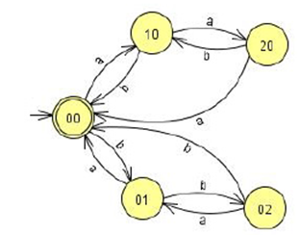

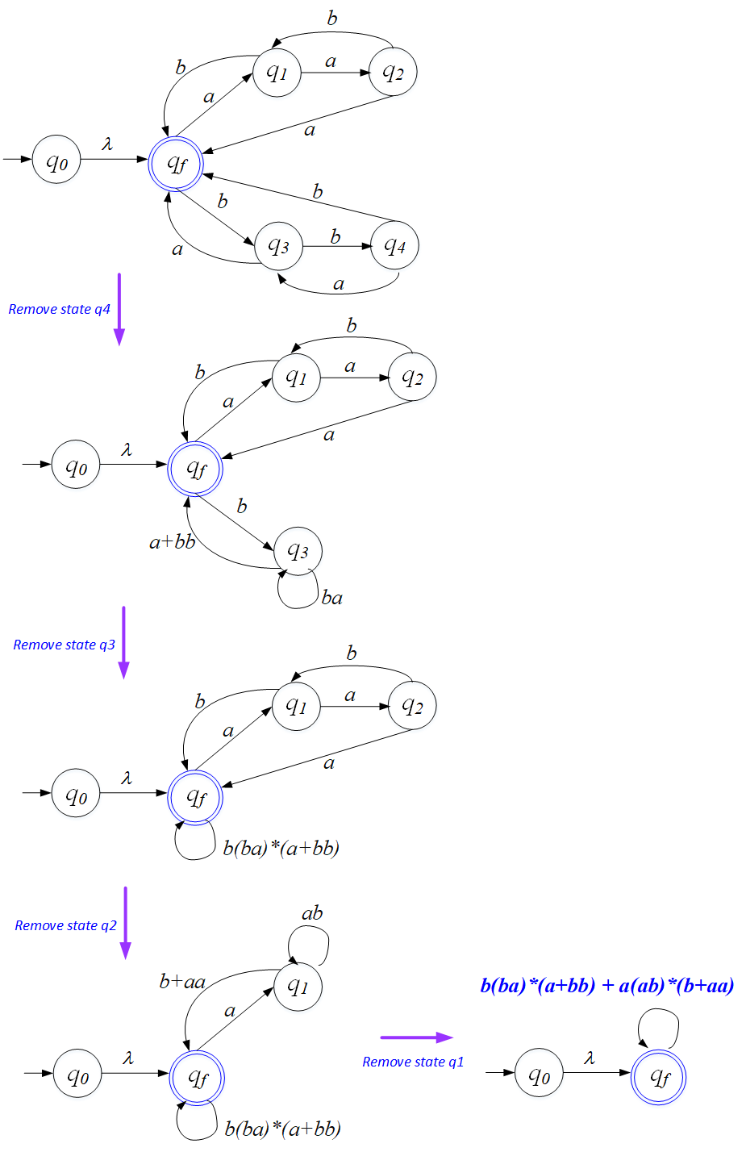

So, the REX is: *b(ba)*(a+bb)+a(ab)*(b+aa).*

Case 2: NFA M

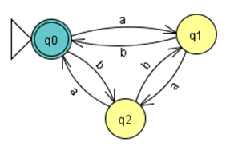

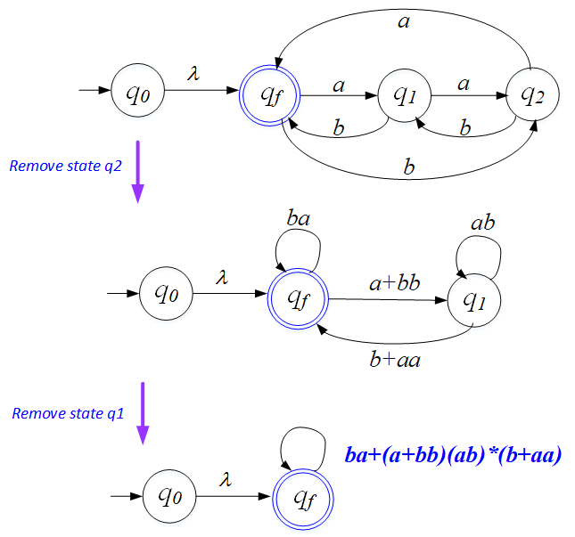

So, the REX is: *ba* + (*a+bb)*(*ab*)*(*b*+*aa*).

Case 3:

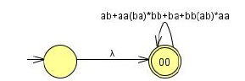

The REX is: (*ab* + *aa*(*ba*)\**bb* + *ba* + *bb*(*ab*)\**aa*)*.

Q3. [8/10] Using the construction in Theorem 3.1, construct an NFA that accepts the complement of the

Language L(*ab*\**aa* + *bba*\**ab*).

NFA was constructed from L then converted to DFA and Final and nonfinal states reversed.

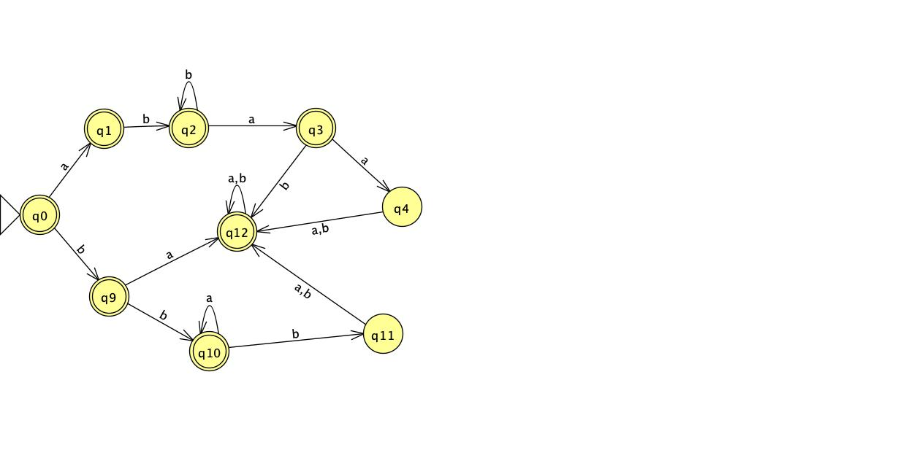

* See the attached solution

Convert the above NFA to a DFA. Then, complement it.

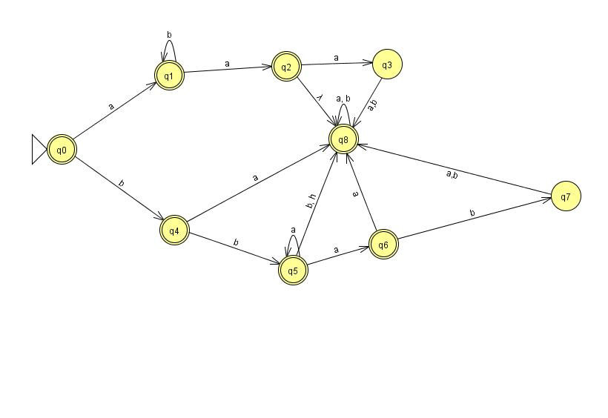

Q4. [20/20] Construct a ***minimal DFA*** that accepts the following language

1. [10/10] L(*ab*(*a*+*ab*)*(*a*+*aa*))
   1. dfa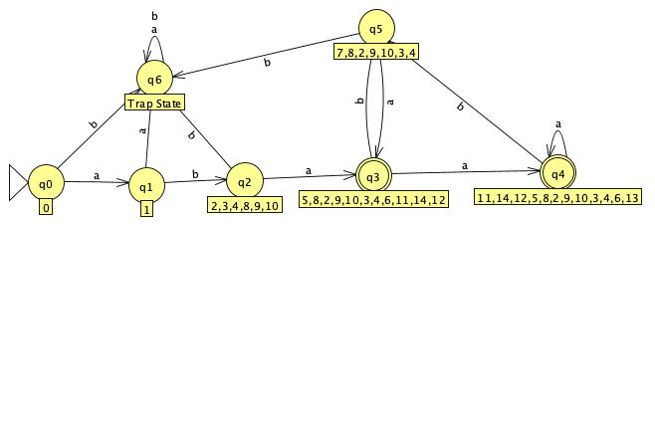
   2. minimal dfa

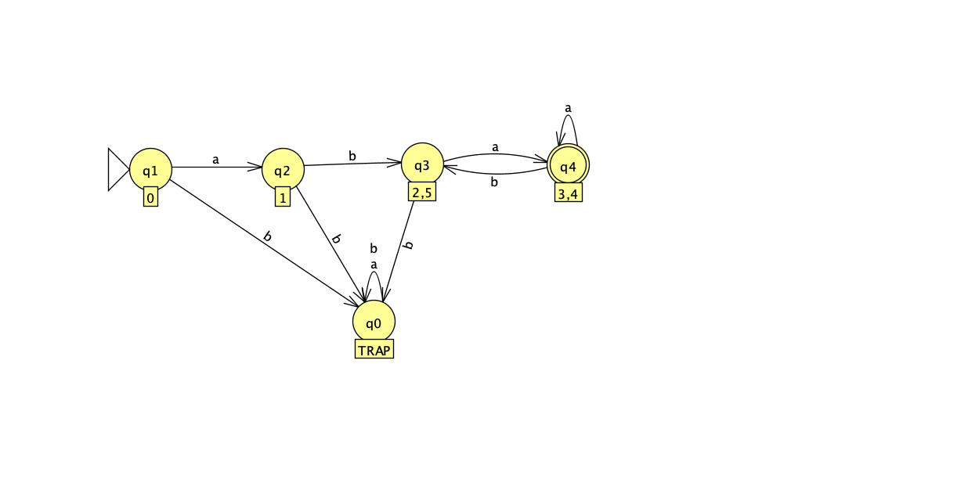

1. [10/10] L((*aa*\*)\**b*)*)

Hint: Start with constructing an NFA (by Theorem 3.1), convert it to DFA, then get the minimal DFA by mark & reduce procedures.

* 1. NFA

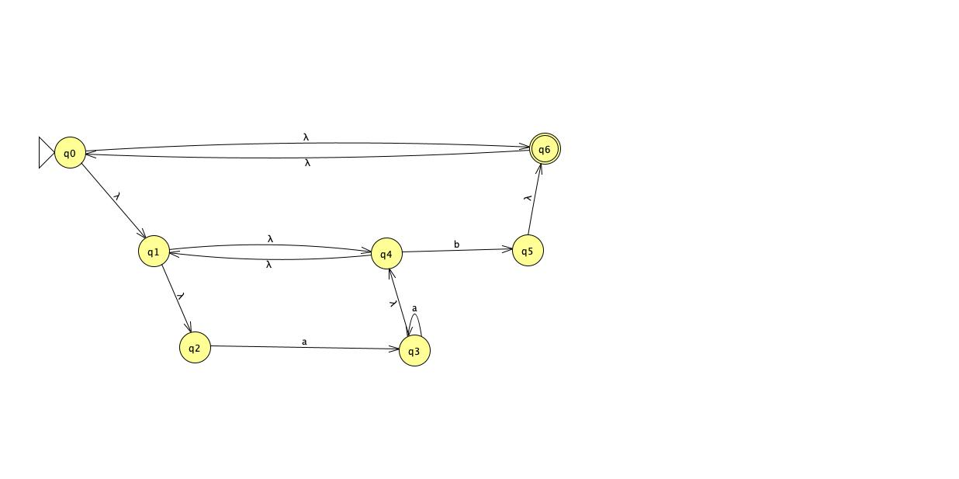

* 1. DFA

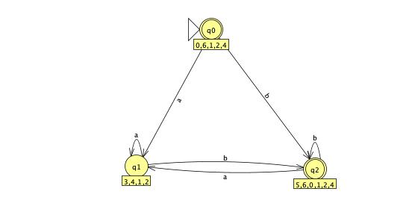

* 1. Min DFA

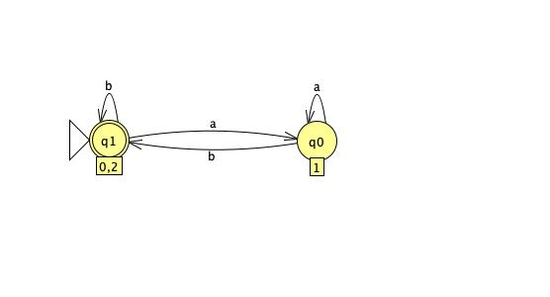

Q5. [17/20] Find ***regular expressions*** for the languages accepted by the following automaton.

1. [10/10]

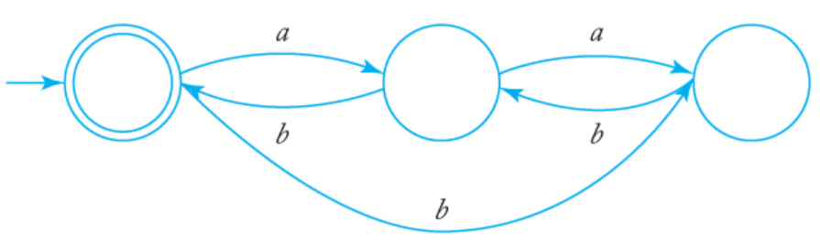

* 1. r = ((a+bb)(ab)*b)*

1. [7/10]

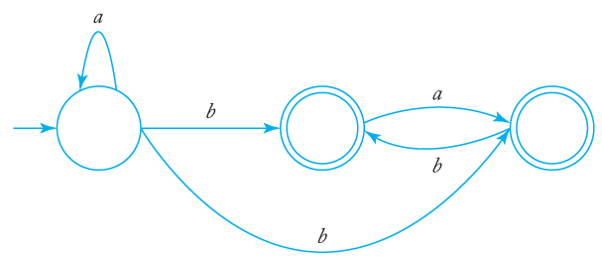

* 1. r = a*(b+bb)(a+b)*
* See the attached solution

**is equivalent to**

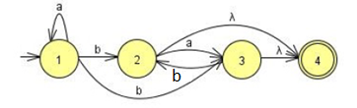**with a single final state.**

Remove q2: Remove q3:

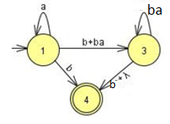 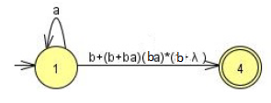

The regular expression then is: **r = *a*\*(b + (b + b*a*)(b*a*)*(b + λ))**

**= *a*\*(b + b( λ + *a*)(*ba*)*(b + λ )**

**= a*b(λ + ( λ + *a*)(*ba*)*(b + λ )**

OR

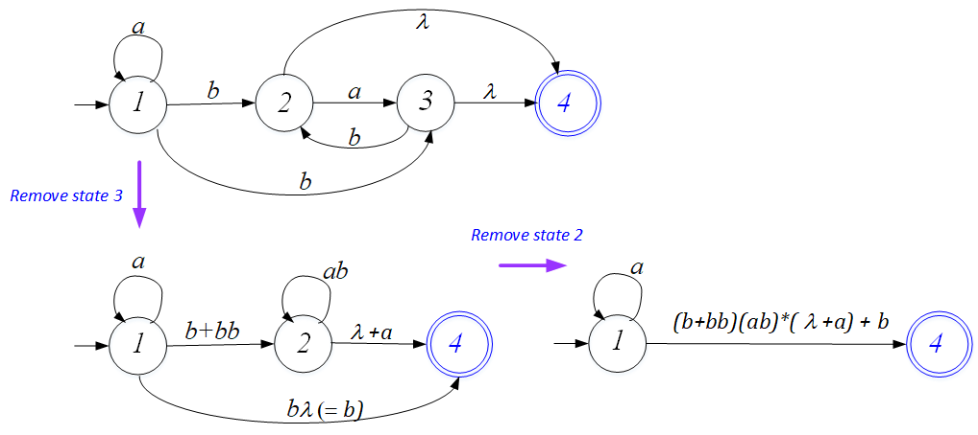

The regular expression then is: **r = *a*\*(b + (*b* + *bb*)(*ab*)*( λ+*a*))**

**= *a*\*(b + (*λ* + *b*)b(*ab*)*( λ+*a*))**

**= *a*\*(b + (*λ* + *b*)(b*a)*b*( λ+*a*))**

**Any of them are correct.**

Q6. [10/10] Construct a ***DFA*** that accepts the language generated by the *grammar*

S → *ab*S | B, A → *a*B | *bb,* B → *ba*A.

NFA

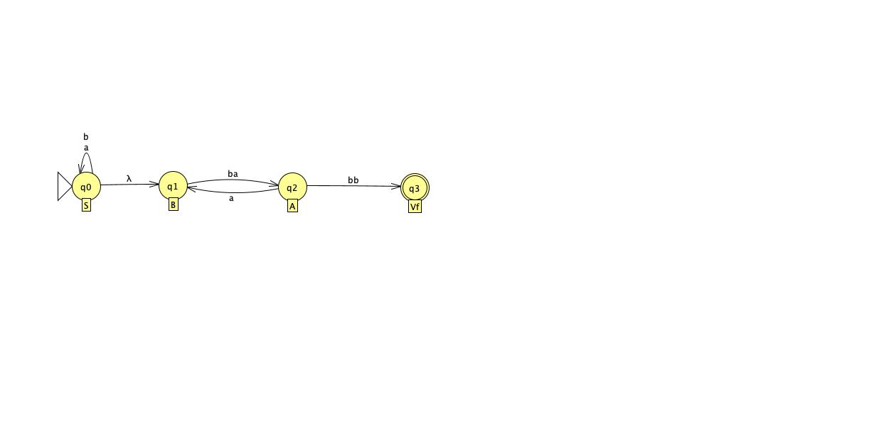

DFA

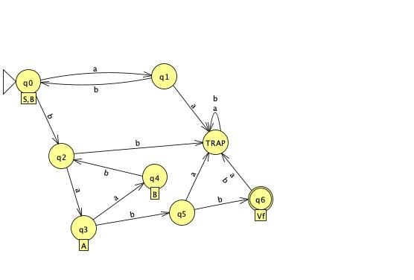

Q7. [20/20] Find a ***regular grammar*** that generates the language on Σ={a, b}

1. [10/10] *L*(*aa*\*(*ab*+*a*)*)
   1. S → aA
   2. A → aA | aB | λ
   3. B → bA

* See the attached sample solution

1. 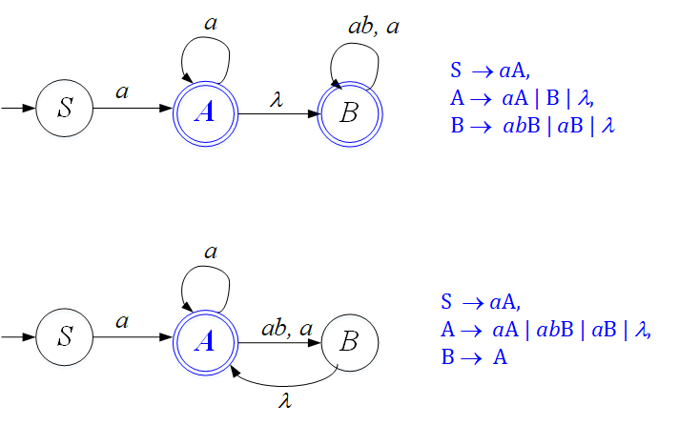
2. { S → *a*A, A → *a*A | B | λ, B → *ab*B | *a*B | λ }
3. or { S → *a*A, A → *aA* | *ab*B | *a*B | λ, B → A }, etc.
4. [10/10] the language consisting of all strings with no more than two *a*’s.
   1. S → aA | bS | λ
   2. A → bA | aB | λ
   3. B → bB | λ