***Abstract***

**In the past few years in has been identified by many industries that there are many reasons for an unmanned aircraft mission to fail. Some of these obstacles to overcome are weather or restricted airspace. Many times an aircraft may have to return to station or a pilot is forced to make a decision on how to get around the obstacle on the fly in order to still accomplish an important flight. This is the basis of the research to be conducted and explored in more detail to solve the problem at hand.**

***Keywords***

***flight optimization; pathfinding; flight simulation; unmanned aircraft, manned aircraft.***

1. *Introduction*

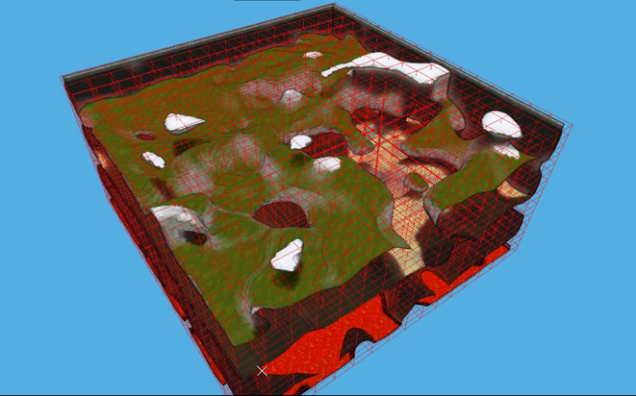

Figure 1: A 3D environment broken into blocks of area

Navigation systems use certain algorithms and data to plan a route from a starting location to a goal destination. This saves drivers time, gas, and optimizes a route. This is the general idea behind this project. We want to be able to plot a flight path before takeoff that optimizes target collection ability based on given information while also avoiding restricted airspace and obstacles. Then, as the plane is in route to its destination if there are any changes to that flight path that need to be made, the algorithm shall be able to recalculate a route around obstacles within certain parameters kept in mind and get back to the flight path. The purpose of this summary is to identify and respect the integrity of some of the available research and uses of pathfinding available. In order to avoid unintended plagiarism, we will examine commonalities of existing algorithms while trying to differentiate features and the scope between this project and others.

The main difference between this and the publicly available application of this research is that this will be applied to a simulation of aircraft in a physics based engine to provide proof of concept and eventually possibly extend it to real unmanned or manned aircraft. As a disclaimer there are very few research articles or products that directly compare and contrast to this research to be performed. The author believes this is because there is probably a lot of proprietary applications and research that has been done and is meant to be kept from the public arena.

1. *Cruise Missile Pathfinding*

The author did some research on possible paths to take to reduce redundant research. One of these paths lead to a talk with Dr. Ronald Marsh, a computer science professor at the University of North Dakota. After discussing the project proposal with Dr. Marsh it was found that he had been on a project with similar parameters and goals. Dr. Marsh stated he was on a project for the Navy as a graduate computer science student which involved cruise missile pathfinding[2]. The basis of this research was to optimize the time it would take to generate these paths for the cruise missile prior to launch.

Before this research had been funded to begin, this process was taking the military personnel between 12-15 hours to calculate. This was not efficient and with computers making leaps and bounds in that time period the Navy knew it could be optimized. By the end of this research the time it took to calculate these routes using graphical algorithms had reduced it down to about 2 hours for a route calculation. Thus reducing cost in man hours and reducing human error.

There are some similarities between this project and flight pathfinding project for the author. Much like the author, Dr. Marsh and his project team decided that as the main pathfinding algorithm they were to use the a*(a-star) algorithm for this flight path search. This algorithm is an extremely efficient and fast algorithm for finding the shortest path in a 3-d environment. It has been used in many video games environments for agent pathfinding.

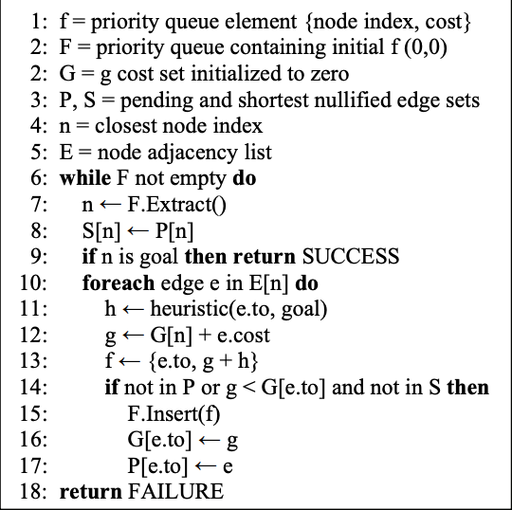

Figure 2: A* algorithm pseudo code: g(n) is the cost from start to node n, h(n) is the heuristic cost from node n to goal; f is the entity to sort in the priority queue, its cost member is the sum of g(n) and h(n)[1].

Another similarity in the projects is that there are many other factors that will influence the path chosen by the algorithms. The cruise missile has fuel range, altitude, and restricted air space that it must take into account when calculating the target route. This is similar to what an aircraft has to take into account in order to optimize and calculate the correct path from origin to destination.

Now, to contrast the two projects and what they aim to solve. The author’s project will be used and applied to both manned and unmanned aircraft, Dr. Marsh’s project was applied to a cruise missile[2]. This brings up some obvious differences. The cruise missile was to fly from a stationary source and strike a target. An aircraft in general is not sent to fly into an object and explode. Another difference is going to be the altitude at which this algorithm will be calculating the route for the aircraft which will reduce altitude based obstacles such as mountains. The efficiency and speed of computers has also vastly improved since this research was conducted, giving hope that this algorithm can be run in minutes or seconds rather than hours based on the hardware available to the author using accelerated GPU pathfinding algorithms.

1. *Autonomous Pathfinding in a Simulated 3D Environment*

The research that is described in this section presents an approach for navigating an autonomous agent in a simulated room environment with multiple obstacles. It also proposes a path planner interfaced with the depth map for locally planning a sequence of steps to the desired location[3]. The main difference between the problem being assessed in this piece and my research is that main agent in the problem for their research is a mobile robot using a middle ground between a depth camera and an RGB camera whereas my research will involve mostly simulated environments at the start for an aircraft.

For the path planning in this paper it was stated that the authors divided the entire 3D environment into unit volume cubes centered at integer coordinates[3]. They also used a heuristic aided search as the basis of the pathfinding portion of the research. This is similar to the research to be conducted by the author of this paper. The heuristics to be used were Manhattan Distance as well as Euclidean Distance[3]. We will also most likely be using the Euclidean distance from current location to goal location as a heuristic for his research.

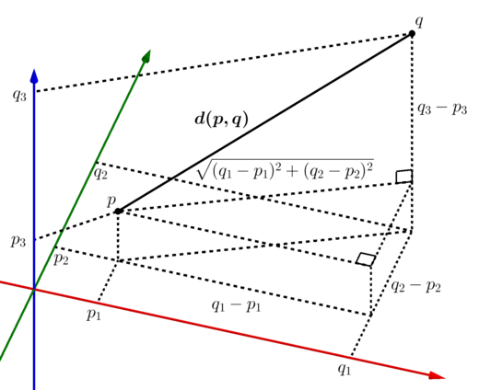

Figure 3: Deriving the n-dimensional Euclidean distance formula by repeatedly applying the Pythagorean theorem

The comparison of this research with mine is important to show that neural networks may be a good path to follow in order to integrate the sensors available for use in the an aircraft. It may be a good choice for finding an optimal path in the environment visible to our agent, the aircraft.

1. *GPU Accelerated Pathfinding*

Avi Bleiweiss explored some of the techniques for optimizing pathfinding on GPUs. He compared the a* algorithm to the breadth first search algorithm and Dijkstra’s algorithm and showed that it is fast and optimal compared to the latter two algorithms[1]. The reason this research is similar to mine is that I will be attempting to also optimize the a* using GPU calculations in order to speed up the pathfinding even further. This research is different from mine because it is just a performance test compared to mine where I will be applying the algorithms to a real world application. What I can draw from this research is some good news about the assumptions I had about the a* algorithm and its applicability to the project at hand.

1. Conclusion

As I stated, the primary goal was to compare and contrast some of the research that is out there against what I am attempting to do. There seems to be a lot of good research as far as the algorithms to be used in the research that I will be conducting. However it is hard to find anything or anyone that is doing what I am conducting which I assume is because it is mostly proprietary information for most companies that may have done this. This project would almost certainly have commonalities however at this time I am unable to find anything in direct conflict with what this project will be addressing that is publicly available.

*References*

[1] A. Bleiweiss, "GPU accelerated pathfinding | Proceedings of the 23rd ACM SIGGRAPH/EUROGRAPHICS symposium on Graphics hardware", *Dl.acm.org*, 2008. [Online]. Available: https://dl.acm.org/doi/pdf/10.5555/1413957.1413968. [Accessed: 02- Nov- 2020].

[2] R. Marsh, "Discussion of Cruise Missile Pathfinding", Office of Dr. Marsh, 2020.

[3] S. Raja, T. Bhatia, A. Mishra, S. Kashyap and O. Verma, "Autonomous Pathfinding in Simulated 3D Environment | Proceedings of the 2017 International Conference on Robotics and Artificial Intelligence", *Dl.acm.org*, 2020. [Online]. Available: https://dl.acm.org/doi/pdf/10.1145/3175603.3175621. [Accessed: 02- Nov- 2020].