**Business Problem and Context**

Big Mountain Ski Resort has historically used the market average alone to set it’s pricing strategy. After adding a new chair lift that will increase operating expenditures by $1.5million annually, the leadership team would like to find a more data driven approach to price setting and see if there might be a business case for raising prices or trimming back some services that don’t mean much to visitors to save on operational costs.

**Methods and Findings**

Alesha Eisman, Database Manager, provided a csv file to be used for analysis. This dataset originally included information about 330 United States ski resorts with 27 different data fields including price information, total chairs, types of chairs, skiable terrain, total vertical drop, snowmaking, etc.

It was found that several ski resorts were missing key information like ticket price so we decided to drop those from the dataset as they would not be useful in an analysis of pricing strategy. Two data fields, fast eight and adult weekend, were dropped from the data set as well. Only one ski resort reported having a fast eight chairlift so it was determined that data would not be useful in assessing the industry as a whole. Adult weekday ticket price was also dropped from the dataset as analysis showed that there were less weekend prices missing from the dataset than weekday. Thus, the adult weekend price became the target value for our analysis.

Additional state population information was also sourced from Wikipedia and used to create a table summarizing ski area and population information by state. Population density might have a correlation with ticket price and could prove useful to the model.

Finally, a random forest model was used to assess each data field looking for strong correlations with ticket price. We would use these in our model to predict a new ticket price. In this analysis it was discovered that the number of fast quads, total runs, snow making area, and vertical drop had the strongest correlation with ticket price, as shown in figure 1 below.

**Figure 1**

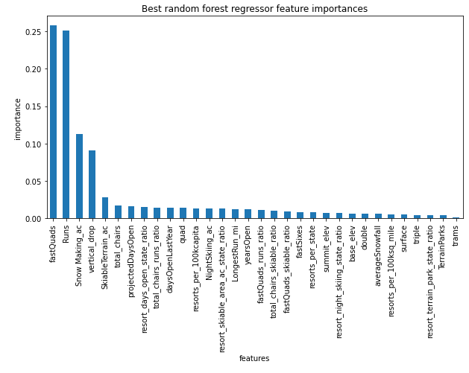

**Findings and Additional Analysis**

Big Mountain ranks high compared to other US ski resorts in the 4 key features outline above (fast quads, runs, snow making, and vertical drop)(see figures 2, 3, 4, and 5). But, Big Mountain does not rank near the top for ticket price (see figure 6). As a result, our model suggests that the market could bear an $8 - $10 ticket price increase at Big Mountain, based on the assumption that total visitors will continue at 350k per year and each visitor will ski for 5 days. This price increase would amount to more than $15m in additional annual revenue for the resort.

There are additional factors to consider beyond this analysis. Although Big Mountain’s pricing does not rank near the top of all US resorts, their ticket price is already the highest in Montana (see Figure 7). It would be wise to assess how many visitors are coming from out of state and how effective the resort may be at attracting more since locals may be more sensitive to price increases than out of state visitors.

We also don’t have visitor information for the resorts included in this data set. That information would prove useful in assessing the accuracy of current pricing trends in the industry. This analysis assumes that other resorts are not under or overvaluing their tickets.

Big Mountain also lies in close proximity to Canada and may have a strong customer base there. It may be useful to include some Canadian resorts in this model as well.

**Figure 2**

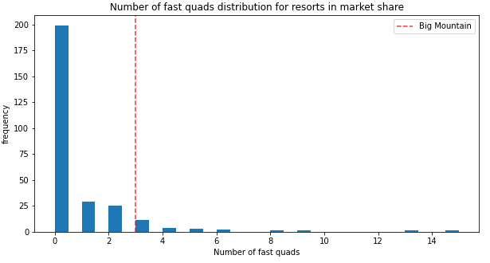

**Figure 3**

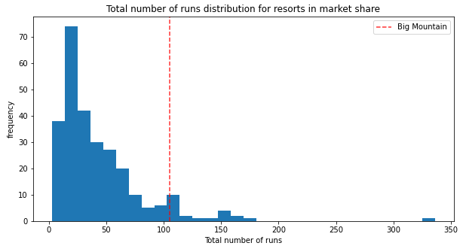

**Figure 4**

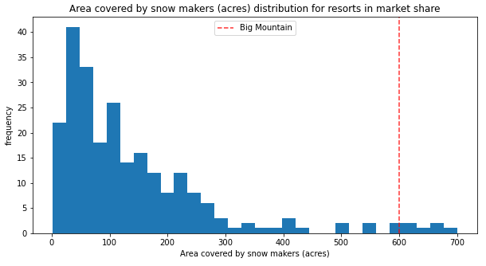

**Figure 5**

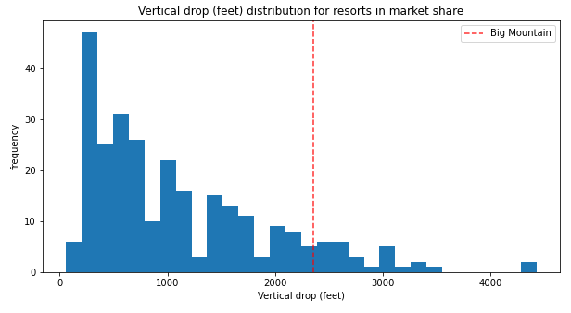

**Figure 6**

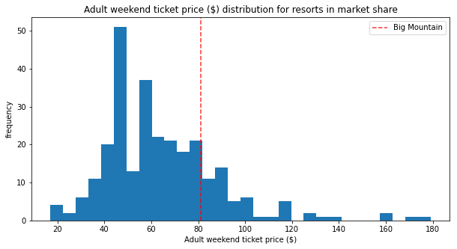

**Figure 7**

