**S-Mart Dress Code** **Updated 4/19**  
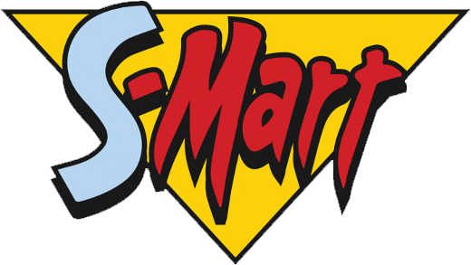

**Objective**

*S-Mart* strives to maintain a workplace environment that is well functioning and free from unnecessary distractions and annoyances. As part of that effort, the company requires employees to maintain a neat and clean appearance that is appropriate for the workplace setting and for the work being performed. To that end, S-Mart department heads may determine and enforce guidelines for workplace-appropriate attire and grooming for their areas; guidelines may limit natural or artificial scents that could be distracting or annoying to others.

**Procedures**

All S-Mart staff members are expected to present a professional image to customers, visitors and the public.

Supervisors should communicate any workplace specific attire and grooming guidelines to staff members during new-hire orientation and evaluation periods. Any questions about the department’s guidelines for attire should be discussed with the immediate supervisor.

Any staff member who does not meet the attire or grooming standards set by his or her department will be subject to corrective action.

(Adjust table below as necessary – clothing listed are merely suggestions)

|  |  |
| --- | --- |
| **APPROPRIATE** | **INAPPROPRIATE** |
| **Pants** | |
| * Khakis or corduroys * Jeans (must be clean and free of rips, tears and fraying; may not be excessively tight or revealing) * Skorts and capris | * Sweatpants, leggings, exercise wear * Shorts, low-rise or hip-hugger pants or jeans |
| **Shirts** | |
| * Polo collar knit or golf shirts * Oxford shirts * Company logo wear * Short-sleeve blouses or shirts * Turtlenecks * Blazers or sport coats * Jackets or sweaters | * Shirts with writing (other than company logo) * T-shirts or sweatshirts * Beachwear * Sleeveless blouses or shirts * Exercise wear * Crop tops, clothing showing midriffs, spaghetti straps |
| **Shoes** | |
| * Boating or deck shoes, moccasins * Casual, low-heel, open-back shoes (e.g., mules, sling backs) | * Sandals, thongs, flip flops, open-toe shoes * Athletic shoes, tennis shoes, Croc-like sandals |

**Addressing workplace attire and hygiene problems**

Violations of the policy can range from inappropriate clothing items to offensive perfumes and body odor.

If a staff member’s dress or poor hygiene is an issue, the supervisor should discuss the problem with the staff member in private and should point out the specific areas to be corrected. If the problem persists, supervisors should follow the normal corrective action process.