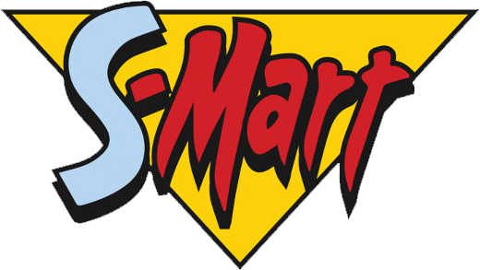

**S-Mart**

Dear *[Name of Employee],*

On (specific date and time), we met to discuss your performance. Specifically, we identified the following as being unsatisfactory: *[Describe in detail].*

In order to improve your performance, you should: *[Describe in detail].*

I will assist you in any way I can to remedy the problem. However, unless these matters can be corrected, I shall have no alternative but to undertake further disciplinary or corrective action, which may include suspension.

Sincerely,

_____________________________

(Name of Employer)

_____________________________

(Date)

_____________________________

(Printed Name and Title)

I hereby acknowledge receipt of this warning:

_____________________________

(Signature of Employee)

_____________________________

(Printed Name of Employee)