**Relex Last Mile Solution LTD**

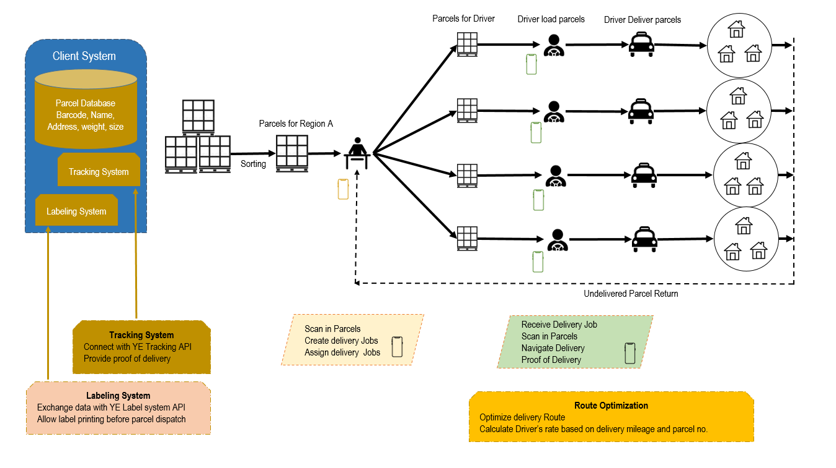

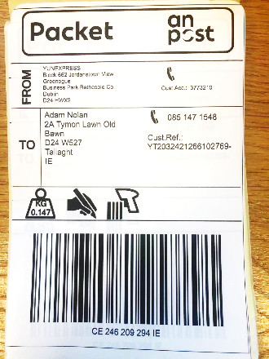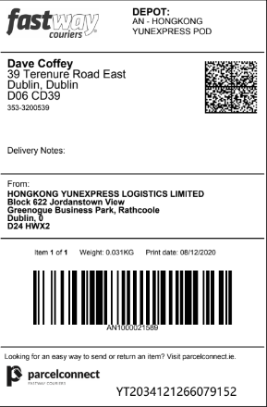

**Labeling System**

* Connect and exchange data with YE Label system API
* Allows YE print RELEX Label before parcel dispatched
* Example Label from Anpost and Fastway

**Parcel Status Tracking**

* Connect with YE Tracking API
* Return parcel status to YE
* Essential Status Parcel take by RELEX (A-Scan), Parcel Delivered (D-Scan)
* Proposed Status

(1) Parcel take by RELEX, (2) Out for Delivery, (3) Delivered, (4) Returned to Warehouse

**Route Optimization**

* Navigate delivery destination
* Route Optimization
* Rate calculation

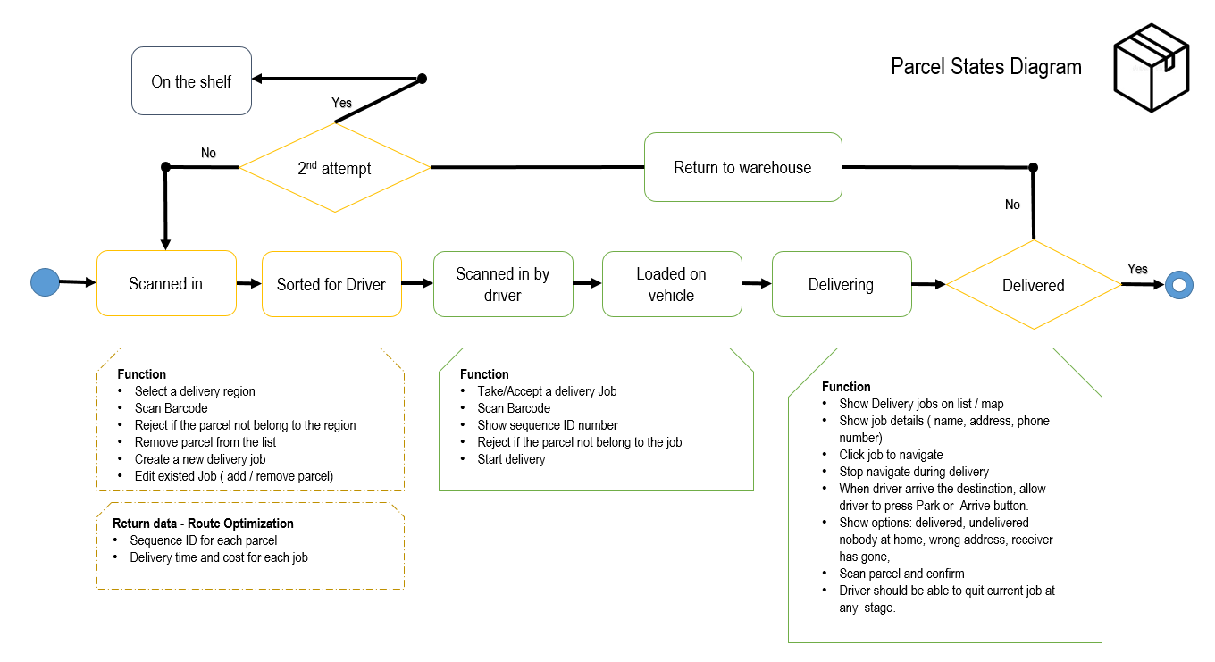

**Warehouse side – Application**

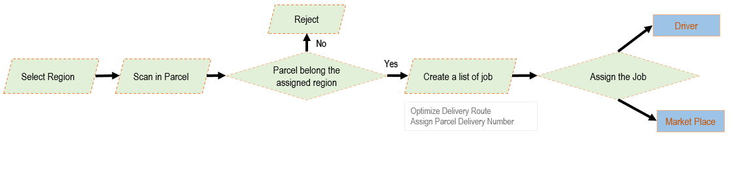

**Driver Side – Application**

