**FREECODE CAMP EDITION:**

HTML (HyperTextMarkupLanguage)

* Markup lang used to describe struct of web page.
* Elements usually have opening and closing tags that surround and give meaning to content.

***TAGS AND HOW TO USE:***

**Header**

* Have h1 – h6
* Used to add levels to web page. Tells browser about structure of website.
  + H1 elements often MAIN headings, h2 generally subheadings.. h3…h4….h6
    - Ex: <h1> text here </h1>

**Paragraph**

* Preferred element for paragraph text on websites.
  + Ex: <p> text here….. </p>

**Comments**

* Way to leave comments for other devs within your code without affecting resulting output.
* Convenient way to make code inactive
  + Starts with <!—and ends with -- >
    - example: <!—this is a comment - ->

**Images**

* Can add images to website using img element to point to specific image url using src attribute.
  + Ex: <img src=”https:// some url with pic” alt=”pic description”>
* Img elements are self closing.
* MUST HAVE alt attribute which improves accessibility and is displayed if img fails to load.
  + IF IMAGEP URELY DECORATIVE KEEP EMPTY

**Anchors**

* An element used to link content outside of web page.
* Needs destination web address called href attribute.
  + - Ex: <a href=”some website url> this is link to some website </a>
      * Browser will display “this is link to some website” that is clickable and takes you to the href url.
  + CAN USE to create internal links to jump to dif sections within webpage.
    - Do this by assign link’s href attribute to a hash symbol plus value of id attribute for element that you want to internally link to.
      * Ex: <a href=”#contacts-header”> Contacts </a>
        + <h2 id=”contacts-header”>Contacts</h2>
  + Can also nest into a paragraph element so part of paragraph is a link.
  + Can turn image into a link
  + Ex:
    - <a href=”#”><img src=” url img “ alt=”description”></a>
    - The # symbol indicates a dead link to jump to.
    - Helpful if we don’t know where to go yet.

**LISTS**

* Unordered Lists <ul>
  + Used to create bullet point list.
    - Ex: <ul>
      * <li>milk</li>
      * <li>cheese</li>
      * </ul>
* Ordered List <ol>
  + Initialize same way except numbered instead of bullets.

**WEB FORMS (input elements)**

* Used to get input from user. Aka INPUT elements
* **TEXTFIELD** 
  + Used to get text input
    - Ex: <input type=”text”>
      * Will gen rectangular box for user to type input
* **Form** 
  + Used to submit data to server using nothing but HTML
  + Can do this by specifying an action on your for melement.
    - Ex: <form action=”/url want to submit form data> </form>
    - Can put other input elements within form to send more data.
* **Button**
  + Click this to do some action like send data from form to URL lspecified with your form’s action attribute.
    - Ex: <button type=”submit”> this button submits form </button>
* **Required**
  + Can require specific form fields so your user will not be able to submit form until filled out.
  + Just add required at end of tag of input element.
  + EXAMPLE:
    - <input type=”text” required>
* **Radio Buttons**
  + Used for questions where want user to only give one answer out of multiple choice.
  + Each can be nested within own label element so auto associate radio button to label surrounding it.
  + 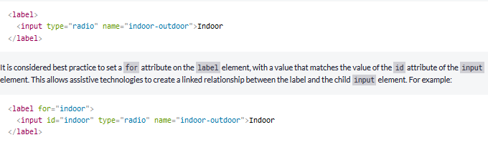EXAMPLE:
    - Will create two radio buttons and since name is same, only one can be clicked at a time.
    - Can check auto using checked keyword at end of tag
      * Ex: <input type=”radio” name=”test” checked>

**CheckBoxes**

* Type of input. Each checkbox also nested in label element.
* By wrapping input element inside label element auto associate.
* BEST PRACTICE to define relationship between checkbox input and corresponding label using for attribute
* Ex:
  + ^

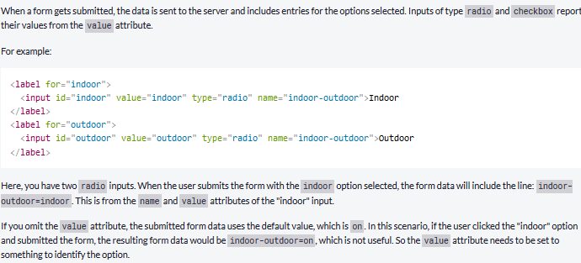

**Descriptive HTML tags**

* these tags give descriptive structure to html, make easier to read and help with search engine optimization.
* **Main** 
  + This tag helps search engines and other devs find main content of page
    - Ex: <main> <h1> hello world</h1> </main>