**Python 3.**

**Summary:**

* General purpose versatile popular programming language. Concise and easy to read, also good language to have in programmer stack as can be used for everything from web dev to software dev and data science

**SYNTAX**

* Comments
  + Text written in prog, but not run by cpu called comment.
  + Python interprets anything after a # as a comment.
  + Provides context for why something is written way it is
* Spacing
  + In python amount of whitespace tells cpuu what is part of a function and what is not part of it.
  + Tabs are not the same as 2 spaces or 4 by default.
  + Stay consistent with using tabs or spaces
* Print
  + print( “whatever u want in here” )
  + print can print anything, no need to convert to string
  + unless doing mix of str and another datatype
* Strings
  + 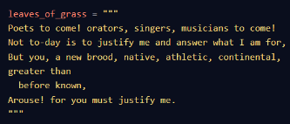Blocks of text.
  + Can be surrounded with double or single quotes, **JUST BE CONSISTANT**
  + Can create string with repeated string by doing
    - String a=anotherString*3; #repeats anotherstring 3 times in a
  + **Multi-Line Strings**
    - If want to write string spanning multiple lines use ‘’’ or “””
    - This lets compiler know string doesn’t end till next ‘’’.
* Variables
  + Way to store data for reuse. Assign variables with = sign in python.
    - Example
      * message_string=”Hello There”
      * print(message_string)
  + After var assigned to initial val, it CAN be reassigned to new val with dif data type from initial.
  + Can check type of a var using the type(var_name) and print to get result displayed
* Errors
  + When error occurs, python will point it out with a ^ character.
  + When prog throws error we don’t expect to encounter, call those BUGS.
  + TWO COMMON ERRORS
    - SyntaxError:
      * Something wrong with way your prog written
        + Punctuation does not belong
        + Command where not expected
        + Missing parenthesis
    - NameError
      * Python Interpreter sees word does not recognize.
      * Code that contains something that looks like var but was never defined will throw error
* Numbers
  + Python has few numeric data types.
  + Int
    - Whole number, no decimal point and contains counting numbers as well as negative and the number 0
    - An_int=2
  + Floating-Point number (float)
    - Decimal number. Can be used to rep fractional quantities.
      * Ex: average test score, length of wall…
      * A_float=2.1
* Calculations
  + Performs standard +, - , * , /
  + When doing devision, result has a decimal place. This is because Pyton converts all ints to float before performing division. (2.8 and up) version
  + DIVISION CAN THROW ZERODIVISIONERROR
  + EXPONENTS
    - Use the notation **
    - Example: print(2 ** 10) # 2 to the 10th power
  + Modulo
    - %
    - Give remainder of division calc
    - If number divisible, then modulo operator will be 0
      * Ex: 29%5=4
      * 25%5=0
  + CONCATENATION (+)
    - Doesn’t just add numbers, CAN ADD STRINGS
    - Concatenating strings can create brand new string compromised of contents of first and second string…
    - IF WANT TO CONCATENATE A STRING WITH A NUM HAVE TO MAKE NUM A STRING FIRST USING str()
    - Ex:
      * Age=10;
      * Print(“I am” + str(age)+” years old”)
  + PLUS EQUALS
    - Shorthand for updating vars.
    - When have num saved in var and want to add curr value of var can use +=
    - Example:
      * Num_hiked=12
      * numHiked+=2;
    - CAN BE UESD FOR STRING CONCATENATION TOO
* **Input**
  + Can assign val to var through user input.
  + We use keyword input()
    - Example:
      * Like_snakes=input(“Do you like snakes”)
* **Functions** 
  + Usually created if some process or calculation have to be repeated.
  + Can save time from having to rewrite code
  + General Format:
    - def function_name() :
      * #code here
  + PARAMETERS
    - Vars that can pass into function
    - Can do this
    - def function_name(par1,par2…):
    - These called positional arguments…assignment depends on order placed in
    - Can use keyword arguments where explicitly refer to what each arg is assigned to in function call
    - 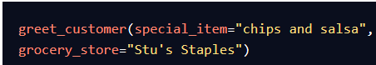Ex:
    - Can also define default args for function so if nothing placed inside, has defaukt.
      * Example:

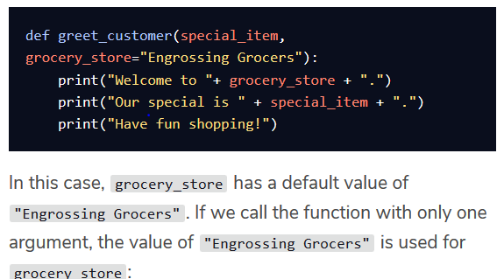

NOTE: KEYWORD ARGUMENTS WRITTEN SO THEY COME AFTER ALL POSITIONAL ARGUMENTS IN FUNCTION DEFINITION

* + RETURNS
    - Functions can return a val to user so that this val can be modified or used later using “return” keyword
    - Can return multiple return values by separating them with a comma
      * 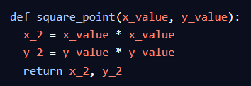
    - Can get these values by doing:
      * X_squared,y_squared=square_point(1,3)
      * When returning mult vals separated by commas, all vals listed actualy wrapped in a tuple (1,2,3…) that tuple is returned containing each val.
      * Can tuple unpack where if tuple has mult vals, can assign same num of vars to number of elements in tuple.
* **Boolean Expressions**
  + To add control flow to program, want to eval if statement true or not.
  + Can assign true or false to vars using var_name=True… # or False
  + Notice first letter capitalized
  + Relational operators:
    - == #equals, compares two items return true or flase
    - != #not equals
    - > …….. >=
    - <………<=
  + Boolean Operators
    - and
    - or
    - not #this is actual word, not ! like in Java
  + Conditional Statements
    - If(some condition):
      * Do stuff…
    - Elif(some condition):
      * Do stuff
    - Else:
      * Do stuff
    - TRY EXCEPT STATEMENS
      * try:
        + #some statement
      * except ErrorName:
        + #some statement
      * 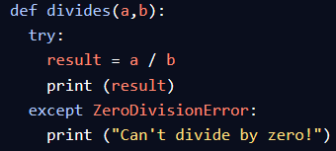Statement under try will execute, if there is an exception then goes to except statement and executes that and try terminates.
    - Can raise errors using “raise” keyword