COSC 360 – Project phase 1

Group members:

Leo Chen 13099197

Zhengyu Yang 21992169

Outline:

1. Logic process
2. Site Map
3. Layout
4. Logic process

All pages’ header: On the top left side, you can click on home to go to the main page. On the top right side, you can click on register, which will take you to the register site. If you click on login, it will pop up a window to let you log in.

Main page: For the main page, you can click on the text or image to go to the specific forum, which are PE forum, Gaming forum, Animation forum and Education forum.

Register page: You need to input all the information showing up. For username, your input must be email.

PE forum: You can click on the orange buttons to lead you to the discussion for the news you would like to discuss.

Animation forum: You can click on the pink buttons to lead you to the discussion for the news you would like to discuss.

Education forum: you could click “ask question” button to post a question, and to click “find solutions” to look up others’ solutions.

Gaming Forum: you could look others’ comments by clicking links.

Post: you can post things here.

Reply: you are replying here.

Discussion: You can click on the reply button on the top to reply the article or you can click on the other reply buttons to reply the specific person you would like to reply.

1. Site Map

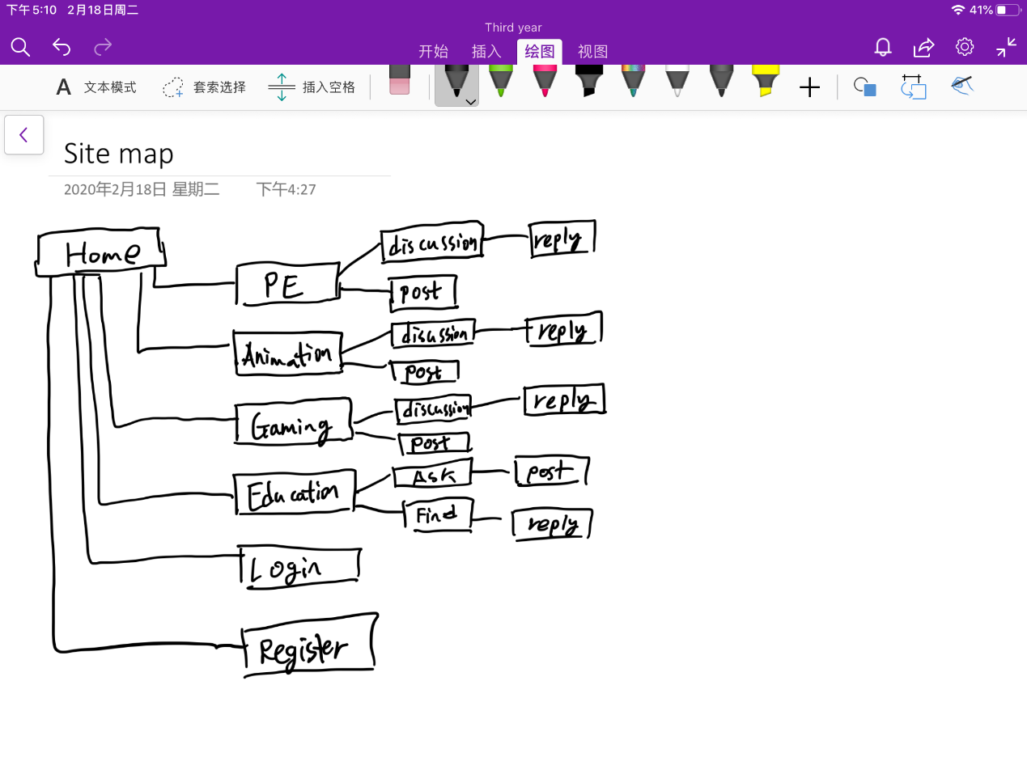

1. Layout

