**Screen Time Project Report**

**-**

Nur Deren Sakin 29078

# 1. Motivation

This project was initiated to gain a deeper understanding of personal mobile phone usage patterns over a one month period. The objective is to analyze how different types of applications contribute to daily screen time and to identify potential areas for reducing unnecessary usage. By reflecting on my personal habits, the insights derived from this project can promote healthier digital behaviors.

# 2. Data Source

The dataset used in this project was collected by tracking daily screen time for various application categories over a one month period. The data is stored in a CSV file named 'Updated_my_data.csv'. This file includes fields such as:  
- Date: The day when data was recorded.  
- Time spent on applications.  
- Daily Total Time: Sum of all usage time.  
  
The file contains daily records of my mobile phone usage, categorized into different application types.

# 3. Data Analysis

## 3.1 Exploratory Data Analysis (EDA)

EDA was performed to understand the distribution and trends of screen time over the this period. The main steps include plotting the total daily screen time, analyzing the contribution of different application categories to the total usage, and identifying peak usage days.

## 3.2 Visualizations

Total daily screen time:  
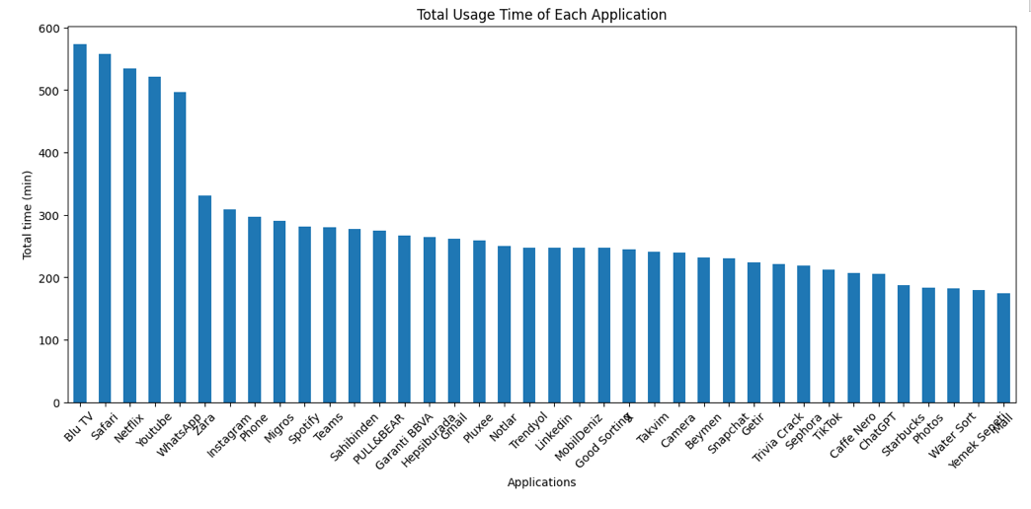çizgi, öykü gelişim çizgisi; kumpas; grafiğini çıkarma, diyagram içeren bir resim

Açıklama otomatik olarak oluşturuldu

Total usage distribution by category with pie and bar chart:

metin, ekran görüntüsü, çizgi, öykü gelişim çizgisi; kumpas; grafiğini çıkarma içeren bir resim

Açıklama otomatik olarak oluşturuldu

metin, diyagram, ekran görüntüsü, daire içeren bir resim

Açıklama otomatik olarak oluşturuldu

Hourly intervals:

metin, ekran görüntüsü, çizgi, diyagram içeren bir resim

Açıklama otomatik olarak oluşturuldu

Daily usage of Blu TV and Netflix applications:çizgi, öykü gelişim çizgisi; kumpas; grafiğini çıkarma, diyagram, eğim, bayır içeren bir resim

Açıklama otomatik olarak oluşturuldu

Categorical distribution:

# metin, diyagram, ekran görüntüsü, daire içeren bir resim Açıklama otomatik olarak oluşturuldu

# metin, ekran görüntüsü, diyagram, dikdörtgen içeren bir resim Açıklama otomatik olarak oluşturuldu

# 4. Findings

Key findings from the data analysis include:  
1. Peak Usage: The highest screen time was observed on certain days due to increased Youtube and Spotify usage.  
2. Category Contribution: Youtube contributed to total usage, followed by Spotify and productivity apps.  
3. Weekend Patterns: Screen time increased significantly during weekends, indicating higher engagement in entertainment apps.

# 5. Limitations and Future Work

Limitations:  
- The dataset covers only two weeks, which may not be representative of long-term usage patterns.  
- Data was collected manually, which could introduce errors.  
- There are some gaps in the data.  
  
Future Work:  
- Automate data collection using a mobile application to improve accuracy.  
- Extend the data collection period to capture seasonal variations in usage.  
- Apply machine learning models to predict future screen time and suggest optimal usage.

# 6. Conclusion

This project provided valuable insights into my personal mobile usage patterns. By identifying high-usage periods and understanding category contributions, it is possible to devise strategies for healthier screen time management. Future enhancements, such as automating data collection and incorporating predictive models, could further improve the analysis.

**Code Explanation**  
1. Import the libraries, load the data

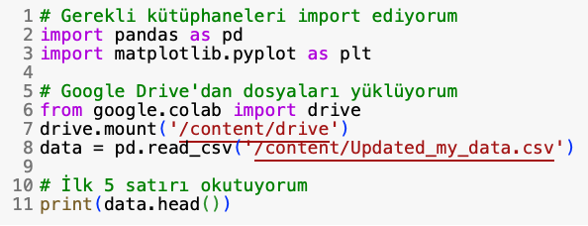

2. Plotting Total Daily Screen Time

metin, ekran görüntüsü, yazı tipi içeren bir resim

Açıklama otomatik olarak oluşturuldu

metin, yazı tipi, ekran görüntüsü içeren bir resim

Açıklama otomatik olarak oluşturuldu