LOCAL FLOW
MLX Cleanup Benchmark
Replacing a 3.3 GB Ollama cleanup hop with a lightweight native MLX model
Research brief | July 6, 2026 | Local benchmark over 24 filler-heavy dictation references
0.240s  median cleanup latency  MLX rerun after unloading 30B model | 3.8x  median speedup  0.914s Ollama / 0.240s MLX | 5.6x  p90 speedup  1.485s Ollama / 0.264s MLX

Executive Summary
The benchmark supports making MLX cleanup the focus of the next Local Flow hardening phase. With Qwen2.5 1.5B Instruct 4-bit loaded through MLX, the cleanup hop dropped from a 0.914 second Ollama median to 0.240 seconds, while keeping the dictation path local and avoiding cloud inference.
This is not yet a production swap. The MLX path needs a deterministic sanitizer, an added-word guard, and an acceptance suite before it replaces Ollama.
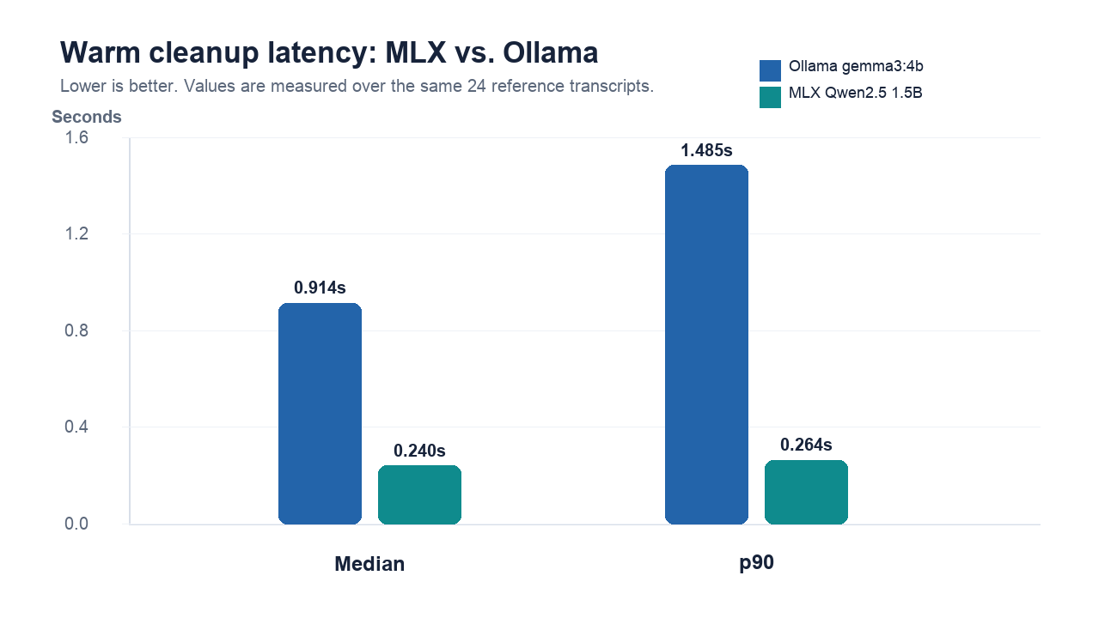

Research Method
Method item | Value
Input set | 24 verbatim references from bench/samples/manifest.json
Baseline | Existing Ollama gemma3:4b cleanup report
Candidate | mlx-community/Qwen2.5-1.5B-Instruct-4bit
Sampling | Temperature 0.0 for the strict rerun
Runtime condition | Qwen3-Coder 30B was unloaded before the final rerun to reduce memory pressure
Decision standard | Lower latency is useful only if meaning preservation remains enforceable

Measured Results
Dimension | Ollama gemma3:4b | MLX Qwen2.5 1.5B | Interpretation
Median warm cleanup | 0.914s | 0.240s | MLX is 3.8x faster
p90 warm cleanup | 1.485s | 0.264s | MLX is 5.6x faster at the tail
First-call / load effect | 12.070s first call | 0.669s load + warmup | MLX has lower observed residency penalty
Model footprint | 3.3 GB | 0.88 GB cached files | MLX candidate is materially lighter
Runtime posture | Localhost daemon | Native MLX target | Both stay local; MLX better matches Mac-native goal
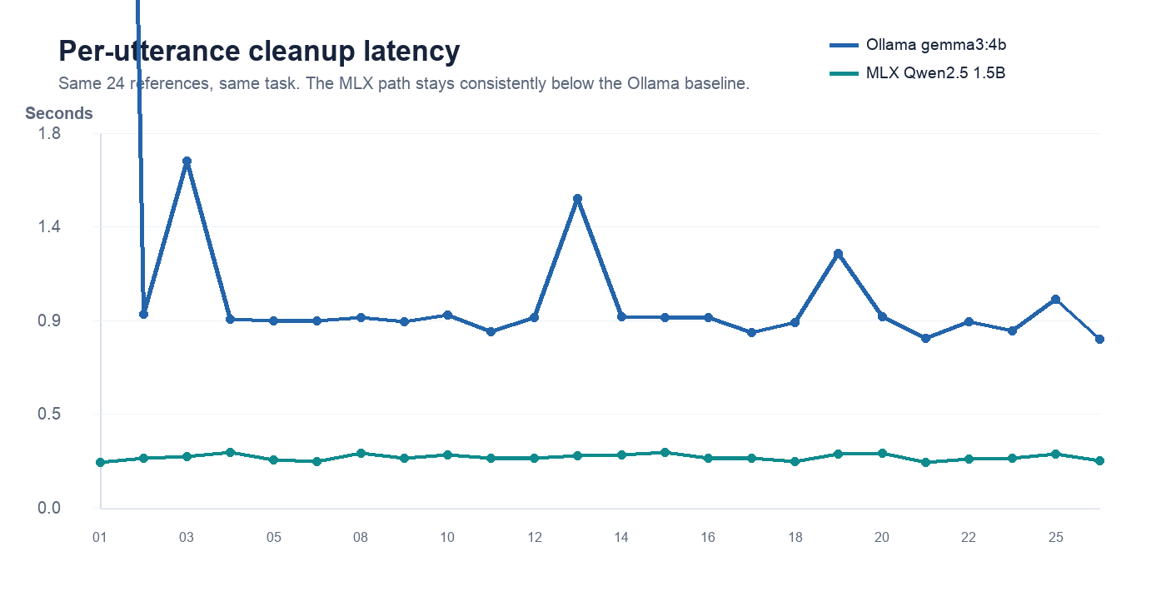
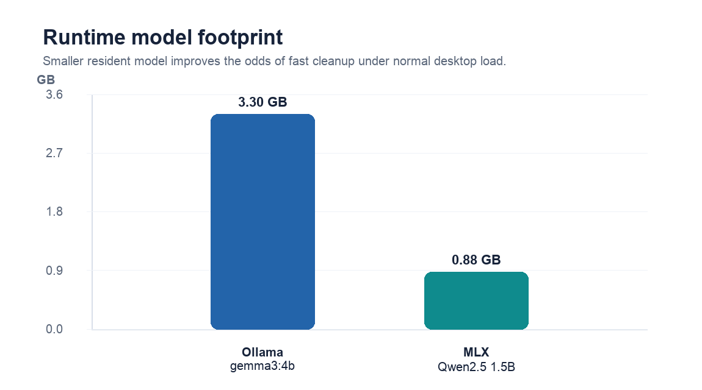

Architecture Implication
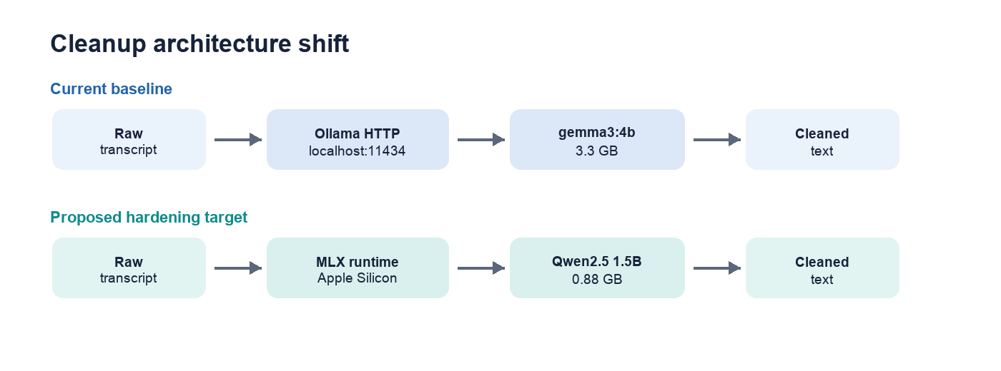
The product goal is not simply local cleanup; it is fast local cleanup. The MLX path removes the Ollama daemon hop, uses a smaller model, and aligns the cleanup engine with Apple Silicon.

Quality Findings
Dimension | Ollama gemma3:4b | MLX Qwen2.5 1.5B | Interpretation
Meaning preservation | No obvious answer-style hallucinations in the strict MLX rerun.
Known artifacts | One Markdown artifact around GROUP BY; one added article in 'the Standup'; a few filler words retained.
Production guard | Strip Markdown/code formatting, reject added content, preserve protected markers, and fall back to raw.
Acceptance gate | Run the 24-reference set plus the production plausibility guard before making MLX default.

Recommendation
Phase 3 Continuation should be scoped as MLX Performance and Reliability Hardening. The first task is not a blind replacement of Ollama; it is an optional MLX cleanup provider with deterministic output controls, benchmark reporting, and rollback to raw or Ollama when safety checks fail.
Recommended acceptance: MLX median cleanup below 0.350 seconds, p90 below 0.500 seconds, zero meaning changes on the acceptance set, no Markdown artifacts, and no non-local network dependency in the dictation path.

Sources And Reproducibility
bench/samples/manifest.json - 24 reference transcripts used as benchmark inputs
raw-ollama-cleanup.md - Ollama gemma3:4b baseline report
raw-mlx-cleanup.md - final MLX rerun report
app/Sources/LocalFlow/Cleaner.swift - production cleanup prompt and plausibility-guard context
https://huggingface.co/mlx-community/Qwen2.5-1.5B-Instruct-4bit - approved MLX model package
https://huggingface.co/Qwen/Qwen2.5-1.5B-Instruct - upstream model card

