LOCAL FLOW
Post-Safety Production Acceptance Benchmark
Run label: Task 11 Rejected Candidate Diagnostics
0.275s  median production latency  warmup excluded | 5.377s  p95 production latency  24 samples | 22/0/2  path split  MLX/Ollama/raw

Executive Summary
This run measures the actual production cleanup chain after one warmup inside a single process: MLX first, Ollama fallback second, and raw transcript fallback last. Manual output review remains required before changing the default provider.
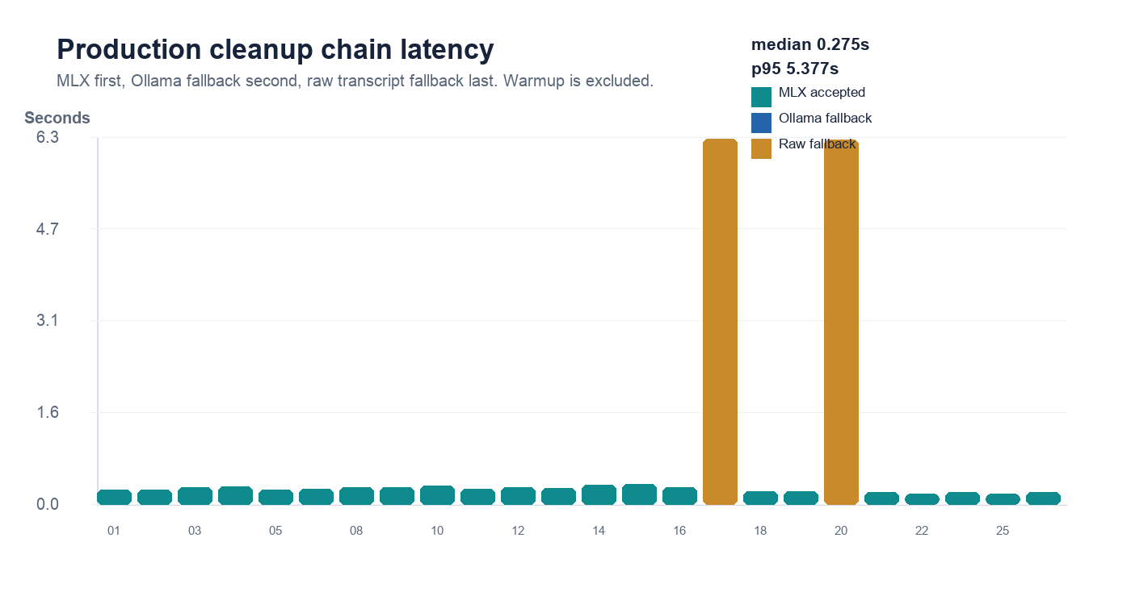

Runtime Contract
Item | Value
Selected provider | mlx
Provider chain | mlx (mlx-community/Qwen2.5-1.5B-Instruct-4bit) -> ollama (gemma3:4b)
Warmup | 1.314s via mlx
Automated decision | hold_for_raw_fallback_review
Manual review | required before default switch

Sample Results
ID | Latency | Path | Attempted | Final text
01 | 0.244s | mlx | mlx | I think we should ship it Friday.
02 | 0.249s | mlx | mlx | Yeah, basically the dashboard is broken again.
03 | 0.287s | mlx | mlx | Can you send me the link to that doc?
04 | 0.301s | mlx | mlx | So I was thinking maybe we grab lunch after standup.
05 | 0.256s | mlx | mlx | Let's move the meeting to three thirty instead.
07 | 0.268s | mlx | mlx | I mean, it's probably a caching issue.
08 | 0.294s | mlx | mlx | so like the query takes forever when i add the group by
09 | 0.295s | mlx | mlx | Remind me to follow up with Sarah tomorrow morning.
10 | 0.322s | mlx | mlx | Yeah, I'll push the fix after I grab a coffee.
11 | 0.260s | mlx | mlx | So, the memory usage spikes every night around midnight.
12 | 0.289s | mlx | mlx | Can we circle back on the pricing thing next week?
13 | 0.282s | mlx | mlx | Honestly, I think the second option is way better.
14 | 0.326s | mlx | mlx | My flight gets in at like seven so dinner at eight works.
15 | 0.351s | mlx | mlx | so basically zendesk tickets should route to the the triage queue
16 | 0.289s | mlx | mlx | I want to test this on the staging cluster first.
17 | 6.271s | raw_fallback | mlx, ollama | yeah the uh the new hire starts monday i think
18 | 0.218s | mlx | mlx | Let's just revert it and investigate tomorrow.
19 | 0.215s | mlx | mlx | so grafana needs the api key rotated before the demo
20 | 6.264s | raw_fallback | mlx, ollama | okay um long story short we we missed the deadline by two days
21 | 0.209s | mlx | mlx | I think we should ship it Friday.
22 | 0.178s | mlx | mlx | Yeah, basically the dashboard is broken again.
23 | 0.202s | mlx | mlx | Can you send me the link to that doc.
25 | 0.182s | mlx | mlx | Let's move the meeting to three thirty instead.
26 | 0.209s | mlx | mlx | okay so the customer said the alerts are firing twice.

Rejected Attempt Diagnostics
ID | Provider | Latency | Outcome | Reason | Detail | Raw candidate
17 | mlx | 0.259s | rejected | protectedMarkerLoss | i think | Yeah, the new hire starts next Monday.
17 | ollama | 6.012s | timeout | requestTimedOut | 6.0s
20 | mlx | 0.259s | rejected | addedMeaningToken | uh | Okay, uh, long story short, we missed the deadline by two days.
20 | ollama | 6.004s | timeout | requestTimedOut | 6.0s

