LOCAL FLOW
Swift MLX Steady-State Benchmark
Run label: Task 5 Swift Steady State
0.139s  median repeated cleanup  load/warmup excluded | 0.166s  p95 repeated cleanup  24 samples | 0.199s  max repeated cleanup  tail observation

Executive Summary
This run measures native Swift MLX cleanup after one model load and one warmup generation. The reported median, p90, p95, and max values describe repeated cleanup calls inside one process.
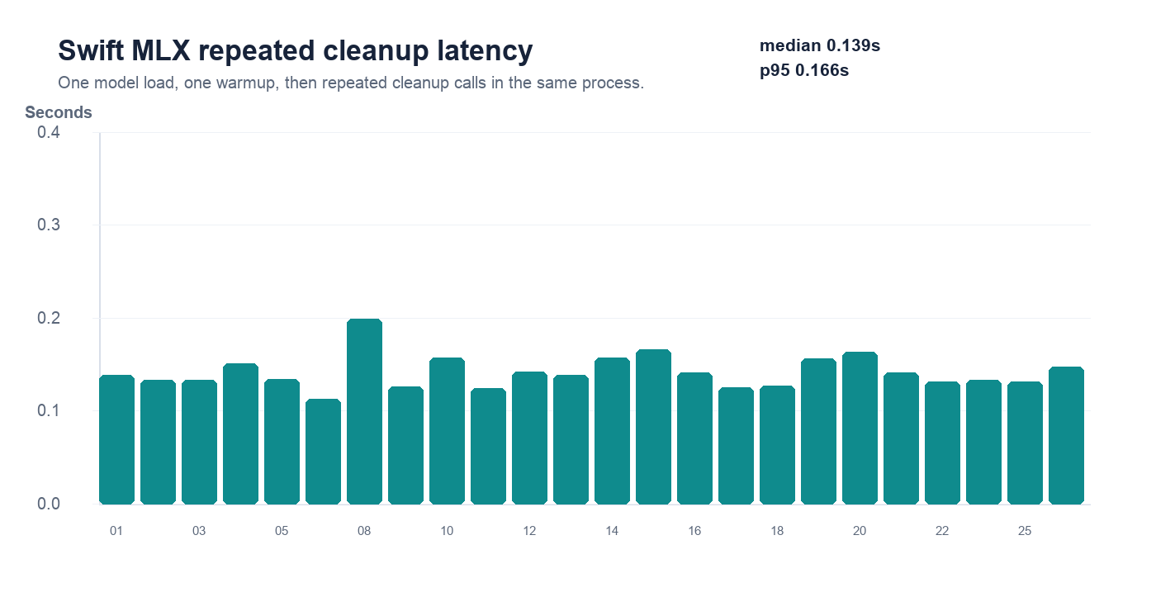

Sample Results
ID | Latency | Cleaned output
01 | 0.139s | So, I think we should ship it on Friday.
02 | 0.133s | Yeah, so basically the dashboard is broken again.
03 | 0.133s | Can you send me the link to that doc?
04 | 0.151s | So I was thinking maybe we grab lunch after standup.
05 | 0.134s | Let's move the meeting to three thirty instead.
07 | 0.113s | It's probably a caching issue.
08 | 0.199s | The query takes a long time to execute when I add the `GROUP BY` clause.
09 | 0.126s | Remember to follow up with Sarah tomorrow morning.
10 | 0.157s | Yeah, I'll push the fix after I grab a coffee.
11 | 0.124s | The memory usage spikes every night around midnight.
12 | 0.142s | Can we circle back on the pricing thing next week?
13 | 0.139s | Honestly, I think the second option is much better.
14 | 0.157s | My flight gets in at seven, so dinner at eight works.
15 | 0.166s | So basically, Zendesk tickets should route to the triage queue.
16 | 0.141s | I want to test this on the staging cluster first.
17 | 0.125s | The new hire starts Monday, I think.
18 | 0.127s | Let's just revert it and investigate tomorrow.
19 | 0.156s | Grafana needs to rotate the API key before the demo.
20 | 0.164s | Okay, long story short, we missed the deadline by two days.
21 | 0.141s | So, I think we should ship it on Friday.
22 | 0.132s | Yeah, so basically the dashboard is broken again.
23 | 0.133s | Can you send me the link to that doc?
25 | 0.132s | Let's move the meeting to three thirty instead.
26 | 0.148s | Okay, so the customer said the alerts are firing twice.

