Lab 3
- Functions
point | C | 32bit | 64bit
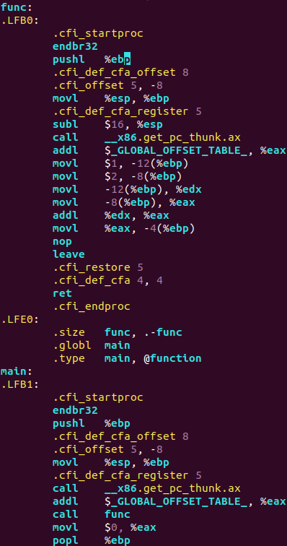  a. No args no ret | 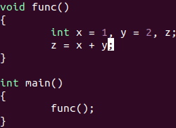 |  | 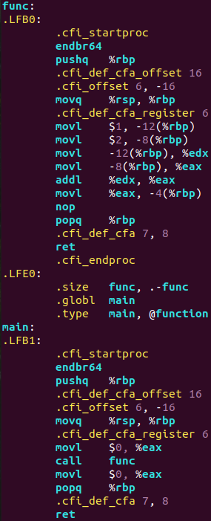
b. No args, ret | 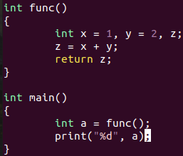 | 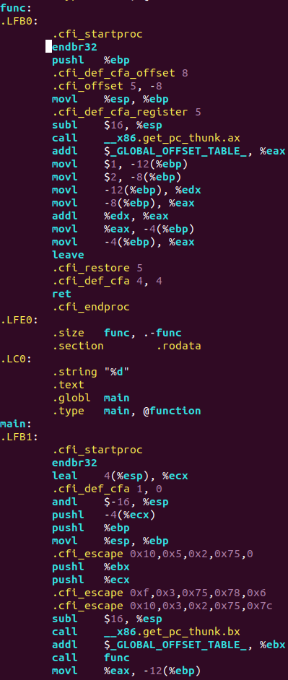 | 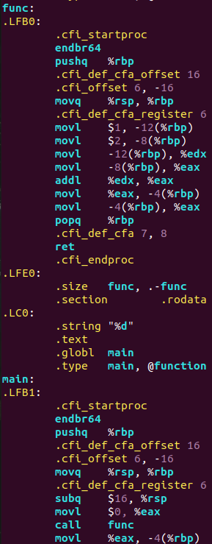
c.1 arg | 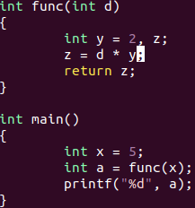 | 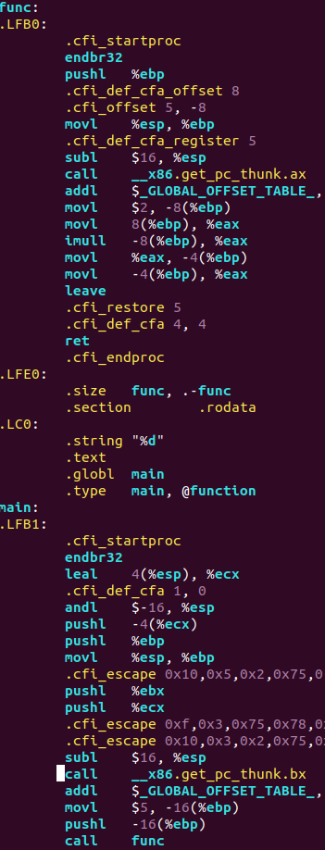 | 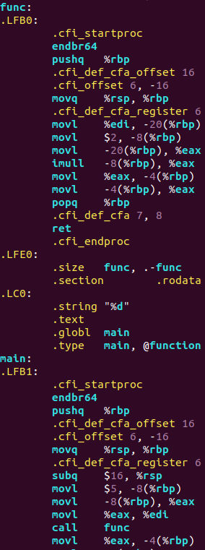
d. many args | 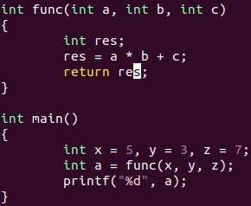 | 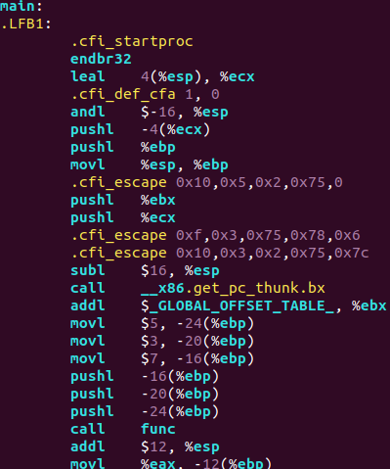  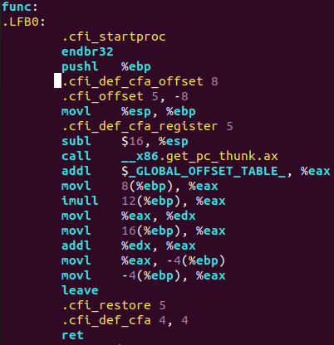 | 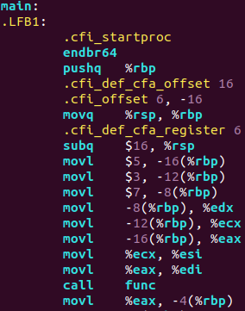  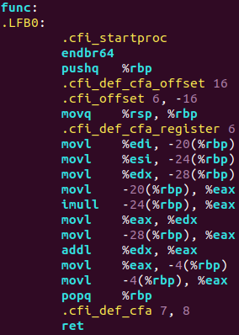
General observations:
- register %eax is used as a return value
- 32bit and 64bit systems operate the setup and cleanup of stack frame differently(i.g. 32bit uses leave(equals movl + popl), 64bit operate with just popq
- another feature of 64bit system is that, unlike 32bit system, which allocate memory for local variables using, i.g., subl $16, %esp in both main and leaf function, there is a “red zone” of 128 bytes below %rsp. These 128 bytes belong to the function as long as it’s a leaf function. Thus, all of local variables of a leaf function fit into the red zone, so no adjustment of %rsp needed (no instructions such as subq $16, %rsp).

2. Local variables.
point | C | 32bit | 64bit
a. 1 loc var | int x = 5 | 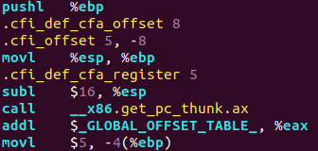 | 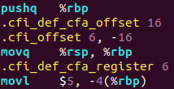
b. 5 loc var | int a = 5, b = 4, c = -6, d = 8, i = 9; | 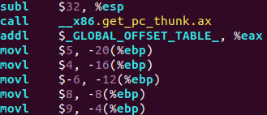 | 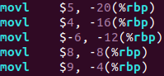
c. static array | int arr[50];  arr[7] = -345; | 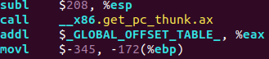 | 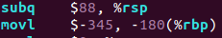  Without stack protector  With stack protector  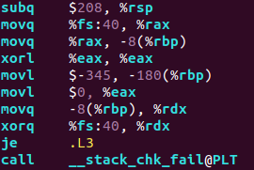
d. dynamic array(C) | 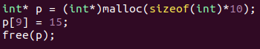 | 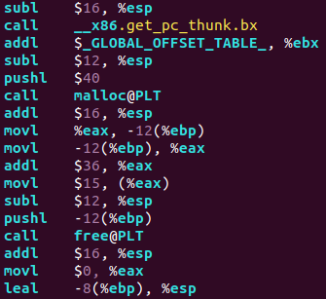 | 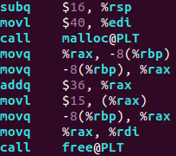
d. dynamic array(C++) | 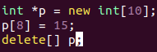 | 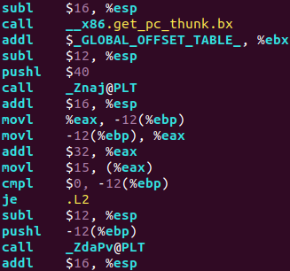 | 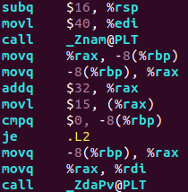  _Znam@PLT = new[]  _ZdaPV@PLT = delete[]

- static array in 64bit shift %rsp to a less amount, than the size of array, perhaps, because of the red zone.
- In 32bit system size of dynamic array is pushed in stack; in 64bit is moved to %edi
- %eax/%rax initially refers to the first element of dynamic array(it must be so because after we call malloc/new[], the result of function, i.e. pointer to the first element, is written in %eax)

3. Structures

point | C++ | 32bit | 64bit
b. global struct | 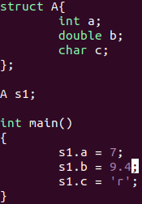 | 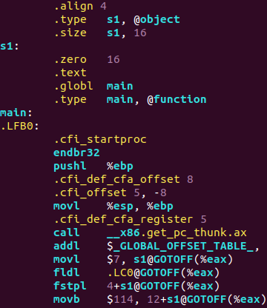 | 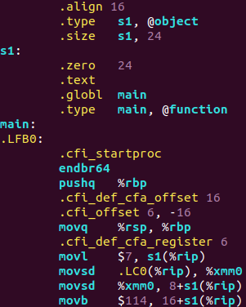
c. static array as a member | 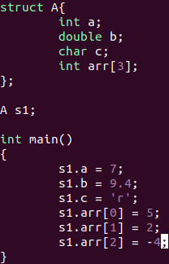 | 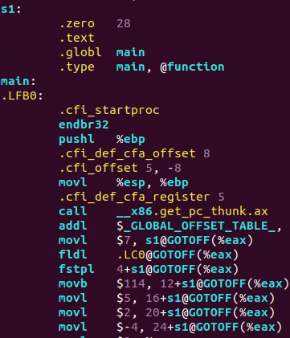 | 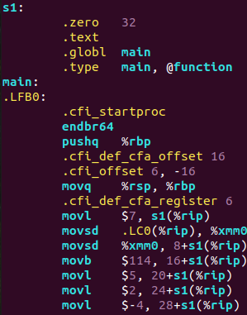
d. struct as an arg in function | 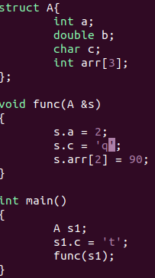 | 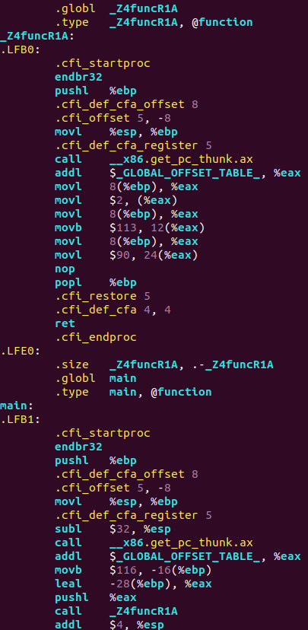 | 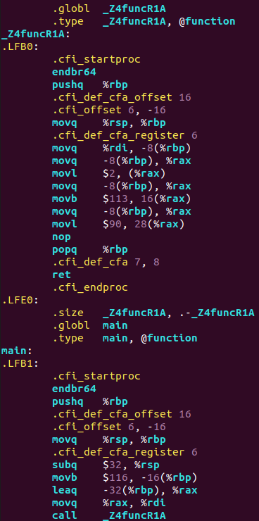
e. struct as a return value | 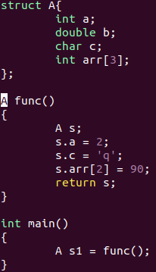 | 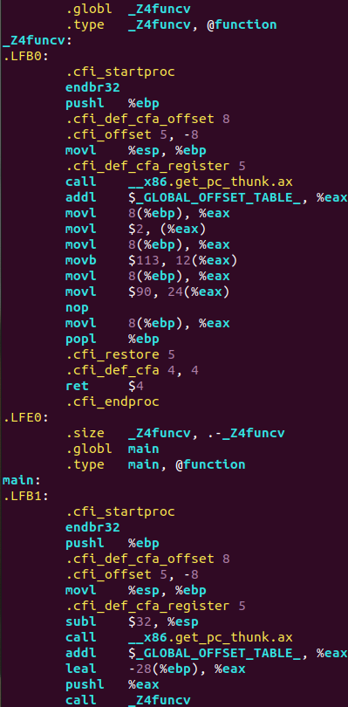 | 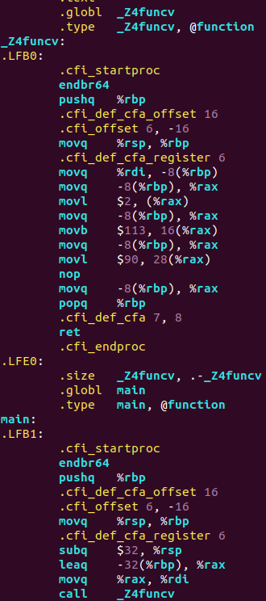

- in 32bit system Global offset table is used to dynamically access structures(in this task) . In a. and b. @GOTOFF is used for global structures – perhaps it stands for GOT Offset, meaning making an offset from GOT address. In 64bit system register %rip was responsible for that.

4. Pointers and references
point | C++ | 32bit | 64bit
a. struct | 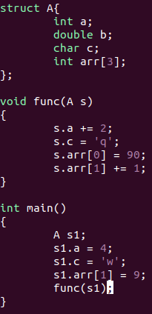 | 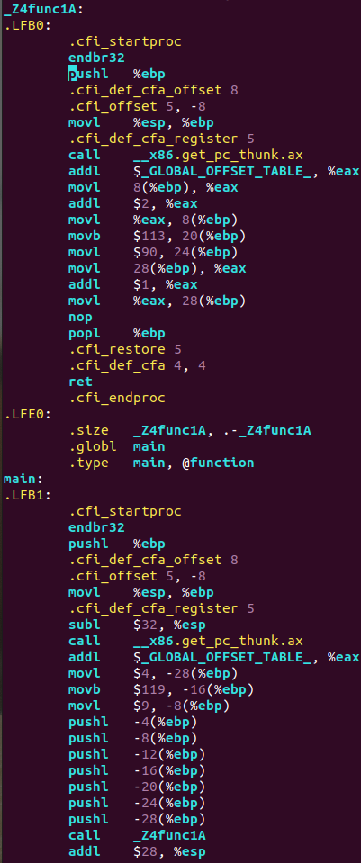 | 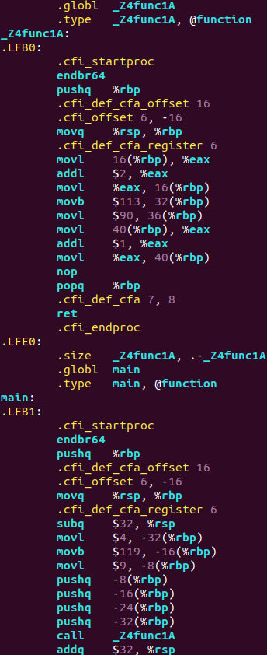
b. struct pointer | 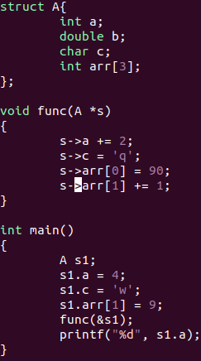 | 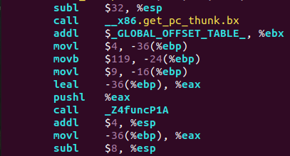  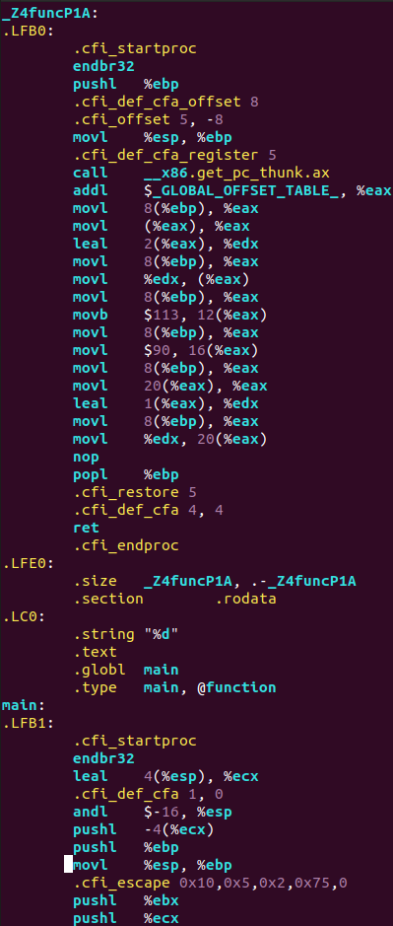 | 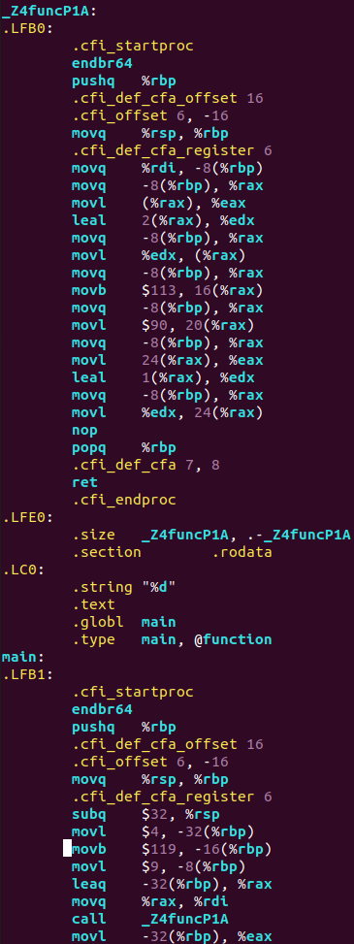
c. struct reference | 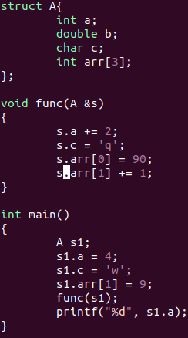 | 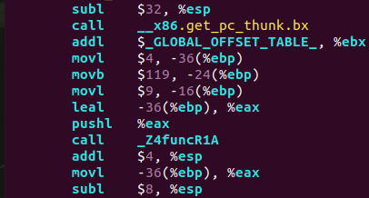  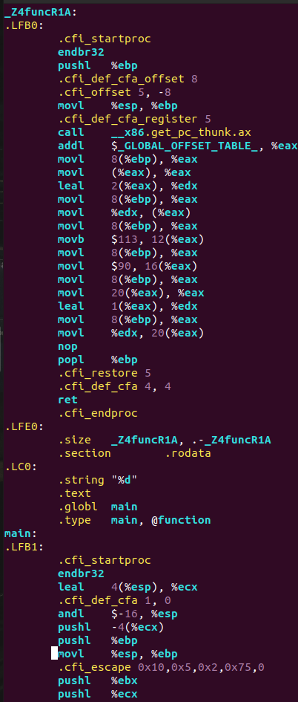 | 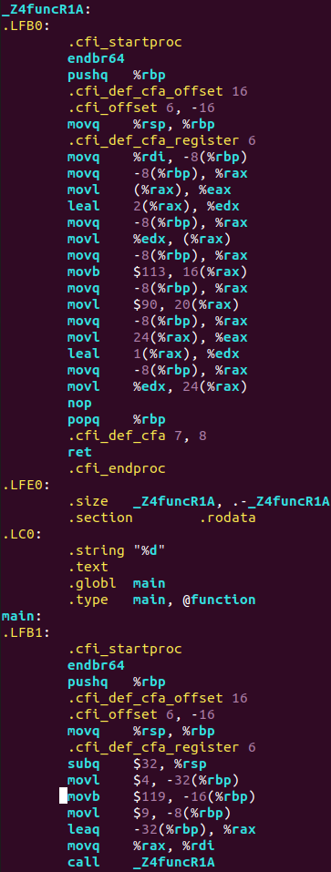

- in a. all struct members are pushed into stack; in b. and c. (pointers and references) struct members are not pushed into stack, only registers and stack frame(via i(%rbp)) are used.

5. Heavy structures
point | C++ | 32bit | 64bit
a. struct as an arg | 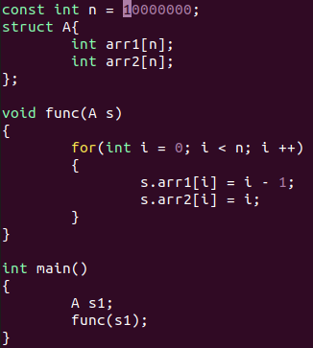 | 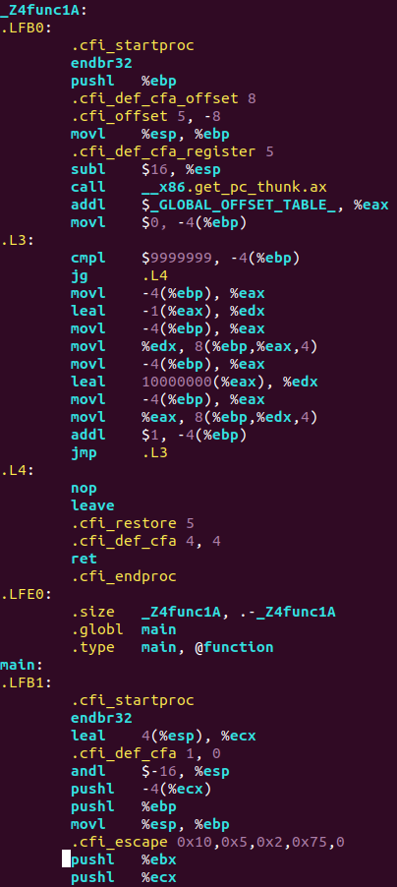  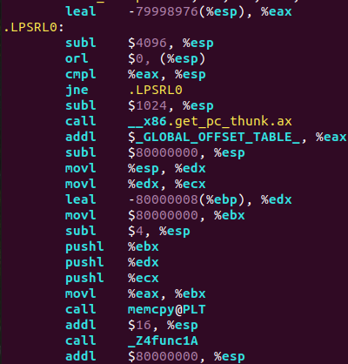 | 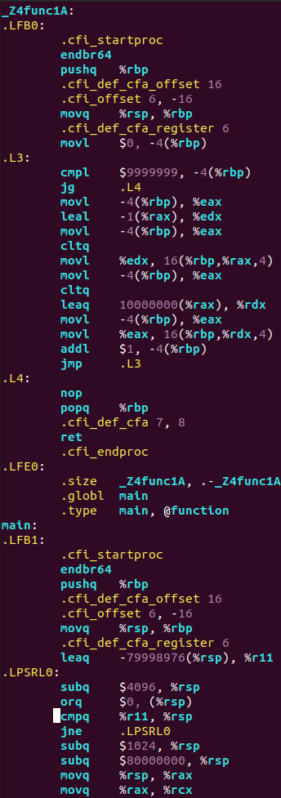  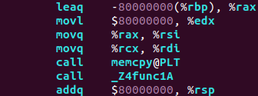
b. struct as a return value | 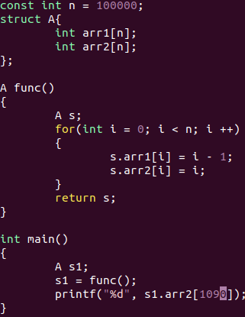 | 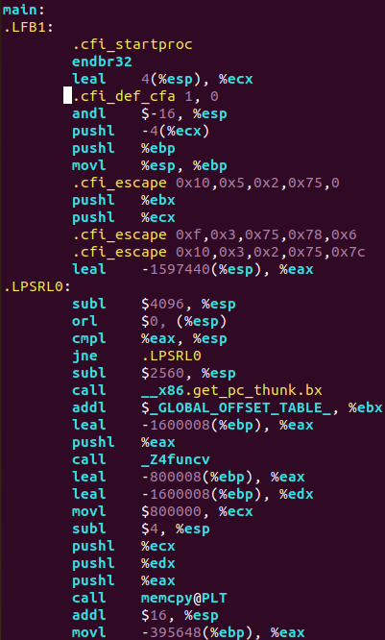  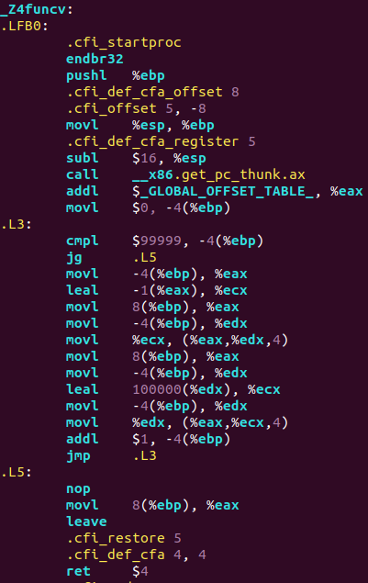 | 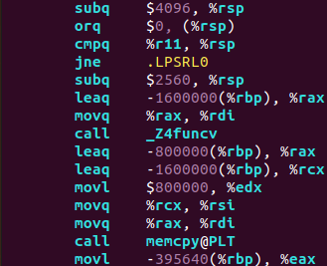  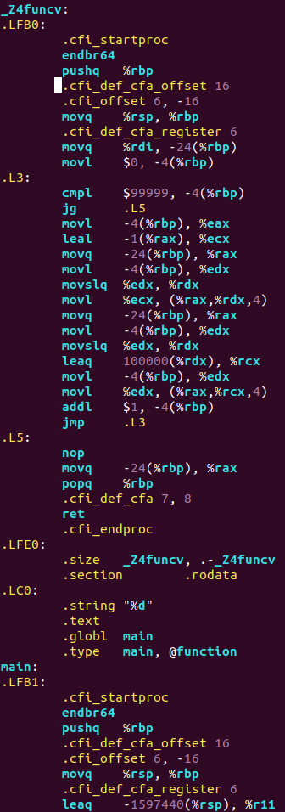
c. struct as local var | 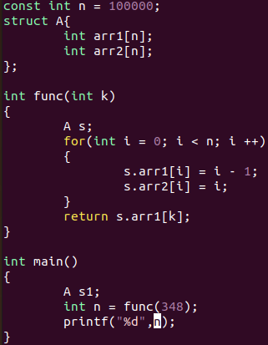 | 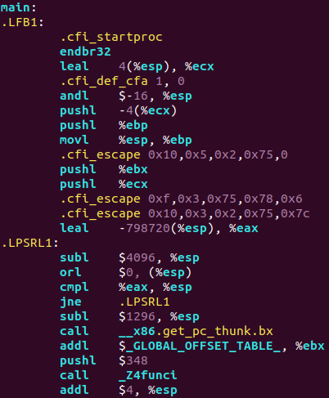  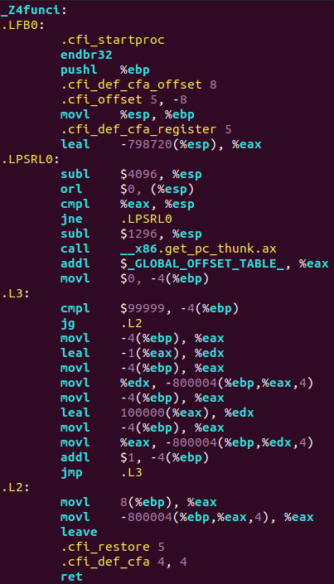 | 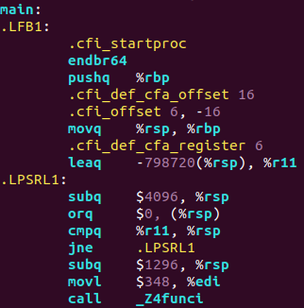  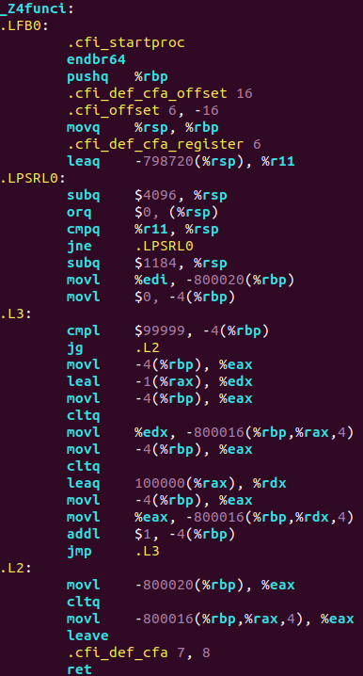
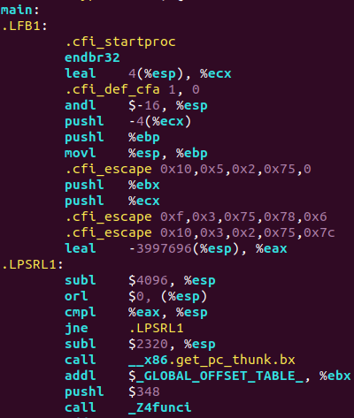  d. changing size(relative to c.) | Size = 500000 | 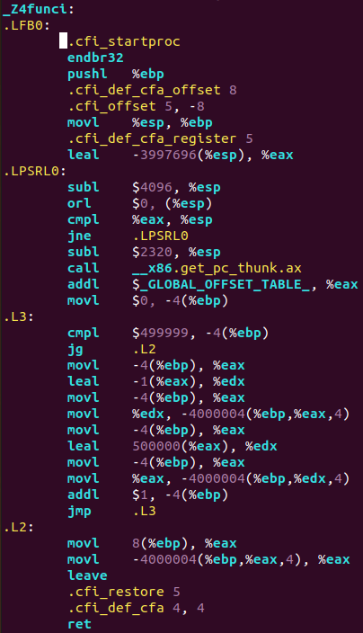 | 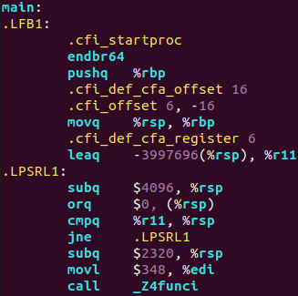  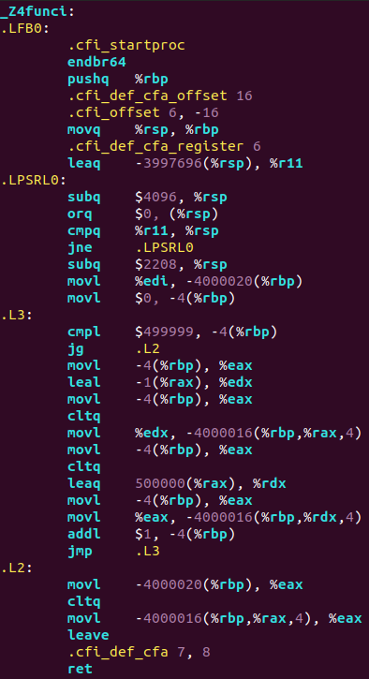

- just big numbers of allocated memory appear
- also it seems that %rsp cannot be reduced by a bigger number than 4096, thus there is a cycle .LPSRL1, which decrements %rsp only by 4096. After that %rsp is once again decremented for lacking bytes.

6. Recursion
C | 32bit | 64bit
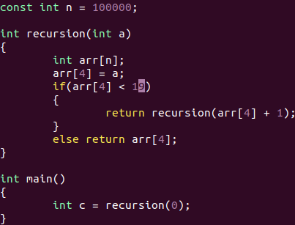 | 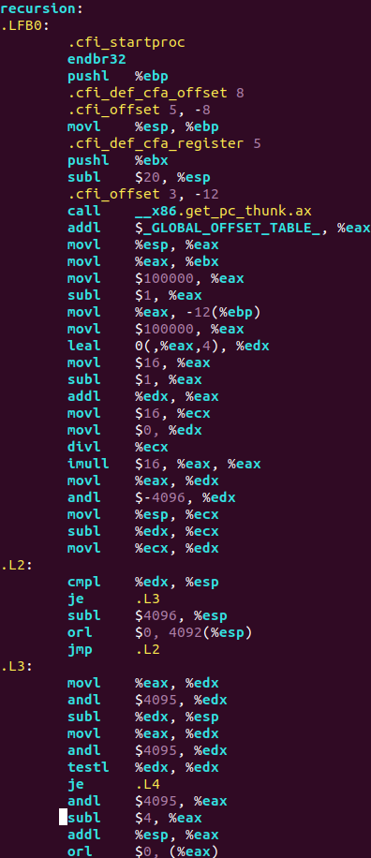  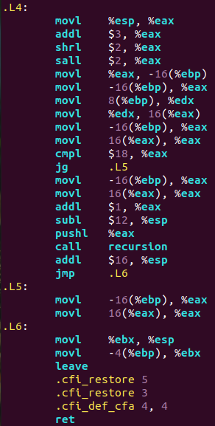  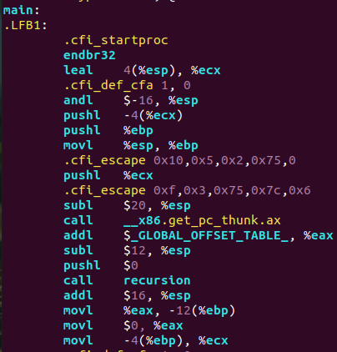 | 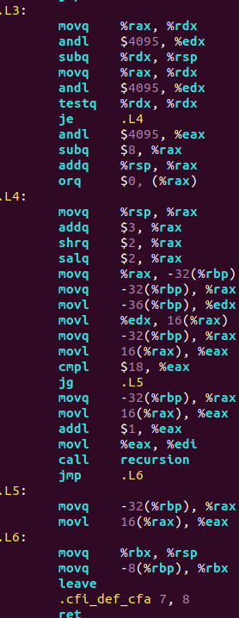  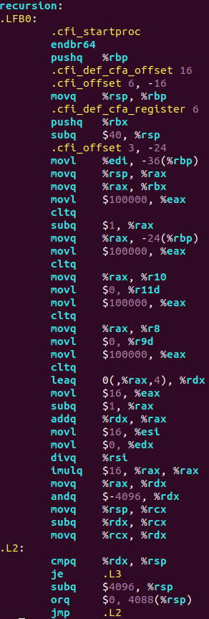  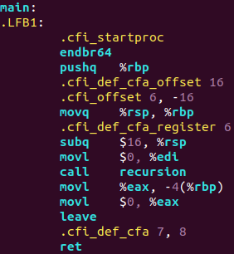
C++ | 32bit | 64bit
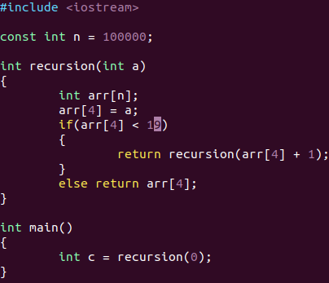 | 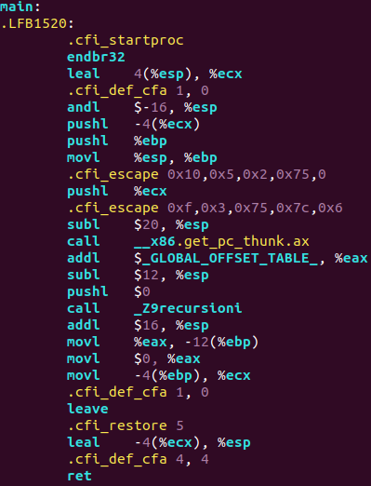  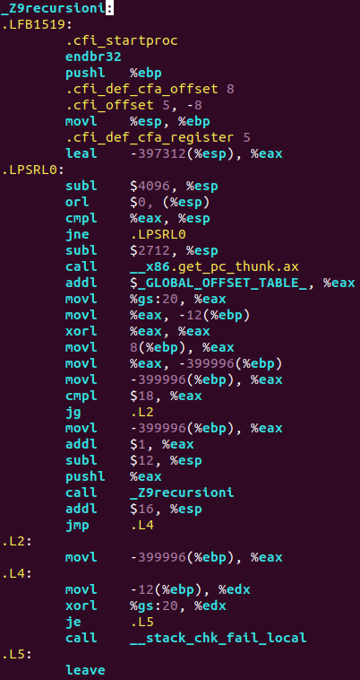 | 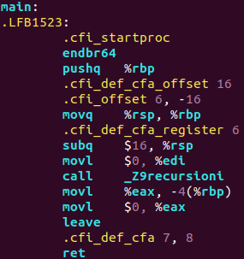  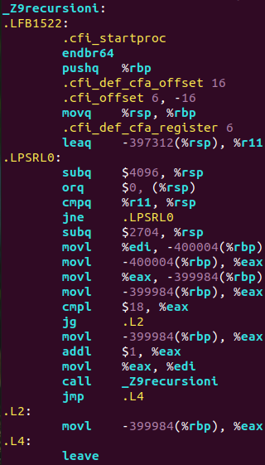
- Differences between 32bit and 64bit are not that significant, just the amount of memory allocated for arrays(differs by approximately 0-20 bytes)
- program executes correctly, when arr[4] < 19, so for 20 recursion calls. If I write arr[4] < 20 – stack overflow occurs. So the estimated stack size is between 20*100000*4 bytes ≈ 7800KB and 8200KB. So assuming that stack size is a good looking number, it’s around 8MB.

