Lab 3/4

Lab 3
- Functions
point | C | 32bit | 64bit
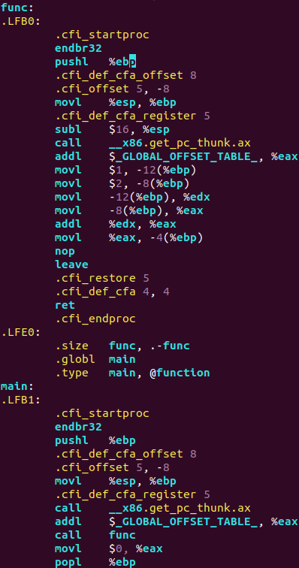  a. No args no ret | 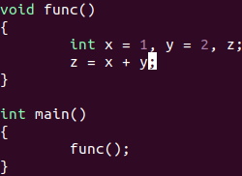 |  | 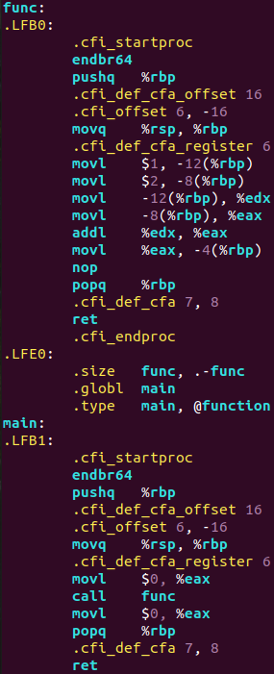
b. No args, ret | 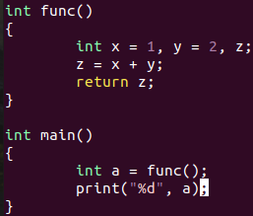 | 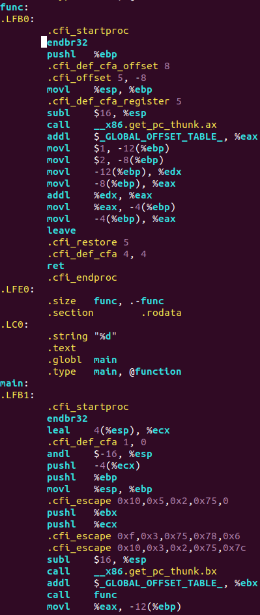 | 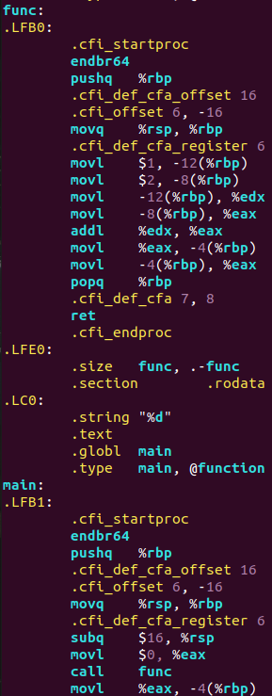
c.1 arg | 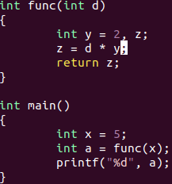 | 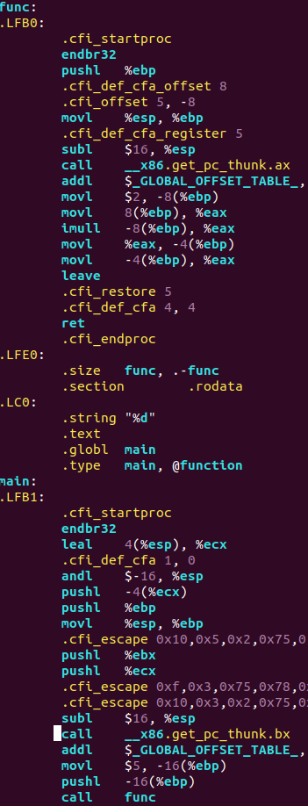 | 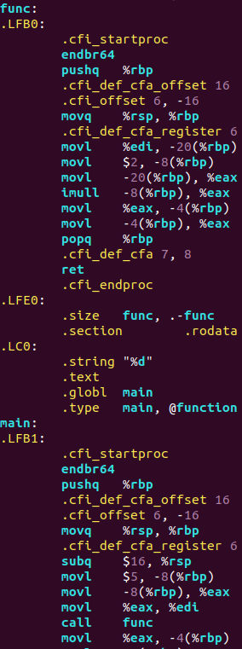
d. many args | 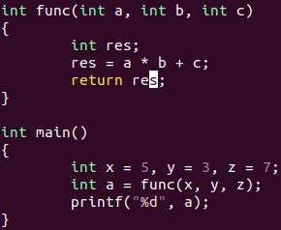 | 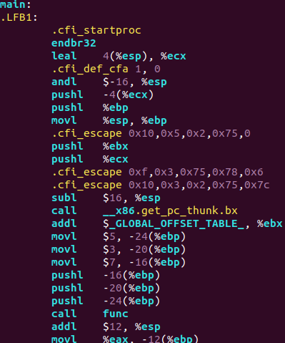  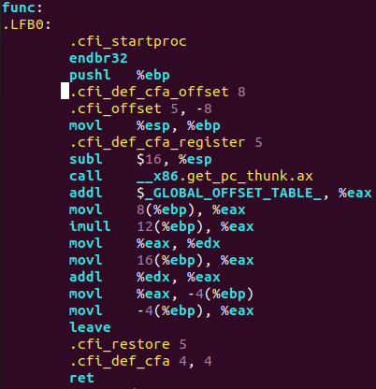 | 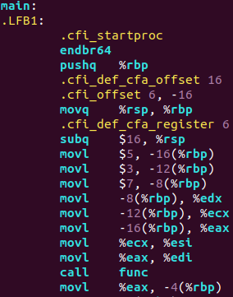  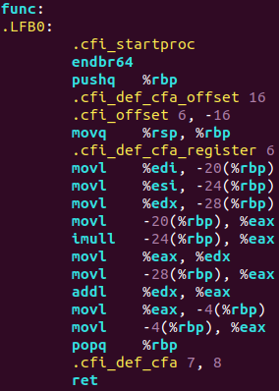
General observations:
- register %eax is used as a return value
- 32bit and 64bit systems operate the setup and cleanup of stack frame differently(i.g. 32bit uses leave(equals movl + popl), 64bit operate with just popq
- another feature of 64bit system is that, unlike 32bit system, which allocate memory for local variables using, i.g., subl $16, %esp in both main and leaf function, there is a “red zone” of 128 bytes below %rsp. These 128 bytes belong to the function as long as it’s a leaf function. Thus, all of local variables of a leaf function fit into the red zone, so no adjustment of %rsp needed (no instructions such as subq $16, %rsp).

2. Local variables.
point | C | 32bit | 64bit
a. 1 loc var | int x = 5 | 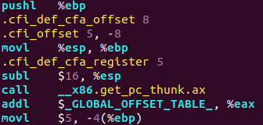 | 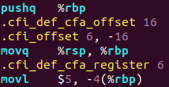
b. 5 loc var | int a = 5, b = 4, c = -6, d = 8, i = 9; | 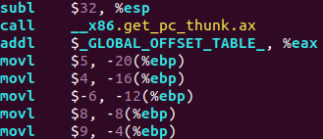 | 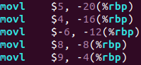
c. static array | int arr[50];  arr[7] = -345; | 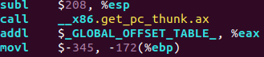 | 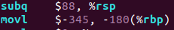  Without stack protector  With stack protector  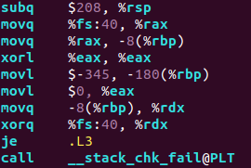
d. dynamic array(C) | 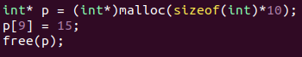 | 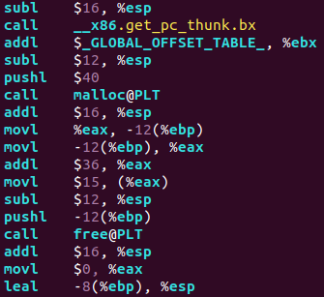 | 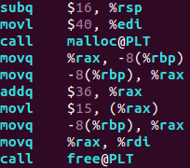
d. dynamic array(C++) | 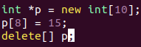 | 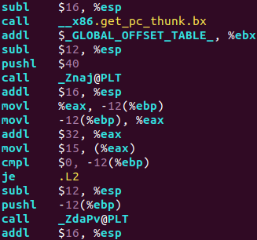 | 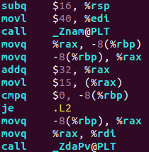  _Znam@PLT = new[]  _ZdaPV@PLT = delete[]

- static array in 64bit shift %rsp to a less amount, than the size of array, perhaps, because of the red zone.
- In 32bit system size of dynamic array is pushed in stack; in 64bit is moved to %edi
- %eax/%rax initially refers to the first element of dynamic array(it must be so because after we call malloc/new[], the result of function, i.e. pointer to the first element, is written in %eax)

3. Structures

point | C++ | 32bit | 64bit
b. global struct | 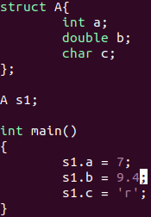 | 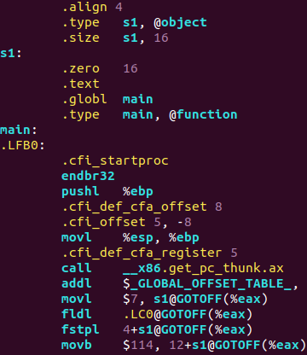 | 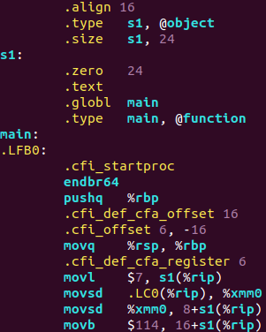
c. static array as a member | 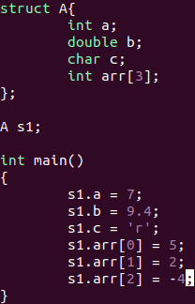 | 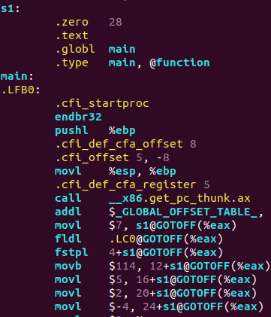 | 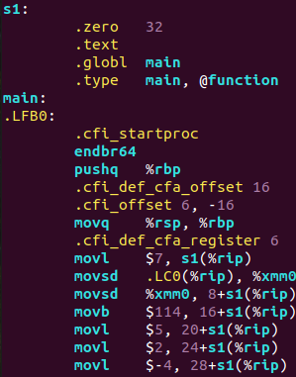
d. struct as an arg in function | 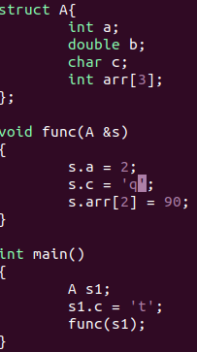 | 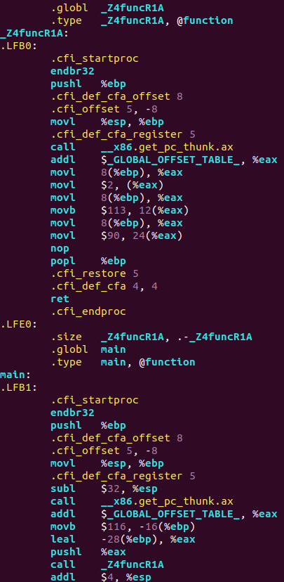 | 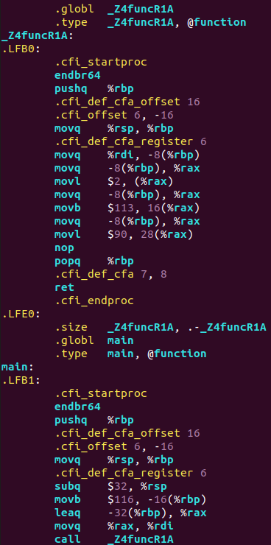
e. struct as a return value | 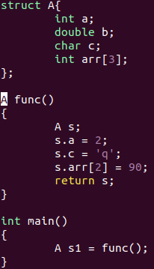 | 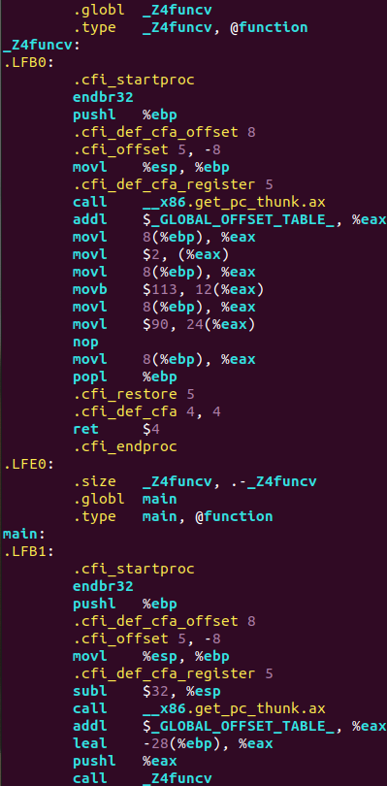 | 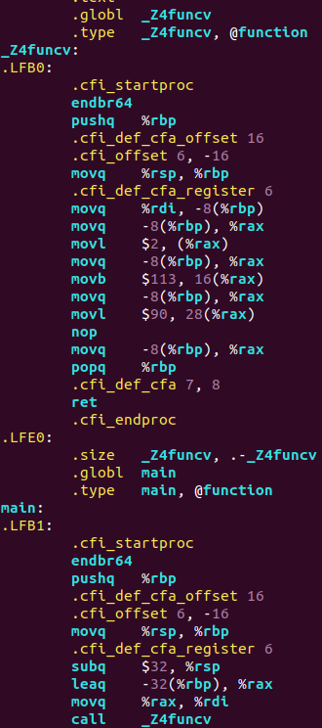

- in 32bit system Global offset table is used to dynamically access structures(in this task) . In a. and b. @GOTOFF is used for global structures – perhaps it stands for GOT Offset, meaning making an offset from GOT address. In 64bit system register %rip was responsible for that.

4. Pointers and references
point | C++ | 32bit | 64bit
a. struct | 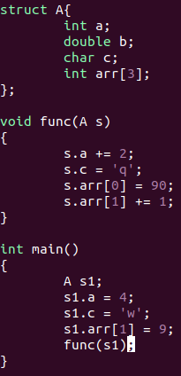 | 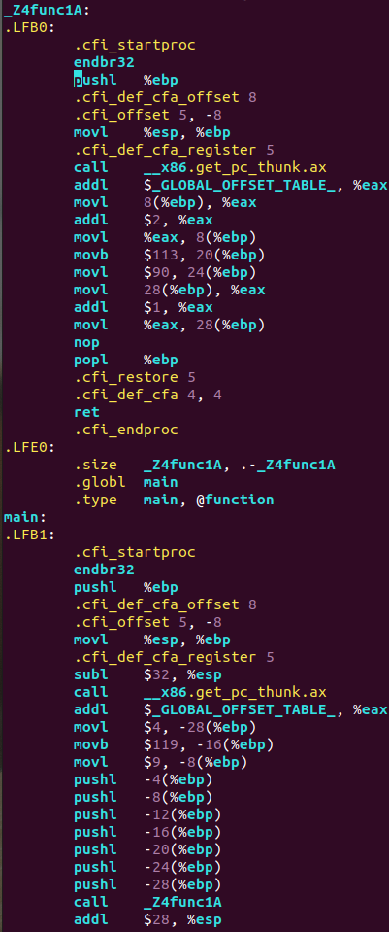 | 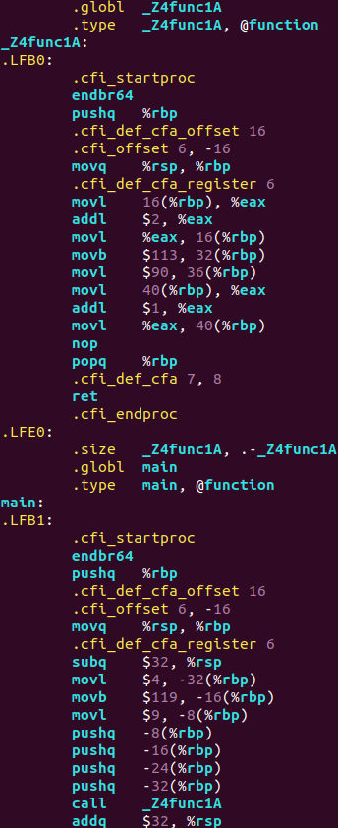
b. struct pointer | 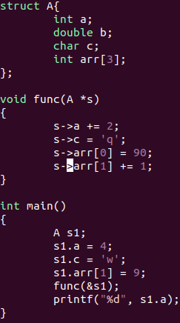 | 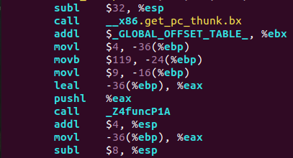  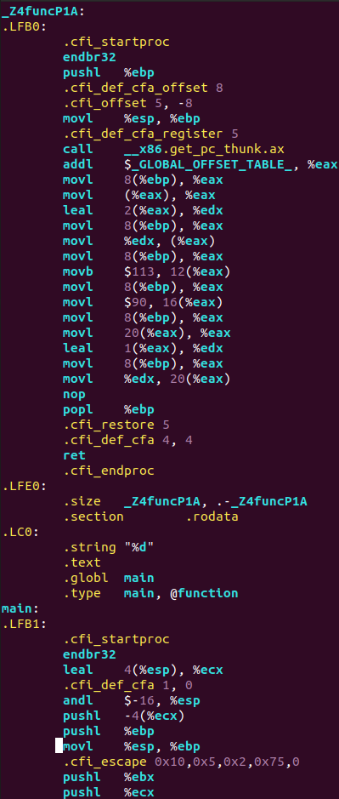 | 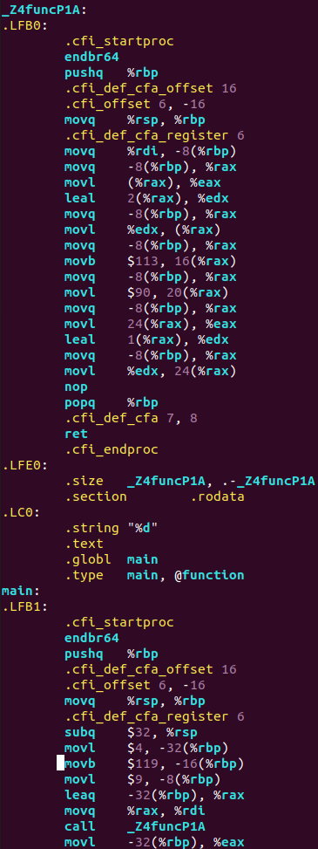
c. struct reference | 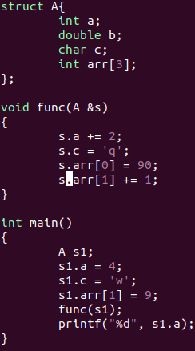 | 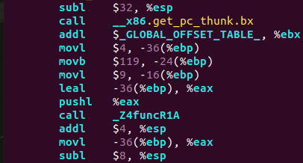  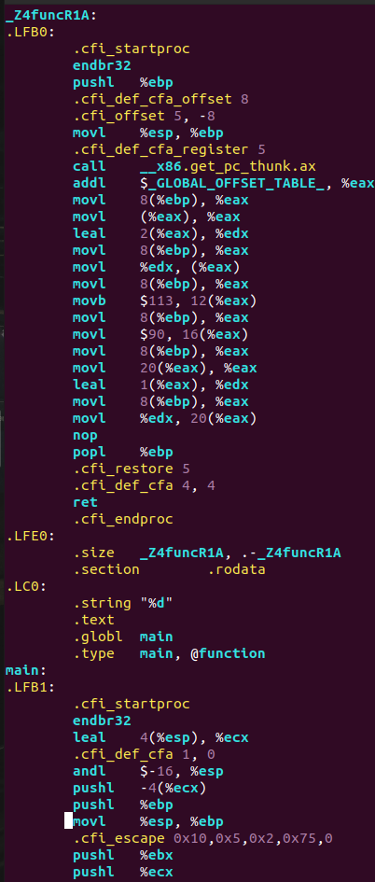 | 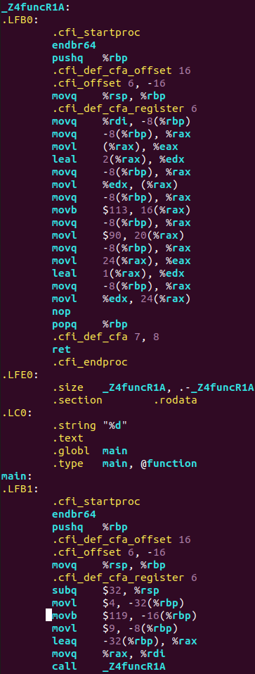

- in a. all struct members are pushed into stack; in b. and c. (pointers and references) struct members are not pushed into stack, only registers and stack frame(via i(%rbp)) are used.

5. Heavy structures
point | C++ | 32bit | 64bit
a. struct as an arg | 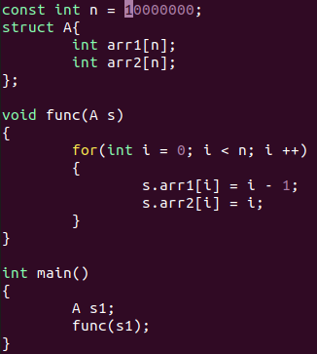 | 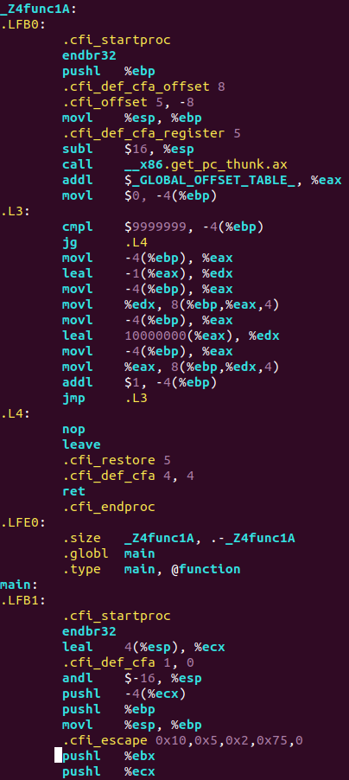  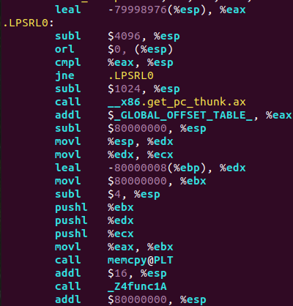 | 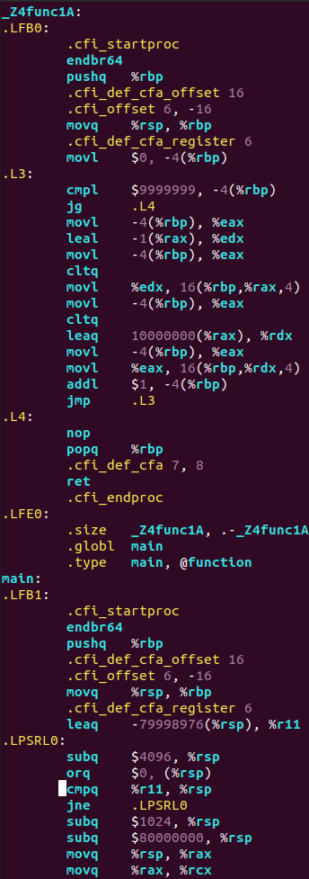  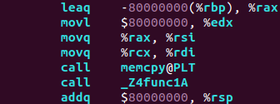
b. struct as a return value | 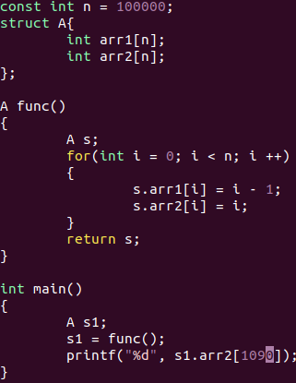 | 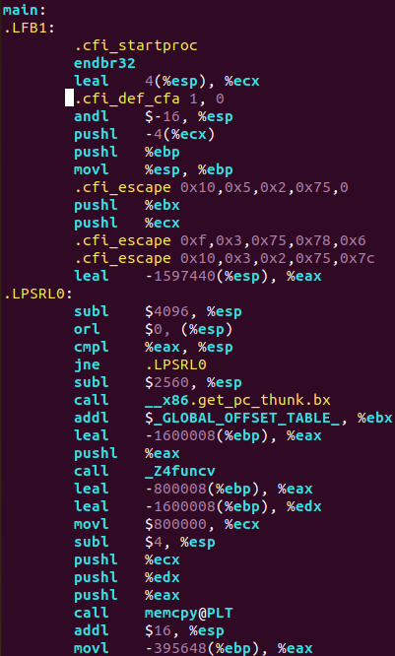  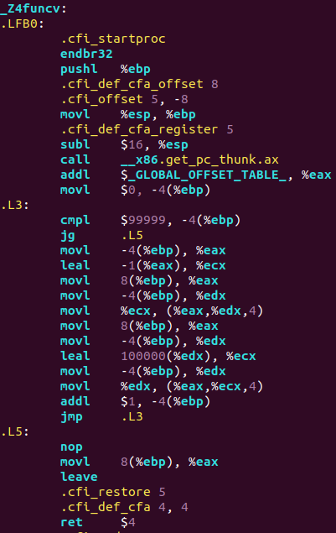 | 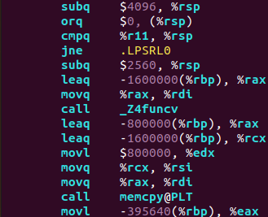  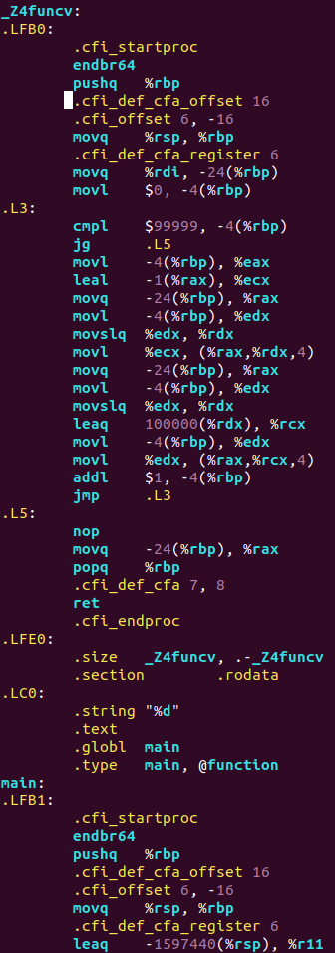
c. struct as local var | 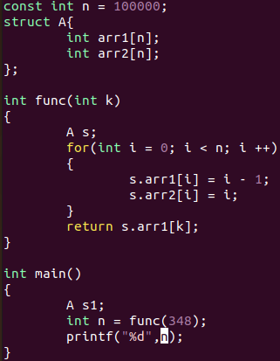 | 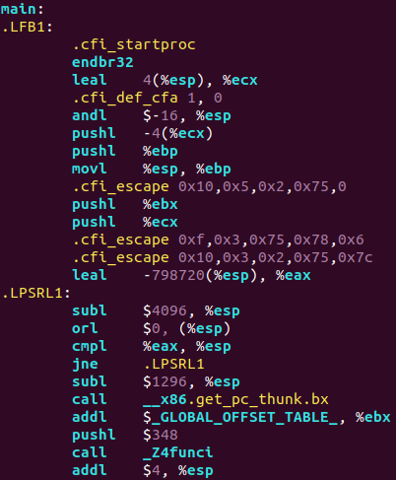  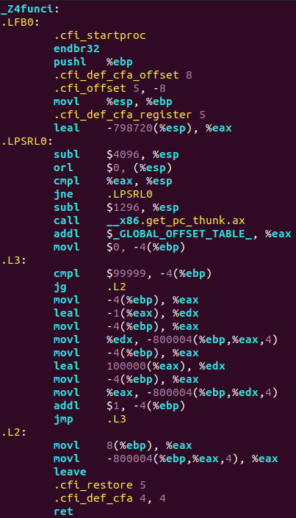 | 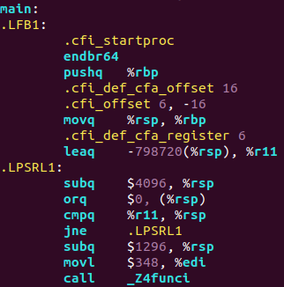  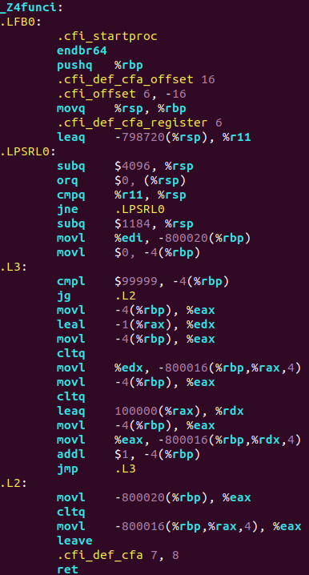
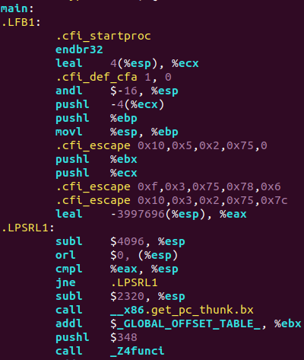  d. changing size(relative to c.) | Size = 500000 | 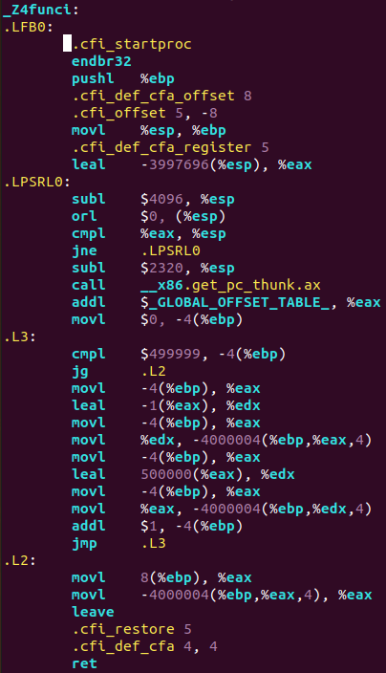 | 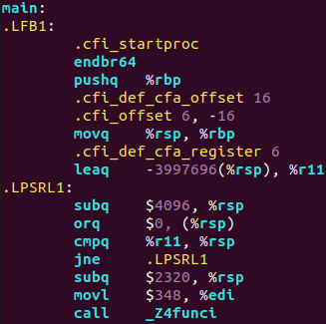  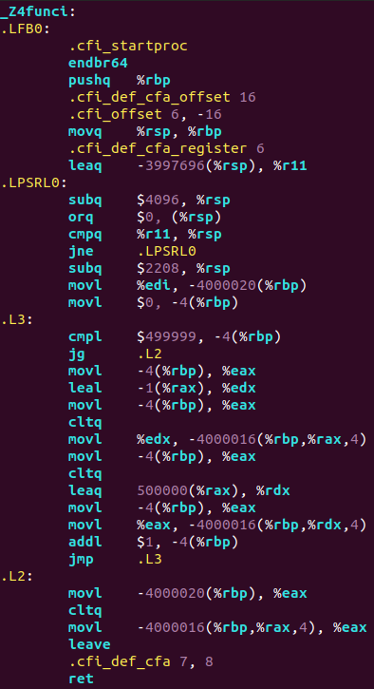

- just big numbers of allocated memory appear
- also it seems that %rsp cannot be reduced by a bigger number than 4096, thus there is a cycle .LPSRL1, which decrements %rsp only by 4096. After that %rsp is once again decremented for lacking bytes.

6. Recursion
C | 32bit | 64bit
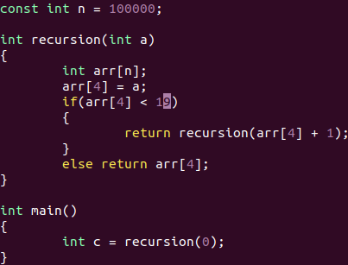 | 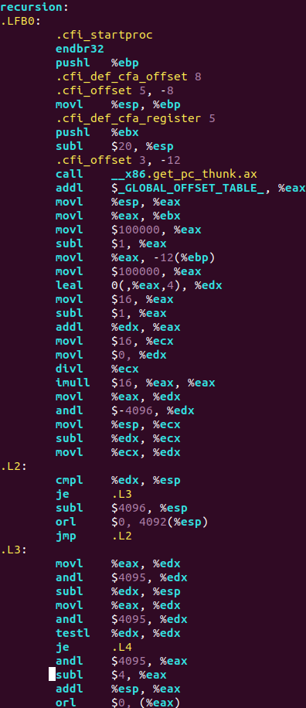  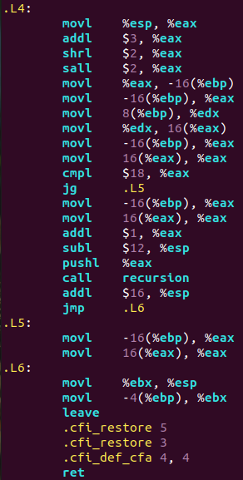  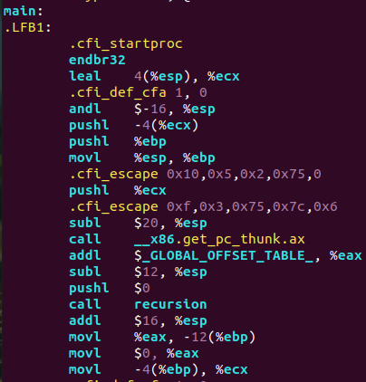 | 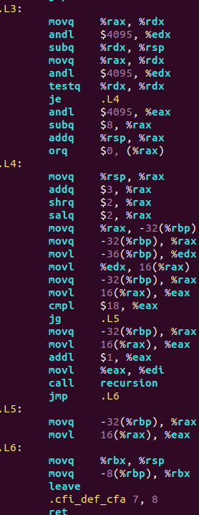  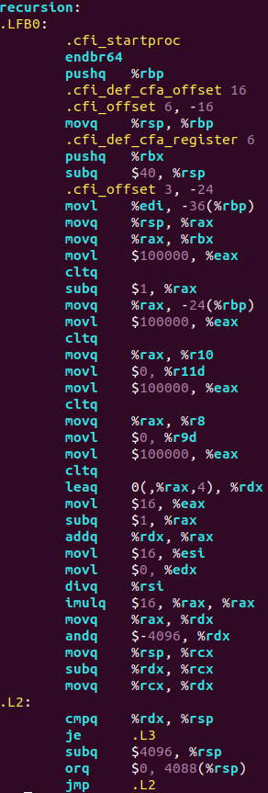  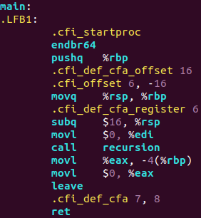
C++ | 32bit | 64bit
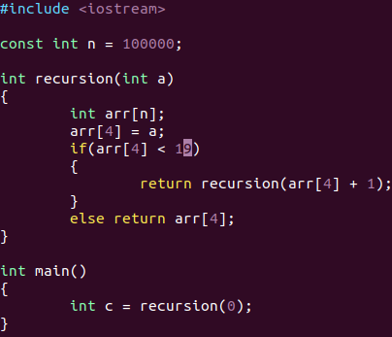 | 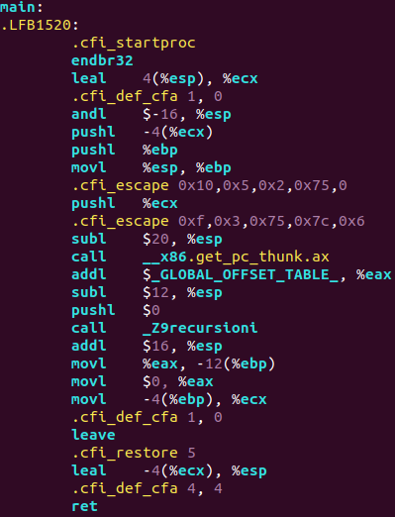  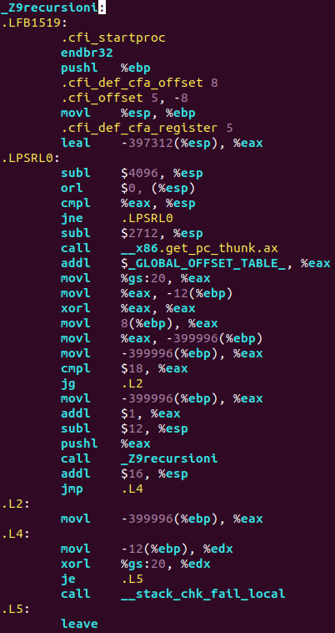 | 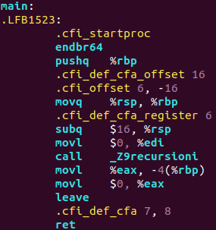  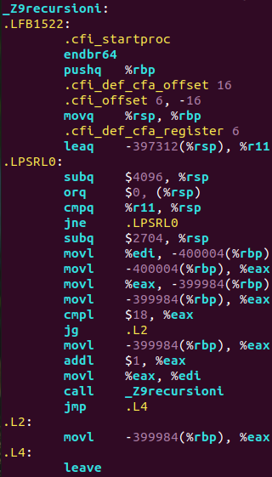
- Differences between 32bit and 64bit are not that significant, just the amount of memory allocated for arrays(differs by approximately 0-20 bytes)
- program executes correctly, when arr[4] < 19, so for 20 recursion calls. If I write arr[4] < 20 – stack overflow occurs. So the estimated stack size is between 20*100000*4 bytes ≈ 7800KB and 8200KB. So assuming that stack size is a good looking number, it’s around 8MB.

Lab 4
1. Static libraries

bit | Assembly(sum.s) | Binary(library part after linking)
32 | 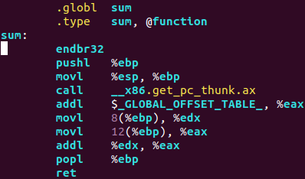 | 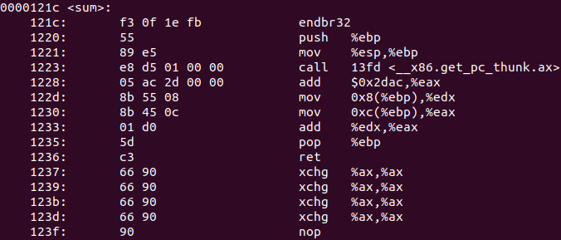
64 | 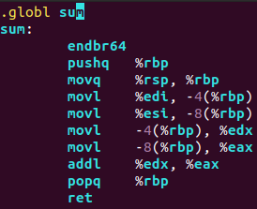 | 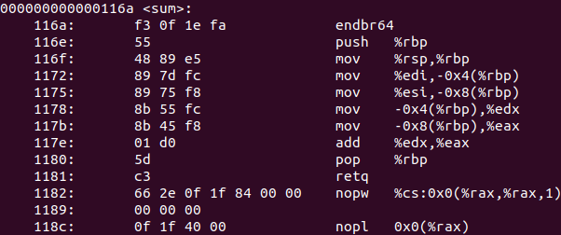  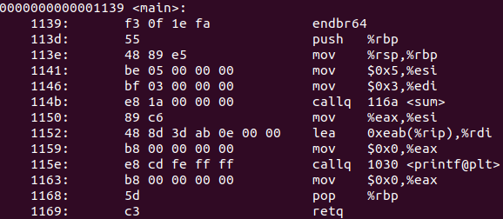
- First obvious remark is 32bit system addresses have 8 digits, 64bit – 16.
- sum function is called in main by its address(116a)
- If we look at binaries of created libraries before linking, we can notice that function and other symbols still have there names definition, in other word functions and variables are not bound to any specific address, thus symbols associated with 00000000(32bit):

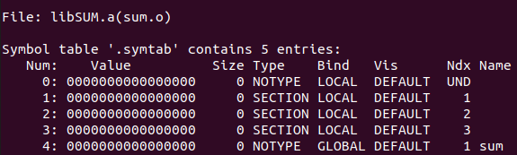

This is a relocatable object file.

After linking all object files (and libraries), an executable object file is created in which all symbols are associated with real address.
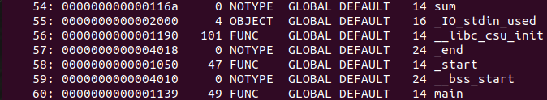
Row 54 is referenced to sum function and has an address.
In total: After the compiler and assembler generate the relocatable object file, the data start at address 0. The linker then relocates these sections by associating each with a location with in memory.

2. Dynamic libraries

bit | Binary(library part after linking)
32 | 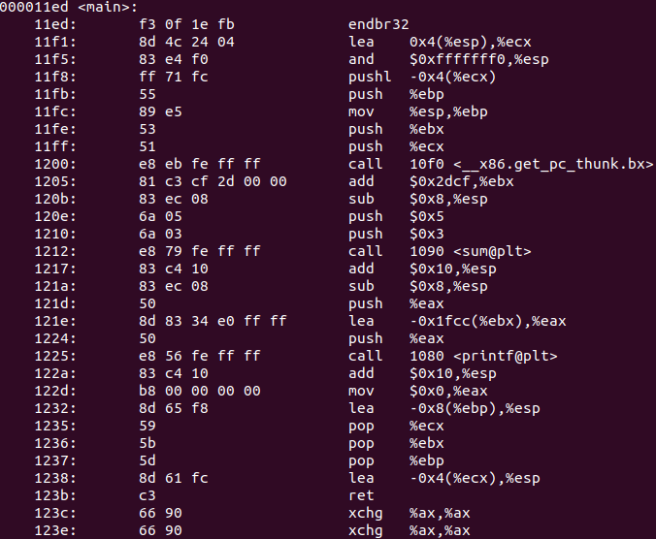  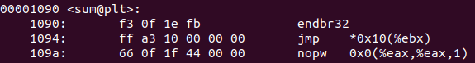
64 | 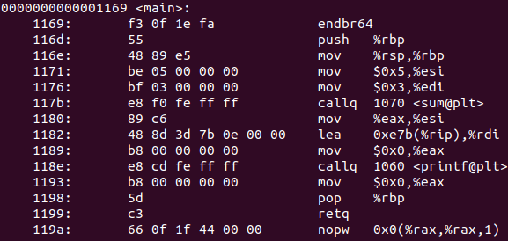  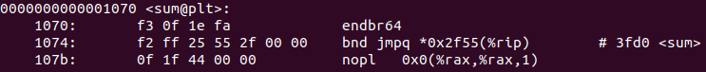  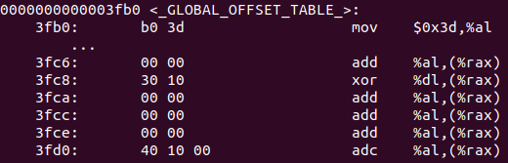
- Both dynamic library and executable are shared object files
- In main there is a call for <sum@plt>, which means that library code is not copied(as with static libraries), but accessed via address. In line 1074(64bit, where underlined with red color) there is another call for a sum function, which is located in GOT. Using GOT allows shared libraries to be relocated to a different memory address at startup and avoid memory address conflicts with the main program or other shared libraries.

To sum up(similarities/differences between static and dynamic libraries):
- both connected to program via linker(static/dynamic, resulting in an executable)
- static library’s code accessed (inserted) at a compile time
- dynamic library’s code accessed at a runtime as well as memory is being loaded with it
- static libraries upgrades require recompiling of all parts of program, whereas dynamic libraries upgrades independently
- static libraries are easy to install, with dynamics ones problems can occur

