Lab 5

1. int

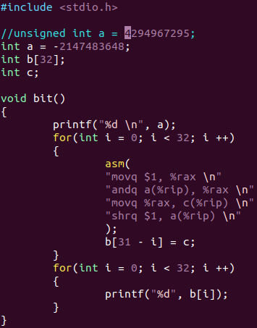
Examples
Number | Two’s complement
-2147483648 | 10000000000000000000000000000000
-2147483646 | 10000000000000000000000000000010
-3 | 11111111111111111111111111111101
2147483648(int) | 10000000000000000000000000000000  (equals to -2147483648)
4294967295(unsigned int) | 11111111111111111111111111111111
2147483648(unsigned int) | 10000000000000000000000000000000

2. float
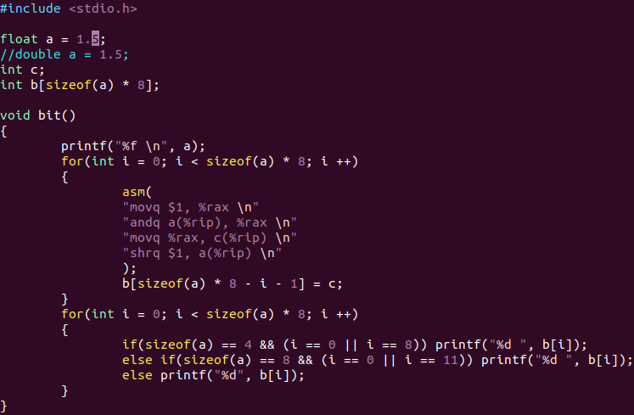
Examples
Number | Two’s complement
1.5(float) | 0 01111111 10000000000000000000000
1.5(double) | 0  01111111111 1000000000000000000000000000000000000000000000000000
3.14(float) | 0 10000000 10010001111010111000011  (=3.1400001049041748046875)
+(-)0 (float) | 0(1) 00000000 00000000000000000000000
+(-)∞ | 0(1) 11111111 00000000000000000000000
NaN | 0 11111111 10000000000000000000000

3. Mantissa overflow
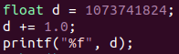

output: 1073741824.0
4. Non-associativity

5. Assembly listing
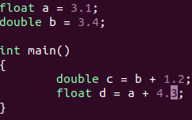
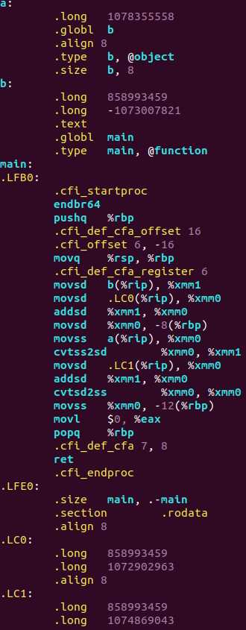

- movsd - moves scalar double-precision floating-point value(b to %xmm1(first 64 bits are rewritten))
- movss – same as movsd, but performs with float values
- addsd – adds two double values
- cvtss2sd - converts one single-precision floating-point value to one double-precision floating-point value(%xmm0 to %xmm1 - first 32 bits of %xmm0 are rewritten as double in first 64 bits of %xmm1)

Interestingly, float and double numbers are written as huge numbers, e.g. float a is written as 10783555588. That is because floating-point number representation(in binary) is converted to decimal. As for doubles, it’s value is divided in 2 rows: first row is for last 32 bits of double(mantissa), second row is for first 32 bits(sign + exp + mantissa)

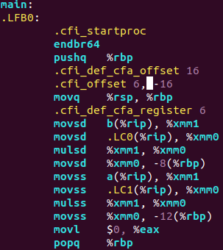
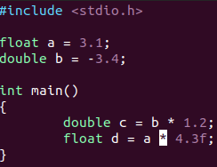
- mulsd – multiplies 2 double values
- mulss – multiplies 2 float values

6. π(N)

Method | Plot
Wallis product | 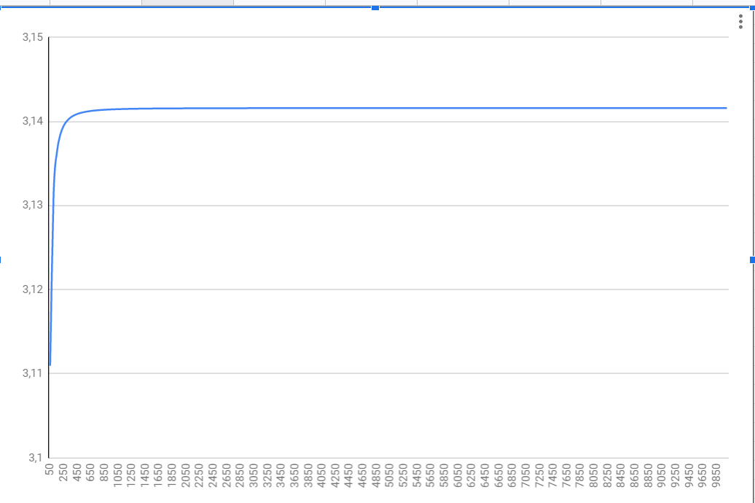
Monte-Carlo method | 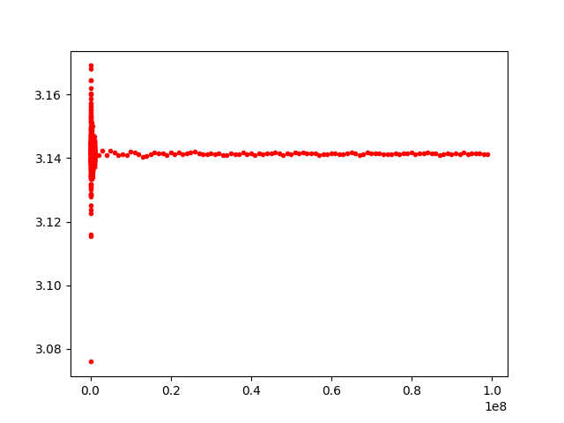
Monte-Carlo method | 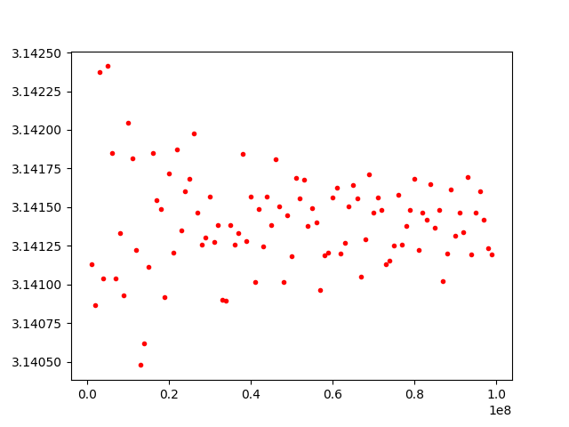
Monte-Carlo method | 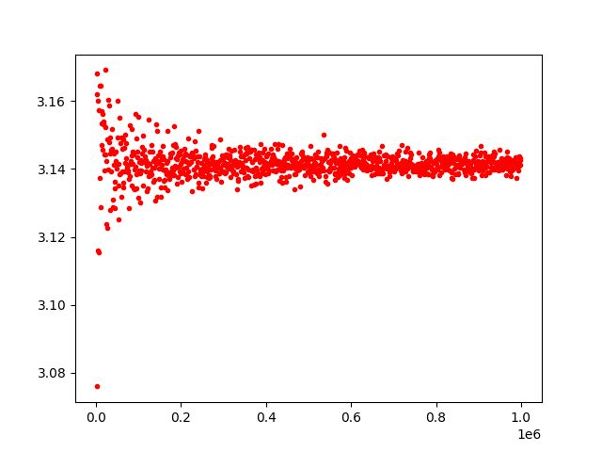
 | 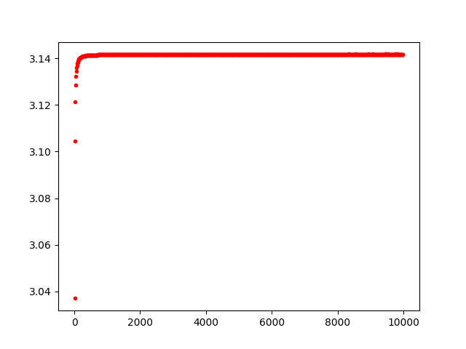dx > 2 * 10⁻⁴
 | 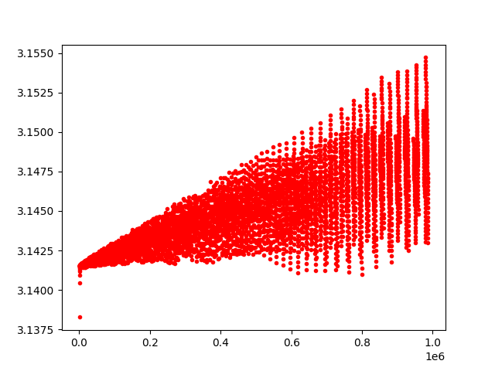dx > 2 * 10⁻⁴
 | 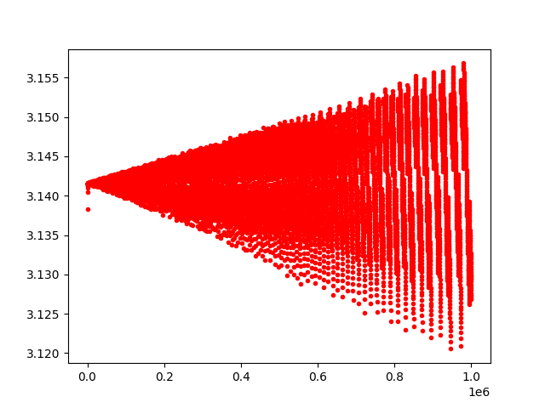dx < 2 * 10⁻⁴ (more strict integration boundaries)

7. Denormalized numbers
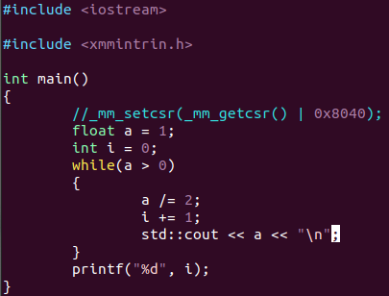
 | float | double
Normalized | 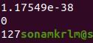 | 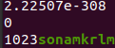
Denormalized | 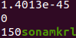 | 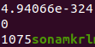
First value is the minimum floating-point number; third value is the abs of maximum power of 2, which represents 0.
8. FTZ and DAZ
FTZ - sets denormal results from floating-point calculations to zero.
DAZ - sreats denormal values used as input to floating-point instructions as zero.

