Lab 6

1. Assembly listing
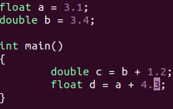
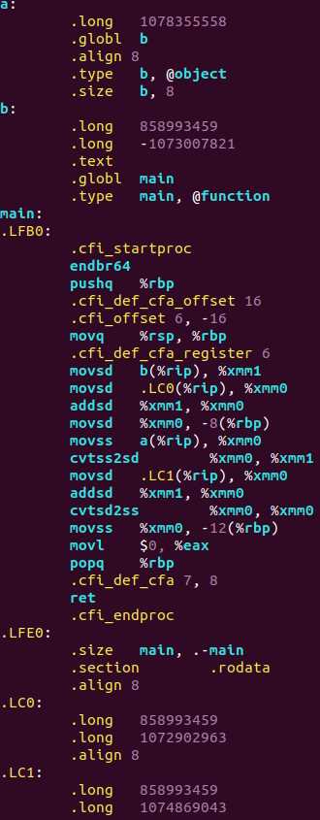

- movsd - moves scalar double-precision floating-point value(b to %xmm1(first 64 bits are rewritten))
- movss – same as movsd, but performs with float values
- addsd – adds two double values
- cvtss2sd - converts one single-precision floating-point value to one double-precision floating-point value(%xmm0 to %xmm1 - first 32 bits of %xmm0 are rewritten as double in first 64 bits of %xmm1)

Interestingly, float and double numbers are written as huge numbers, e.g. float a is written as 10783555588. That is because floating-point number representation(in binary) is converted to decimal. As for doubles, it’s value is divided in 2 rows: first row is for last 32 bits of double(mantissa), second row is for first 32 bits(sign + exp + mantissa)

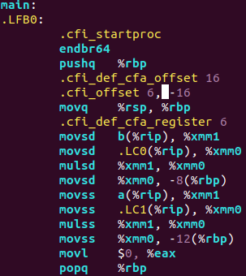
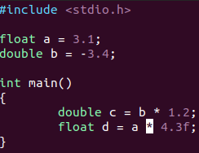
- mulsd – multiplies 2 double values
- mulss – multiplies 2 float values

2. Mean value
Basic code:
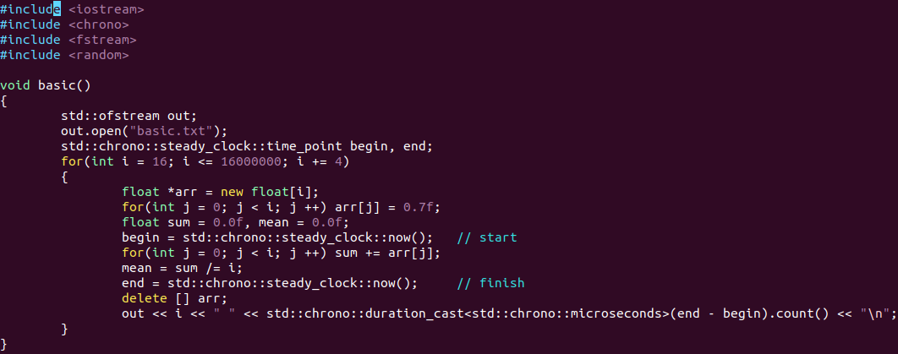
Code, using SSE:
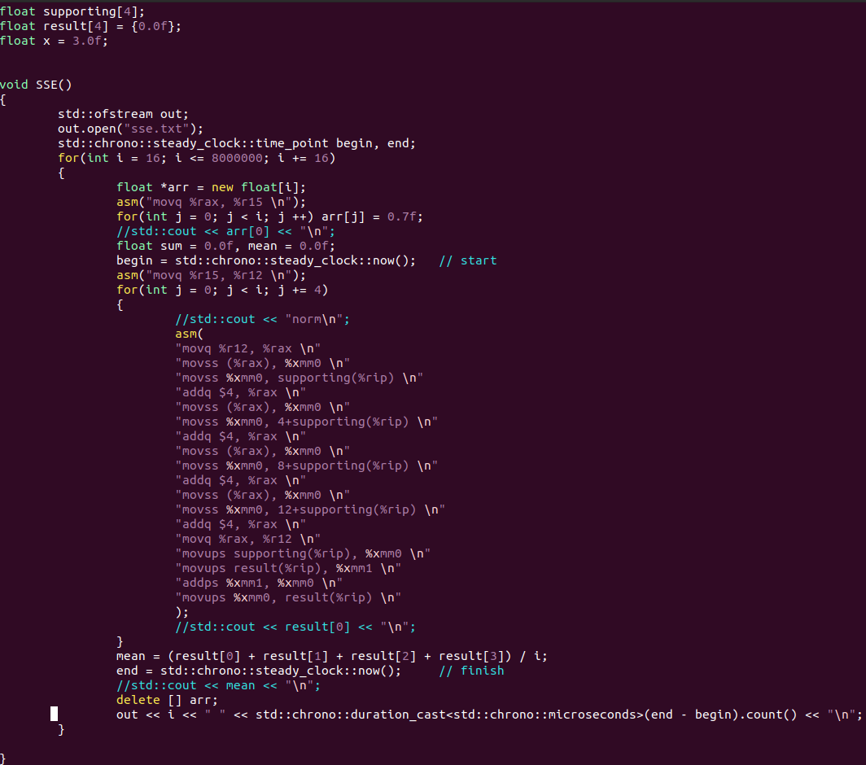
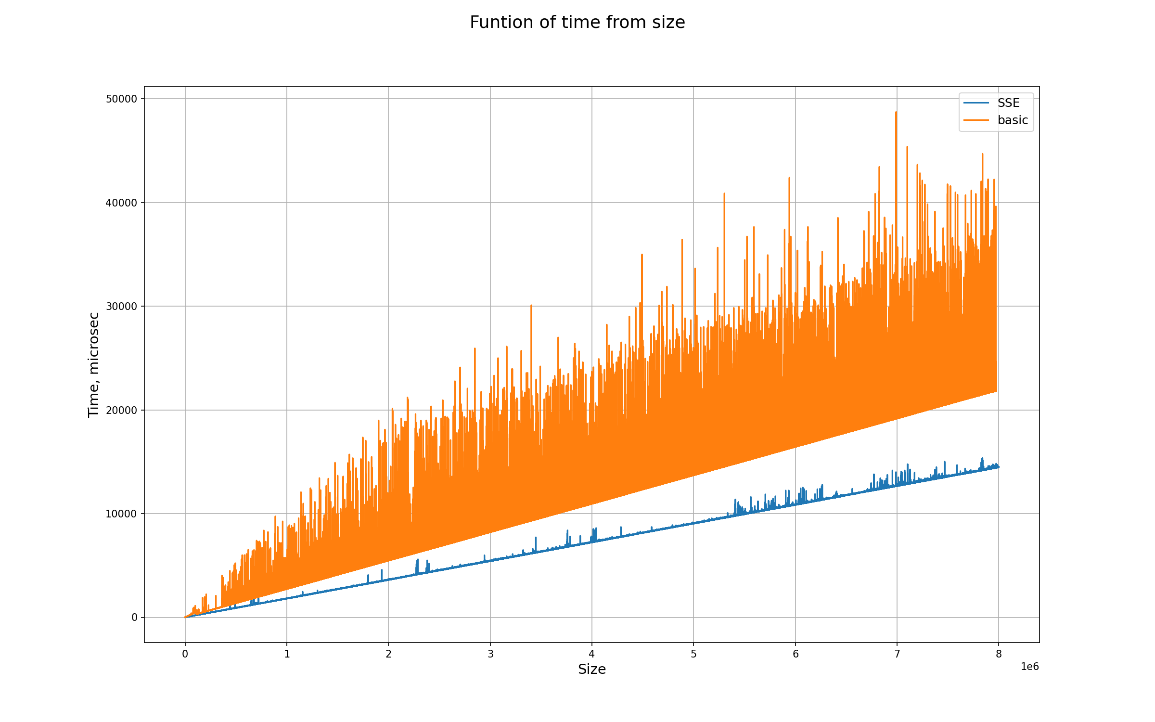
Basic algorithm works almost twice slower, than with using SSE, as was expected.
3. π(sign)
Method | Plot
Monte-Carlo  float | 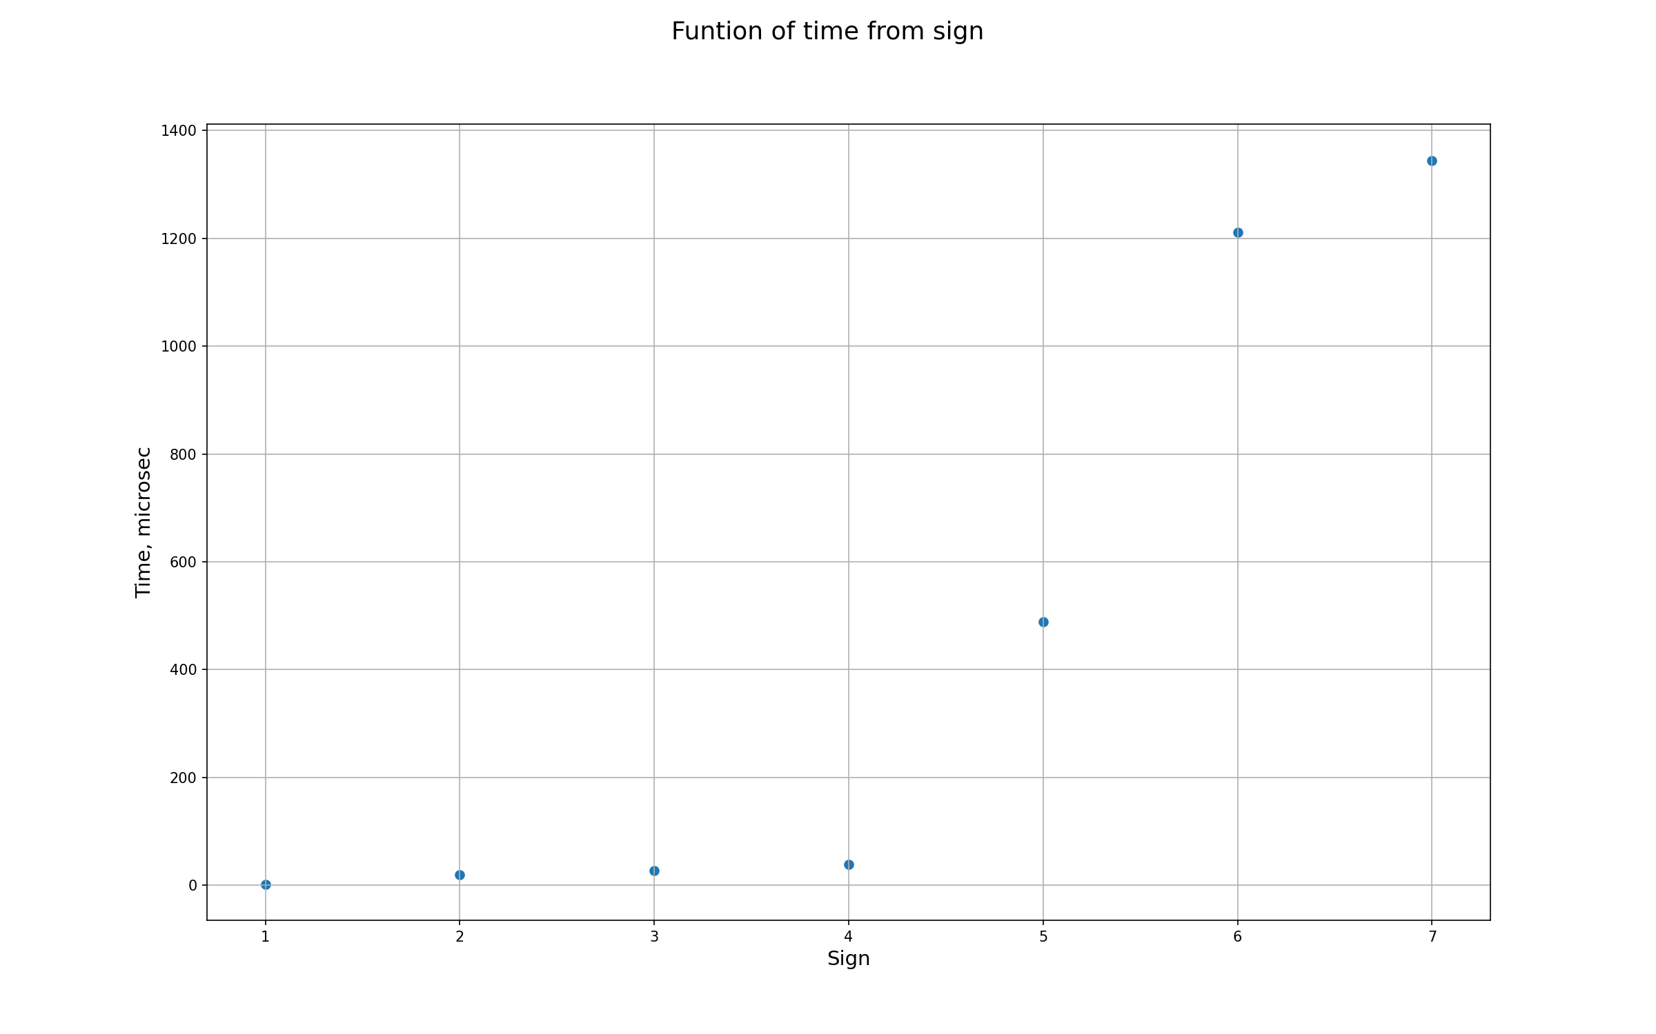
Wallis double | 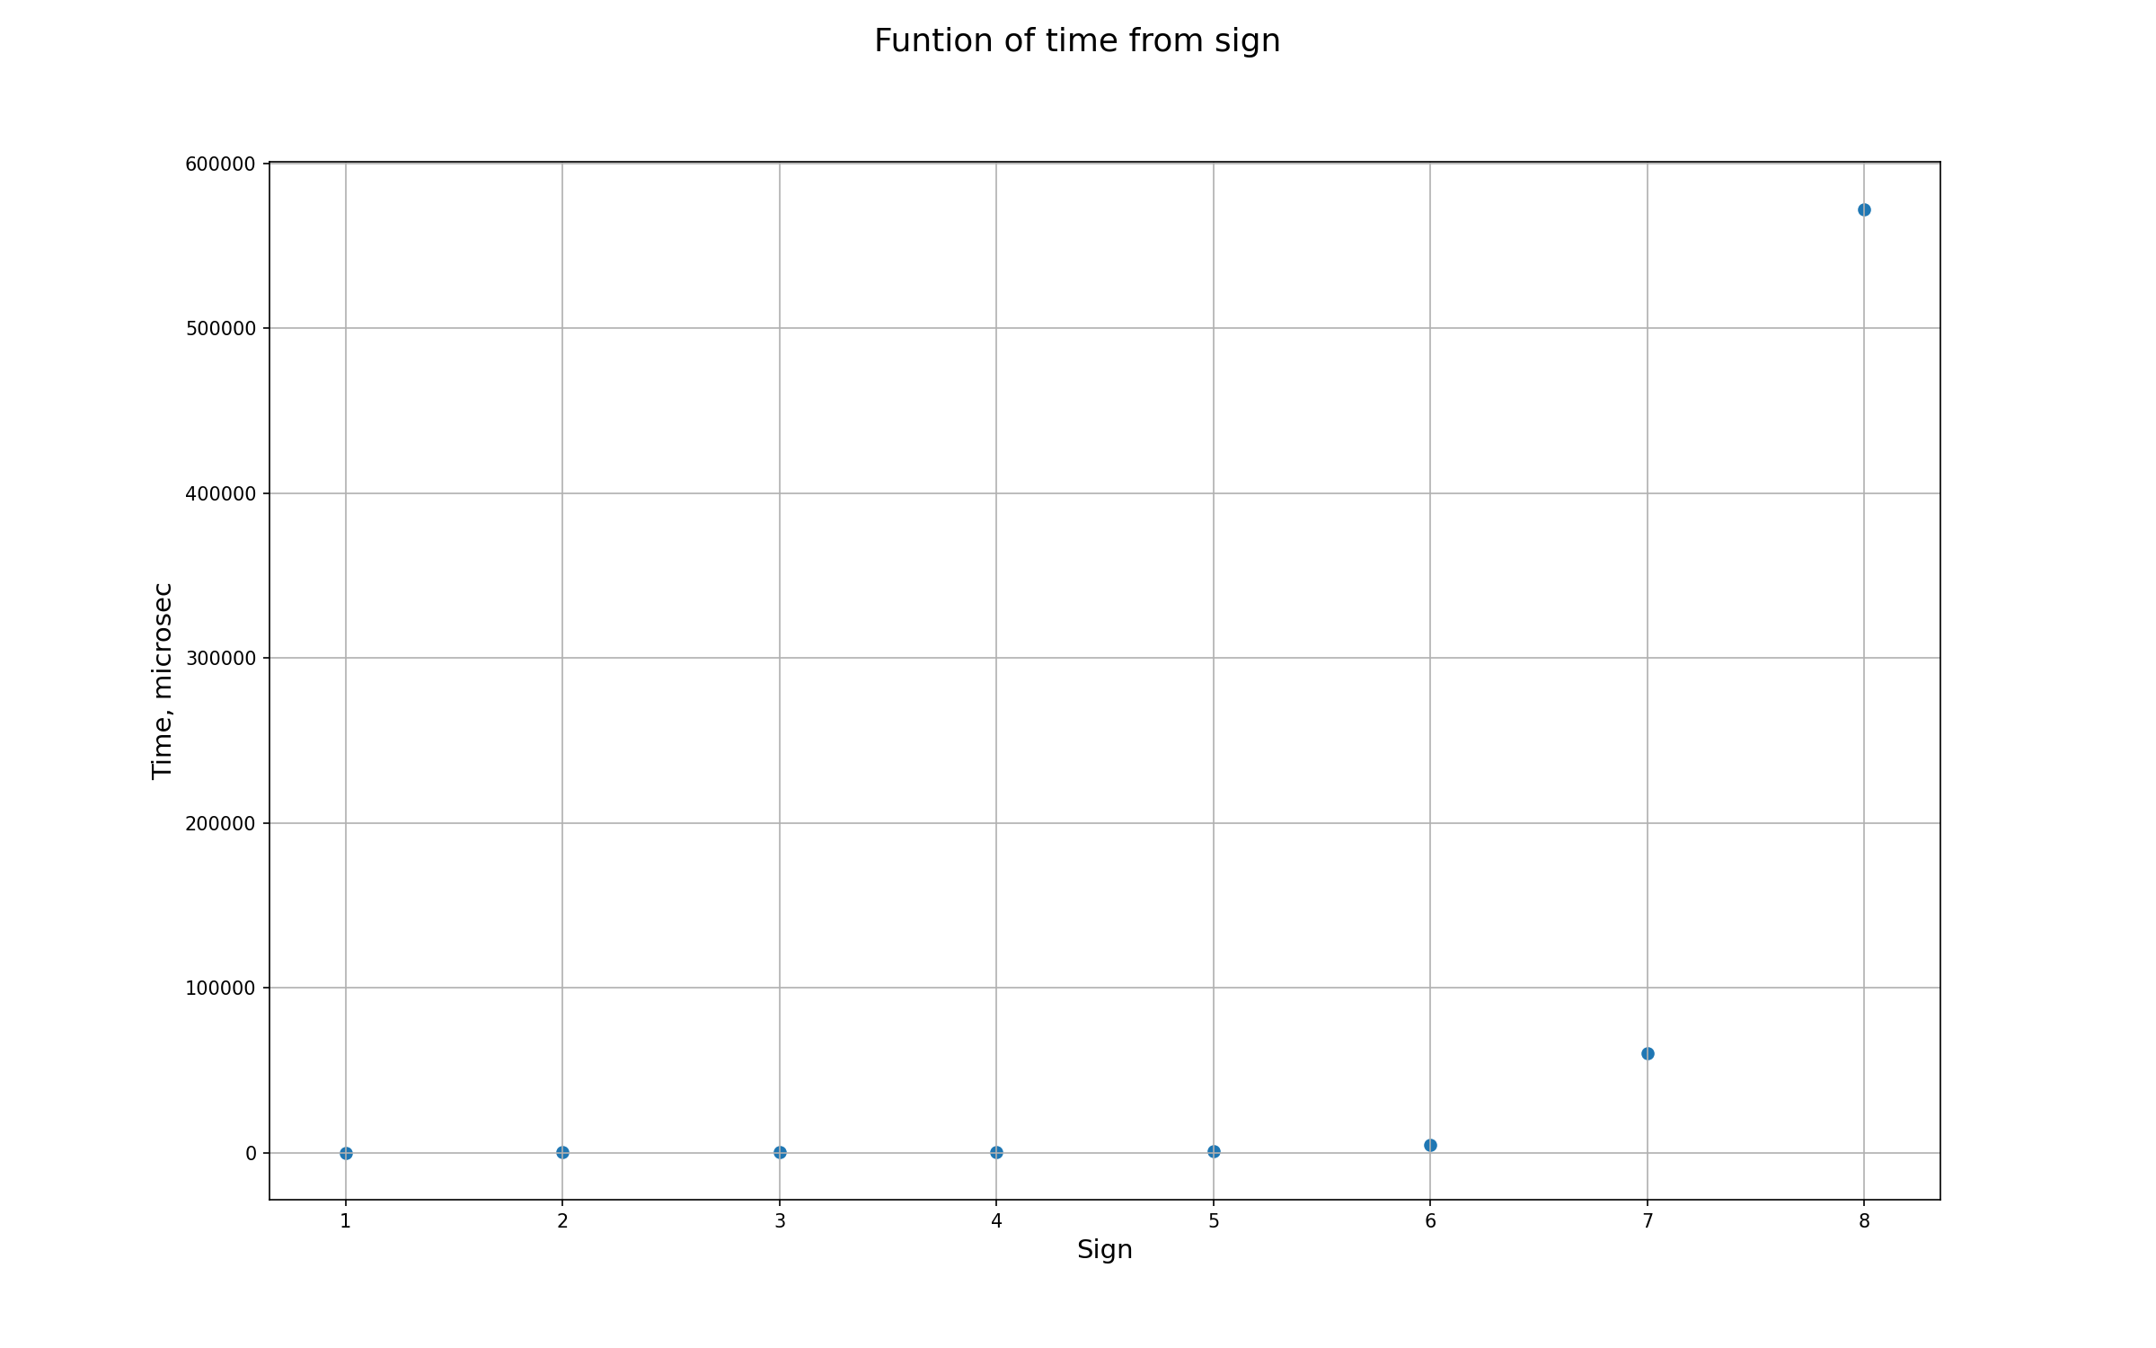
Wallis float | 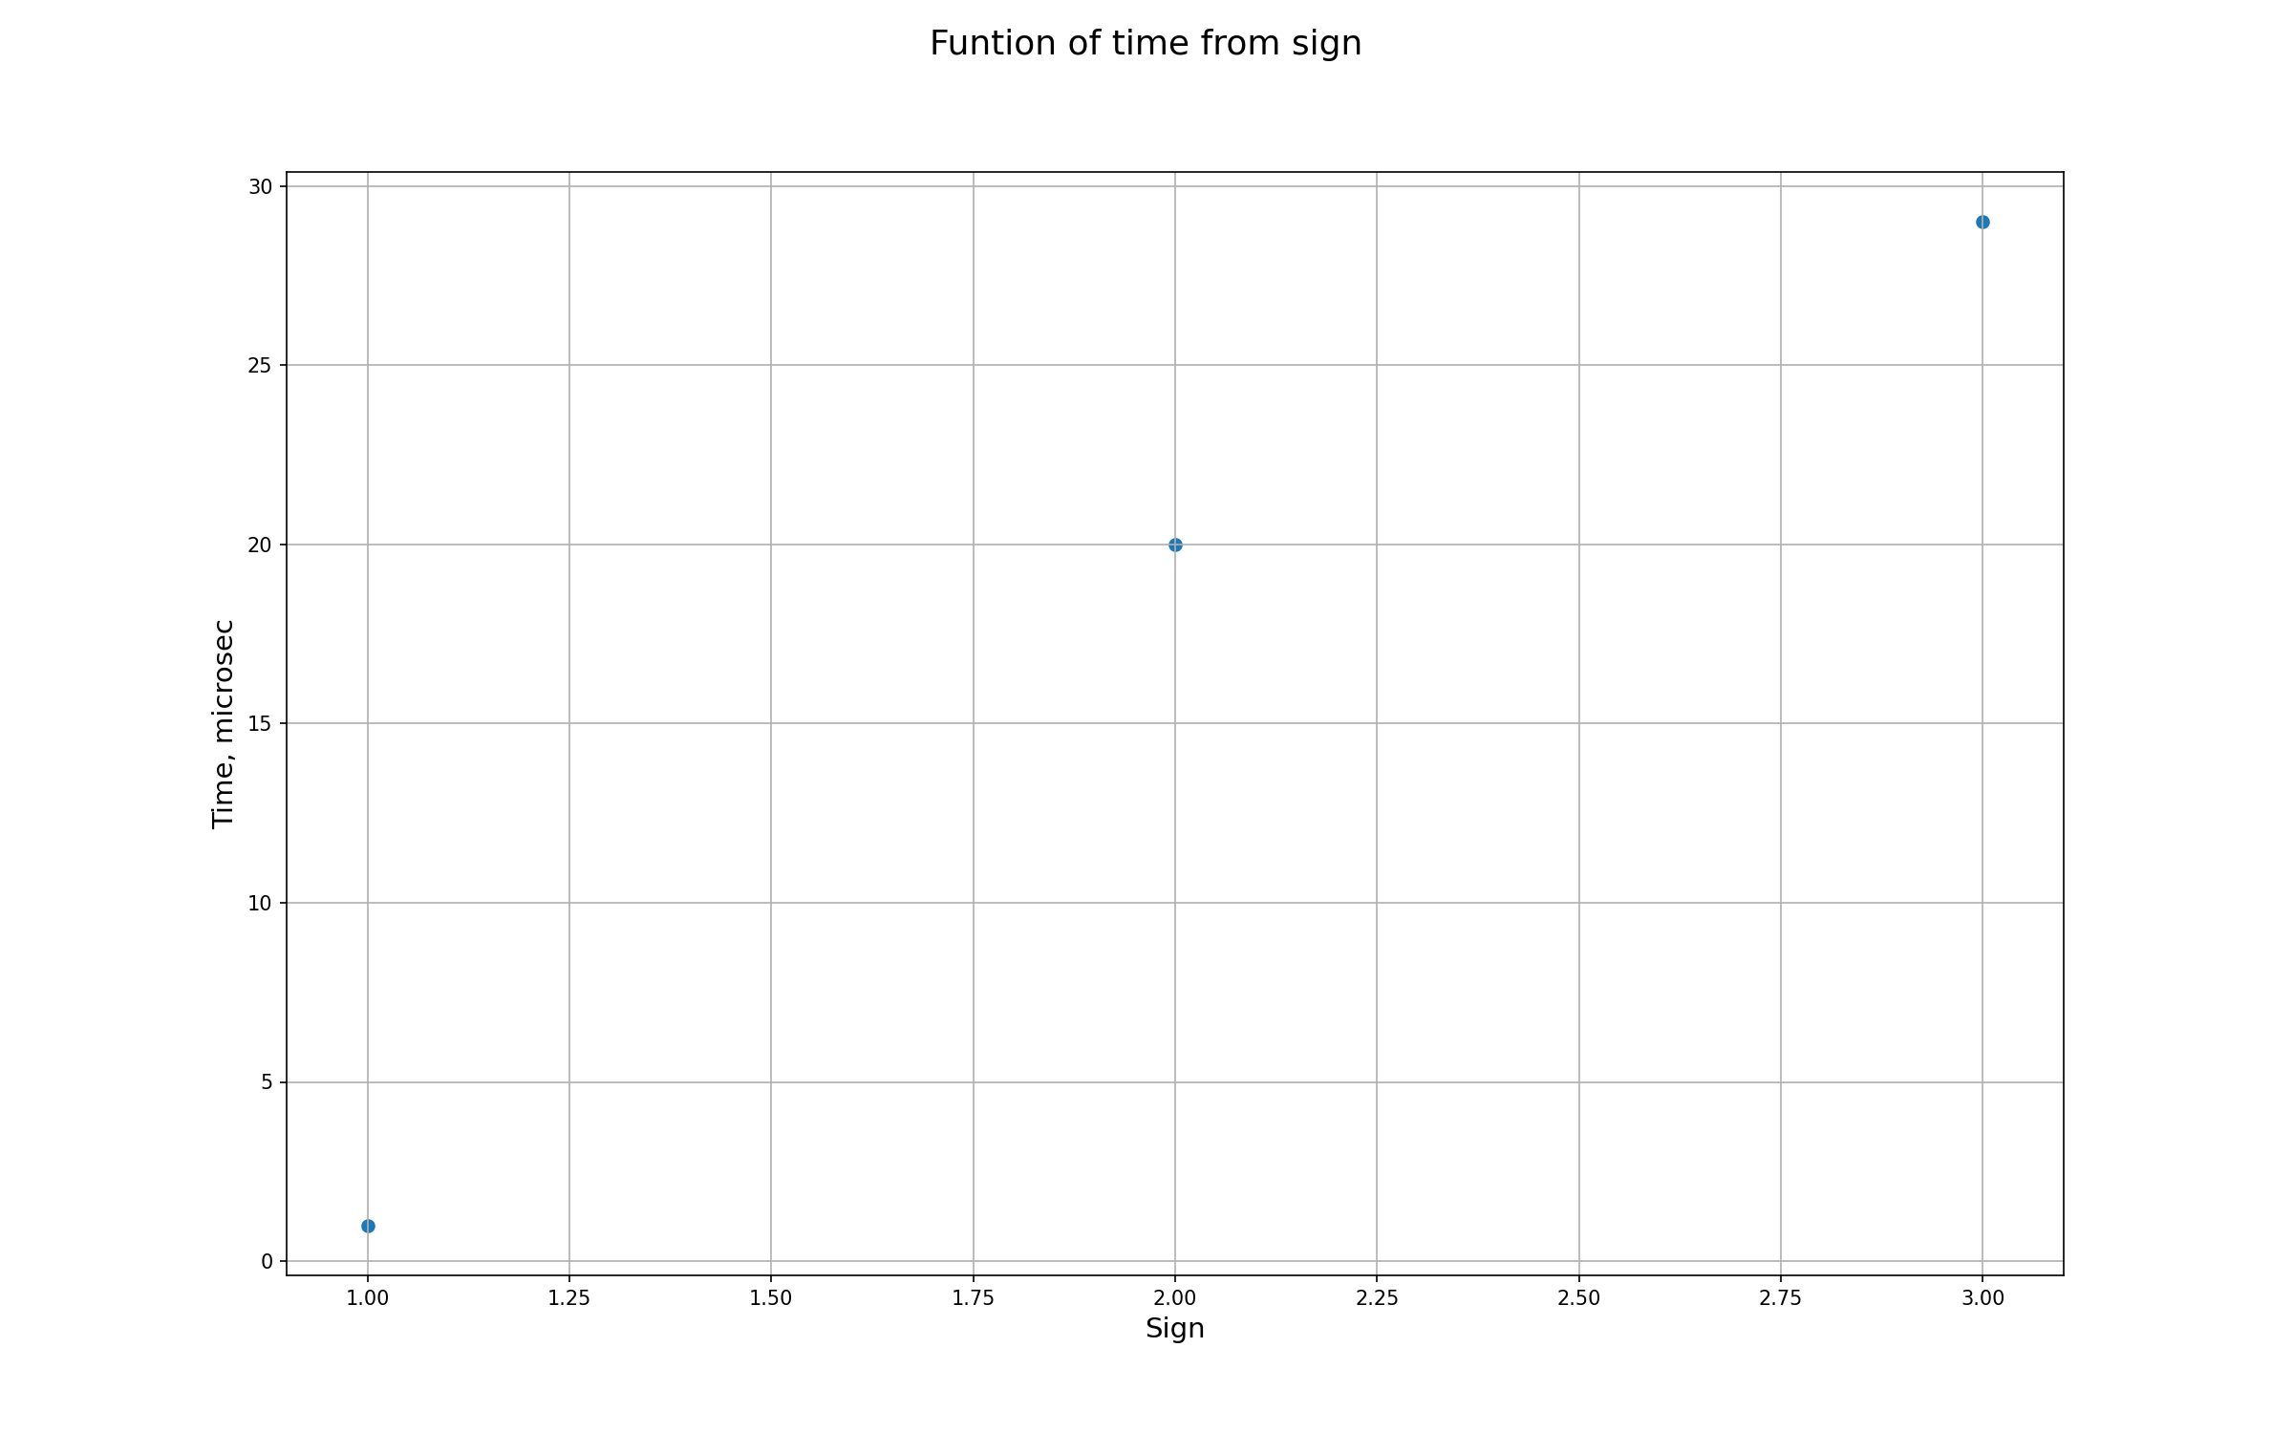
Leibniz double | 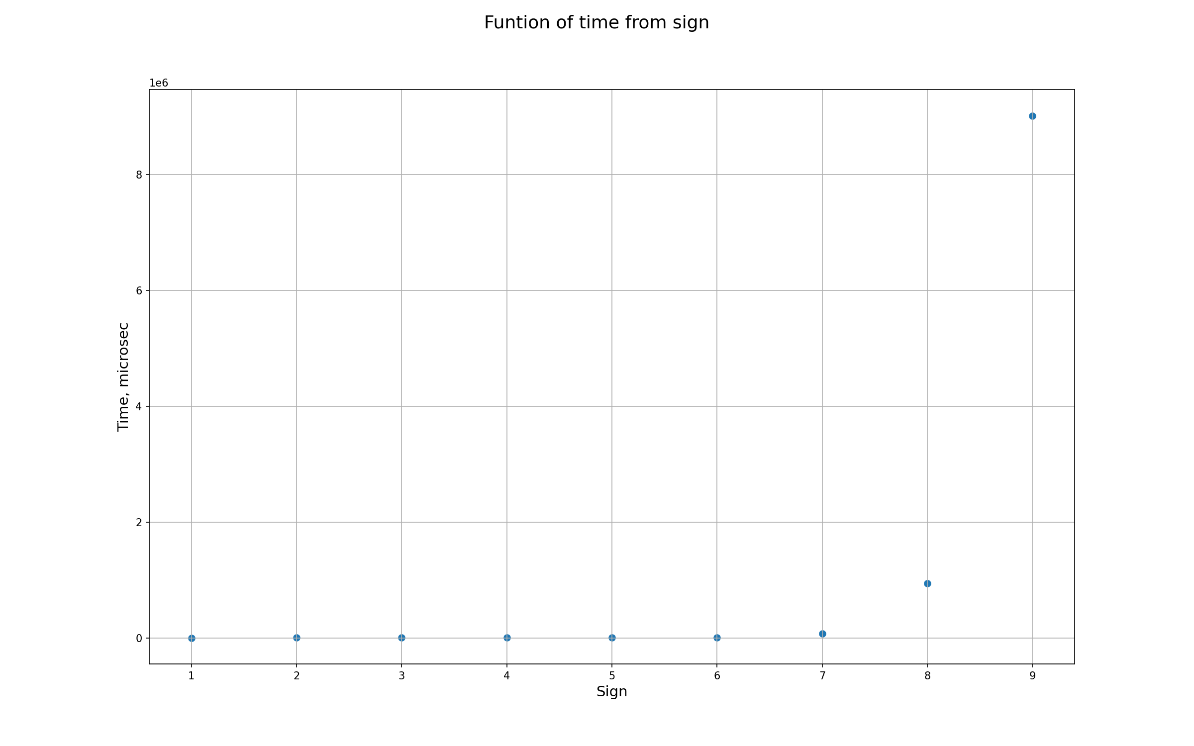
Leibniz float | 